The Effect of Chronic Disease Family History on the Adoption of Healthier Lifestyles

Alexandre Costa e Silva Barra de Sá

Dissertação de Mestrado apresentada à Faculdade de Medicina da Universidade do Porto em Saúde Pública

Porto, Setembro 2016

Agradecimentos

Em primeiro lugar, gostaria de destacar o carinho e o apoio dos meus pais e da minha família durante a realização desta Dissertação.
Seguidamente, enaltecer o papel da minha orientadora, a Doutora Bárbara Neves Peleteiro, pelo apoio e disponibilidade concedidos, assim como, pela transmissão de conhecimentos e por um conjunto de aprendizagens adquiridas que foram essenciais para a realização deste Trabalho, com particular relevância para a pesquisa bibliográfica.
Por fim, salientar a importância dos meus colegas e dos docentes que me acompanharam, no ISPUP, ao longo do ano curricular de 2014/2015 e que contribuíram para o meu crescimento enquanto pessoa, profissional de saúde e da minha consciência enquanto investigador.
O meu muito obrigado a todos,
Alexandre Sá

Index
Resumo 5
Abstract 7
1. Introduction…………………………………………………………………………………..8
1.1 – Epidemiological Transition 8
1.2 – Epidemiology of Chronic Diseases 10
1.3 – Changing Patterns of Chronic Diseases 14
1.4 – Common Risk Factors 19
1.5 – Promotion and Prevention Measures 22
1.6 – The Role of the Family 27
1.7 – Bibliography 29
2. Objectives 31
3. Manuscript 32
4. Conclusions...…………………………........................................................................52

Figures and Tables Index
I-Figure 1: Chronic diseases worldwide perspective | 8
II-Figure 2: Communicable and non-communicable diseases – Portugal 2013: Both sexes, all ages | 9
III-Figure 3: Australia Chronic Disease Report 2014 – Distribution between 1979 and 2011: Deaths per 100,000 population | 11
IV-Figure 4: Portugal – Percent of total deaths | 13
V-Figure 5: Chronic Diseases (cancer, diabetes cerebrovascular disease and chronic respiratory disease) and DALYS per 100,000 – Both sexes | 13
VI-Figure 6: Cardiovascular Diseases 2013 – YLD per 100,000; Both sexes, all ages | 17
VII-Figure 7: Tobacco Smoke Distribution 2013 – YLD per 100,000; Both sexes, all ages | 20
VIII-Figure 8: Risk factors related with Chronic Diseases 2013 – DALYS per 100,000; Both sexes, all ages | 20
IX-Figure 9: Self-Management of Chronic Care Model and Patient | 23
X-Figure 10: Estimated Proportion of Preventable Cancer Associated with 9 Learning Modifiable Risk Factors | 25
XI–Figure 11: All causes 2013 – DALYS per 100,000; Both sexes, all ages | 27
XII-Figure 12: Flowchart of the study participants, and distribution according to family history (FH) and personal history (PH) of chronic disease (CD) | 47
XIII-Table 1: Characteristics of the participants, overall and according to personal history (PH) and family history (FH) of chronic disease (CD) | 48
XIV-Figure 13: Distribution of the type of chronic disease (CD) for family history (FH) according to personal history (PH), and for PH according to FH | 50
XV-Table 2: Association between personal history (PH) and/or family history (FH) of chronic disease (CD) and healthy behaviors | 51

Resumo
Introdução:. Os estilos de vida são os principais fatores de risco para as doenças crónicas, podendo-se, deste modo, evitar, a maior parte deste tipo de patologias. Os profissionais de saúde devem aproveitar esta oportunidade, de igual modo, para influenciar os hábitos dos familiares dos pacientes, numa abordagem mais integrada da gestão da doença crónica. Por isso, o nosso objetivo foi determinar a influência da história familiar e da história pessoal de doença crónica na adoção de estilos de vida saudáveis.
Métodos: Este estudo baseou-se na primeira avaliação de seguimento da coorte EPIPorto (n=1588), durante a qual se procedeu à recolha de dados sobre caraterísticas sociodemográficas, informação clínica incluindo história familiar de 1º grau e pessoal, assim como, características comportamentais. Os participantes foram agrupados tendo em conta a história familiar (HF) e a história pessoal (HP) de doença crónica (DC), tais como diabetes, enfarte agudo do miocárdio, acidente vascular cerebral, asma e cancro, e se, para pelo menos um dos membros da família tidos como relevantes para este estudo, a causa de morte tivesse sido DC. Indivíduos sem HF nem HP de DC foram considerados o grupo de referência em todas as análises. Odds ratio (OR), ajustados para a idade, sexo e escolaridade, e intervalos de confiança 95% (IC95%) foram calculados através de regressão logística multinominal para quantificar a associação entre HF e HP de DC e estilos de vida mais saudáveis.
Resultados: Indivíduos com HP e HF de DC em que tinha ocorrido a morte de pelo menos um membro da família por DC eram mais propensos a seguir as recomendações sobre o consumo de sal, mas menos propensos a seguir recomendações relativas a medidas de obesidade. Em geral, resultados semelhantes foram encontrados quando se repetiram as análises de acordo com o tipo de DC, em particular naqueles com diagnóstico de diabetes.
Conclusões: Recomendações para estilos de vida mais saudáveis não são seguidas por indivíduos com HP e/ou HF de DC, pelo menos no que diz respeito a parâmetros relacionados com a obesidade. Novos estudos, com uma abordagem longitudinal, são necessários para confirmar este resultado. Ainda assim, o nosso estudo, sugere a redução da obesidade como um dos principais alvos de potenciais intervenções neste grupo de indivíduos.

Abstract
Background: Lifestyles are the main risk factors for chronic diseases, making these largely preventable diseases. Health professionals should take this opportunity also to influence the habits of the patients’ relatives in a broader approach to chronic disease management. Therefore, our aim was to determine the influence of family and personal history of chronic disease in the adoption of healthy lifestyles.
Methods: This study was based on the first follow-up evaluation of the EPIPorto cohort study (n=1588), through the collection of data on socio-demographic characteristics, personal and first degree family medical history, and behavioral features. Participants were grouped taking into account family history (FH) and personal history (PH) of chronic disease (CD), such as diabetes, myocardial infarction, stroke, asthma and cancer, and if at least one of the relatives had died from the CD. Subjects with no PH or FH of CD were considered the reference group in all the analyses. Age-, sex- and education-adjusted odds ratios (OR) and corresponding 95% confidence intervals (95%CI) were computed using multinomial logistic regression to quantify the association between PH and/or FH of CD and healthier lifestyles.
Results: Subjects with PH of CD and FH of CD with death of the relative by CD were more likely to follow recommendations regarding salt intake but less likely to follow recommendations regarding obesity measures. Overall similar results were observed when repeating the analyses according to the type of CD, particularly in those with diabetes.
Conclusions: Recommendations towards healthier lifestyles are not followed by individuals with PH and/or FH of CD, at least in what concerns obesity measures. Further studies with a longitudinal approach are needed to confirm this result. In any case, our study suggests reducing obesity as a major target for interventions in these groups of individuals.

1. Introduction

Figure 1: Chronic disease worldwide perspective
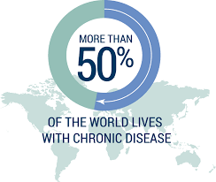

1.1 – Epidemiological Transition
A silent pandemic of chronic diseases is gradually enveloping the world population, spreading to all corners of the globe. This distinct spectrum of human afflictions is systematically replacing infectious and parasitic diseases as the leading cause of mortality and morbidity worldwide, thereby producing one of the greatest public health challenges of all times. The global pandemic of chronic diseases has emerged in accordance with the changing demographics. Overall, the birth rates exceed the death rates and the world population continues to increase. At the same time, more and more people are living to older ages thereby creating the phenomenon of «global aging». Aging populations are particularly evident in the industrialized and developed nations, where the proportion of elderly people (over 65 years of age) has doubled (from 10% to 20%) in the past half century. As a general consequence, long-term mechanisms of pathogenesis are more likely to cause disease late in life, thus resulting in vastly increased rates of chronic diseases, particularly among the elderly. To sum up, by the year of 2020, the contribution of chronic diseases is expected to rise to 73% of all deaths and 60% of the global burden of disease [1,2,3].
As result of this epidemiological transition, we have observed, in the last century, a dramatic shift, from non-industrialized countries suffering from communicable diseases to industrialized/modernized ones that lead with emergence of chronic diseases. This phenomena, continues in many areas of the world and implies some of the most populated countries such as China and Brazil. The increase on chronic disease rates has created a huge impact on emotional, social and economic dimensions throughout the world. Health transition is characterized by a demographic transition in the age profile and an epidemiologic transition marked by the shift in the cause of death profile with the increasing dominance of non-communicable diseases [4].
As people are living longer and experiencing more non-communicable disease, they are living with a greater range of disabilities as well. Most countries in the world have succeeded in reducing deaths early in life. To a growing extent, longer lives are redefining «old age» in many countries, and people in all age groups are dying at lower rates than in the past. Simply living longer, however, does not mean that people are healthier. Little progress has been made in reducing the prevalence of disability, so people are living to an older age but experiencing more ill health resulting in many people suffering from different forms of disability throughout their lives [3].
Figure 2: Communicable and non-communicable diseases – Portugal 2013
Both sexes, all ages
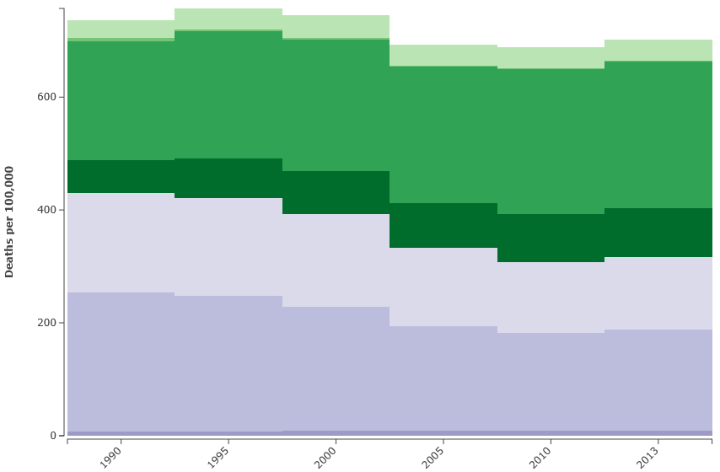

1.2 – Epidemiology of Chronic Diseases
According to the World Health Organization (WHO), chronic diseases (CD) could be defined as «diseases with a long-term duration and slow progression» and the Center for Diseases Prevention and Control (CDC) identifies these pathologies based on the fact of being «conditions that couldn´t be cured, once acquired». In Europe, the most prevalent chronic diseases are cardiovascular, cancer, respiratory, diabetes and mental health disorders. Globally, WHO estimates that three out of four deaths (four out of five if we considered low or middle-income countries), are due to chronic diseases, corresponding to twice the number of deaths from other causes combined, such as infectious diseases, maternal and prenatal conditions and also nutritional deficiencies. These latter causes of death, according to the same report, should decrease over the next 10 years, in about 3%. Among the state members of the European Union, chronic diseases are responsible for 86% of mortality [18].
Data retrieved from the British National Health System highlights the pressure that chronic diseases have in the financing of health care and the quality of services provided to the citizens, as they are responsible for about 80% of consultations in the primary care. Taking into account the complications associated with these conditions, these same patients have more than 60% of days of hospital stays, and 70% in the emergency services. This translates into costs for patients with more than one chronic disease that are six times higher than for individuals presented with only one chronic disease. A 10% increase of the intensive service users contributes to 55% of hospitalizations. Taking these data into account, it is not difficult to admit that, in most health systems, the direct costs related to chronic diseases could be between 50% and 80% the global health expenses, which calls the attention to the central question of financial sustainability of the health sector. This reinforces the appropriate maintenance of promotion and prevention programs that aim essentially to fix measures and incentive strategies that reinforce the need to introduce and change behaviors that provide greater well-being and quality of life to the population and capacity for health professionals to, using a closely manner, inform the public with a more careful, complete and correct approach [19,24].
Chronic diseases are the leading cause of mortality and morbidity in the United States (US) and Europe and research suggests that complex conditions such as diabetes and depression will impose an even larger burden in the future [7]. Some years ago, chronic diseases were considered a problem of rich and elderly societies. Nowadays, within high-income countries, poor as well as young and middle age people are affected by chronic diseases which involves also serious economic and social implications. Chronic diseases depress wages, earning, workforce participation and labor productivity, as well as promote early retirement, high job turnover and disability. Disease-related impairment of household consumption and educational performance has a negative effect on gross domestic product (GDP). As the expenditure on chronic care rises across the Europe, it takes up increasingly proportions in terms of public and private budgets. Many chronic diseases and conditions are linked to an ageing society, but also to lifestyles like smoking, diet and exercise as well as to age and genetic predispositions [27].
Figure 3: Australia Chronic Disease Report 2014
Distribution between 1979 and 2011: Deaths per 100,000 population
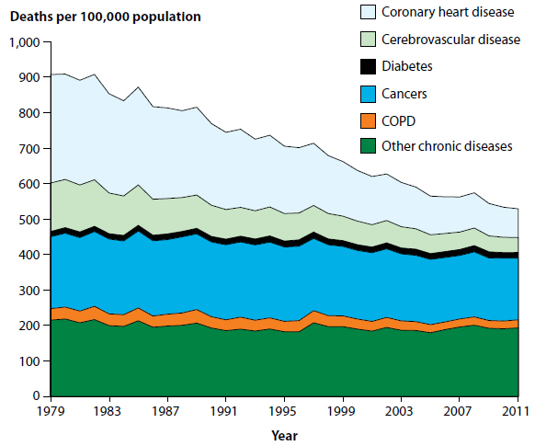
Chronic diseases have a group of characteristics in common: multiple etiologies, a variety of complex risk factors, and a long natural history of disease, with an origin in young ages and with a long period of latency; their development is influenced by the individual´s life condition and it implies a systematic approach, based on a long treatment and an reinforcement of the efficacy of the multidisciplinary teams of health professionals, because this type of diseases involve varietal levels of evolution in terms of functional loss or significant steps of disability. Recently, some authors, have proposed a statement defining chronic diseases, based on the following criteria: duration of, at least six months, presenting a recurrence pattern or deteoration, have a poor prognosis, produce consequences or after-effects, with a more or less significant impact on the quality of the patient´s life [8,9]. Chronic diseases, as epidemic episodes, are considered a serious public health issue, worldwide, having at the same time, a significantly impact for personal, family and social level; besides this, we can describe these diseases by their repercussions in terms of severe incapacity and premature death; we can observe also expensive treatments for these patients. What these diseases have in common is that they require a long-term and complex response, coordinated by different health professionals with the access to the necessary groups of drugs and equipment and extend into social care. Given this background, the management of chronic diseases is increasingly considered an important issue by policy-makers and researchers. Policy makers across Europe are searching for interventions are strategies to tackle chronic disease. Based on the definition of the World Health Organization (WHO), chronic disease management is «ongoing management of conditions over a period of years or decades» [21,22].
Besides the main risk factors mentioned above, we can also explain the influence of socioeconomic elements that act as primary causes for the «chronic diseases epidemic», such as poverty, inequality, unemployment, social instability, unfair trade and global imbalances. Poverty is a powerful contributor to chronic disease. Poor people may have fewer resources with which to make lifestyle changes; they may also have less access to quality health services that include interventions to prevent or eliminate exposure to risk factors as well as diagnostic services, treatment and essential drugs. Preventing disease reduces health inequalities by narrowing gaps between the vulnerable and privileged populations. Other health risks are related to environmental factors, rural-to-urban transitions, increased exposure to violence and injuries, persistent childhood diseases, disadvantages in early childhood development and maternal health issues that over the life course are associated with non-communicable diseases [7].
Figure 4: Portugal – Percent of total deaths
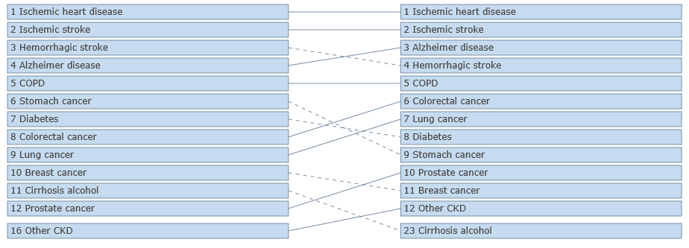
More than 80% of the deaths occurred in Portugal in 2014 were due to chronic diseases. Cardiovascular diseases are the first cause of death, followed by cancer, which justify a reason for the pattern of disability, normally, evidenced by these patients. Besides, it is estimated that the prevalence of hypertension is about 46% and 13% is reported as the prevalence of diabetes, creating risk factors for other chronic diseases. Furthermore, chronic respiratory diseases are increasing and are the third leading cause of death in Portugal, after cardiovascular diseases and cancer, due to the progressive rise in life expectancy and the effects of smoking. Respiratory diseases are the principal cause of intra-hospital mortality, responsible for one in four deaths and are the fifth cause of hospitalization (6.6%). Overall, chronic respiratory diseases are responsible for about 12% of deaths at national level, especially in individuals with more than 65 years. According to recent data, it is estimated that in Portugal there are about 500 to 600 thousand people living with five or more chronic diseases; the most prevalent being hypertension, depression, rheumatic diseases, osteoporosis, diabetes and kidney stones. About half of these individuals are aged over 65 years, and 40% have between 45 and 64 years. National health surveys also show that more than half of the adult Portuguese population has, at least, one chronic disease and about one third are presented with, at least, two chronic diseases. Furthermore, 70% of the patients that attend emergency services, at least four times a year, are chronic patients, which usually go to hospitals due to complications or side effects related to this type of pathologies [5,6].

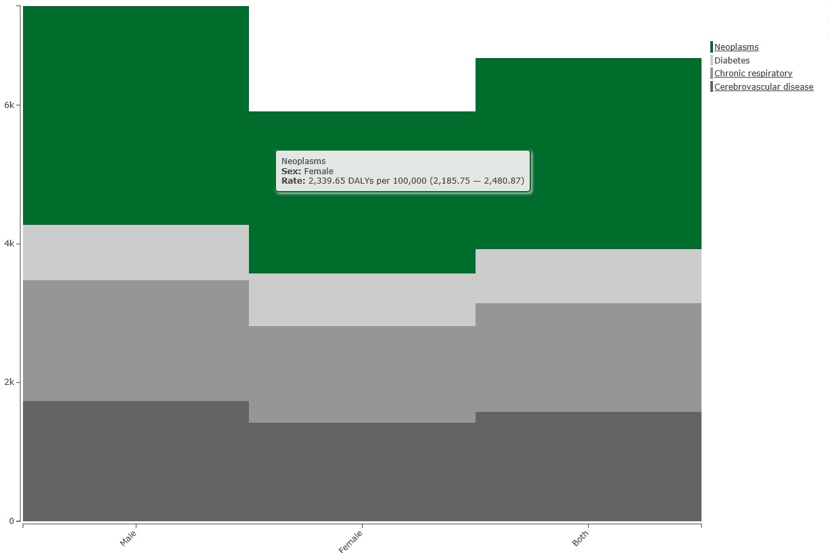

1.3 – Changing Patterns of Chronic Diseases
Figure 5: Chronic diseases and DAYLS per 100,000- Both sexes
Although most of the knowledge about chronic diseases is based on descriptive epidemiology, less is known about the reasons why these conditions cluster in the same individual or in a group of people related with each other. Given that chronic diseases induce irreversible damage, causing a long asymptomatic period and a variety of common and preventable factors, it becomes important to establish a surveillance system for this type of diseases that monitor their risk and protective factors, establishing measures and actions of promotion and prevention in order to encourage the improvement of quality of life. The growing prevalence of chronic diseases is justified by the profound transformations in society that have resulted in a greater preponderance of technology in individuals’ lives and the role of innovation in the health sector, the phenomena of industrialization and the ageing of the populations (while, at the same time, one of the greatest achievements, but also one of the biggest challenges of the Humanity, resulting in significant healthcare and community burden due to the impact of the chronic diseases in the quality of life), as well, and consequently, the increase of the need for health care. The burden of chronic diseases is rapidly increasing worldwide. About half of these group of pathologies are attributable to cardiovascular diseases, whereas obesity and diabetes are also showing worrying trends not only because the fact they involve nowadays a large proportion of the population, but also they have started to appear earlier in life [16].
Regarding the analysis of the Global Burden of Disease 2013, for most of the leading non-communicable diseases, the number of deaths has increases, by 42%, between 1990 and 2013 (from 27,0 to 38,3 million) but age standardized mortality rates have fallen. Allowing for changes in the age structure of the world´s population between 1990 and 2013, age standardized death rates from non-communicable diseases fell by 18,6%. Global age-standardized death rates have fallen by more than 20% for ischemic heart disease and stroke. Although age-standardized mortality for cardiovascular and circulatory diseases decreased by 22%, significant increased occurred for atrial fibrillation and peripheral vascular disease [16].
Cancer
The NCRI (National Cancer Research Institute) has predicted that by 2020 the number of new cases of cancer will arise to 41.703, almost the double of the annual number in 1998-2002. The highest increases in both sexes are led by cancers in liver, kidney and melanoma. For women, the numbers will arise for cancers of breast and lung and for men the negative evolution is focused on prostate cancer and testis. According to the American Cancer Society and Cancer Research UK, tobacco accounts for approximately 30% of the cancer deaths. Smoking is the main responsible for almost 90% of the cases of lung cancer, and is also an established risk factor for other cancers, such as those occurring in the aero-digestive tract, bladder, stomach, liver, kidney, cervix and certain forms of leukemia.
According to the Global Burden of Disease 2013, cancer is among the leading causes of death worldwide. In 2013, there were 14.9 million incident cancer cases, 8.2 million cancer deaths and 196.3 million DALYs associated with cancer. Prostate cancer was the leading cause for cancer incidence (1.4 million) for men and breast cancer for women (1.8 million). Lung cancer was the main cause for cancer death in men and women, with 1.6 million deaths. Along with this, lung cancer was the main cause of DALYs among men with 24.9 million, whereas, for women, the main cause of DALYs was breast cancer, with 13.1 million [2,16,17].
Stroke
The burden of stroke in young adults aged 20-64 years has recently come to greater attention with studies showing an increase in the incidence of stroke in young adults over the last 3 decades. A systematic review of the literature on young stroke (between 20 and 44 years) suggests that stroke in those younger than 45 years is not as uncommon as previously perceived with standardized incidence rates ranging from 8.7 to 21.0 per 100.000. Evidence suggests that changes in unfavorable lifestyle factors such as unhealthy diets high in sugar, salt and processed foods, smoking, alcohol intake, drug abuse and reduced levels of physical activity have led to the increased exposure to stroke risk factors in the young. The risk of strokes in adults aged 20-64 years is lower than in older adults, but the societal impact is higher due to the greater number of years of life lost and the resulting loss in the productivity. Disparities were also found in trends of stroke burden between developing and developed countries, as death rates and DALYs from stroke were significantly higher in developing countries than those in developed countries, and their rates declined appreciably in developed countries but not in developing countries. However, recent evidence suggests that there is also an increasing association of stroke in younger adults with the prevalence of traditional vascular risk factors such as hypertension, diabetes and obesity. The significant decline in death rates and DALYs in developed countries may be the result of improved blood pressure control, acute care (for example, stroke units, thrombolysis), increased levels of neuroimaging leading to better diagnosis and improvements in rehabilitation and chronic care [16,17].
Ischemic heart disease
Ischemic heart disease (IHD) was responsible for 8.1 million deaths in 2013 corresponding to 14.8% of deaths worldwide. IHD was the leading cause of death globally among men and women in both 1990 and 2013. In 2013, it was responsible for nearly half of all deaths from cardiovascular disease, causing as many deaths as chronic obstructive pulmonary disease, diabetes mellitus, cirrhosis, lung cancer and liver cancer combined. There was an increase of 42% in the numbers of IHD since 1990. The number of men dying from IHD was consistently higher compared to women during this time period and there was a larger relative increase in IHD deaths among men than in women. However, IHD is responsible for a slightly higher percentage of deaths among women than among men (15.3% vs. 14.4%) because of significantly more IDH deaths among women aged above 80 years [2,17].
Diabetes
Type II diabetes mellitus is an increasing public health burden and managing the disease and its complications accounts for close to 10% of the entire National Health Service (NHS) budget in the United Kingdom. OECD research (2003) showed a generalized increase in the prevalence of diabetes among the elderly. Deaths directly attributable to diabetes are predicted to rise from about 166.000 in 2009 to over 209.000 in 2030. Globally, in 2013, it is estimated that almost 422 million people, according to the WHO, will suffer from diabetes (predominantly in low and middle income countries). In terms of disability, between 1990 and 2013, diabetes moved from the 10th to the 7th position. Thus, the prevalence of diabetes has increased in the last decades and Portugal is no exception. According to the first WHO global report for diabetes, it is estimated that 9.2% of the Portuguese (about 952.000 thousand persons) suffer from this disease, affecting more predominantly men (10.7%), but also women (7.8%). These figures are lower than those calculated in 2014 by the National Observatory for Diabetes, according to which the prevalence estimated for this pathology, in the Portuguese population, aged between 20 and 79 years, was 13.1%, with over 2 million people with a pre-diabetes diagnosis. In one hand, the growth of diabetes type 2 is partly a result of the increase in obesity, namely among the children. Obesity due to physical inactivity or to poor diet is a risk factor for diabetes. On the other hand, diabetes is common in older people and is often undiagnosed. While undiagnosed, diabetes may produce symptoms, resulting in complications and aggravating existing co-morbidities [3,16].
Asthma
The most recent global estimated of asthma suggests that as many as 334 million people have the disease and that the burden of disability is high. Asthma is the 14th most important disorder in terms of global years lived with a disability (YLD) and deaths are less common from this pathology than from other chronic diseases. However, for people in older age groups premature death due to asthma contributes more to the burden of disease. The historical view of asthma being a disease of high-income countries no longer holds: most people affected in low and middle-income countries and its prevalence is estimated to be increasing fastest in those countries. The burden of asthma, measured by disability and premature death, is greatest in children approaching adolescence (ages 10-14) and the elderly (ages 75-79). However, treating symptoms early can result in prevented or less severe episodes and most cases can be managed with proper ongoing therapy in an outpatient basis. Besides this, some home-based interventions, such as those related to multi-component measures for children and adolescents to improve asthma symptoms and reduce the number of school days missed due to asthma. Additionally, we can stimulate tobacco use cessation among adults due to the strong evidence of the effectiveness of this measure. Furthermore, smoking bans and restrictions, whether used alone or as part of a multi-component community or workplace intervention, reduce exposure to secondhand smoke. Nevertheless, global surveillance of asthma requires standardized measures of asthma implemented in large scale surveys of both children and adults in diverse settings worldwide [3].
Figure 6: Cardiovascular Diseases 2013– YLDs per 100,000; Both sexes, all ages
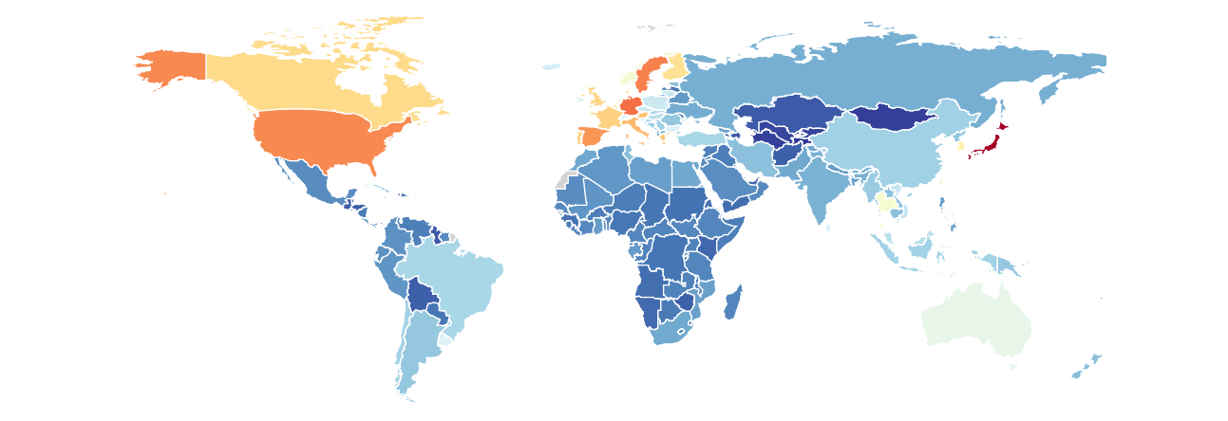

1.4 – Common Risk Factors
Lifestyles are the main risk factors for chronic diseases. Some of these indicators are smoking, unbalanced food habits or an unhealthy diet, the excessive alcohol consumption, obesity, sedentary lifestyle, and the incorrect management of stress – this could be the fundamental elements responsible for the origin of this type of diseases [4]. Based on estimates obtained in Portugal, related to the total number of years of healthy life lost and establishing the relationship between the risk factors described before, in the study of the Global Burden of Diseases (GBD), the more predominant are: unhealthy food habits (19%), high body mass index (BMI) (13%), besides smoking (11%). These are the principal risk factors, very often modifiable, and which could possibly be changed or avoided, related to a diverse group of diseases, for example, oncologic diseases, circulatory pathologies and a group that include diabetes and other metabolic disorders [10,12]. To sum up, the behaviors and lifestyles influence the individual and collective health, because these are the common denominators, of practically, all chronic diseases. Globally, the main risk factors for chronic diseases are tobacco use, low fruit and vegetable intake, sedentary lifestyle and alcohol abuse. Except for low fruit and vegetable intake, all of them are major risk factors in more developed countries that in low and middle-income countries. Considering the non-communicable diseases as the causes of death of more than two-thirds of people worldwide, the emergence of chronic diseases is perceptible as the main challenge for global health [5].
Despite the severity of noncommunicable diseases (NCDs) and the increase of its incidence, most of these diseases could be avoided. As the most common chronic diseases (cardiovascular disease, cancer and diabetes) share several risk factors, WHO proposes an integrated approach to prevent and control, focused in all ages, based on the reduction of the following key problems: hypertension, smoking, excessive alcohol consumption, physical inactivity, poor diet, obesity and hypercholesterolemia. A reduction of 10% in the major risk factors, modifiable risk factors, at the population level, could save thousands of lives. Exposure to factors increasing or reducing the risk of chronic diseases and the burden of this kind of pathologies, concerned mortality and morbidity also varies by gender, race and ethnicity, urban or rural location, occupation and other socioeconomic characteristics [2].
In the USA, chronic diseases are the main causes of poor health, disability and death and account for most of the health care expenditures. The chronic disease burden in this country largely results in this short list of risk factors – including tobacco use, poor diet and physical inactivity (both strongly associated with obesity), excessive alcohol consumption, uncontrolled blood pressure and hyperlipidemia – which could be easily addressed for individuals and populations. Increases in the conditions and the risk factors (which occurs separately and in combination), along with the demographic transformations, consequently lead to the ageing impact on society and health disparities. We can mention certain measures and strategies that we can apply to reduce the burden of chronic diseases in our develop civilizations and based on global health. The Centers of Disease Control and Prevention (CDCs) of USA states that we could focus our attention in epidemiology and surveillance to monitor trends and inform programs, trying to involve the stakeholders of all health systems, to develop environmental approaches that promote health and support healthy behaviors. Health system interventions to improve the effective use of clinical and other preventive services, and organize and monitoring a group of community resources linked to clinical services can sustain improved management of chronic conditions. According to WHO, although reliable data for cause-specific mortality are scarce, non-communicable diseases were estimated to be responsible for 23.4 million deaths (64% of the total) in 23 countries analyzed, with 47% occurring in people younger than 70 years. Besides this, it is estimated that about 80% of the cardiovascular diseases and diabetes mellitus and 40% of the cancers can be prevented through healthier lifestyles (namely, related to changes in food regimens); also, in many cases, these preventive measures could be based in simple, cheap and profitable acts [6].
Physical inactivity is already a major global health risk and is prevalent in both industrialized and developing countries, particularly the urban poor in crowed mega cities. Measures and policies required to promote healthier food consumption patterns and facilitate a physically active life share common grounds and are mutually interactive in determining healthier behaviors, highlighting the importance of physical activity as part of nutrition and health. Physical activity is a key determinant of energy expenditure and also fundamental for energy balance and weight control. Besides this, some benefits, such as increased cardiorespiratory fitness and muscular strength as well as decreased depressive symptoms and blood pressure, require only a few weeks or months of participation in active exercise [9]. Although some health benefits seem to begin with as little as 60 minutes (1 hour) a week, research shows that a total amount of 150 minutes (2 hours and 30 minutes) a week of moderate-intensity aerobic activity, such as brisk walking, consistently reduce the risk of many chronic diseases and other adverse health outcomes. To sum up, the emergence of chronic diseases requires preventive measures such as a balanced diet and exercise, because both work together to provide the body with optimal performance in daily life. Lifestyles play an important role in determining chronic diseases and behavior changes are likely to be responsible for a significant proportion of their increase over time. Smoking alone is estimated to be responsible for 22% of cardiovascular diseases in industrialized countries, and for the vast majority of some cancers and chronic respiratory diseases [2]. Alcohol abuse is deemed to be the source of 8-18% of the total burden of disease in men and 2-4%in women. Overweight and obesity account for an estimative of 8-15% of burden of disease in industrialized countries, while high cholesterol explains about 5-12% [2].
Figure 7: Tobacco Smoke Distribution 2013 – YLD per 100,000; Both sexes, all ages
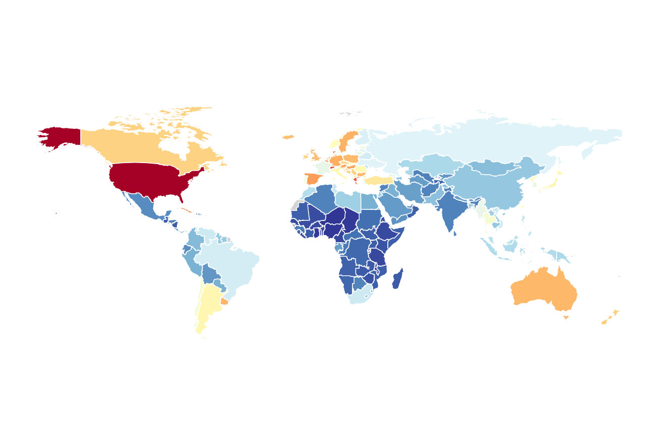
Figure 8: Risk Factors related with Chronic Diseases 2013 – DAYLS per 100,000; Both sexes, all ages

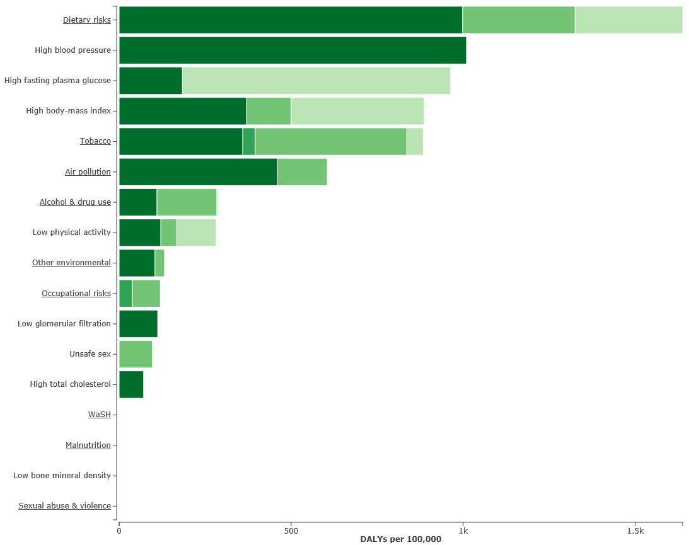

1.5 – Promotion and Prevention Measures
Chronic diseases are largely preventable diseases. Although more basic research may be needed on some aspects of the mechanisms that link diet to health, the currently scientific evidence provides a sufficiently strong and plausible basis to justify action now. Beyond the appropriate medical treatment for those already affected, the public health approach of primary prevention is considered to be the most cost-effective, affordable and sustainable course of action to cope with the chronic disease epidemic worldwide. The adoption of a common risk-factor intervention to chronic disease prevention is a major development in the thinking behind an integrated health policy. Sometimes chronic diseases are looked as communicable at the risk factor level. Modern dietary and physical activity patterns are risk behaviors that travel across countries and are transferable from one population to another like an infectious disease, affecting disease patterns globally [11].
Promoting healthy diets and lifestyles to reduce the global burden of non-communicable diseases requires an amount of food strategies that must not merely be directed at ensuring food security at all, but must also achieve the consumption of adequate quantities of safe and good quality foods that together make up a healthy diet. Some innovative proposals have come to light to fight chronic diseases and have been developed in the workplace, where we can find health professionals, that , normally, make up multidisciplinary teams of General Familiar Medicine, promoting some practices related to health improvement, both in the individual as well as the collective dimension, involving also education and communication actions in health, aimed to encourage behavioral change and applying for gradual modification of certain habits and lifestyles of individuals [26]. Through the participation of these teams in multi-target actions, we can impact the quality of life of populations and, at the same time, improve the sustainability and the quality of health systems. On the other hand, given that the determinants of chronic diseases depend on certain individual elements (genetic, biologic and psychological), we can also put in evidence the influence of environmental, economic, social and cultural atmospheres, that have been implemented, at European and national level. Networks and programs, with particular attention to schools, workplaces and cities, mainly relate to the empowerment of the patient and the adoption of healthy lifestyles, as well as, the creation of organizational and social conditions to give better health to citizens [22].
The intervention on lifestyles is usually defined by the group of habits and behaviors that try to answer the common unbalanced situations on daily routine, resulting from continuous learning, based on the socializing process. Thus, these habits, with a certain impact on the individual´s life were expressed by how higher or lower the morbidity of chronic diseases is and that these behaviors need, at every moment, a new interpretation and to be tested in different social situations [26]. This awareness of the patient requires the application of health promotion strategies, with the collaboration of multidisciplinary teams that have comprehension, diversity and the responsibility of being evaluated overtime. Regarding what WHO proposes, we can focus on five essential domains: 1) policies definition, laws and legislation; 2) creation of supportive environments; 3) strengthening; 4) information, health education and individual and collective capability; and 5) reform health services. The control of chronic diseases is composed of primary prevention of risk factors, for secondary prevention of complications that results from them and tertiary prevention in the case of rehabilitation and prevention of future complications resulting from an episode of disease [11,22].
For instance, the success of population based interventions, addressing multiple risk factors common to most noncommunicable diseases (NCDs), through lifestyle linked community programs has been demonstrated both in developed and developing countries. Such population strategies require both «bottom-up» (community health education and empowerment) and «top-down» (legislation and regulation) approaches. Whether it is food (producing, pricing, labeling), tobacco (production, sale, advertising), physical activity (a constructive transport policy which favors urban cycle lanes and curbs vehicular transport as well as provides facilities for leisure time exercise in community playgrounds), active health policy measures are require alongside public health education. An enlightened policy and an empowered community can together stall the advance of the emerging epidemics of chronic diseases. There are several opportunities for new global and national actions to minimize the emergence of chronic diseases, including strengthened interaction and partnerships; regulatory, legislative and fiscal approaches and more stringent accountability mechanisms. Surveillance of NCDs and their risk factors should also become an integral function of health systems, complementary to other surveillance programs that they are currently performing. Evidence based clinical practice and appropriate use of technologies should be promoted at all levels of health care, including tertiary services. Populations will benefit from continuous quality improvements in health systems aimed at offering the most effective, evidence-based and cost-effective interventions possible, depending on the country contexts and emphasizing equitable distribution of services [10].
In addition, in order to increase self-care and healthy living, there must be a commitment to increase health literacy. The low levels of health literacy among seniors is particularly worrisome, considering the fact of they are the heavy users of the health care system and new to develop their knowledge or capacity to acquire self-care skills about health promotion measures and how to keep themselves healthy and, in many cases, to effectively manage their chronic conditions in partnership with their care providers. Low levels of health literacy among deprived populations may mean that they are less likely to adopt or delay in adopting new health behaviors compared to their better-educated and more health-literate counterparts. Lifestyle programs that do not explicitly allow and address low levels of health literacy can actually result in a widening of the health gap and an increase in healthy inequity. Furthermore, lifestyle modification and sustaining changes from unhealthy but often pleasurable behaviors is in principle an individual’s responsibility. Success in avoiding lifestyles causing disease ultimately depends more on personal qualities – self-discipline, responsibility and impulse control – than an effort, artificially sustained with a group of well-implemented public health policies to instill in people, healthier lifestyles, who do not already possess them [12].
Figure 9: Self-Management of Chronic Care Model and Patient
«Self-management and decision support are recognized as integral components of many models for chronic disease prevention and management»[31].Self-management involves a promising approach to improve outcomes and reducing health care costs associated with chronic conditions, with the responsibility of addressing multiple behavioral risk factors, such as physical activity, diet, smoking and alcohol, through three basic tasks: 1) monitoring and managing the signs and symptoms of disease; 2) engaging in health and lifestyle behaviors and taking medications appropriately; 3) maintaining regular contact with health care providers. Managing these chronic conditions will allow individuals to prevent and minimize their admissions to hospital, continue their lives at home, maintain employment, contribute to their communities and enjoy their families and friends. Promoting an effective self-management approach of any chronic disease encourages the patient to assume a leadership role, in partnership with the health care professionals, in achieving a healthful and satisfying life. A self-management intervention promotes strengthening the self-efficacy of individuals, who through their own abilities derive solutions to the problems they face as a result of their chronic health condition [25,26].
One of the aspects that compose self-management support is the group of educational strategies and techniques used by health care professionals, named «self-management education». It has long been considered the essential first step in successfully preparing patients to manage and live with their chronic condition. Based on work done by Bodenheimer et al (2002), patient education is a term that has often focused largely on disease process, where technical skills related to managing the disease are taught, for example, we can mention the process of insulin administration [26].
However, the main objective of self-management education is to teaching patients skills that they can use to self-identify problems related to the capacity of living with a chronic disease and how to address with those problems. Both types of education are essential in assisting the individual to achieve the best quality of life and independence. The aim is to provide education that enables patient to understand the disease process, acquire knowledge related to technical management, as well as learn how to live a complete life with the disease [26].
The disease is assumed, in this way, as a risk factor for the homeostasis in your family, where your balance depends on a group of elements inherent to both patient and family. These days, the family is increasingly requested as a responsible of the role of career. Indeed, in recent decades, has been an innovative approach with the goal to make families more responsible with an increased role in supporting environments that have the objective to give the best conditions to these patients in terms of well-being and quality of life. It is also important to create conditions for health professionals and patient’s family could work with each other [15].
In this new approach health professionals, belonging to the community and business, integrated into the health system, should support and guide these families, taking into account the particular characteristics of each user, as well as the specific clinical challenges of each disease, not forgetting the attention to signs of alarm and the review, in every moment, of certain preventive measures, so that they can find together a stability for trying to cure the patients or, at least, to reduce the perception of emotional and physical changes verified in this process, so that the adaptation can be easier, faster and more consistent, guarantying the success for this step in the patient´s life [16].
In this way, chronic disease can act as a driving force which focuses on the family elements in the intensive care of the patient and reviews the biopsychosocial aspects of family life, preparing the main caregiver, possibly elected by the patient, in line with health care professionals, for the correct discharge of the tasks necessary for everyday welfare of the chronic patient. The family must be trained to supervise all of these activities, being prepared to be called in times of overload or caregiver exhaustion and deal, at any time, with demonstrations and feelings of guilt, frustration, anger, depression and other emotional manifestations that accompany that responsibility and can be experienced by the patient. Thus, the presence and support provided by the family (which may help manifest by concern for the health and well-being of the individual, with the purchase of medicines, medical consultations, follow-up house calls, among other interventions under the family health care, dealing with these daily or continuous aspects), expresses a decisive factor in motivating a patient wishing to start a healing process or therapy session in order to mitigate the consequences of a chronic pathology [23].
Figure 10: Estimated Proportion of Preventable Cancer Associated with 9 Leading Modifiable Risk Factors
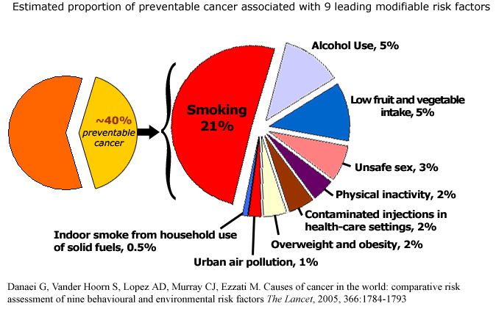

1.6 – The Role of the Family
Family history of specific diseases is based on the consequences of genetic susceptibilities, shared environment and common behaviors. The scope of family history information ranges from knowing a parent or sibling who had a specific disease to very detailed pedigree analyses about disease and age at onset for first, second and even third-degree relatives. In some families, highly penetrate genetic mutations are transmitted through generations, in a high likelihood of disease [30].
Family history has been shown to be a risk factor for a majority of chronic diseases of public health significance, like cardiovascular disease, diabetes, several cancers and asthma. Besides this, most early cardiovascular-related events (coronary heart disease, stroke, hypertension and diabetes), in the population, occur in families with a positive family history of cardiovascular disease. Generally, family history of a common chronic disease is associated with relative risks ranging from 2 to 5 times those of the general population. Evidences suggests that family history by itself is most useful for predicting disease when there are multiple family members affected, the relationship among relatives is close and the disease is premature, that is, that occurs in younger ages that would be expected. To summarize, family history information is able to function as public health tool for identifying a large proportion of the population who is at moderate risk for disease [15].
In order to use family history information as a determinant of an individual’s disease risk, the accuracy of self-reported family history should be ascertained. Studies show that for breast, colorectal and prostate cancer, as well as for cardiovascular diseases, relatives report with a reasonable degree of accuracy on the diseases status of their close family members. The family history of other common chronic diseases, such as type 2 diabetes and ovarian cancer and in less close family members (second-degree relatives) are often reported with a lower degree of accuracy. Cultural variation in how family is conceptualized can also affect the accuracy. For example, in many cultures individuals place greater importance on, and have greater knowledge about, one side of the family. Raising public awareness of the importance of family history of cardiovascular diseases, type 2 diabetes and specific types of cancers (e.g. by mass-media campaigns) is likely to increase the accuracy of self-reporting of family history information [16].
Patients with chronic diseases are those who less adhere to therapy, which implies a collective effort of the individual involved in treatment, family and the health professionals that are collaborating with their clinic control, often divided into multidisciplinary teams. It is estimated, that in developed countries, only 50% of the chronic patients meet the agreed treatment with the health professional, which has consequent impacts on the economy, well-being and quality of life of individuals and society [14].
The involvement of the family members of a patient with chronic disease is crucial not only for therapeutic adherence but also in the management of the disease. Besides pharmacological treatment, most chronic diseases require a behavioral change towards the adoption of healthier lifestyles in order to successfully achieve its control. At this point, participation of family members is important to guarantee that the patients keep up with the recommendations. Furthermore, relatives may feel motivate to change their own behaviors if they are faced with an increased risk of developing the same chronic disease. This should be seen as an opportunity by health professionals to not only care for the patient who has already been diagnosed with the chronic condition but also to influence the habits of the relatives in a broader approach to chronic disease management [14,15].
To sum up, detailed family information can be used along with personal risk factors such as weight and smoking status – as a simple, easily applied and cost-effective tool to determine a person´s disease risk. In addition to risk assessment, family history information can also be used to personalize health messages, with may be more effective in motivating people to adopt and maintain a healthy lifestyle that standardized health messages [16].
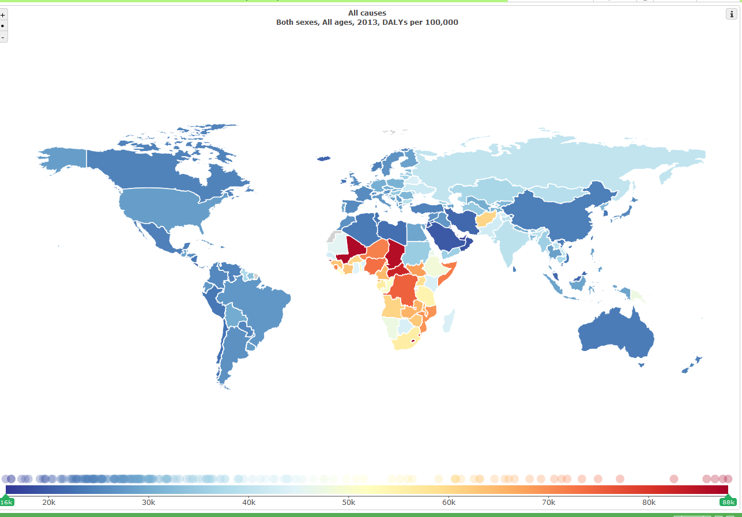
Figure 11: All causes 2013 – DALYS per 100,000; Both sexes, all ages

1.7 – Bibliography
[1]-Global Epidemiology of Chronic Diseases: The Epidemiology Transition; 13thApril 2012; samples. Jbpub.com; Chapter 1;
[2]-www.who.int; Chapter 1- Burden: mortality, morbidity and risk factors;
[3]-Mckeown, Robert E.; The Epidemiologic Transition: Changing Patterns of Mortality and Population Dynamics; 2009; 3(1 Suppl.); Am J. Lifestyle Med.;
[4]-Oni, Tolu; Unwin, Nigel; Why the communicable/non-communicable disease dichotomy is problematic for public health control strategies: implications for multimorbidity for health systems in an era of health transition; 2015; International Health;
[5]-Pereira et al.; Changing patterns of cardiovascular diseases and cancer mortality in Portugal, 1980-2010; 2012; BMC Public Health; 12: 1126;
[6]-www.ine.pt Statistics Portugal 2016; World Health Day – 7th April;
[7]-Co-occurrence of Leading Lifestyle –Related Chronic Conditions Among Adults in the United States, 2002-2009, April 25 2013;
[8]-Prevalence of risk/health behavior among members of private health insurance plans: results from the 2008 national telephone survey Vigitel, Brazil;
[9]-Nutrition, lifestyle, obesity and chronic disease; 2011; United Nations; New York;
Larry Durstine J.; Gordon, Benjamin; Wang, Zhenghen; Luo, Xijuan; Chronic disease and the link to physical activity; Journal of sport and Health Science 2 (2013) 3-11;
[10]-DGS- Programa Nacional de Intervenção Integrada sobre Determinantes da Saúde relacionados com os Estilos de Vida; 2003;
[11]-Goulart, Flavio; Doenças crónicas não transmissíveis: estratégias de controlo e desafios para os Sistemas de Saúde; 2011; Brasília; Brasil;
[12]-Busse, Reinhard; Blûmel, Mirian; Scheller –Kreinsen, David; Zentner, Annette; Tacking chronic disease in Europe: strategies, interventions and challenges; 2010; Observatory Studies Series nº20;
[13]-Europeans of retirement age: chronic diseases and economic activity; December 2012; Dutch National Institute for Public Health and the Environment (RIVM);
[14]-S. Acheson Louise; Wang, Catherine et al. Family History and Perceptions about risk and prevention for chronic diseases in primary care: A report from the family healthware; Impact Trial; 2010; Genetics in Medicine; Vo12; No4;
[15]-Claassen et al.; Using family history information to promote healthy lifestyles and prevent diseases: a discussion of the evidence; 2010; BMC Public Health; 10:248;
[16]-W. Upon, Paula; Scheuner T., Maren et al.; Can family history be used as a tool for public health and preventive medicine? July/ August 2002; Genetics in Medicine; Vol 4, No4;
[17]-Global, regional and national age-sex specific all cause and cause-specific mortality for 240 causes of death, 1990-2013: a systematic analysis for the Global Burden of Disease- study 2013; Lancet 2015; 385: 117-171;
[18]-Global status report on noncommunicable diseases; 2014; WHO;
[19]-Position Paper on Lifestyle and Chronic Disease; September 2008; Irish Medical Organization;
[20]-Pareth, Anand; Goodman, Richard A.; Gordon, Cartherine; K.KOH, Howard; Managing Multiple Chronic Conditions: A strategic framework for improving health outcomes and quality of life; July-August 2011; Public Health reports; Volume 126;
[21]-Halpin, Helen Ann; Varela, Maria M.; Moreno, José M; Chronic Disease Prevention and the New Public Health; vol. 32; No1; pp. 120-154;
[22]-Perk, Joep (Presidente do Grupo de Trabalho); Recomendações Europeias para a prevenção da doença cardiovascular na prática clínica; 2012; European Heart Journal; 33: 1635-1701;
[23]-Silva et al.; Estratégias de promoção de saúde e prevenção primária para enfrentamento de doenças crónicas: revisão sistemática; 2013; 34(5): 343-350; Rev. Panam. Salud Publica;
[24]-Macinko, James; Dourado, Ines; Guanais, Frederico C.; Doenças Crónicas, Atenção Primária e Desempenho dos Sistemas de Saúde – Diagnósticos, instrumentos e intervenções; Novembro 2011; Banco Interamericano de Desenvolvimento; Setor Social: Divisão de Protecção Social e Saúde;
[25]-Darnton-Hill, I; Nishida, C; James, WPT; A life course approach to diet, nutrition and the prevention of chronic diseases; 2004; Public Health Nutrition: 7(1A), 101-121;
[26]-Strategies to support Self- Management in Chronic Conditions: Collaboration with Clients; September 2010; Clinical Best Practice Guidelines; Registered Nurses’ Association of Ontario – Toronto;
[27]-Schramm, J.M.A. et al.; Epidemiological Transition and the study of the burden of disease in Brazil; 2004;
[28]-The Global Economic Burden of Non-Communicable diseases; September 2011; Harward School of Public School;
[29]-http://www.healthdata.org/gbd/data-visualizations;
[30]-Tavares, Paula; História Familiar de Doença Coronária, Cuidados e Comportamentos em Saúde; 2008; Mestrado em Saúde Pública; Universidade do Porto;
[31]-Figure 3: Self-Management of Chronic Care Model and Patient; Improving Chronic Illness 2005; World Health Organization 2002;

2. Objectives

The aim of this study was to determine the influence of family and personal history of chronic disease in the adoption of healthy lifestyles. Besides this, the analyses of an individual’s personal history allowed to get to know the chronic diseases that affected the patient in question, as well as to study the risk factors that had a role in a certain pathology, to establish the actual given diagnoses with the individual’s family history and to think about possible preventive measures. In addition to risk assessment, family history information can also be used to personalize health messages, with may be more effective in motivating people to adopt and maintain a healthy lifestyle than standardized health messages.

3. Manuscript

The effect of chronic disease family history on the adoption of healthier lifestyles

Alexandre Sá¹, Bárbara Peleteiro^{1,2}

¹ ISPUP-EPIUnit, Universidade do Porto, Porto, Portugal
² Departamento de Epidemiologia Clínica, Medicina Preditiva e Saúde Pública, Faculdade de Medicina, Universidade do Porto, Porto, Portugal

Corresponding author:
Bárbara Peleteiro
Instituto de Saúde Pública da Universidade do Porto
Rua das Taipas, 135
4050-600 Porto, Portugal
Phone: +351 222 061 820; Fax: +351 222 061 821; E-mail: barbarap@med.up.pt

Abstract
Background: Lifestyles are the main risk factors for chronic diseases, making these largely preventable diseases. Health professionals should take this opportunity also to influence the habits of the patients’ relatives in a broader approach to chronic disease management. Therefore, our aim was to determine the influence of family and personal history of chronic disease in the adoption of healthy lifestyles.
Methods: This study was based on the first follow-up evaluation of the EPIPorto cohort study (n=1588), through the collection of data on socio-demographic characteristics, personal and first degree family medical history, and behavioral features. Participants were grouped taking into account family history (FH) and personal history (PH) of chronic disease (CD), such as diabetes, myocardial infarction, stroke, asthma and cancer, and if at least one of the relatives had died from the CD. Subjects with no PH or FH of CD were considered the reference group in all the analyses. Age-, sex- and education-adjusted odds ratios (OR) and corresponding 95% confidence intervals (95%CI) were computed using multinomial logistic regression to quantify the association between PH and/or FH of CD and healthier lifestyles.
Results: Subjects with PH of CD and FH of CD with death of the relative by CD were more likely to follow recommendations regarding salt intake but less likely to follow recommendations regarding obesity measures. Overall similar results were observed when repeating the analyses according to the type of CD, particularly in those with diabetes.
Conclusions: Recommendations towards healthier lifestyles are not followed by individuals with PH and/or FH of CD, at least in what concerns obesity measures. Further studies with a longitudinal approach are needed to confirm this result. In any case, our study suggests reducing obesity as a major target for interventions in these groups of individuals.
Keywords: Chronic disease; Family history; Healthy behavior; Lifestyles.

Introduction

Globally, the World Health Organization (WHO) estimates that three out of four deaths are due to chronic diseases, corresponding to twice the number of deaths from other causes combined, and its burden is rapidly increasing worldwide [1]. Most of them are showing worrying trends not only because they involve nowadays a large proportion of the population, but also they are appearing earlier in life [2].
Lifestyles are the main risk factors for chronic diseases at global level, and a reduction of 10% in these modifiable risk factors, at population level, could potentially save thousands of lives [3]. As the most common chronic diseases share several risk factors [4], WHO proposes an integrated approach to its prevention and control, focused in all ages, and based on the reduction of key problems [5]. Besides pharmacological treatment, most chronic diseases require a behavioral change towards the adoption of healthier lifestyles in order to successfully achieve its control [6]. At this point, participation of family members is important to guarantee that the patients keep up with the recommendations [7]. Furthermore, relatives may feel motivate to change their own behaviors if they are faced with an increased risk of developing the same chronic disease [8]. This should be regarded by health professionals as an opportunity not only to care for the patient who has already been diagnosed with the chronic condition but also to influence the habits of the relatives in a broader approach to chronic disease management [9]. In addition to risk assessment, family history information can also be used to personalize health messages, with may be more effective in motivating people to adopt and maintain a healthy lifestyle than standardized health messages [10].
Therefore, the aim of this study was to determine the influence of family and personal history of chronic disease in the adoption of healthy lifestyles.

Methods

Study participants
This study was based on the first follow-up evaluation of a cohort of adults living in Porto (the EPIPorto study – figure 12). The recruitment of the initial sample has been previously described [11]. Briefly, the assembling of the cohort was conducted between 1999 and 2003 and comprised the evaluation of 2485 individuals selected by random digit dialing having households as the sampling unit. When a household was selected, all residents were identified by age and gender, and one resident (aged 18 or more years) was randomly selected as the respondent, without replacement if there was a refusal. A visit to the Department of Clinical Epidemiology, Predictive Medicine and Public Health of the Faculty of Medicine of the University of Porto was scheduled by telephone according to the participant’s convenience. A personal interview was conducted by trained interviewers, using a structured questionnaire, and a physical examination, including anthropometric measurements, was also performed. A venous blood sample was drawn after a 12-hour overnight fast. All the samples were analyzed at the central laboratory of the university hospital. The baseline proportion of participation was 70%.
From 2005 to 2008, the whole cohort was contacted according to the initial inclusion order for a follow-up evaluation. From the whole cohort, 1682 participants were scheduled to visit our department for questionnaire, physical examination, and blood collection (67.7% of the cohort, after a median follow-up of 4.4 years). During this period, 107 participants had died, 261 refused to participate in this second follow-up evaluation, and 435 were lost to follow-up. Among the ones evaluated in the follow-up, 1048 (62.3%) were women, median age was 53 years (percentiles 25-75: 43-64) and median education was 9 schooling years (percentiles 25-75: 4-14) When we compare respondents with non-respondents (excluding participants who died between evaluations), we found no significant differences regarding gender (62.3% women among respondents vs. 64.2% among non-respondents, p=0.379), and age (median age at baseline: 53 years in respondents vs. 52 years in non-respondents, p=0.512). However, the respondents were more educated (median schooling years at baseline: 9 years in respondents vs. 6 years in non-respondents, p=0.002) than non-respondents.
In individuals aged above 64 years, a rapid evaluation of cognitive function was done using the Mini-Mental State Examination test (MMSE) [12], and subjects were excluded when scoring below than 24 points (n=74) [13].

Data collection
A structured standard questionnaire was applied by trained interviewers to obtain data on socio-demographic characteristics, personal and family medical history, and behavioral features.
Educational level was collected as the complete number of schooling years completed by the participant. Marital status was grouped as married/living together, single/divorced/separated and widowed. Occupation was classified according to the Portuguese Classification of Occupations [14] and participants were grouped in white-collar (comprising skilled non-manual occupations), blue-collar (comprising manual and non-skilled non-manual occupations) or housewives/students. Retired or unemployed participants were classified according to their occupation prior to retirement or unemployment, respectively.
History of chronic disease, such as diabetes (types I and II), myocardial infarction, stroke, asthma and cancer, was retrieved for all first-degree relatives of the participant, father, mother, brothers and sisters. A positive family history of chronic disease was defined as at least one first-degree relative having had any of the above mentioned chronic diseases. Furthermore, cause of death for the relatives that had died was collected, and taken into account if referring to one of the chronic diseases under study. Personal history of chronic disease for the same group of diseases was retrieved from each participant.
Subjects were classified as daily smokers (current consumers of at least one cigarette per day, on average), occasional smokers (current consumers of less than one cigarette per day, on average), ex-smokers (not smoking for more than six months) and never-smokers [15]. Never and ex-smokers were grouped into currently non-smokers for data analysis.
Regarding the consumption of alcoholic beverages, participants were classified as daily drinkers (current consumers of at least one alcoholic drink per day, on average), occasional drinkers (current consumers of less than an alcoholic drink per day, on average), ex-drinkers (not drinking for more than six months) and never-drinkers. Daily alcohol intake during the previous year was estimated, and cut-offs were defined as non-drinker or drinker of no more than one drink per day for women and two drinks per day for men according to the proposed by the American Heart Association [16].
Information on the frequency of vegetable soup, vegetables and fruits consumption during the previous year was collected. For analysis, the cut-off of five servings per day recommended by the World Cancer Research Fund on their 2007 report on “Food, Nutrition, Physical activity and the Prevention of Cancer” was used to classify participants [17].
Dietary salt intake was estimated through a 10-cm (3.94 inches) visual analogical scale limited by the expressions ‘without salt’ and ‘salty’, on the left and right sides of the rule, respectively. The median was used as cut-off to classify each subject regarding salt intake using this method.
Physical activity was evaluated by questionnaire, exploring all activities over the past 12 months [18]. Participants reported the average time spent on exercise with different intensities, such as light, moderate or vigorous. Subjects were classified as physical active if performing at least 150 minutes of moderate intensity physical activity per week or at least 75 minutes of vigorous intensity physical activity per week [19].
Anthropometric measurements were obtained after a 12-hour overnight fast, with the participant wearing light clothing and no footwear. Body weight was measured to the nearest 0.1kg using a digital scale, and height was measured to the nearest centimeter in the standing position using a wall stadiometer. Body mass index (BMI) was calculated as weight (kg) divided by squared height (m), and further divided into three categories: normal and underweight (< 24.9 kg/m2), overweight (25.0-29.9 kg/m2) or obese (≥ 30.0 kg/m2) [20]. Central obesity was defined by waist circumference, which was measured midway between the lower limit of the rib cage and the iliac crest, to the nearest centimeter, with the subject standing, using a flexible and non-distensible tape and avoiding exertion of pressure on the tissues. Subjects were classified as having central obesity, according to the World Health Organization criteria [21].

Statistical analysis
After excluding subjects with missing information in family history (n=14) or personal history (n=6) of chronic disease, a total of 1588 participants were included in the analysis. Sample characteristics were described through proportions for categorical variables, compared using chi-square test or Fisher´s exact test, when applicable, and median values for continuous variables, compared using the Kruskal-Wallis test. Age-, sex- and education-adjusted odds ratios (OR) and corresponding 95% confidence intervals (95%CI) were computed using multinomial logistic regression to quantify the association between personal and/or family history of disease and healthier lifestyles. STATA®, version 11.2 (StatCorp LP, College Station, TX, USA), was used for all the analyses.

Ethics
The local ethics committee (Centro Hospitalar de São João) approved the study protocol. All participants gave written informed consent to participate, and the study was carried out in accordance with the Helsinki Declaration.

Results

Among the 1588 participants included in the analysis, 227 had no personal history or family history of chronic disease (No PH or FH of CD), 991 had family history but no personal history of chronic disease (No PH of CD and FH of CD), 32 had personal history and no family history of chronic disease (PH of CD and no FH of CD), and 338 had personal and family history of chronic disease (PH of CD and FH of CD) (Figure 12). Among subjects with family history of chronic disease, 764 of the relatives had died from the chronic disease (536 in the No PH of CD and FH of CD and 228 in the PH of CD and FH of CD. The subjects with no PH or FH of CD were considered the reference group in all the analyses.
Taking into account the socio-demographic characteristics of the participants (Table 1), the group PH of CD and FH of CD with death was older, less educated, and with a higher proportion of subjects married or in civil union and individuals with a blue-collar occupation. This group also presented the highest proportion of never smokers and obese subjects, whereas the highest proportion of never drinkers was observed in the group PH of CD and FH of CD without death. No statistically significant differences in sex, fruits and vegetables and salt intake, and regular practice of physical exercise were observed across the groups.
The distribution of the type of CD in FH was similar in subjects in whom the FH of CD occurred without dead of any relative, regardless of the existence of PH of CD, with diabetes being the most frequent CD in both groups (Figure 13, A and B). When at least one of the relatives had died from the CD, the distribution of CD type in FH was also similar and independent of the existence of PH of CD (Figure 13, A and B). In this case, cancer was the most frequent CD in these groups, with stomach and lung cancer being the most frequent in men and breast and colorectal in women. The distribution of the type of CD in PH was similar across groups with PH of CD, despite there was FH of CD or death within those with FH of CD (Figure 13, C). The most frequent CD were diabetes and asthma in all these groups.
Subjects in the group of no PH of CD and FH of CD with death or in the groups of PH of CD and FH of CD with and without death were more frequently non-smokers at the moment of the interview, when compared with those with no PH or FH of CD. Those with no PH of CD and FH of CD with death along with those with PH of CD and FH of CD without death were less likely to follow recommendations regarding alcohol drinking. Among those with PH of CD and FH of CD with death, there was a higher proportion of subjects consuming salt below the median, in comparison with the reference group. With the exception of group PH of CD and no FH of CD, in all other groups there was a higher chance of following the recommendations regarding physical activity. An opposite trend was observed for obesity measures, namely not being overweight or not presented with central obesity. While a lower proportion of subjects with BMI < 30 Kg/m² was found among those with PH of CD and FH of CD regardless of death of any relative by CD, for WHR the negative association was only statistically significant in the group where relatives had died from the CD. In fact, this group was the one following fewer recommendations regarding obesity measures, whereas recommendations for smoking, salt intake and physical activity were the ones more followed by this group. After adjustment, associations remained statistically significant for this group regarding salt intake and anthropometric parameters. Statistically significant results after adjustment were also observed for obesity measures in the groups of PH of CD and FH of CD without death and no PH of CD and FH of CD with death, in comparison with the reference group. Overall, no significant differences across groups were found for fruits and vegetables intake.
When repeating the analyses taking into account the type of CD, overall similar results were observed for obesity measures particularly when diabetes was the CD (data not shown). In fact, among subjects with PH and FH of diabetes, a lower salt intake was found (OR=1.29, 95%CI: 1.01-1.65), whereas individuals with PH and FH of cancer were more physically active (OR=1.68, 95%CI: 1.18-2.41). Contrary to what we have observed for CD as a whole, those with PH and FH of stroke were less likely to follow the recommendations regarding smoking (OR=0.25, 95%CI: 0.07-0.90) but more likely to present with a lower WC (OR=10.81, 95%CI: 2.80-41.71). When asthma was the CD being studied, subjects with both PH and FH were more likely to comply with recommendations regarding alcohol intake (OR=2.36, 95%CI: 1.14-4.90). Finally, subjects with PH and FH of diabetes were more prone to consume at least 5 servings of fruit and vegetables per day (OR=1.96, 95%CI: 1.21-3.18).

Discussion

Although healthy behaviors were observed in some groups, an opposite trend was found for obesity measures. The group with PH of CD and FH of CD regardless of death of any relative by CD was the one following fewer recommendations regarding obesity measures, whereas recommendations for salt intake were the ones more followed by this group.
The main strength of the present study was the inclusion of both family and personal history of chronic disease in order to determine if these variables were essential factors or, at least, influenced the adoption of healthier lifestyles. According to previous studies taking into account family history of a varied group of chronic diseases, diagnosis in a close relative member (father, mother, brother or sister) could be a strong precedent, based on the risk period in which any individual could develop the disease [22, 23]. Comparing to these studies, the methodology used in this study introduces the influence of both family and personal history resulting in particular interesting findings related to obesity parameters. Family history reflects a genetic susceptibility, which simultaneously with behavioral and environmental agents affect largely the personal history of disease in the individual, acting as major risk factors for multifactorial chronic diseases, such as cardiovascular disease, diabetes and a diverse group of cancers [23-27].
The other new aspect was conceptualizing chronic diseases as a group of pathologies and not isolated as others have addressed for only specific diseases such as cancer and cardiovascular diseases [24, 26, 27]. Our aim was to understand the importance of a global and integrated view concerning these diseases and their risk factors, based on the benefits for the patients and their relatives. In fact, chronic diseases can be treated as a single group of pathologies because they share a complex varied number of risk factors such as unbalanced diet, sedentary habits, smoking, alcohol consumption, overweight and obesity, etc. In what concerns prevention measures, this knowledge may be crucial to develop some interventions with the objective of modifying an individual’s risk profile [9, 28, 29].
Subdividing the groups in which family history of chronic disease was present according to the existence of death of that relative due to the chronic disease is a differential criterion from the previously mentioned studies, putting in evidence, for example, the effect of the death of a family member on the lifestyles modification in an individual’s daily routine and self-perception of disease risk. However, «death» is also a marker of disease severity as a the more extreme measure, and, among the group of chronic pathologies considered in this study, there is a mixture of more and less lethal diseases. Therefore, this may be a better marker for, for example, cardiovascular diseases than for diabetes, which are responsible for higher and lower mortality, respectively. On the other hand, the distribution of the chronic disease taking into account family history shows that the diseases which are related to an increased mortality of people in the family environment are usually cancers and cardiovascular diseases; whereas, in the personal history, the most prevalent diseases were with the ones with lower case-fatality, diabetes and asthma. These results are in accordance with national estimates of the frequency of these chronic diseases [30-33], confirming the representativeness of the study sample.
Regarding the group that has both family and personal history of chronic disease, we noticed that, on the contrary to what would be desirable for compliance with recommendations and in relation to having healthier habits, the individuals in this group are less likely to comply with the demands related to the anthropometric parameters, particularly waist circumference, in opposition to what happened with same group regarding the salt content in food. Moreover, taking into account the analysis according to the type of chronic disease, these individuals also follow less the recommendations for smoking when the disease is a stroke, which is a relevant aspect, mainly because that is one of the most frequent pathologies. However, the positive association with waist circumference shows that there is room for improvement in the guidance of these individuals towards healthier behaviors.
The association between asthma and the greater compliance with the recommendations targeting a lower alcohol consumption can be mainly explained by the fact that alcohol intake may worsen asthma symptoms [34]. Finally, taking in account that diabetes is a pathology which requires alterations in diet, our results show that individuals with family history may in fact be more aware of the need of an adapted diet [35].
This study presents certain limitations that are mostly related with the loss of information, at the level of participant distribution by each chronic disease or risk factor. Previous studies have already shown the difficulty of obtaining accurate data regarding family history of disease [7]. Another limitation is the cross-sectional nature of the study, but longitudinal approach was not possible to conduct as the number of individuals without personal and family history at baseline was considerably low. Besides this, the general definition of the type of chronic disease could have been improved if more detailed information was available.
The results obtained with this study show the importance of family and personal history for chronic disease patients, susceptible to a varied group of risk factors, and to describe their behavior, which could lead to the adoption of preventive measures, aiming at modifying their habits and improving their quality of life. In that case, we would expect individuals with PH and/or FH of CD to be more under surveillance by the health services, not only to detect the disease earlier but also to prevent it through recommendations for the adoption of healthier lifestyles. However, this did not occur at least in what concerns obesity measures. Further studies are needed with a longitudinal approach to confirm this result. In any case, our study suggests reducing obesity as a major focus in interventions in these groups of individuals.

References

[1] World Health Organization (WHO). Global status report on noncommunicable diseases. WHO; Genebra: 2014.
[2] R.E. Harris, Global epidemiology of chronic diseases: the epidemiologic transition, in: R.E. Harris (Ed.), Epidemiology of chronic Disease, Jones & Bartlett Publishers, Massachusetts, USA, 2013.
[3] GBD 2013 Mortality and Causes of Death Collaborators, Global, regional, and national age-sex specific all-cause and cause-specific mortality for 240 causes of death, 1990-2013: a systematic analysis for the Global Burden of Disease Study 2013, Lancet 385(9963) (2015) 117-71.
[4] M. Pereira, B. Peleteiro, S. Capewell, K. Bennett, A. Azevedo, N. Lunet, Changing patterns of cardiovascular diseases and cancer mortality in Portugal, 1980-2010, BMC Public Health 12 (2012) 1126.
[5] World Health Organization (WHO). Assessing national capacity for the prevention and control of noncommunicable diseases: report of the 2015 global survey. WHO; Genebra: 2015.
[6] D. Ding, K. Rogers, H. van der Ploeg, E. Stamatakis, A.E. Bauman, Traditional and Emerging Lifestyle Risk Behaviors and All-Cause Mortality in Middle-Aged and Older Adults: Evidence from a Large Population-Based Australian Cohort, PLoS Med 12(12) (2015) e1001917.
[7] L. Claassen, L. Henneman, A.C. Janssens, M. Wijdenes-Pijl, N. Qureshi, F.M. Walter, P.W. Yoon, D.R. Timmermans, Using family history information to promote healthy lifestyles and prevent diseases; a discussion of the evidence, BMC Public Health 10 (2010) 248.
[8] L.S. Acheson, C. Wang, S.J. Zyzanski, A. Lynn, M.T.t. Ruffin, R. Gramling, W.S. Rubinstein, S.M. O'Neill, D.E. Nease, Jr., Family history and perceptions about risk and prevention for chronic diseases in primary care: a report from the family healthware impact trial, Genet Med 12(4) (2010) 212-8.
[9] A.K. Parekh, R.A. Goodman, C. Gordon, H.K. Koh, H.H.S.I.W.o.M.C. Conditions, Managing multiple chronic conditions: a strategic framework for improving health outcomes and quality of life, Public Health Rep 126(4) (2011) 460-71.
[10] World Health Organization (WHO) on behalf of the European Observatory on Health Systems and Policies. Tackling chronic disease in Europe: strategies, interventions and challenges. WHO; Copenhagen: 2010.
[11] E. Ramos, C. Lopes, H. Barros, Investigating the effect of nonparticipation using a population-based case-control study on myocardial infarction, Ann Epidemiol 14(6) (2004) 437-41.
[12] M.F. Folstein, S.E. Folstein, P.R. McHugh, "Mini-mental state". A practical method for grading the cognitive state of patients for the clinician, J Psychiatr Res 12(3) (1975) 189-98.
[13] J.C. Anthony, L. LeResche, U. Niaz, M.R. von Korff, M.F. Folstein, Limits of the 'Mini-Mental State' as a screening test for dementia and delirium among hospital patients, Psychol Med 12(2) (1982) 397-408.
[14] Instituto do Emprego e da Formação Profissional. Classificação Nacional de Profissões. (cited 19 November 2007); Available from: http://portal.iefp.pt/pls/gov_portal_iefp/docs/PAGE/PORTAL_IEFP_INTERNET/CPROFISSONAL/CNP/INDICE.PDF.
[15] World Health Organization (WHO). Guidelines for Controlling and Monitoring the Tobacco Epidemic. In WHO Tobacco or Health Programme, Edition 1997.
[16] C. American Heart Association Nutrition, A.H. Lichtenstein, L.J. Appel, M. Brands, M. Carnethon, S. Daniels, H.A. Franch, B. Franklin, P. Kris-Etherton, W.S. Harris, B. Howard, N. Karanja, M. Lefevre, L. Rudel, F. Sacks, L. Van Horn, M. Winston, J. Wylie-Rosett, Diet and lifestyle recommendations revision 2006: a scientific statement from the American Heart Association Nutrition Committee, Circulation 114(1) (2006) 82-96.
[17] World Cancer Research Fund & American Institute for Cancer Research (WCRF/AICR). Food, Nutrition, Physical Activity and the Prevention of Cancer: a Global Perspective. Washington, DC: WCRF/AICR, 2007.
[18] M. Camoes, M. Severo, A.C. Santos, H. Barros, C. Lopes, Testing an adaptation of the EPIC physical activity questionnaire in Portuguese adults: a validation study that assesses the seasonal bias of self-report, Ann Hum Biol 37(2) (2010) 185-97.
[19] World Health Organization (WHO). Global recommendations on physical activity for health. Genebra: WHO, 2010.
[20] Clinical guidelines on the identification, evaluation, and treatment of overweight and obesity in adults: executive summary. Expert Panel on the Identification, Evaluation, and Treatment of Overweight in Adults, Am J Clin Nutr 68(4) (1998) 899-917.
[21] Clinical Guidelines on the Identification, Evaluation, and Treatment of Overweight and Obesity in Adults--The Evidence Report. National Institutes of Health, Obes Res 6 Suppl 2 (1998) 51S-209S.
[22] E.K. Laan, R.A. Kraaijenhagen, N. Peek, W.B. Busschers, M. Deutekom, P.M. Bossuyt, K. Stronks, M.L. Essink-Bot, Effectiveness of a web-based health risk assessment with individually-tailored feedback on lifestyle behaviour: study protocol, BMC Public Health 12 (2012) 200.
[23] A.I. Zlot, S.L. Cox, K. Silvey, R. Leman, The effect of chronic disease family history on healthcare provider practice and patient behavior among Oregonians, Public Health Genomics 15(3-4) (2012) 189-200.
[24] P. Tavares, A. Oliveira, C. Lopes, Family history of coronary heart disease, health care and health behaviors, Rev Port Cardiol 30(9) (2011) 703-10.
[25] G.H. Montgomery, J. Erblich, T. DiLorenzo, D.H. Bovbjerg, Family and friends with disease: their impact on perceived risk, Prev Med 37(3) (2003) 242-9.
[26] D. Spector, M. Mishel, C.S. Skinner, L.A. Deroo, M. Vanriper, D.P. Sandler, Breast cancer risk perception and lifestyle behaviors among White and Black women with a family history of the disease, Cancer Nurs 32(4) (2009) 299-308.
[27] G.P. Tarr, A. Crowley, R. John, J.B. Kok, H.N. Lee, H. Mustafa, K.M. Sii, R. Smith, S.E. Son, L.J. Weaver, C. Cameron, J.D. Dockerty, M. Schultz, I.A. Murray, Do high risk patients alter their lifestyle to reduce risk of colorectal cancer?, BMC Gastroenterol 14 (2014) 22.
[28] J.M. Cramm, S.A. Adams, B.H. Walters, A. Tsiachristas, R. Bal, R. Huijsman, M.P. Rutten-Van Molken, A.P. Nieboer, The role of disease management programs in the health behavior of chronically ill patients, Patient Educ Couns 95(1) (2014) 137-42.
[29] D. Stuckler, Population causes and consequences of leading chronic diseases: a comparative analysis of prevailing explanations, Milbank Q 86(2) (2008) 273-326.
[30] L. Gardete-Correia, J.M. Boavida, J.F. Raposo, A.C. Mesquita, C. Fona, R. Carvalho, S. Massano-Cardoso, First diabetes prevalence study in Portugal: PREVADIAB study, Diabet Med 27(8) (2010) 879-81.
[31] A. Sa-Sousa, M. Morais-Almeida, L.F. Azevedo, R. Carvalho, T. Jacinto, A. Todo-Bom, C. Loureiro, A. Bugalho-Almeida, J. Bousquet, J.A. Fonseca, Prevalence of asthma in Portugal - The Portuguese National Asthma Survey, Clin Transl Allergy 2(1) (2012) 15.
[32] A. Macedo, A. Santos, E. Rocha, C. Perdigao, Self-reported cerebrovascular and heart diseases and cardiovascular risk factors in Portugal: the AMALIA study, Rev Port Cardiol 27(5) (2008) 569-80.
[33] F. Bray, J.S. Ren, E. Masuyer, J. Ferlay, Global estimates of cancer prevalence for 27 sites in the adult population in 2008, Int J Cancer 132(5) (2013) 1133-45.
[34] H. Vally, P.J. Thompson, Allergic and asthmatic reactions to alcoholic drinks, Addict Biol 8(1) (2003) 3-11.
[35] M.A. Martinez-Gonzalez, C. de la Fuente-Arrillaga, J.M. Nunez-Cordoba, F.J. Basterra-Gortari, J.J. Beunza, Z. Vazquez, S. Benito, A. Tortosa, M. Bes-Rastrollo, Adherence to Mediterranean diet and risk of developing diabetes: prospective cohort study, BMJ 336(7657) (2008) 1348-51.
Figure 12: Flowchart of the study participants, and distribution according to family history (FH) and personal history (PH) of chronic disease (CD).

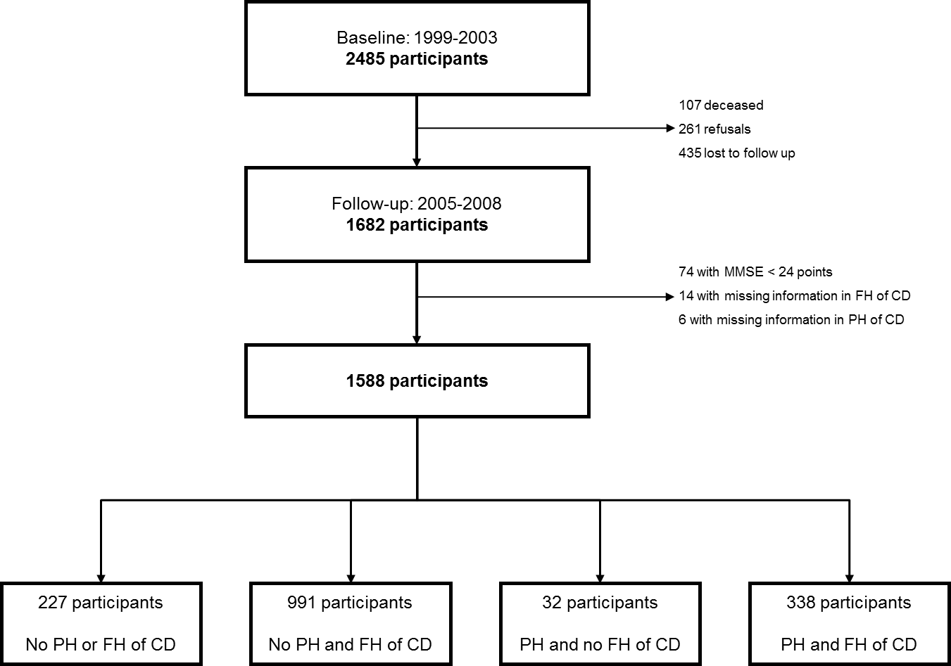

Table 1. Characteristics of the participants, overall and according to personal history (PH) and family history (FH) of chronic disease (CD).

 | All participants |  | According to PH and FH of CD
 | All participants |  | No PH or  FH of CD | No PH of CD  and FH of CD  without death | No PH of CD  and FH of CD  with death | PH of CD and  no FH of CD | PH of CD and  FH of CD  without death | PH of CD and  FH of CD  with death | p-value
Age (years), median (IQR) | 58 (48-68) |  | 47 (34-60) | 54 (43-63) | 60 (53-69) | 62 (43-76) | 62 (50-70) | 65 (57-72) | <0.001
Gender, N (%)  Female  Male | 973 (61.3)  615 (38.7) |  | 126 (55.5)  101 (44.5) | 273 (60.0)  182 (40.0) | 337 (62.9)  199 (37.1) | 16 (50.0)  16 (50.0) | 68 (61.8)  42 (38.2) | 153 (61.1)  75 (32.9) | 0.106
Education (years), N (%) ª  0-4  5-6  7-9  10-12  >12 | 532 (33.5)  124 (7.8)  231 (14.6)  249 (15.7)  450 (28.4) |  | 40 (17.6)  14 (6.2)  28 (12.3)  42 (18.5)  103 (45.4) | 134 (29.6)  41 (9.1)  68 (15.0)  69 (15.2)  141 (31.1) | 189 (35.3)  43 (8.0)  91 (17.0)  82 (15.3)  131 (24.4) | 9 (28.1)  1 (3.1)  3 (9.4)  2 (6.3)  17 (53.1) | 46 (41.8)  8 (7.3)  16 (14.6)  13 (11.8)  27 (24.6) | 114 (50.0)  17 (7.5)  25 (11.0)  41 (18.0)  31 (13.6) | <0.001
Marital status, N (%)  Married/Civil union  Single  Widowed  Divorced/Separated | 1081 (68.1)  183 (11.5)  201 (12.7)  123 (7.7) |  | 142 (62.6)  52 (22.9)  16 (7.0)  17 (7.5) | 303 (66.6)  71 (15.6)  45 (9.9)  36 (7.9) | 380 (70.9)  34 (6.3)  77 (14.4)  45 (8.4) | 19 (59.4)  5 (15.6)  8 (25.0)  0 (0.0) | 75 (68.2)  12 (10.9)  18 (16.4)  5 (4.6) | 162 (71.1)  9 (4.0)  37 (16.2)  20 (8.8) | <0.001
Occupation, N (%) ª  White-collar  Blue-collar  Housewives/Students | 1016 (64.1)  468 (29.5)  102 (6.4) |  | 167 (73.6)  49 (21.6)  11 (4.9) | 309 (68.1)  119 (26.2)  26 (5.7) | 320 (59.7)  175 (32.7)  41 (7.7) | 24 (75.0)  7 (21.9)  1 (3.1) | 68 (61.8)  36 (32.7)  6 (5.5) | 128 (56.4)  82 (36.1)  17 (7.5) | 0.005
Smoking status, N (%) ª  Never  Former  Current | 856 (54.0)  406 (25.6)  324 (20.4) |  | 109 (48.2)  50 (22.1)  67 (29.7) | 231 (50.9)  112 (24.7)  111 (24.4) | 305 (56.9)  142 (26.5)  89 (16.6) | 14 (43.8)  7 (21.9)  11 (34.4) | 57 (51.8)  33 (30.0)  20 (18.2) | 140 (61.4)  62 (27.2)  26 (11.4) | <0.001
Drinking status, N (%) ^{b}  Never  Former  Current | 241 (15.3)  103 (6.5)  1230 (78.2) |  | 36 (16.0)  10 (4.4)  179 (79.6) | 74 (16.4)  18 (4.0)  359 (79.6) | 83 (15.5)  30 (5.6)  421 (78.8) | 2 (6.9)  4 (13.8)  23 (79.3) | 22 (20.2)  10 (9.2)  77 (70.6) | 24 (10.6)  31 (13.7)  171 (75.7) | <0.001
Fruits and vegetables intake (servings per day), median (IQR) ^{c} | 3.93 (2.56-5.43) |  | 3.93 (2.43-5.43) | 3.71 (2.43-5.43) | 3.93 (2.78-5.43) | 3.93 (3.00-5.60) | 3.93 (2.43-5.43) | 3.93 (3.00-5.43) | 0.210
Dietary salt intake as evaluated by visual analogical scale (mm), median (IQR) ^{d} | 45 (28-52) |  | 47 (27-53) | 44 (28-52) | 46 (29-52) | 48 (32-54) | 46 (26-51) | 41 (23-51) | 0.058
Regular practice of physical exercise, N (%) ^{e}  No  Yes | 831 (52.4)  755 (47.6) |  | 112 (49.6)  114 (50.4) | 235 (51.8)  219 (48.2) | 292 (54.5)  244 (45.5) | 12 (37.5)  20 (62.5) | 60 (54.6)  50 (45.4) | 120 (52.6)  108 (47.4) | 0.442
BMI categories, N (%) ^{f}  Underweight/Normal weight  Overweight  Obese | 549 (34.7)  651 (41.2)  382 (24.1) |  | 111 (49.1)  83 (36.7)  32 (14.2) | 177 (39.1)  193 (42.6)  83 (18.3) | 164 (30.7)  227 (42.4)  144 (26.9) | 16 (50.0)  8 (25.0)  8 (25.0) | 31 (28.2)  42 (38.2)  37 (33.6) | 50 (22.1)  98 (43.4)  78 (34.5) | <0.001
Waist circumference (cm), median (IQR) ^{g} | 91.8 (83.7-99.7) |  | 88.0 (79.0-97.0) | 89.5 (82.0-97.6) | 92.4 (85.4-100.2) | 91.3 (82.0-100.0) | 96.2 (87.7-103.8) | 95.8 (87.6-103.4) | <0.001
BMI – body mass index; IQR – interquartile range.
Missing information for: ª 2 participants, ^{b} 14 participants, ^{c} 7 participants, ^{d} 11 participants, ^{e} 2 participants, ^{f} 6 participants, ^{g} 12 participants.

Figure 13: Distribution of the type of chronic disease (CD) for family history (FH) according to personal history (PH) (A, B), and for PH according to FH (C).

A
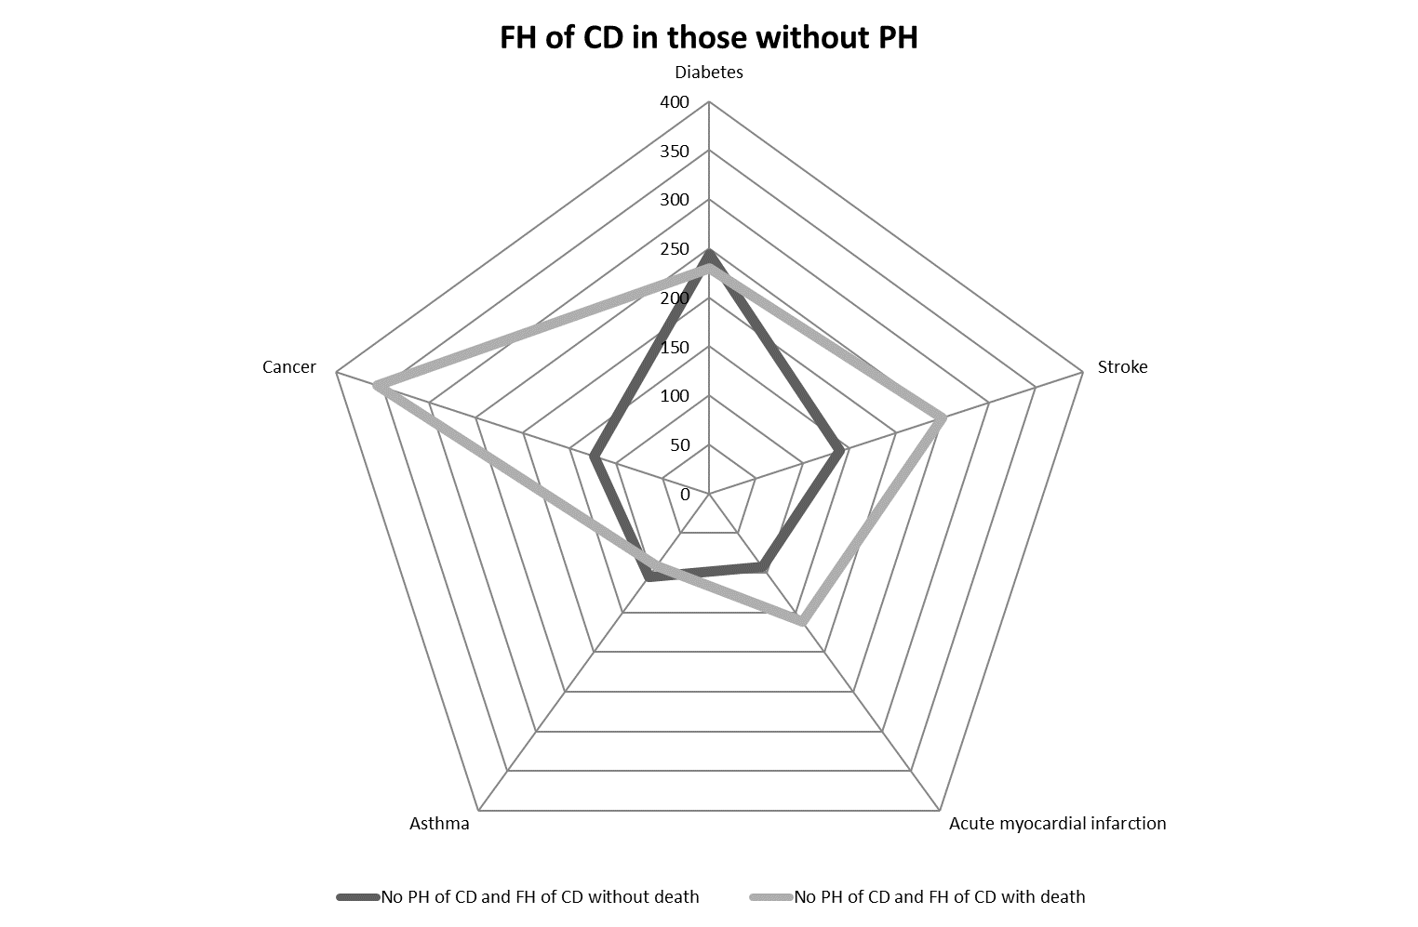
B
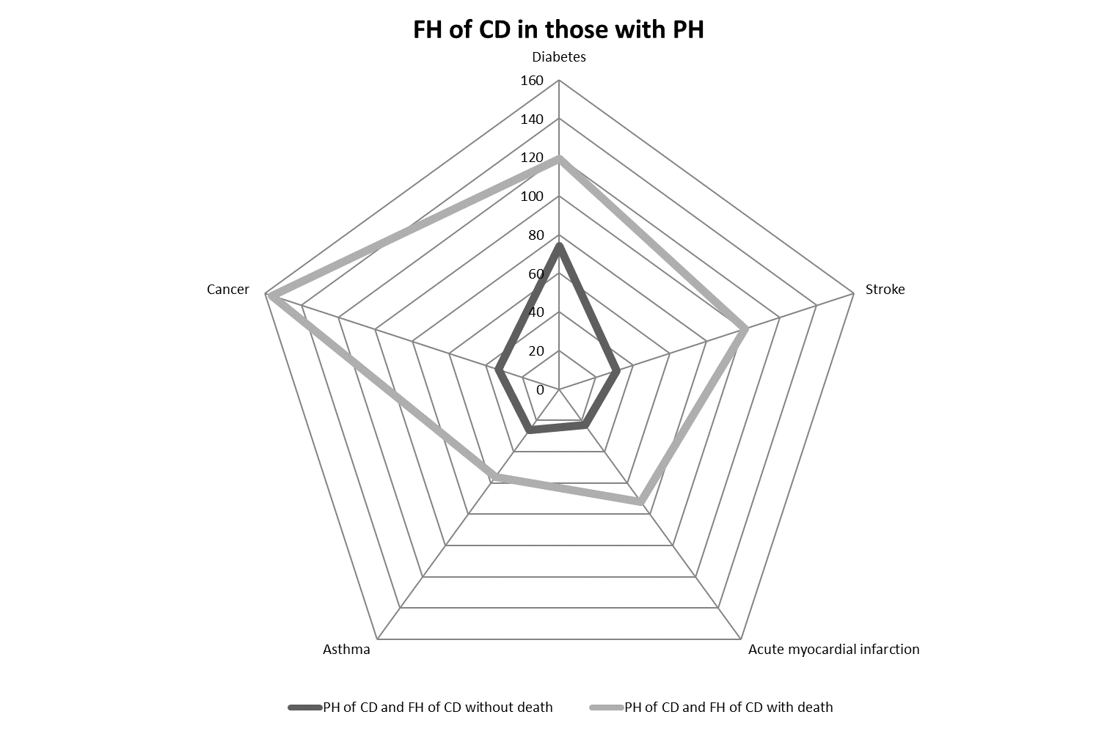
C
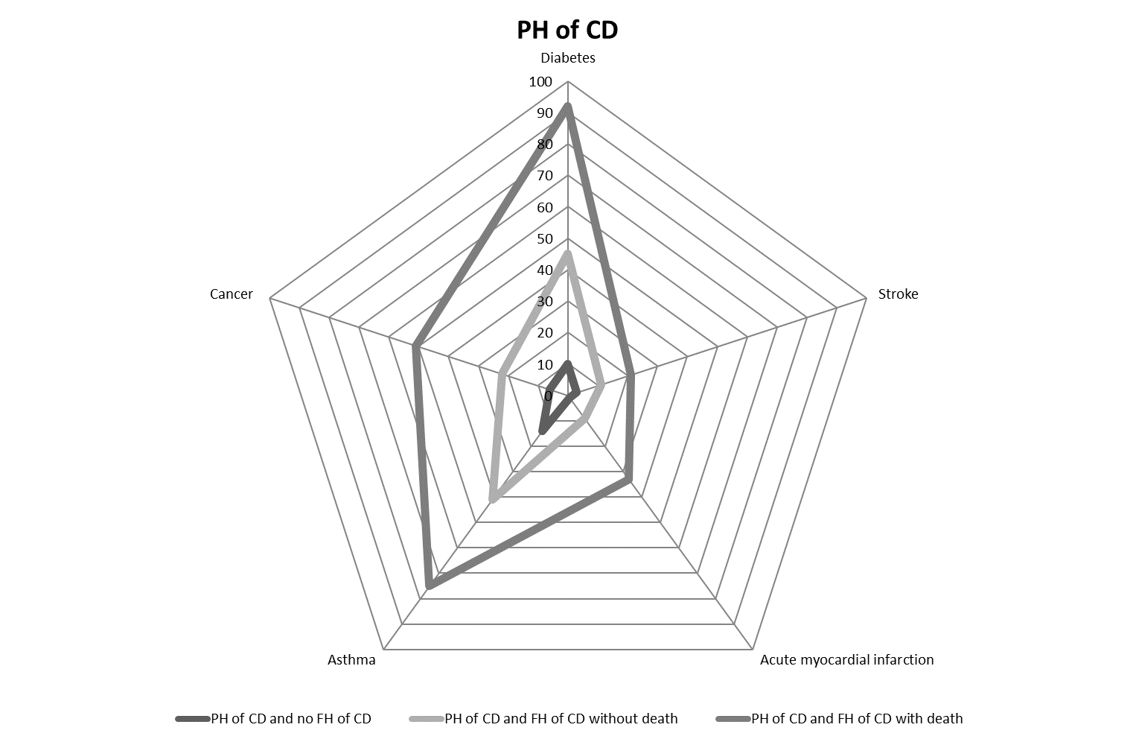

Table 2. Association between personal history (PH) and/or family history (FH) of chronic disease (CD) and healthy behaviors.

Healthy behaviors | No PH of CD and FH  of CD without death |  |  | No PH of CD and FH  of CD with death |  |  | PH of CD and  no FH of CD |  |  | PH of CD and FH of CD  without death |  |  | PH of CD and FH of CD  with death
Healthy behaviors | Crude OR  (95% CI) | Adjusted * OR  (95% CI) |  | Crude OR  (95% CI) | Adjusted * OR  (95% CI) |  | Crude OR  (95% CI) | Adjusted * OR  (95% CI) |  | Crude OR  (95% CI) | Adjusted * OR  (95% CI) |  | Crude OR  (95% CI) | Adjusted * OR  (95% CI)
Currently non-smoker ª | 1.30  (0.91-1.86) | 0.95  (0.64-1.40) |  | 2.12  (1.47-3.05) | 1.03  (0.69-1.55) |  | 0.80  (0.37-1.76) | 0.45  (0.19-1.07) |  | 1.90  (1.08-3.33) | 0.98  (0.53-1.81) |  | 3.27  (1.99-5.39) | 1.16  (0.67-2.01)
Currently non-drinker or drinker of no more than 1 drink per day for women and 2 drinks per day for men ^{b} | 0.80  (0.58-1.10) | 0.95  (0.68-1.34) |  | 0.69  (0.50-0.95) | 0.90  (0.64-1.26) |  | 1.62  (0.71-3.69) | 1.98  (0.86-4.59) |  | 0.55  (0.35-0.88) | 0.73  (0.45-1.17) |  | 1.04  (0.71-1.52) | 1.43  (0.95-2.14)
Consuming at least 5 servings of fruit and vegetables per day ^{c} | 0.91  (0.64-1.29) | 0.87  (0.61-1.25) |  | 0.90  (0.64-1.27) | 0.75  (0.52-1.07) |  | 1.14  (0.52-2.48) | 0.82  (0.37-1.84) |  | 1.16  (0.72-1.88) | 1.04  (0.63-1.73) |  | 0.88  (0.59-1.32) | 0.74  (0.48-1.14)
Consuming salt below the median of dietary salt intake as evaluated by visual analogical scale (< 45 mm) ^{d} | 1.24  (0.90-1.71) | 1.26  (0.91-1.74) |  | 1.11  (0.81-1.52) | 1.09  (0.79-1.52) |  | 1.03  (0.49-2.16) | 0.94  (0.44-2.00) |  | 1.10  (0.70-1.74) | 1.11  (0.69-1.78) |  | 1.50  (1.04-2.18) | 1.53  (1.03-2.26)
At least 150 minutes of moderate intensity physical activity per week or at least 75 minutes of vigorous intensity physical activity per week ^{e} | 1.83  (1.20-2.80) | 1.42  (0.92-2.21) |  | 2.04  (1.35-3.10) | 1.25  (0.80-1.96) |  | 1.42  (0.52-3.88) | 1.16  (0.41-3.27) |  | 2.14  (1.09-4.23) | 1.32  (0.65-2.67) |  | 3.48  (1.91-6.35) | 1.67  (0.88-3.17)
BMI < 30 Kg/m² ^{f} | 0.74  (0.47-1.15) | 0.97  (0.61-1.55) |  | 0.45  (0.29-0.68) | 0.66  (0.42-1.03) |  | 0.49  (0.20-1.20) | 0.48  (0.19-1.20) |  | 0.33  (0.19-0.56) | 0.48  (0.27-0.85) |  | 0.31  (0.20-0.50) | 0.55  (0.33-0.91)
BMI < 25 Kg/m² ^{f} | 0.66  (0.48-0.92) | 0.83  (0.59-1.17) |  | 0.46  (0.33-0.63) | 0.68  (0.48-0.97) |  | 1.04  (0.49-2.17) | 1.30  (0.60-2.80) |  | 0.41  (0.25-0.66) | 0.61  (0.37-1.02) |  | 0.29  (0.20-0.44) | 0.52  (0.33-0.80)
WC < 88 cm for women and WC < 102 cm for men ^{g} | 0.67  (0.47-0.96) | 0.93  (0.62-1.37) |  | 0.41  (0.29-0.58) | 0.68  (0.46-1.00) |  | 0.57  (0.22-1.23) | 0.63  (0.27-1.47) |  | 0.26  (0.16-0.42) | 0.38  (0.23-0.66) |  | 0.28  (0.19-0.42) | 0.58  (0.37-0.90)
WC < 80 cm for women and WC < 94 cm for men ^{g} | 0.59  (0.42-0.81) | 0.79  (0.55-1.13) |  | 0.35  (0.25.0.49) | 0.63  (0.44-0.90) |  | 1.05  (0.50-2.19) | 1.51  (0.68-3.35) |  | 0.37  (0.22-0.61) | 0.63  (0.36-1.09) |  | 0.27  (0.18-0.41) | 0.62  (0.40-0.99)
WHR < 0.90 for women and WHR < 0.85 for men ^{h} | 0.99  (0.72-1.36) | 1.24  (0.78-1.95) |  | 0.78  (0.57-1.07) | 1.08  (0.69-1.69) |  | 0.72  (0.34-1.55) | 1.21  (0.41-3.55) |  | 0.74  (0.46-1.18) | 1.04  (0.41-1.95) |  | 0.60  (0.41-0.88) | 0.84  (0.50-1.42)
BMI – body mass index; WC – waist circumference; WHR – waist-to-hip ratio.
ª Adjusted for sex, age and education.
Missing information for: ^{b} 2 participants, ^{c} 14 participants, ^{d} 7 participants, ^{e} 11 participants, ^{f} 2 participants, ^{f} 6 participants, ^{g} 12 participants, ^{h} 13 participants.

Conclusions

The results obtained with this study allow to show the importance of family and personal history for chronic disease patients, susceptible to a varied group of risk factors, and to describe their behavior, which could lead to the adoption of preventive measures, aiming at modifying their habits and improving their quality of life. In that case, we would expect individuals with PH and/or FH of CD to be more under surveillance by the health services, not only to detect the disease earlier but also to prevent it through recommendations for the adoption of healthier lifestyles. However, this did not occur at least in what concerns obesity measures. Further studies are needed with a longitudinal approach to confirm this result. In any case, our study suggests reducing obesity as a major focus in interventions in these groups of individuals.

