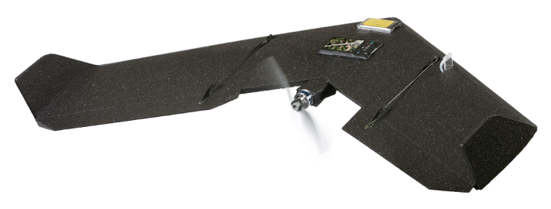

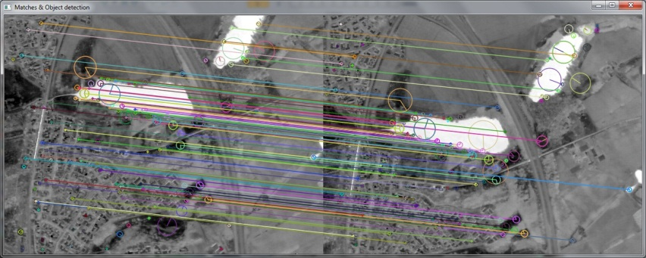



Feature Extraction and Matching
Methods and Software for UAV Aerial Photogrammetric Imagery

Sérgio Santos,
Mestrado em Engenharia Geográfica
Departamento de Geociências, Ambiente e Ordenamento do Território 2013

Orientador
Ismael Colomina, PhD, Senior Researcher, Institut of Geomatics of Catalonia
Coorientador
Dr. José Alberto Gonçalves, PhD, Assistant Professor, Faculdade de Ciências da Universidade do Porto



Todas as correções determinadas
pelo júri, e só essas, foram efetuadas.
O Presidente do Júri,
Porto, ______/______/_________

Acknowledgments

I would like to express my thanks to all the people that guided and helped me, throughout the development of the activities described in this document. Without them this would not be possible.
I would like to thank all my degree colleagues and teachers, especially to Prof. José Alberto Gonçalves, with whom I worked and learned in the last years.
In particular, I would like to thank all the people in the Institut de Geomàtica de Barcelona for the wonderful time I’ve spent there and all that I’ve learned with them, more than I can demonstrate in this document. Among them, I must give special praise to Ismael Colomina, Alba Pros and Paula Fortuny that invaluably guided this work more closely, and also to Pere Molina and Eduard Angelats for all the extra help provided.
Finally, it is indispensable to thank the firm Sinfic, in the person of Engº. João Marnoto, for gently providing the image set from Coimbra, used in this work.

Summary

The analog and human intensive aerial photogrammetry is becoming a thing of the past. The digital era is enabling the development of ever more computerized tools and automated software to provide computers with “vision” to make decisions autonomously. Computer Vision research is progressively turning that dream into a reality. Algorithms like SIFT, SURF and BRISK are capable of finding features of interest in images, describe and match those same features in other images to automatically detect objects or stitch images together in seamless mosaics. Primarily this is made in close-range applications but has been progressively implemented in medium- and long-range applications. Some of these algorithms are very robust but slow, like SIFT, others are quicker but less effective, SURF for instance, and others still are more balanced, for example, BRISK.
Simultaneously, the rise of the lightweight autonomous aerial vehicles increasingly accessible to more people and small businesses, besides only big corporations, has fueled the creation of more or less easy to use software to process aerial imagery data and to produce photogrammetric products such as orthophotos, digital elevation models, point clouds, 3D models. Pix4UAV and PhotoScan are two examples of user-friendly and automated software but also quite reasonably accurate and with some surprising characteristics and performance given its simplicity.
On the other end of the spectrum, there are also more complex and high quality software like GENA. The network adjustment software GENA provides detailed statistical analysis and optimization of most types of networks where unknown parameters are computed given a set of known observations. GENA inclusively is able to handle and adjust aerial image sets obtained by UAVs.

Keywords: Feature, points of interest, keypoint, detection, description, matching, photogrammetry, adjustment, unmanned aerial vehicle, Pix4UAV, PhotoScan, GENA.

Resumo

A fotogrametria analógica e dependente do trabalho humano está a tornar-se numa atividade do passado. A era digital está a proporcionar o desenvolvimento de ferramentas computacionais cada vez mais automatizadas para dotar os computadores de “visão” para tomar decisões autonomamente. Pesquisa em Visão de Computador está progressivamente a tornar esse sonho em realidade. Algoritmos como o SIFT, SRIF e BRISK são capazes de identificar locais de interesse (Features) em imagens, descrevê-las e associá-las com essas mesmas features em outras imagens, de modo a automaticamente detetar objetos e sobrepor imagens em mosaicos. Este processo é feito primeiramente em aplicações de curta distância mas têm sido progressivamente implementado em aplicações de média e longa distância . Alguns destes algoritmos são bastante robustos mas lentos, como o SIFT, outros são mais rápidos mas menos eficientes, como o SURF, e outros ainda são mais equilibrados, como por exemplo o BRISK.
Simultaneamente, o crescimento dos veículos aéreos de não tripulados de baixo peso, cada vez mais acessíveis a pessoas singulares ou pequenas empresas, para além das grandes corporações exclusivamente, permitiu o desenvolvimento de software especializado mais ou menos fácil de utilizar para processar dados de imagens aéreas e criar produtos fotogramétricos como ortofotos, modelos digitais de terreno, nuvens de pontos, modelos 3D. O Pix4UAV e o PhotoScan são dois exemplos de software fácil de usar e automatizado, mas também razoavelmente preciso e com características e performances surpreendentes dada a sua simplicidade de processos.
No outro lado do espectro, existe outro software mais complexos e alta qualidade, como por exemplo, o GENA. Este software de ajuste de redes fornece uma análise estatística e optimização detalhada da maioria dos tipos de redes, onde um conjunto de parâmetros desconhecidos são estimados, a partir de um outro conjunto de observações conhecidas. O GENA inclusivamente é capaz de trabalhar e ajustar conjuntos de imagens aéreas obtidas UAVs.

Palavras-chave: Característica, ponto de interesse, ponto-chave, deteção, descrição, emparelhamento, fotogrametria, ajustamento, veículo aéreo não tripulado.

Table of Contents

I Introduction 5
1. Historical retrospective 5
2. Open problems and objectives 6
II State of the Art 8
1. Photogrammetry image acquisition 8
2. Unmaned Autonomous Vehicles 9
2.1 Fixed-Wing UAVs 10
2.2 Rotary-wing UAV 11
2.3 UAV vs conventional airplane 12
3. Image Matching Process 13
3.1 Image Features 13
3.2 Feature detection 15
3.3 Feature Description 19
3.4 Feature Matching 20
4. Matching Algorithms 22
4.1 Scale-Invariant Feature Transform 24
4.2 Speeded-Up Robust Features 27
4.3 Binary Robust Invariant Scalable Keypoints 30
5. Camera calibration Process 33
5.1 Ebner model 34
5.2 Conrady-Brown model 34
6. Photogrammetric data processing software 35
6.1 Pix4UAV 35
6.2 PhotoScan 36
6.3 GENA 37
III Data sets processing and results 40
1. Data set description 40
2. OpenCV matching algorithms comparison 42
3. Imagery Data sets analyzed 45
3.1 Pix4UAV processing and results 45
3.2 PhotoScan processing and results 51
3.3 GENA processing and results 55
IV Conclusions 69
V Works Cited 70
VI Anexes 73

Figures List

Figure 1 - Tipical photogrametric products (below: orthophoto, Digital Elevation Model (DEM), map) obtained from image set (above). 5
Figure 2 - Some fixed-wing UAV without tale. Swinglet with case and control system (left), SmartOne hand-launch and Gatewing X100 slingshot-launch (right). (Sources: Sensefly, SmartPlanes and Wikimedia Commons websites) 11
Figure 3 - Three examples of conventional fuselage design fixed-wing UAV. From left to right: Sirius, LLEO Maja and Pteryx. (Sources: Mavinci, G2way, Trigger Composites websites) 11
Figure 4 - Rotary-wing UAV examples. From left, Vario XLC-v2 single-rotor, ATMOS IV and Falcon-8 multi-rotors. (Source: Vario Helicopter, ATMOS Team, Asctec websites) 12
Figure 5 – Types of image features: points, edges, ridges and blobs (Sources: [8] left, [9] center left and center right), [10] right) 14
Figure 6 – Auto-correlation functions of a flower, roof edge and cloud, respectively [7]. 16
Figure 7 – Pseudo-algorithm of a general basic detector [7]. 17
Figure 8 - Scale-space representation of an image. Original gray-scale image and computed family of images at scale levels t = 1, 8 and 64 (pixels) [13]. 19
Figure 9 – Feature matching in two consecutive thermal images. 21
Figure 10 - Map of some of the most well-known matching algorithms according to their speed, feature extraction and robustness. 23
Figure 11 – Feature detection using Difference-of-Gaussians in each octave of the scale-space: a) adjacent levels of a sub-octave Gaussian pyramid are subtracted, generating a difference-of-Gaussian images; b) extrema in the consequent 3D volume are identified by comparison a given pixel and its 26 neighbors [16]. 26
Figure 12 - Computation of the dominant local orientation of a sample of points around a keypoint, with an orientation histogram and the 2x2 keypoint descriptor [16]. 26
Figure 13 - Integral images make possible to calculate the sum of intensities within a rectangular area of any dimension with only three additions and four memory accesses [17]. 27
Figure 14 - Integral images enables the up-scaling of the filter at constant cost (right), contrary to the most common approach of smoothing and sub-sampling images in the (left) [17]. 28
Figure 15 – Approximations of the discretized and cropped Gaussian second order derivatives (filters) in yy- and xy-directions, respectively (smaller grid), in two successive scale levels (larger grids): 9x9 and 15x15 [17]. 29
Figure 16 – Estimation of the dominant orientation of the Gaussian weighted Haar wavelets (left). Descriptor grid and the four descriptor vector entries of every 2x2 sub-regions [17]. 30
Figure 17 - Scale-space framework for detection of interest points: a keypoint is a maximum saliency pixel among its neighbors, in the same and adjacent layers [14]. 31
Figure 18 - Sampling pattern with 60 locations (small blue circles) and the associated standard deviation of the Gaussian smoothing (red circles). This pattern is the one with scale t = 1 [14]. 32
Figure 19 - PhotoScan environment with 3D model of Coimbra from image data set. 37
Figure 20 – GENA’s network adjustment system concept [25]. 38
Figure 21 – Swinglet’s flight scheme above Coimbra: trajectory in blue, first and last photos of each strip in red and GCP in yellow. 41
Figure 22 - Linked matches in two consecutive images of Coimbra data set. 44
Figure 23 - Average keypoints extracted and matched. 44
Figure 24 - Average time of computation of extraction and matching stages (in seconds), per image pair. 45
Figure 25 – Pix4UAV main processing window (red dots represent the position of the images and the green crosses the positions of the GCPs). 46
Figure 26 – Offset between image geo-tags (little red crosses) and optimized positions (little blue dots), and between GCP’s measured positions (big red crosses) and their optimized positions (green dots). Upper left figure is the XY plane(top-view), upper right is YZ (side view) plane and XZ plane (front-view) in the bottom. 48
Figure 27 - Number of overlapping images for each image of the orthomosaic. 48
Figure 28 – 2D keypoint graph. 49
Figure 29 – Final products preview: Orthomosaic (above) and DSM (below). 50
Figure 30 - Artifacts in Pix4UAV orthomosaic. 51
Figure 31 – Part of the 3D model generated in PhotoScan with GCP (blue flags). 52
Figure 32 - Image overlap and camera position. 53
Figure 33 - Color coded error ellipses depict the camera position errors. The shape of the elipses represent the direction of error and the color is the z-component error. 54
Figure 34 - DEM generated by PhotoScan 54
Figure 35 - Artifacts in PhotoScan generated orthophoto. 55
Figure 36 - Method for attributing initial approximations to the tie points based on the proximity to the closest image center. 59
Figure 37 - Scheme of the estimation of the initial approximations of the tie points' ground coordinates. 61

Table List

Table 1 - Processing quality check with the expected good minimum 2
Table 2- Camera calibration paramters (radial and tangential distortions) estimated by Pix4UAV. 2
Table 3 - Calibrated parameters, in pixels, computed by PhotoScan. 2
Table 4 - Computed S0 and residuals statistics of image coordinates observations. 2
Table 5 - SO and residuals statistics estimated for the GCP coordinates. 2
Table 6 - Estimated S0 and residual statistics for the camera position and orientation. 2
Table 7 – Computed S0 and residual statistics for the interior parameters of the sensor. 2
Table 8 – Estimated Ebner parameters for the camera. 2
Table 9 - Adjusted Exterior Orientation parameters against initial values. Only 4 images are represented to avoid putting all 76 images. 2
Table 10 - Adjusted tiepoint coordinates versus initial coordinates. 2
Table 11- Lever arm estimated values of displacement. 2
Table 12 – Computed Boresight angle. 2
Table 13 – Computed Shift and Drift displacements for each of the 7 strips. 2

Abbreviations List

BBF – Best Bin First
BRISK – Binary Robust Invariant Scalable Keypoints
BRIEF – Binary Robust Independent Elementary Features
DEM – Digital Elevation Model
DOG – Difference of Gaussian
DSM – Digital Surface Model
GENA – General Extensible Network Approach
GIS – Geographic Information System
GLOH – Gradient Location-Oriented Histogram
GCP – Ground Control Points
IMU - Inertial Measurement Unit
PCA-SIFT – Principal Components Analysis SIFT
ROC – Receiver Operating Characteristic curve
SIFT – Scale-Invariant Feature Transform
SAR – Synthetic Aperture Radar
SURF – Speeded-Up Robust Features
UAV – Unmanned Aerial Vehicle

Introduction

Historical retrospective
The use of photography obtained by aerial platforms is one of the main technical milestones in land surveying activities. Before the aviation and satellite eras there were other, more rudimentary, aerial platforms that allowed the production of images from the air. Since the mid XIX century onward to early XX century, experimental photography was made by means of manned balloons, model rockets, and even kites or pigeons carrying cameras.
Immediately, the advantages of aerial photography were acknowledged. First and for most, the elevated position, virtually without obstacles, provide an unprecedented all-round spatial perspective. Since then, many other advantages were found: repeatability was possible as re-measurements could be made again which is useful for time-series analysis; using different films and sensors enables multi-spectral analysis such as infra-red and thermal; its remote sensing nature allows for a more secure access to rough or dangerous zones; and versatility because it can be used in a wide range of biological and social phenomena [1].
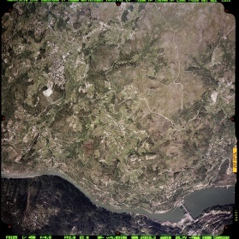
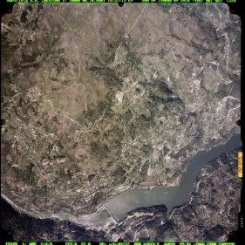
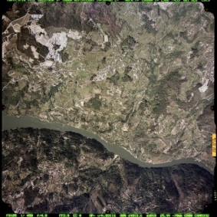
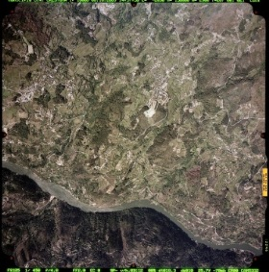
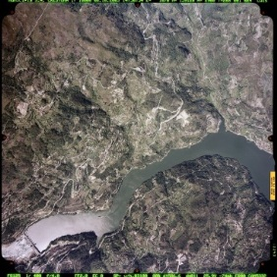
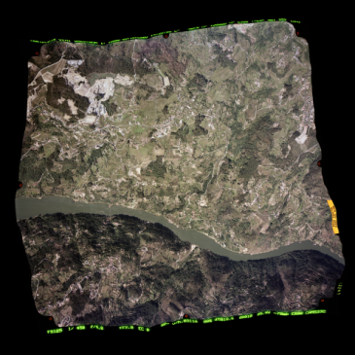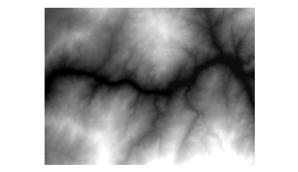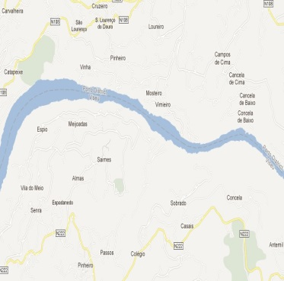
Figure 1 - Tipical photogrametric products (below: orthophoto, Digital Elevation Model (DEM), map) obtained from image set (above).

Although being more expensive to operate an airplane, this fact is largely compensated by the quickness on surveying large areas, the true visual perspective of the land and versatile applicability on diverse subjects. For these reasons the aerial based imagery has established itself as the main source to produce geographical information, substituting on most accounts the classical in loco sole topographic campaigns, relegating them to a verification or complementary resource.
This new approach of working directly on photographs required the use of newer analogue and mechanical instruments, such as the stereoscopes. These instruments are used to orient, interpret, measure and extract information in the form of two-dimensional and also three-dimensional coordinates, in order to make reliable maps, terrain elevation models, orthorectified images, among other products (Figure 1).
Therefore, alongside the aeronautical and camera achievements many mathematical techniques and methods were developed to allow measurements on the photos/images to obtain and derive information from them. Yet, such new methods demanded time-consuming calculations. This problem didn’t remain unresolved for much long since the beginning of the digital era, in the second half of the 20th century, brought forth the processing power of the computers to aid on these calculations on images obtained by new digital high-resolution cameras.

Open problems and objectives
Until recently, the processing of digital images, in spite of significantly aided by computer calculation, bundle adjustments algorithms for instance, and visualization such as image set mosaic generation, was considerably dependent on human command in most of its decision making phases. This fact is especially clear on issues concerning interpretation of images, such as identifying features of interest and associating the same features in different images to accurately match successive images. Projects based on big sets of images from a single flight, related with photogrammetric land surveying for instance, with several ground control points and tie points in each image, can be a very long, repetitive and tiresome work, and therefore prone to errors. The most likely answer to avoid human errors might be to teach computers, in some way, “see” like humans do or, in other words, to simulate human vision in computers, i.e., Computer Vision.
Computer vision has been one of the major sources of problem solving proposals in fields like robotics and 3D modeling, in particular, regarding image registration, object and scenario recognition, 3D reconstruction, navigation and camera calibration. Some of these challenges are also challenges to surveying engineering and mapping, yet, most of these developments are not design specifically to these areas. Several commercial software tools (Match-AT, Pix4UAV, Dronemapper, Photoscan) already supply this automation, in some level, although the development of even preciser, quicker and autonomous aerial image processing surveying tools would not be a possibility to disregard. Yet, these available tools still struggle with image invariance issues on optical images as well as with matching and non-optical imagery (thermal, for instance). And up until a few years ago, the knowledge behind image matching was mainly limited to the big corporations and its research teams. Now with the rise of open source and crowd source communities (OpenCV, for instance) this knowledge is more available to everyone who wants to investigate these areas. If by using these alternative and open source matching algorithms could open new opportunities for people outside big commercial corporations to also develop new tools to manipulate image data more easily and with increasing quality it would be a significant step forward.
Knowledge on the performance of some of the latest matching methods in photogrammetric surveying real world cases are not very common. Most available studies either are a few years old, made with close range image sets, or very specific goals which are not directly related to surveying or mapping applications and problems. And considering the significant development in image matching algorithms in the last few years it would be important to evaluate the performance in these fields of some of most popular algorithms in particular with UAV obtained imagery.
That is one of the purposes of this work: to evaluation of some of the most popular image matching algorithms, in medium/long range aerial image sets obtained, in particular, by UAV. Special importance will be given to algorithms that present, first and foremost, reduced computational cost (quick performance), but also robust feature extraction and invariance to scale and rotation. The most popular and promising algorithms that present these characteristic are SIFT, SURF and BRISK, that’s why the analysis will be done with these methods. This comparison will be done based on the open source implementations of this algorithms form the OpenCV routines publicly available.
Besides comparing the performance between open source algorithms, it would be interesting to evaluate them with other commercial photogrammetric software that uses feature matching tools, for example, Pix4UAV and PhotoScan.
Finally, will be tested the performance in camera calibration and block adjustment software called GENA in a UAV data set.

State of the Art

Photogrammetry image acquisition
Several mediums have been mentioned to support in the air the different cameras or sensors to capture aerial images. The main platforms today are aircrafts and orbital satellites. Both technologies are progressively converging as their instruments improve over time, but overall both are can still be seen as complementary on mapping projects. The crucial question to answer is each of them is particularly best fitted to the specific project to be performed. Several topics are traditionally considered to evaluate the pros or cons of both of them.
Probably one of the first characteristics that come to mind is resolution. Most of the latest observational satellites are capable of acquiring images with sub-meter resolution. But given their much greater distance to the Earth surface, satellites have naturally slightly lowest resolution capabilities than equivalent or even inferior sensors abroad aircrafts. On top of that there are also probable limitations applied to civil users resulting in a maximum available resolution of 50 cm, with the possibility of reaching 30 cm in the near future. But with the current available technologies this resolution isn’t expected to be improved easily. On the other hand, airplanes equipped with large format digital cameras are able to acquire images with up to 2.5 cm resolution. Some recent aerial camera types have also large frame resulting in an enormous amount of data obtained that cover a bigger area so less runs over the target region are required.
Parallel to resolution, the costs are always a fundamental point in any decision making. Aerial imagery acquisition depends on many variables, such as the flight specification, type sensors, resolution and accuracy needed, so is very dependable. Satellite imagery is easier to calculate and is usually the same regardless the location to be captured
Coverage and speed are also other very important factors when deciding between satellite and aerial imagery. Satellites can produce imagery covering a bigger area with less images but in each image the amount of data is also bigger that increase somewhat the processing time and have to be transmitted back to Earth. Therefore, a complete set of images may take up to a couple of days to receive. The increase of the number of ground stations around the world and data relay satellites, as well as improvements on data transmition rates can reduce somewhat the time needed to transfer the images. Besides one satellite can only cover a specific area or event of interest for small periods of time while they are overflying them. Consequently, the observation of time-dependent events can be difficult. In compensation, from the moment an observation is decided to be made, a satellite can execute quickly within some minutes or hours depending on its position at that moment, as long as its orbital path overflies the target area. Aircrafts can compensate the smaller coverage area per image with the ability to perform several runs in the same flight and have more flexibility to overfly a specific area at a determined time to capture local events that depend on time. On the other hand, each flight has to be planned in advance and can take several days from the decision to make the flight to actually having the images ready, while satellites, once they’re established in orbit can be managed to observe the desired event
Another important parameter is the data types that can be obtained. Both airplanes and satellites can be equipped with different sensors besides standard RGB photography for instance multispectral, hyperspectral, thermal, Near-infra-red and even radar. Yet, once they are launched satellites can’t be upgraded and don’t usually have stereo imagery capabilities, limiting the ability to derive highly accurate Digital Elevation or Surface (DSM) models, contours, orthophotos and 3D Geographic Information System (GIS) feature data on their own, without external data sources. Aircraft have a higher degree of freedom of movements and can relatively quickly change and use different sensor types.
Weather is a very important conditioning factor to take into account. Apart from synthetic aperture radar (SAR) satellites, which aren’t affected by clouds and bad illumination condition, these factors are a big obstacle to satellite based imagery and usually must be applied important corrections to minimize their effects. On the contrary, airplanes are sufficiently flexible to avoid atmospheric effects due to bad weather conditions or even fly under the clouds, with only minor post-processing adjustments.
Location accessibility is one of the main assets of satellites since they can obtain imagery of almost any place on Earth while disregard for logistical and borders constrains, as long as the area of interest is below the satellite orbit track. Aircrafts are usually very limited to local national or military airspace authorizations for obtaining images [2].

Unmaned Autonomous Vehicles
However, recently in the last couple of decades, a lot of interest has been arising on the idea of Unmanned Aerial Systems (UAS). This concept can be defined as the set of operations that features a small sized Unmanned Aerial Vehicle (UAV) carrying some kind of sensor, most commonly, an optical camera and navigation devices such as GNSS receptor and an Inertial Measurement Unit (IMU). Additionally to the sensor equipped UAV, there’s also another fundamental element of that complete the system which is the transportable ground station. This station is comprised of a computer with a dedicated informatics system to monitor the platform status, the autonomous flight plan and a human technician to overview the system performance and take control, remotely, of the platform if necessary. Curiously, the UAS concept resembles much like the satellite concept but in the form of an aircraft, which in some sense, could be seen as a hybrid system between conventional aircraft and satellite system.
Remotely operated aircrafts in the form of airplanes or missiles are not a new concept, especially in warfare applications, going back, in fact, to the World War I. Yet, their adaptation to civilian applications is recent. Technological advances in electronic miniaturization and building materials allowed for the construction of a lot smaller, lightweight flying vehicles as well as sensors. As their costs also decreased significantly UAVs progressively became accessible to commercial corporations and academic institutions. Numerous surveying and monitorization applications are on the front line of services that UAVs can be useful, compared with traditional methods.
Lightweight UAV can be seen as the midpoint that fills the large void between traditional terrestrial surveying and airplane surveying.
In terms of classification, lightweight UAV platforms for civil use based on airframes can generally be divided into fixed-wing and rotary-wing categories [3]. Tactical UAV are a completely different subject. There are several categories differing mainly with sizes and type functions to perform, but are most of the times significantly larger than civil lightweight UAV, but is not going to be approached in this document.

Fixed-Wing UAVs
Although there are various designs, fixed-wing UAV resemble a regular airplane only much smaller in size and mostly electrically-powered. They constitute a fairly stable platform and relatively easy to control while their autonomous flight mode that can be previously planned. Nonetheless, given its structure they have to keep a constant forward flight to be able to generate enough lift to remain in the air and enough space to turn and land. Some models can be hand-launched or “catapult-launched” to take-off. Furthermore, fixed-wing UAV are also distinguished by the type of airframe that have tail, similarly to normal airplane formed by fuselage, wings, fin and tail plane, or on the contrary not having tail. The conventional fuselage designs are able to carry more sensors due to the added space of the fuselage or support heavier instruments, such as multicamera setups for multispectral photography, in comparison with the tailless designs [4].
This type of UAV has longer flight times than rotary-wing UAV, so are more suited to larger areas of the order of few square kilometers, in particular, outside urban areas where infrastructural obstacles are less likely to exist. Another characteristic that separates fixed-wings from rotary-wing UAVs is the higher payload capacity of the first.

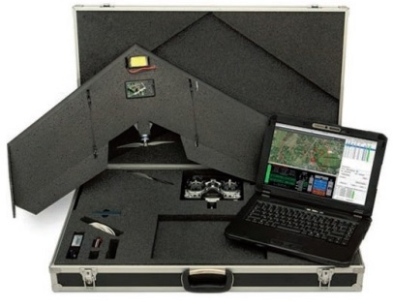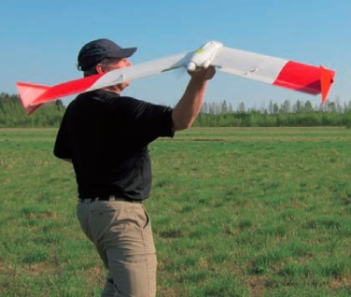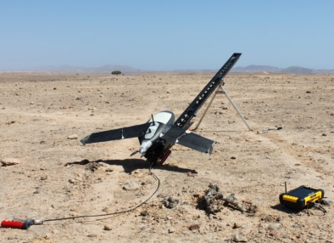
Figure 2 - Some fixed-wing UAV without tale. Swinglet with case and control system (left), SmartOne hand-launch and Gatewing X100 slingshot-launch (right). (Sources: Sensefly, SmartPlanes and Wikimedia Commons websites)
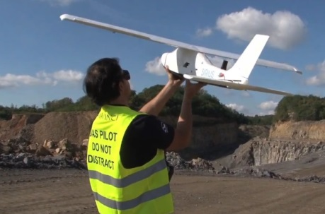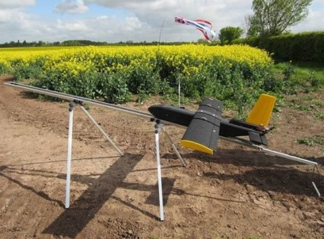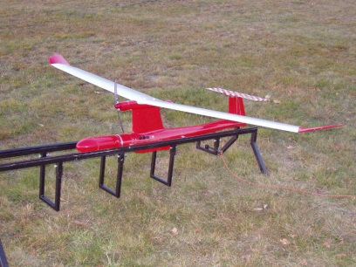
Figure 3 - Three examples of conventional fuselage design fixed-wing UAV. From left to right: Sirius, LLEO Maja and Pteryx. (Sources: Mavinci, G2way, Trigger Composites websites)

Rotary-wing UAV
On the other hand, rotary-wing UAV are not so stable and usually more difficult to maneuver in flight. They can have only one main rotor (single-rotor and coaxial UAV) like a helicopter or be multi-rotor (usually, 4, 6 or 8 rotors, respectively, quad-, hexa-, octocopters). For this reason, they have the ability of flying vertically and keep a fixed position in midair. Also, they require much less space to take off or land. This characteristic is particularly useful in certain types of monitoring tasks and to obtain panoramic photos or circling around an object, such as buildings. Some models are gas-propelled so can support heavier payloads.
One little drawback of having a conventional motor is the resulting noise and vibrations in the platform that may cause slight distortions to the quality of the images captured (if the camera is not sufficiently well sheathed) and might scare people or animals in the flight area.
Single and multi-copters excel in small urban areas or buildings, where their superior dexterity in smaller spaces or with frequent obstacles.

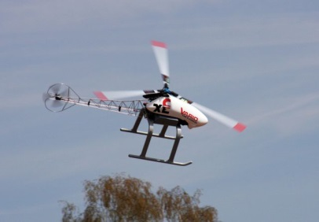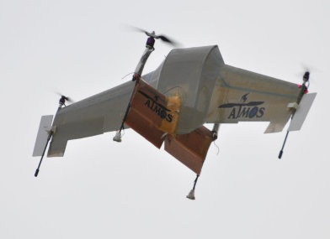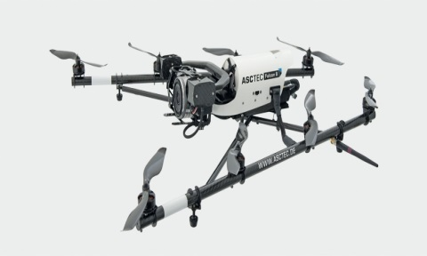
Figure 4 - Rotary-wing UAV examples. From left, Vario XLC-v2 single-rotor, ATMOS IV and Falcon-8 multi-rotors. (Source: Vario Helicopter, ATMOS Team, Asctec websites)

UAV vs conventional airplane
It can still be considered a relatively new technology, but the latest generations of UAVs present a set of capabilities that already makes them a game-changing technology.
Probably the most obvious advantages of UAV over conventional airplanes are that fact they are pilotless and small sized. In case of an accident while in action, the eventual resulting human casualties and material losses would be drastically reduced or even eliminated: the risk of human lives being lost, in particular the pilot’s and also nearby persons become minimal; additionally, the impact of a relatively small object should provoke considerable less damages than conventional aircraft, which, per se, have a higher economic value.
UAVs don’t need to have a fully trained pilot with enough experience to be capable of controlling a several hundred thousand euros airplane. The requirements for a certified UAV ground controller are much less demanding.
Most UAV can’t support large format sensors with high resolutions, but they typically fly on significantly lower altitudes, therefore can achieve similar image resolutions with lower end and, consequently, cheaper sensors. Also, some models can replace quickly the instruments they carry and can be deployed in a fraction of the time needed to take off an airplane.
The advanced navigation software available in most UAVs includes normal operational auto-pilot modes as well as emergency modes that can return the device to an initial departure point, for instance in case of communication failure.
An increasing percentage of light-weight UAV are equipped with an electric propulsion system making them more environmentally friendly and silent which would be a plus for night flights or applications where noise is an issue, such as fauna monitoring related projects.
Mobilization time is another point in favor for UAVs. Due to their small size and weight, these UAVs can be quickly transported within small and medium distances at a reduced logistical cost. Even though some of them have to be assembled, they are specifically made to be assembled quickly and can be even launched by hand which make them extremely quick to put in to action. And to collect the imagery acquired.
Their wide range of applications is getting increasingly wider: from military to civilian use, from surveying projects to entertainment and sportive events, from agriculture to urban scenarios.
It’s a common feeling in the UAV industry that the rapid technical development and popularity that UAVs have been experiencing is only being limited by the slow regulation by the majority of the national policy-making institutions. Another obstacle to get by is to conquer public opinion riddled with privacy concerns and negative association to tactical warfare drones [3].

Image Matching Process
Most of the times a given target area or object to be studied is wider than what the camera viewing angle can capture in a single shot. A possible solution would be to increase the distance to a level where all the area of interest could be seen as a whole. Yet, if it’s also important to have some certain degree of detail – as most of the times is – not considering also technical limitations, moving further from the target is not a solution because resolution is affected. For these reasons, the most practical answer is to take several sequential images of the target to encompass the whole area and afterwards “stich” the images together in a mosaic. If many photos are needed, as it is very common on land surveying and mapping projects for example, that task can be a longstanding one, if done manually.
Fortunately, the improvement of computational tools and the development of mathematical methods lead to the creation of software that can substitute human vision and feature recognition, with some degree of automation (“computer vision”). The general process that all of them use is based on the extraction of image features.

Image Features
The base concept in every image matching process is the image feature which doesn’t have a unique and consensual precise definition. The best general definition may be saying that a feature is an interesting part or point of interest of an image, in other words, a well-defined location exhibiting rich visual information [5]. In other words, locations whose characteristics (shape, color, texture, for instance) are such that can be identified in contrast with the nearby general scenario, even when that scenario changes slightly, this is, stable under local or global changes in illumination, allowing the establishment of correspondences or matches. Some examples of these features might be mountain peaks, tips of tree branches, building edges, doorways and roads.
A more consensual idea is the fundamental properties that such image features should possess. They should be clearly distinguished from the background (distinctness), the associated interest values should have a meaning, possibly useful in further operations (interpretability), also independent from radiometric and geometric distortions (invariance), robust against image noise (stability) and distinguishable from other points (uniqueness) [6]. Besides the term “feature”, other terms such as points of interest, keypoints, corners, affine region, invariant region are also used [7]. Each different method adapts some of these concepts of features to their functional specificities.
The already vast literature produced on this subject, since the start of the efforts to develop computer vision in the beginning of 1970 decade, defines several types of features, depending on the methodology proposed. However, features have two main origins: texture and geometric shape. Texture generated features are flat and usually reside away object borderlines and are very stable between varying perspectives. On the contrary, features generated by geometrical shape are located close to edges, corners and folds of objects. For this reason are prone to self-occlusions and, consequently, much less stable to perspective variations. These geometrically shape generated features tend to be the largest portion of all the detected features.

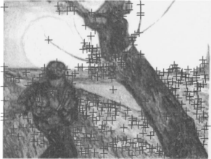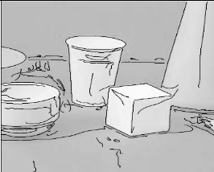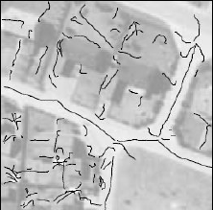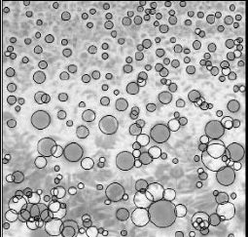
Figure 5 – Types of image features: points, edges, ridges and blobs (Sources: [8] left, [9] center left and center right), [10] right)
In general, image features are classified in three main groups: points, edges and regions (or patches). From these classifications some related concepts have been derived: corners, as a point-like feature resulting from the intersection of edges [11]; ridges as particular case of an edge that represents an axis of symmetry [9]; blobs, bright regions on dark backgrounds or vice-versa, derived from at least one point-like local maximum, over different image scales, whose vicinity present similar properties along a significant extent [12], making this concept a mixture of point as well as region-like feature.
Taking these concepts into account the general process of image matching follows three separate phases: a feature detection stage using a so called feature detector, a feature description phase using a feature descriptor and finally an image matching phase, to effectively “stich” together all the images in one single image or mosaic, using the previously identified features.

Feature detection
The feature detector is an operator applied to an image that seeks two-dimensional locations that are stable in terms of its geometry when subject to various transformations and that contains also significant amount of information. This information is crucial to afterwards describe and extract the features identified, in order to establish correspondences with the same locations in other images. The scale or spatial extent of the features may also be derived in this phase, in particular for instance in scale invariant algorithms.
Two approaches can be implemented in the detection process. One of them uses local search techniques, like correlation and least squares, to find and track features with some degree of desired accuracy on other images. This approach is especially suited to images acquired in rapid succession. The other point of view consists of separately detect features on every image and afterwards match corresponding similar features from different images according to their local appearance. This approach excels in image sets with large motion or appearance change, establish correspondences in wide base line stereo or in object recognition [7].
The detection process is performed by analyzing image local characteristics with several methods, being two of the most important based on texture correlation and gradient based orientations. One of the simplest and most useful mathematical tools to identify a good, stable feature is the auto-correlation function,
(1)
$E_{AC}\left(∆u\right)=\sum_{i}{w(x_{i})}{[I_{0} (x_{i}+∆u)-I_{0} (x_{i})]}^{2}$

where $I_{0}$ is the image in consideration w(x) is a spatially varying weighting (or window) function, $∆u$ represents small variations in position of the displacement vector u = (u,v), along each i pixels of a small patch of the image.
In figure 5 there are three examples of possible outcomes of applying an auto-correlation function in an image to identify features. The locations of an image that present a unique minimum are regarded as good candidates of a solid image feature. Other features can exhibit ambiguities in a given direction which can also be candidates of good features if they present other feats such as a characteristic gradient. If no stable peak in the auto-correlation function is evident the location is not a good candidate for a feature.
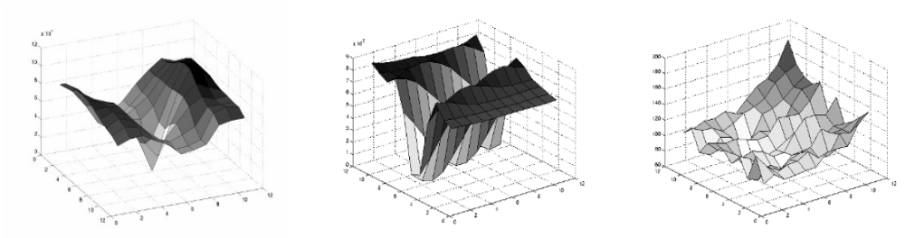
Figure 6 – Auto-correlation functions of a flower, roof edge and cloud, respectively [7].

By expanding the image function $I_{0} (x_{i}+∆u)$ in equation (1) with a Taylor Series, the auto-correlation function can be approximated as:

$$E_{AC}\left(∆u\right)= ∆u^{T}A∆u$$
where,
$$∇I_{0}\left(x_{i}\right)= \left(\frac{∂I_{0}}{∂x},\frac{∂∂I_{0}}{∂y}\right)(x_{i})$$
is the image gradient at $x_{i}$ and A is the auto-correlation matrix convoluted with a weighting kernel, instead of the weighted summations. This change enables the estimation of the local quadratic shape of the auto-correlation function. It can be calculated through several processes but final result is a useful indicator of which feature patches can be most trustworthily matched by minimizing the uncertainty associated with the auto-correlation matrix, which means finding the maxima of the matrix’s smaller eigenvalues. This is just an example of a basic detection operator. A possible pseudo-algorithm of this basic detector can be seen in Figure 7.

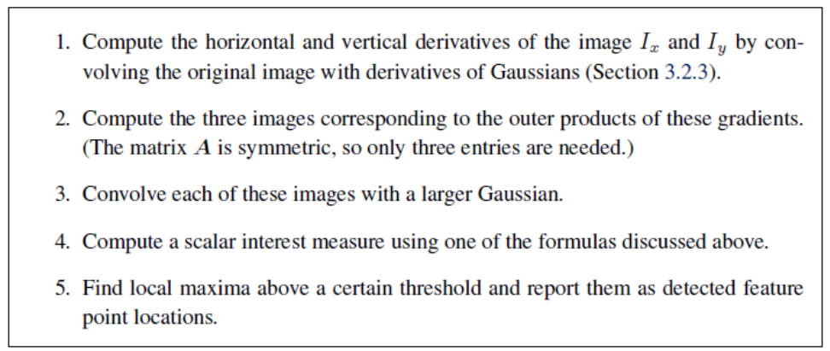
Figure 7 – Pseudo-algorithm of a general basic detector [7].
Many other more complex detectors have been proposed, with different approaches and based on different types of feature concepts. Some examples of point-based detectors are: Hessian(-Laplace), Moravec, Förstner, Harris, Haralick and Susan, among others. As for region-based detectors, the following can be mentioned as the most used: Harris-affine, Hessian-affine, Maximally Stable Extremal Region (MSER), Salient Regions, Edge-based Region (EBR) and Intensity Extrema-based Region (IBR) [6]. Other well-known detectors such as Canny(-Deriche), Sobel, Differential, Prewitt and Roberts Cross, have been developed to best perform in the detection of edges.
In the middle of so many options it is necessary to assess a method to evaluate their performance in order to decide which is better for a particular kind of project. To achieve this it was proposed in [8] the measurement of repeatability which determines the frequency that the keypoints identified in a given image are found within a certain distance of the corresponding location in another image of the same scene but slightly transformed (whether it be rotation, scale, illumination, viewpoint, for example). In other words, it expresses the reliability of a detector for identifying the same physical interest point in different viewing conditions. In consequence, repeatability can be considered the most valuable property of an interest point detector, so its measurement is a very common tool in every detector comparison testing efforts. According to the same authors, another concept that can be used along with repeatability for performance evaluation is the information content available at each detected feature point, that can be described as the entropy of a set of rotationally invariant local grayscale descriptors.
It was mentioned in the beginning of this section that one of the properties that a good feature should have is invariance to image transformations. Dealing with this problem is very important nowadays, in particular, in projects that involve rapid camera movements such as in aerial surveying projects of non-planar surfaces, where not just affinity transformations but also illumination, scale and rotation transformations between consecutive images are very common. In fact, recently a lot of effort is being channeled to improving the available main matching methods to withstand transformation, making them even more robust and invariant.
Scale transformations, in particular, can have a big influence on the number of feature that can be identified in an image, depending on the scale that the detector in use works. Many algorithms in computer vision assume that the scale of interpretation of an image has been decided a priori. Besides, that fact is that real-world objects’ characteristics can only be perceived at certain levels of scale. For example, a flower can be seen as such at a scale range in the orders of centimeters; it doesn’t make sense to discuss the concept of flower at scales levels of nanometers or kilometers. Furthermore, the viewpoint at which a scene is observed can also produce scale problems due to perspective effects: an object closer to the camera appears bigger that other object further away, with the same size. This means that some characterizing structures of real-world objects are only visible at the adequate scale ranges. In other words, in computer vision and image analysis, the concept of scale is fundamental for conceiving methods to retrieving abundant and more precise information from images, in the form of interest points [13].
One of the most reasonable approaches to this problem, i.e., to achieve scale invariance, is to construct a multi-scale representation of an image, by generating a family of images where fine-scale structures are successfully suppressed. This representation of successively “blurred” images by convolution with a Gaussian kernel, is known as space-scale representation (Figure 8) and enables the detection of the scale at which certain kinds of features only express themselves. This approach is adequate when the images do not suffer a large scale change, so is a good option for aerial imagery or panorama image sets taken with a fixed-focal-length camera.
The selection of the scales to be part of the space-scale can be done using extrema in the Laplacian of Gaussian (LoG) function as interest point locations [9] [12] or by sub-octave Difference of Gaussian filters to search for 3D maxima so that it can be determined a sub-pixel space and scale location by quadratic fitting.
In-plane image rotations are another common image transformation, especially in UAV missions. There are descriptors specialized in rotation invariance based in local gray value invariants but suffer from poor discriminality, this means that they map different patches to the same descriptor. A more efficient alternative is to assign to each keypoint an estimated dominant orientation. After estimating both the dominant orientation and the scale it is possible to extract a scaled and oriented keypoint-centered patch used as an invariant feature extractor.
One simple strategy to estimate an orientation of a keypoint is to calculate the average gradient in a region around it, although frequently the averaged gradient is small and consequently may be a dubious indicator. One of the latest and most reliable techniques is the orientation histogram of a grid of pixels around a keypoint in order to estimate the most frequent gradient orientation of that patch [7].
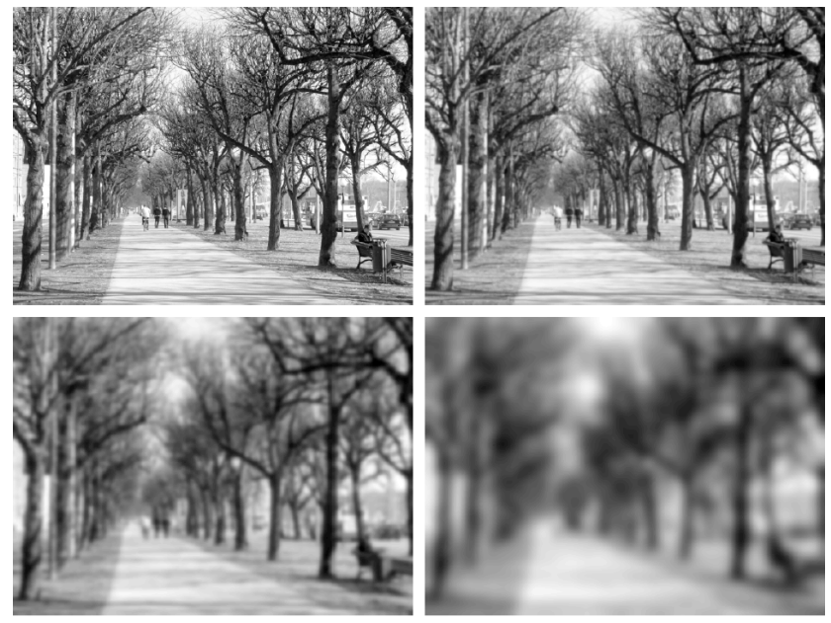
Figure 8 - Scale-space representation of an image. Original gray-scale image and computed family of images at scale levels t = 1, 8 and 64 (pixels) [13].
Different applications are subjected to different transformations. For example, wide baseline stereo matching and location recognition projects despite usually benefiting from scale and rotation invariance methods, full affine invariance is particularly useful. Affine-invariant detectors are equally effective to consistent locations affected by both scale and orientation shifts but also react steadily to deformations in affinity, like significant viewpoints changes Affine invariance can be achieved by applying an ellipse to the auto-correlation matrix, followed by the use of the principal axis and ratios of this application as the affine coordinate frame. Another alternative possibility is to detect maximally stable extremal regions (MSERs) through the generation of binary regions by thresholding the image at all possible gray levels. Unfortunately this detector is obviously only suitable for grayscale images.

Feature Description
Once a set of features or keypoints is identified, the immediate logical step is the matching phase, where the corresponding keypoints from different images are connected. Just like the ideal keypoint detector should identify salient features such that they are repeatedly detected despite being affected by transformations, likewise should the ideal descriptor be able to acquire their intrinsic fundamental and characteristic information content, so that the same structure can be recognized if encountered. Depending on the type of situations that is at work, different methods are more efficiently applied. The sum of squared differences (normalized cross-correlation) method is adequate for comparing intensities in small patches surrounding a feature point, in video sequences and rectified stereo pairs image data. Nevertheless, for the majority of the other possible cases, the local appearance of features suffers orientation and scale changes, as well as affine deformations. For this reason, before proceeding for the of constructing the feature descriptor, it is advisable to make an additional step comprising of extracting a local scale, orientation or affine frame estimate in order to resample the patch. This provides some compensation for these changes, yet the local appearance will still differ between images, in most cases. For this reason some recent efforts have been made to improve invariability to the keypoint descriptors. The main methods, detailed in [7] are the following: Bias and gain normalization (MOPS), Scale-invariant feature transform (SIFT), Gradient location-orientation histogram (GLOH) and Steerable filters.
With this in mind a descriptor can be defined as a structure (usually in the form of vector) to store characteristic information used to classify the detected features in the feature detection phase [6]. Nowadays, a good feature descriptor is one that not only classifies sufficiently well a feature but also distinguishes a robust and reliable feature, invariant to distortions, from a weaker feature that might originate a dubious match.
This world of feature descriptors is very dynamic continuing to grow very rapidly with newer techniques being proposed regularly, with some of the latest based on local color information analysis. Also, most of them tend to optimize for repeatability across all object classes. Nevertheless, a new approach is arising towards the development of class- or instance-specific feature detectors focused on maximizing discriminability from other classes [7].

Feature Matching
Having extracted both the features and their descriptors from at least two images, it’s possible to connect the corresponding features in those images (Figure 9). This process can be divided into two independent components: matching strategy selection, and the creation of efficient data structures with fast matching algorithms.
In the matching strategy is determined which feature matches are appropriate to process depending on the context the matching is made. Considering a situation where two images have considerable superposition, the majority of the features of one of the images has a high probability of having a match in the other, but due to the change in of the camera viewpoint, with the resulting distortions mentioned earlier, some features may not have a match since they can now be occluded or their appearance changed significantly. The same might happen in another situation where there are many known objects but piled confusingly in a small area, originating also false matches besides the correct ones. To overtake this issue efficient matching strategies are required.
As it is expected, several approaches for efficient matching strategies exist, although most of them are based on the assumption that the descriptors use Euclidian (vector magnitude) distances in feature space to facilitate the ranking of potential matches. Since some descriptor parameters (axes) a more reliable than others is usually preferable to re-scale them by computing their variation range against other known good matches, for example. The whitening process is a broader alternative approach, although much more complex, implicating the transformation of the feature vectors into new scale basis [7].
In the context of an Euclidian parameterization, the most elementary matching strategy is to define an adequate threshold above which the matches are rejected. This threshold should be very carefully chosen to avoid, as much as possible, either false positives – wrong matches accepted, resulting from a too high threshold – , or false negatives – true matches rejected due to a too low threshold. In opposition there are also true positives and negatives, which can also be converted to rates in order to compute accuracy measurements and the so-called receiver operating characteristic (ROC) curves to evaluate eventual good matches [7].
These matching strategies are most common in object recognition where there is a training set of images of known objects that are intended to be found. However, it is not unusual to simply be given a set of images to match, for instance in image stitching tasks or 3D modeling from unordered photo collections. In these situations, the best simple solution is to compare the nearest neighbor distance to that of the second nearest neighbor.
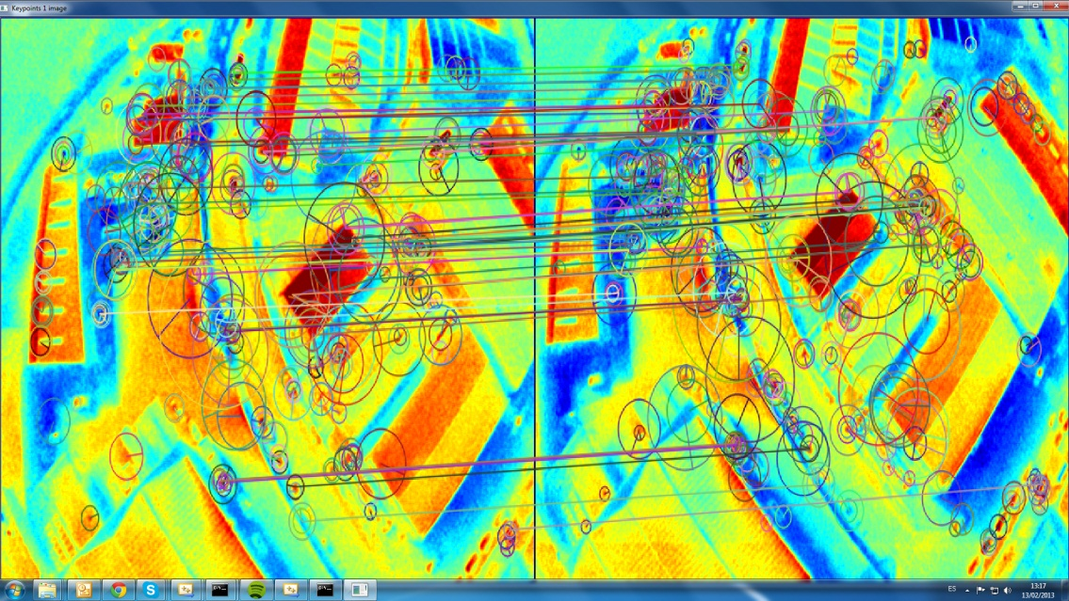
Figure 9 – Feature matching in two consecutive thermal images.
Chosen the matching strategy, it still has to be defined an efficient search process for the potential candidates found in other images. Comparing each and every keypoint of every image would be extremely inefficient, since typically for the majority of projects it results in a quadratic function process. Therefore, applying an indexing structure such as a multi-dimentional search tree or a hash table to quickly search for features near a certain feature is usually a better option. Some popular examples of these approaches are the Haar wavelets hashing, locality sensitive hashing, k-d trees, metric trees and Best Bin First (BBF) search, among others.

Matching Algorithms
As we seen in chapter 3 there are many options of methods and techniques available, and even more are being proposed, whether they be new or improved versions. The intrinsic idea behind the latest algorithms is to focus on applications with either strong precision requirements or alternatively computation speed. Besides SIFT approach, which is regarded as one of the highest quality algorithms presently available although with considerable computational cost, other algorithms with a more time efficient architecture have recently been proposed. For example, by combining the FAST keypoint detector with the BRIEF approach to description it is obtained a much quicker option for real-time applications, although is less reliable and robust to image distortions and transformations. Another similar algorithm SLAM, with focus on real-time applications that need to employ probabilistic methods for data association to match feature.
Taking advantage of SIFT’s robustness, it was built an improvement based on a reduction of dimensionality, from a 128 dimensions to a 36 dimensions, called PCA-SIFT descriptor. This in fact resulted in a speedier performance but at a cost of distinctiveness and slowing, on the other hand, the description formation, which overall almost eliminates the increased speed by the reduction on the dimensionally. Another descriptor from the family of SIFT-like methods, GLOH also primes for its distinctiveness but is even heavier than SIFT itself, in terms of computation. The Binary Robust Independent Elementary Features (BRIEF) is a recent descriptor conceived to perform very fast because is constituted by binary a string that stores the outcomes of simple comparisons of image intensity at random pre-determined pixels. But like PCA-SIFT and GLOH, it suffers from shortcomings regarding image rotation and scale changes, limiting its use to general tasks, even though its simple and efficient design.
A recent speed-focused matching descriptor that has been attracting a lot of attention is the Speeded-Up Robust Features (SURF) algorithm. Its detector built on the determinant of the Hessian matrix (blob detector) and a descriptor based in the summing Haar wavelet responses at the region of interest yields both proven robustness and speed.
One of the newest methods developed has been demonstrated to have a comparable performance, to the established leaders in this field such as SIFT and SURF with less computational costs. The Binary Robust Invariant Scalable Keypoints is inspired in the FAST detector in association with the assembly of a bit-string descriptor from intensity comparisons retrieved by dedicated sampling of each keypoint neighborhood. In addition, as its name indicates, scale and rotation transformations are very well tolerated by its algorithm [14]. In a certain way, it can be said that BRISK combines efficiently the best characteristics of some of the most distinct tools and methods available in the field (FAST, SIFT, BRIEF) into a robust extraction and matching algorithm.
In parallel with the research of these matching methods, some comparison work is also being done to evaluate the performance of the various algorithms. But most of the mentioned detectors and descriptors are originated from the Computer Vision community that, although seeking the best performance over all applications, tend to be more frequently tested in close-range photogrammetry projects. There is still plenty of room for experimenting these algorithms with more medium-range or long-range imagery set such as aerial photogrammetric missions (either in conventional or UAV platforms) or even satellites, although some work as already been made [15].

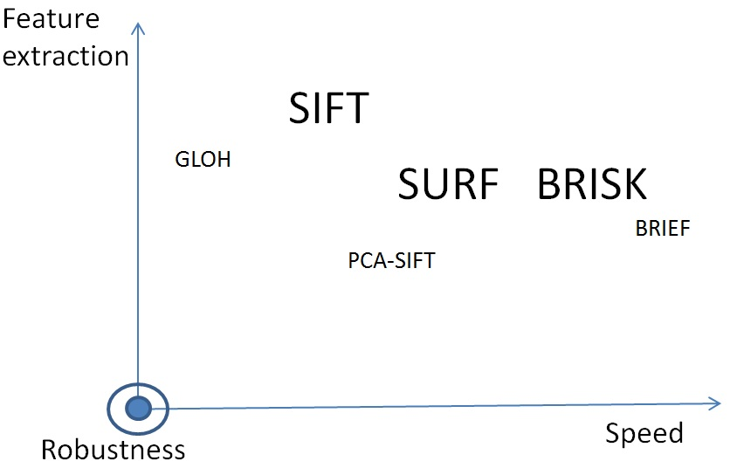
Figure 10 - Map of some of the most well-known matching algorithms according to their speed, feature extraction and robustness.

Given the previously exposed about some of the main matching algorithms in the field and their availability as open source routines were chosen three of them to make a brief comparison: SIFT, SURF and BRISK.
In the context of this document, these popular algorithms will be described with a bit more detail, in order to make a comparison between them with a UAV obtained photogrammetric data. This brief analysis will be based on their open source implemented routines available from OpenCV community, written in C++.

Scale-Invariant Feature Transform
The name of this approach derives from the base idea behind it which is that it converts image data into coordinates invariant to scale of local features. Its computational workflow is composed of four main phases.
The first step is the scale-space extrema detection where a search for keypoints is performed at all scale levels and image locations that can be repeatedly assigned under differing views of the same object. One of the most efficient implementations is using a difference-of-Gaussian functions (DoG) convolved with the image.
Figure 11 depicts one efficient approach to build the DoG. The original image is progressively smoothed by convolution using Gaussian functions to generate images set apart by a constant factor k in each octave of the scale space. An octave is family of smoothed images with the same resampling dimension, half of the precious octave. Each pair of adjacent images of the same scale level are then subtracted to originated the DoG images. When this process is done in the first octave, the next octave of half-sampled Gaussian family of images, by taking every second pixel of each row and column, is then processed until the last level of the scale space. The detection of local extrema (maxima and minima) of the DoG is done by comparing each sample pixel to its immediate neighbors, of its own image and also the ones from the adjacent scale, above and below, that amount for 26 neighbors in three 3x3 regions. This way the keypoint candidates are identified.
The next stage is the keypoint localization where each keypoint location, scale and ratio of principal curvatures is analyzed. If the keypoint candidates present low contrast (meaning that are sensitive to noise) or poor localization along an edge they are discarded, leaving only the most stable and distinctive candidates.
Orientation assignment is the third phase. This task is fundamental to achieve rotation invariance. The first step is to use the scale of the corresponding keypoint to choose the Gaussian smoothed image with the closest scale to guarantee that the computations are made in scale-invariant manner. Then for each image sample, at the adequate scale, are calculated the gradient magnitude and orientation using pixel differences. With this information at each pixel around the keypoint, a 36 bins orientation histogram is constructed, to cover the 360 degrees range of possible orientation values. Additionally, each sample of points used in computation of the histogram is weighted by its gradient magnitude and by a Gaussian-weighted circular window. The highest bins of this histogram are then selected as the dominant orientation of the local gradients.
At this point, every keypoint have already been described in terms of location, scale and orientation. The fourth and final main stage is the construction of the keypoint descriptor. The descriptor vector summarizes the previous computed information over the 4x4 sub-regions into a 2x2 descriptor array where the size of the arrows represent the sum of the gradient magnitudes near that direction within the region (Figure 12). The descriptor is constructed from a vector that stores the values of all the orientation histograms entries. Finally the feature vector is tweaked to partially resist the effects of illumination change, by normalizing the vector to unit length and also by thresholding its gradient values to be smaller than 0.2 and renormalizing again to unit length.
To search for a matching keypoint from the other images SIFT uses a modified k-d tree algorithm known as Best-bin-first search method that identifies the nearest neighbors with high probability. This probability of a correct match is calculated by the ratio of distance from the closest neighbor and the second closest. The matches that have a distance ratio greater than 0.8 are discarded, removing 90% of the false matches but only rejects 5 % of correct matches. But since this search method can be somewhat computationally slow, this rejection step is limited to the first 200 nearest neighbor candidates verification.
SIFT also searches for common clusters of features that can be very hard to obtain a reliable keypoint because it originates many false matches. This problem can be surpassed using a hash table implementation of the generalized Hough transform. This technique filters the correct matches from the entire set of matches by identifying subsets of keypoints that agree on the object and its location, scale and orientation in the new image. This way is much more probable that any individual feature match will be in error than several features will agree on the referred parameters.
For every cluster with a minimum of 3 features that agree on an object and its pose is the further analyzed by a two-step verification. Initially a least-squares estimate is made for an affine approximation of the object pose, where any other image feature consistent with this pose is identified while the outliers are rejected. Finally, a detailed computation is performed to evaluate the probability that a certain set of features pinpoints the presence of an object according to the number of probable false matches and the accuracy of fit. The object matches that successfully pass all these trials are then identified as correct with high confidence [16].

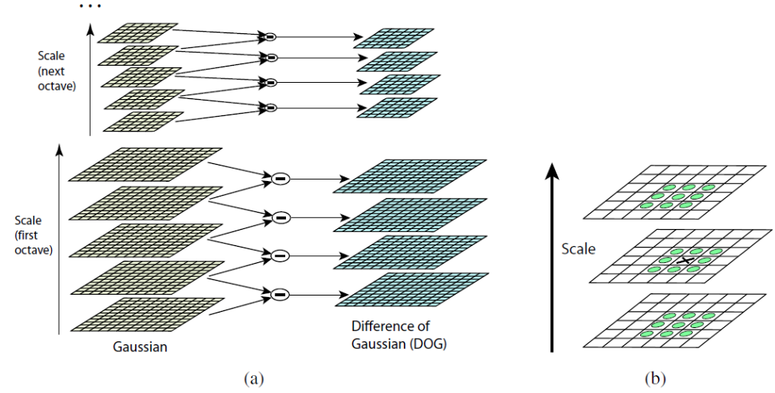
Figure 11 – Feature detection using Difference-of-Gaussians in each octave of the scale-space: a) adjacent levels of a sub-octave Gaussian pyramid are subtracted, generating a difference-of-Gaussian images; b) extrema in the consequent 3D volume are identified by comparison a given pixel and its 26 neighbors [16].

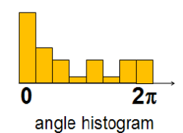

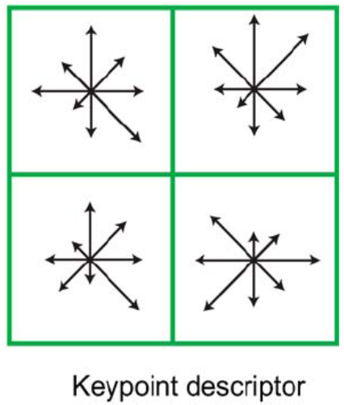
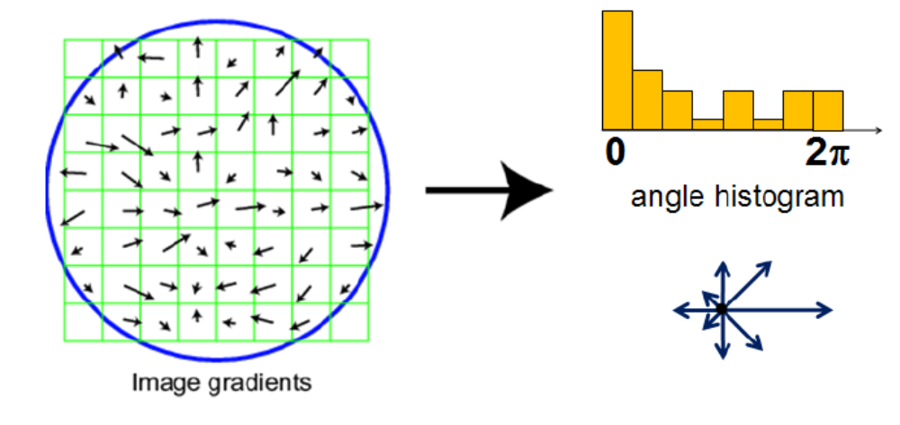
Figure 12 - Computation of the dominant local orientation of a sample of points around a keypoint, with an orientation histogram and the 2x2 keypoint descriptor [16].

Speeded-Up Robust Features
This detection and description algorithm is focused in superior computational speed, while at the same time maintaining a robust and distinctive performance in the task of interest point extraction, comparable to the best methods available currently. This algorithm can be seen as a SIFT variant that uses box filters to approximate the derivatives and integrals from SIFT [7].
SURF’s significant gains in speed are due to the use of a very simple Hessian-matrix approximation combined with the innovative inclusion of integral images for image convolutions. Integral images is a concept that computes very quickly box type convolution filters. An integral image $I_{Σ}\left(X\right)$ in a location $X={(x,y)}^{T}$ represents the sum of all pixels in the input image I inside a rectangular region constituted by the origin and x:
$$I_{Σ}\left(X\right)=\sum_{i=0}^{i≤x}{\sum_{j=0}^{j≤y}{I(x,y)}}$$

With the integral image, the calculation of the total intensities of a rectangular area is only three additions away (Figure 13); therefore the computation time is not dependent on its dimension. Since there will be used big filter sizes, this is extremely convenient. The Hessian matrix, in X at scale σ is can be represented as follows [17]:

$$H\left(X,σ\right)=\left[\begin{matrix}L_{xx}(X,σ) & L_{xy}(X,σ) \\ L_{xy}(X,σ) & L_{yy}(X,σ)\end{matrix}\right]$$

where $L_{ij}(X,σ)$ is the convolution of the Gaussian second order derivative with the image I in point X.
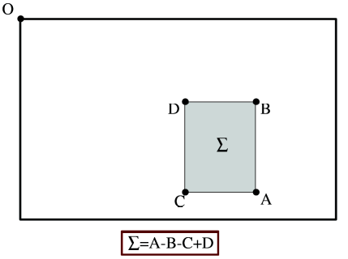
Figure 13 - Integral images make possible to calculate the sum of intensities within a rectangular area of any dimension with only three additions and four memory accesses [17].
The feature detection technique used is inspired on the Hessian matrix due to its good accuracy. This detector searches for blobs features in locations where the determinant is maximum. The reason to use Gaussian functions is that they are known to be optimal for scale-space analysis. Although, in practice they need to be discretized and cropped which results in reduced repeatability under image rotations around odd multiples of π/4. In fact this is a general vulnerability of Hessian-based detectors. However, the advantage of fast convolution due to the discretization and cropping still compensates largely the small performance decline. The Hessian matrix is approximated with box filters because the evaluation of such approximation responds particularly efficiently with an integral image evaluation. The resulting approximated determinant represents the blob response in the image at location X, whose responses are mapped along different scales so that maxima can be identified.
Scale-spaces are usually implemented as an image pyramid like SIFT does. But taking advantage of its integral images and box filters approach, the scale-space is inspected by up-scaling the filter size rather than iteratively reducing the image size. This implementation avoids aliasing but, on the other had box filters preserve high-frequencies components that can vanish in zoomed-out scenes, which can limit invariance to scale.
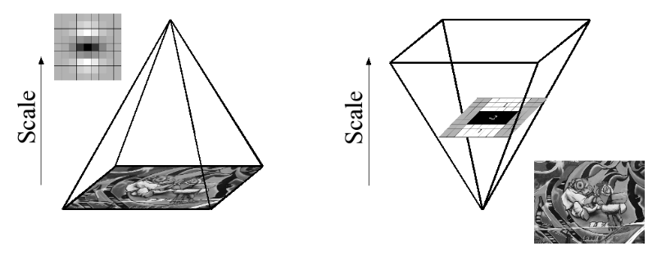
Figure 14 - Integral images enables the up-scaling of the filter at constant cost (right), contrary to the most common approach of smoothing and sub-sampling images in the (left) [17].
Like SIFT, the scale-space is divided into octaves, but in the case of SURF the images are kept at the same size; the filters are the elements that vary, increasing in size. Each successive level implies an increase of the filter size by a minimum of 2 pixels to guarantee an uneven size so that it maintains the existence of a central pixel. In consequence, the total increase of the mask size is 6 pixels, as it is represented in Figure 15. The first level (smallest scale) uses a 9x9 filter, where blob responses of the image’s smallest scale are calculated. For each new octave, the size increase of the filter is doubled, 6 to 12 to 24 and so on. Simultaneously, the sampling intervals for the extraction of interest points can be doubled also to reduce the computation cost. The resultant loss in accuracy is similar to the traditional image sub-sampling approaches.
Usually is enough to analyze just the first three octaves because the number of detected interest points per octave diminishes very quickly.
The localization of interest points in the image and throughout scales is made applying non-maximum suppression in a 3x3x3 neighborhood. The maxima of the determinant of the Hessian matrix are afterwards interpolated in scale and image space with the invariant features from interest point groups method [18]. The interpolation procedure of the scale-space is crucial because the scale difference between the first layers at every octave is moderately large.

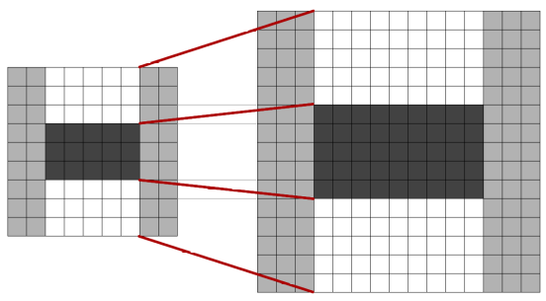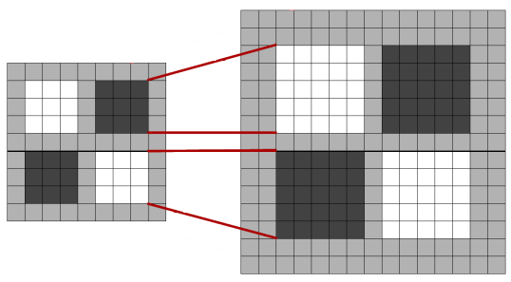
Figure 15 – Approximations of the discretized and cropped Gaussian second order derivatives (filters) in yy- and xy-directions, respectively (smaller grid), in two successive scale levels (larger grids): 9x9 and 15x15 [17].
SURF’s descriptor is inspired in gradient information extraction of SIFT approach describing the distribution of the intensity content in the neighborhood of the interest points. But instead of the gradient the distribution is built on first order Haar wavelet responses in x and y direction (dx, dy) taking advantage of integral images speed, with just 64 dimensions. The Haar wavelets responses are also weighted with a Gaussian function. This plan permits to attribute an estimated dominant orientation, to achieve rotation invariance, by computing the sum of all responses within a sliding orientation window of size π/3. Both vertical and horizontal responses are summed to obtain a local orientation vector and the longest one is assign as the prevalent orientation of the interest point. This step is followed by the construction of an oriented quadratic region centered in the interest point. The descriptor is formed by a 2x2 regions grid, each of them sub-divided into 4x4 sub-regions, preserving spatial information. Every sub-region is then subjected to a calculation of the Haar wavelet responses at 5x5 regularly spaced sample points. Afterwards, the wavelet responses dx and dy are summed in each sub-region to form the first elements of the descriptor vector v. Additionally, the absolute values of the responses are also summed to increment in the descriptor vector the information of the polarity of the intensity changes. Consequently, each 2x2 sub-regions have a four dimensional vector v to represent its respective intensity structure of the form $v=\left(\sum{dx}, \sum{dx},\sum{\left|dx\right|}\sum{\left|dy\right|}\right)$. Since there are 16 sub-regions, the descriptor vector has a length of 64. Converting this vector to a unit vector is obtained invariance to contrast (a scale factor). Furthermore, it is invariant to bias in illumination and less sensitive to noise.

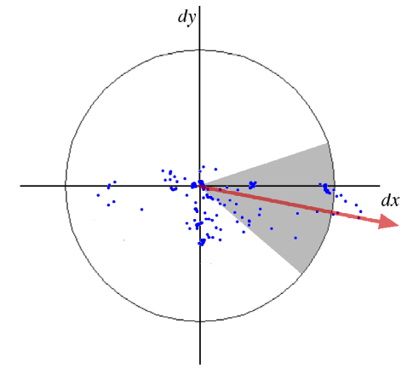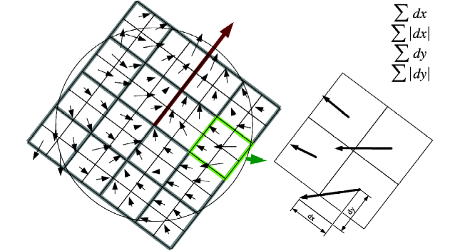
Figure 16 – Estimation of the dominant orientation of the Gaussian weighted Haar wavelets (left). Descriptor grid and the four descriptor vector entries of every 2x2 sub-regions [17].

The final step in SURF’s algorithm is the matching that uses a new fast indexing method based on the sign of the Laplacian (trace of the Hessian matrix) for the underlying interest point. With it bright blobs in white backgrounds are distinguished from the reverse situation, at no additional computational cost since it was already determined in the detection stage. In this matching phase only is made the comparison of the features with same contrast, therefore this small operation accelerates the matching maintain the descriptor’s performance.

Binary Robust Invariant Scalable Keypoints
The feature detection stage of this recent algorithm is inspired in the methodology of the AGAST detector [19], an accelerated extension of FAST. Scale invariance, which is fundamental for high-quality keypoints, is also a feature sought be BRISK. However, BRISK goes even further as it searches for maxima in the image scale and, on top of that, in scale-space with the FAST score s as a measure for saliency. The used discretization method at coarser intervals of the scale axis, compared to other leading detectors, doesn’t diminish BRISK’s efficient execution since it estimates the true scale of each keypoint in the continuous scale-space.
The scale-space framework is designed as a pyramid of n octaves c_{i}, formed by successively half-sampled images of the original one (c₀), as well as intra-octaves (d_{i}) between them. The initial intra-octave (d₀) is acquired by downsampling the original image with a factor of 1.5 while the rests of intra-octave layers are halfsampled. This means that if t is the scale, then t(c_{i}) = 2^{i} and t(d_{i}) = 2^{i} * 1.5.
The detector uses a mask with a minimum of 9 consecutive pixels in the 16-pixel circle to be sufficiently darker or brighter that the central pixel, in order to satisfy the FAST criterion (Figure 17). This FAST9-16 detector is applied on each octave and intra-octave independently with a threshold to identify to identify candidate regions of interest. Afterwards, the points within these regions are filtered with a non-maxima suppression in scale-space. This is done by, in the first place, check if those points are a maximum with respect to its 8 neighboring FAST scores s, which is the maximum threshold that considers a point as a corner. Then, the same is done with scores in the lower and higher layers. Some adjacent layers have distinct discretizations, so it might be needed to implement an interpolation to the boundaries of the patch [14].
For each maximum, a sub-pixel and continuous scale refinement is performed because image saliency is considered a continuous quantity not just along the image but in scale dimension as well. To simplify the refinement process, firstly is fitted a 2D quadratic function in the least squares sense of each of the three scores-patches culminating in three sub-pixel refined saliency maxima. The reason to use a 3x3 score patch is due to the fact that it avoids significant resampling. After this refinement of the scores, they allow to fit a 1D parabola along the scale axis to obtain the final score and scale estimate at its maximum. The last step in detection phase is to re-interpolate the image coordinates between the patches in the adjacent layers to the determined scale.

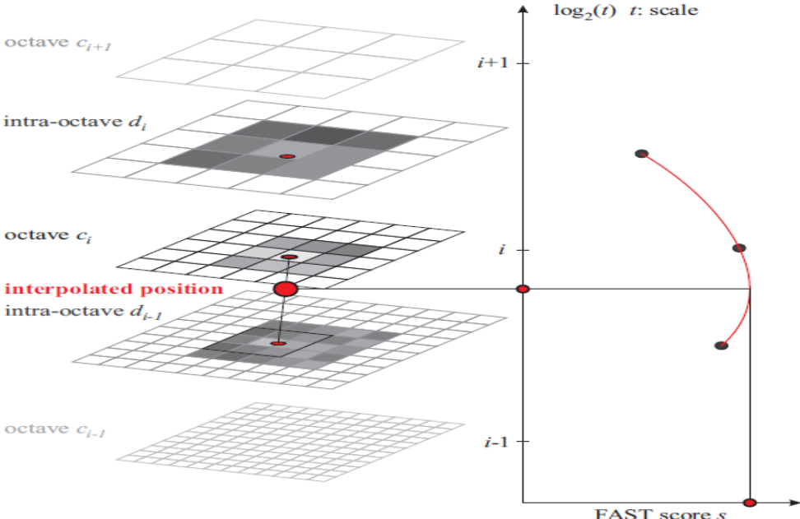
Figure 17 - Scale-space framework for detection of interest points: a keypoint is a maximum saliency pixel among its neighbors, in the same and adjacent layers [14].
BRISK descriptor has an efficient binary string nature, integrating the results of simple brightness comparison trials. As it is a fundamental feature in every recent robust matching algorithm, rotation invariance is also taken into consideration by BRISK. Making use of the sampling pattern of the keypoint vicinity (Figure 18), N equally spaced locations on circle concentric with keypoints are defined. In this kind of procedures, aliasing effects can occur. To prevent that BRISK implements smoothing process using Gaussian functions with standard deviation σ_{i}, proportional to the distance between the points on the respective circle.
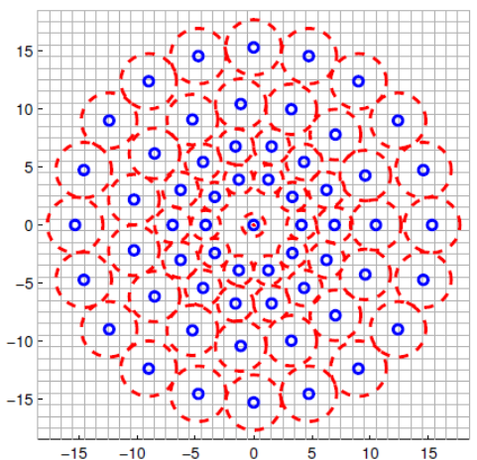
Figure 18 - Sampling pattern with 60 locations (small blue circles) and the associated standard deviation of the Gaussian smoothing (red circles). This pattern is the one with scale t = 1 [14].
Considering one of the N.(N-1)/2 sampling-point pairs (p_{i},p_{j}), the smoothed intensity values in these points are I(p_{i}, σ_{i}) and I(p_{j},σ_{j}), respectively, are used to estimate the local gradient g(p_{i},p_{j}) with the following equation:

$$g\left(p_{i},p_{j}\right)=\left(p_{j}-p_{i}\right).\frac{I\left(p_{j}, σ_{j}\right)-I(p_{i}, σ_{i})}{{\left\|p_{j}-p_{i}\right\|}^{2}}$$

Considering also as A the set of all sampling-point pairs, and the subsets S’ and L’ for the pairings with distance inferior to a σ_{max} (short-distance pairs) and superior to σ_{min} (long-distance pairs), respectively, can be written the following equation:
$$g=\left(\begin{matrix}g_{x} \\ g_{y}\end{matrix}\right)=\frac{1}{L}.\sum_{\left(p_{i},p_{j}\right) ∈ L’}{g\left(p_{i},p_{j}\right)}$$

that represents the estimated overall characteristic pattern direction of the keypoint k. The calculation is done iterating through the points pairs in L’. The threshold distance to define the subsets S’ is σ_{max} = 9.75t while L’ is σ_{min} =13.67t, being t the scale of k). The idea to behind the long-distance pairs is the assumption that local gradients neutralize each other and therefore are not needed in the global gradient determination.
For the construction of the rotation and scale-normalized descriptor, BRISK rotates the sampling pattern by an angle α = arctan2(g_{y},g_{x}) around keypoint k. The binary vector descriptor is built by performing all the short-distance intensity comparisons of the rotated point pairs $\left({p_{i}^{α},p}_{j}^{α}\right)$ from the subset S’. This way the bit b is given by:
$$b=\left\{\begin{matrix}1, I\left(p_{j}^{α},σ_{j}\right)> I\left(p_{i}^{α},σ_{i}\right) \\ 0, otherwise\end{matrix}, \right.∀\left({p_{i}^{α},p}_{j}^{α}\right) ∈S'$$

This sampling pattern and these sampling thresholds create a bit-string of length 512.
With its binary nature, matching two BRISK descriptors is quite a straightforward computation of their Hamming distances: the difference of the number of bits between them is the measure of their dissimilarity. The inherent operations are simply a bitwise XOR followed by a bit count.

Camera calibration Process
A camera can be defined as an optic sensor that transforms the three-dimensional world into a two-dimensional representation of it. In projects such as aerial photogrammetric missions where the two-dimensional representation of the real world is expected to be as accurate as possible, it is very important to know in detail the how the sensor makes that transformation. Inevitably there are distortions from several sources that occur when a camera generates a picture. The process that enables the knowledge these distortions in a given camera sensor is known as calibration.
The two main types of calibration: pre-calibration and self-calibration. Pre-calibration can be defined as a separate procedure performed before and independently of any actual mapping data collection,. In rigor, pre-calibration can assume two forms: laboratory calibration and filed calibration. The first is performed using precise calibration, features or equipment indoors in a controlled environment a laboratory [20]. The latter is when a calibration procedure is performed “in the filed”, near the real operational environment before a data collection mission because the parameters determined in the laboratory, may not remain valid after a considerable time-lapse as passed, or if no laboratory calibration has been done. On the other hand self-calibration is a procedure calibrates the sensor together with the derivation of the orientation parameters with the data collected for production purposes.
It is generally considered two types of calibration. The physical-oriented approach attempts to comprehend and model the diverse physical origins of the sensor systematic errors, such as image, optics or CCD-matrix deformations. This idea goes back to the decades of 50 and 60 of the past century when the classical physical-oriented lab and self-calibration close-range photogrammetry models were developed. These models, that extend the colinearity equations with the self-calibration functions, were widely implemented to the calibration of airborne small and medium-format cameras. The numerical oriented self-calibration approach recognize the complexities of image deformations and instead of comprehend it, attempts only to blindly model it with a truncated orthogonal base of some functional space. This ideology has been and continues to determinant to the precise calibration of large-format cameras.
There are several different procedures and models for calibrating a camera sensor but two of the most well-known models are the Ebner Model and the Conrady-Brown Model.

Ebner model
The Ebner model is an efficient numerical-oriented self-calibration model. It is composed by bivariate polynomial functions Δx and Δy parametrized by the 12 coefficients b₁ ,…, b₁₂ also known as Ebner set or the “12 orthogonal Ebner set” [21]. These functions can be written as:
$$∆x= b_{1}x+b_{2}y-{2b}_{3}k+b_{4}xy+b_{5}l+b_{7}xl+b_{9}yk+b_{11}kl$$

$$∆y= -b_{1}y+b_{2}x+b_{3}xy-{2b}_{4}l+b_{6}k+b_{8}yk+b_{10}xl+b_{12}kl$$

being, $k= x^{2}-\frac{2}{3}b^{2}$ and $l= y^{2}-\frac{2}{3}b^{2}$
where b is the photo base that characterizes the image measurement distribution set.

Conrady-Brown model
The Conrady-Brown function models the Seidel aberrations and is the leading reference of the physical-oriented approach [21]. The five Seidel aberrations are spherical, coma, astigmatism, curvature of field and distortion. The first four affect the image quality but instead the distortion affects the position of an image point in the image surface. Distortion has two components, radial and decentering distortions. The Conrady-Brown function that compensates the radial and decentering distortions is given by [22]:
$$x_{L}=x+\hat{x}\left[k_{1}r^{2}+k_{2}r^{4}+k_{3}r^{6}\right]+\left[p_{1}\left(r^{2}+2{\hat{x}}^{2}\right)+2p_{2}\hat{x}\hat{y}\right]$$

$$y_{L}=x+\hat{x}\left[k_{1}r^{2}+k_{2}r^{4}+k_{3}r^{6}\right]+\left[p_{1}\left(r^{2}+2{\hat{x}}^{2}\right)+2p_{2}\hat{x}\hat{y}\right]$$

where, $\hat{x}=x-x_{0}-δx_{0}$ , $\hat{y}=y-y_{0}-δy_{0 }$ and $r^{2}={\hat{x}}^{2}+y^{2}$, being (x₀,y₀) the coordinates of the camera’s principal point of symmetry, (δx₀,δy₀) are corrections to the possible errors of (x₀,y₀).
This model only recently have been applied to aerial photogrammetry and remote sensing, having previously been used primarily in close range photogrammetry [22].

Photogrammetric data processing software

Pix4UAV
Following the rapid growth of the civil light weight UAV market, Pix4UAV is one of the most well-known applications for automated survey and mapping products specialized in imagery obtained ultra-light UAV imagery.
Although UAV imagery are characterized for having relatively low accuracy of their image location and orientation estimates, it’s possible to obtain accurate results similar to those of traditional photogrammetric systems on board of conventional airplanes. This is done with the integration of fast and scalable computer vision techniques into photogrammetric techniques. Furthermore, its fully automated process and relatively simple design of the application enables most users – even those without any knowledge in photogrammetry, while providing a reduced labor cost and time expenditure to more experienced professional users. The final products generated are geo-referenced orthomosaic and Digital Elevation Model with or without ground control points, although using GCP yields more accurate results [23].
Besides the traditional desktop solutions, Pix4UAV also provides a web-based service (Pix4UAV Cloud) capable of processing up to 1000 images.
The general workflow adopted by Pix4UAV starts with a matching points search and describing them with a binary descriptor similar to the LDAHash [7]. The second step is to perform a bundle block adjustment, from the found keypoints and the estimated image position and orientation given by the UAV navigational instruments, to reconstruct the correct position and orientation of the camera for all images. Thirdly, the 3D coordinates of the verified matching points are computed from that reconstruction. Afterwards, it’s performed an interpolation on those 3D points to construct a triangulated irregular network in order to obtain a DEM. If a dense 3D model has been computed in the previous steps the triangle structure can have an increased spatial resolution. Finally, the DEM is used to project the image and calculate the geo-referenced orthomosaic or true orthophotos [23].
There are five different versions of the software. Each of the above mentioned Cloud and Desktop versions have a 2D and 3D version, which as it can be deduced provide 2D maps and 3D models results. The Desktop version also enables post-processing mosaic editing and measurements tools as well as additional processing options. Desktop also comes in a so-called “Rapid” version which gives 2D results using rapid processing mode. The Cloud version has a free installation and unlimited test processings with a statistical preliminary report and also 3 free trials to download the final products available: geo-referenced orthomosaic, point cloud, 3D model, DSM and a collection of project parameters information.

PhotoScan
PhotoScan is an image-based 3D modeling software design to create professional-level three-dimensional products from still images. It uses the latest multi-view 3D reconstruction technology to be able to operate with arbitrary images and demonstrates the high efficiency not only with controlled conditions but also with uncontrolled conditions. It handles photos taken from any position, as long as the object to be reconstructed is visible on at least a pair of photos. Task such as image alignment and reconstruction of 3D models are entirely auto-operated by the software.
Normally, the main objective of image processing with PhotoScan is to create a textured 3D model which is a workflow that comprises three predominant phases:
The initial processing stage is the photo alignment. Once the images are loaded a feature detection and matching is performed. Additionally, the position of the camera for each is determined as well as the refined camera calibration parameters. As a result a sparse point cloud and the relative position of the photos are created. The point cloud is derived from the photo alignment but it doesn’t enter directly in the 3D modeling operation unless for the point cloud based reconstruction method. Nevertheless, it is possible to export it in order to be used in other data processing software packages, such as a 3D editor as a reference. By contrast, the camera positions are fundamental for the successful construction 3D model. At this point, can be included ground control coordinates to geo-reference the model and if necessary, convert them to a coordinate system of our choosing.
The second phase is to build geometry. With the information of the estimated camera positions and the photos it is generated a 3D polygon mesh of the object surface. To do this, PhotoScan provides four alternative algorithmic methods to implement it: Arbitrary (Smooth), Arbitrary (Sharp), Height field (Smooth) and Height field (Sharp). For less precise but faster processing there is also a Point Cloud based method for fast geometry generation that uses only the sparse point cloud. The built mesh might need to be edited and various correcting tools are available to meet that end: mesh decimation, detached components removal, mesh holes filling, are some of the most important of them. Similar to the point cloud exportation possibilities, this mesh can also be exported for more complex editing in external software, and imported back to PhotoScan, making it a very interoperable solution.
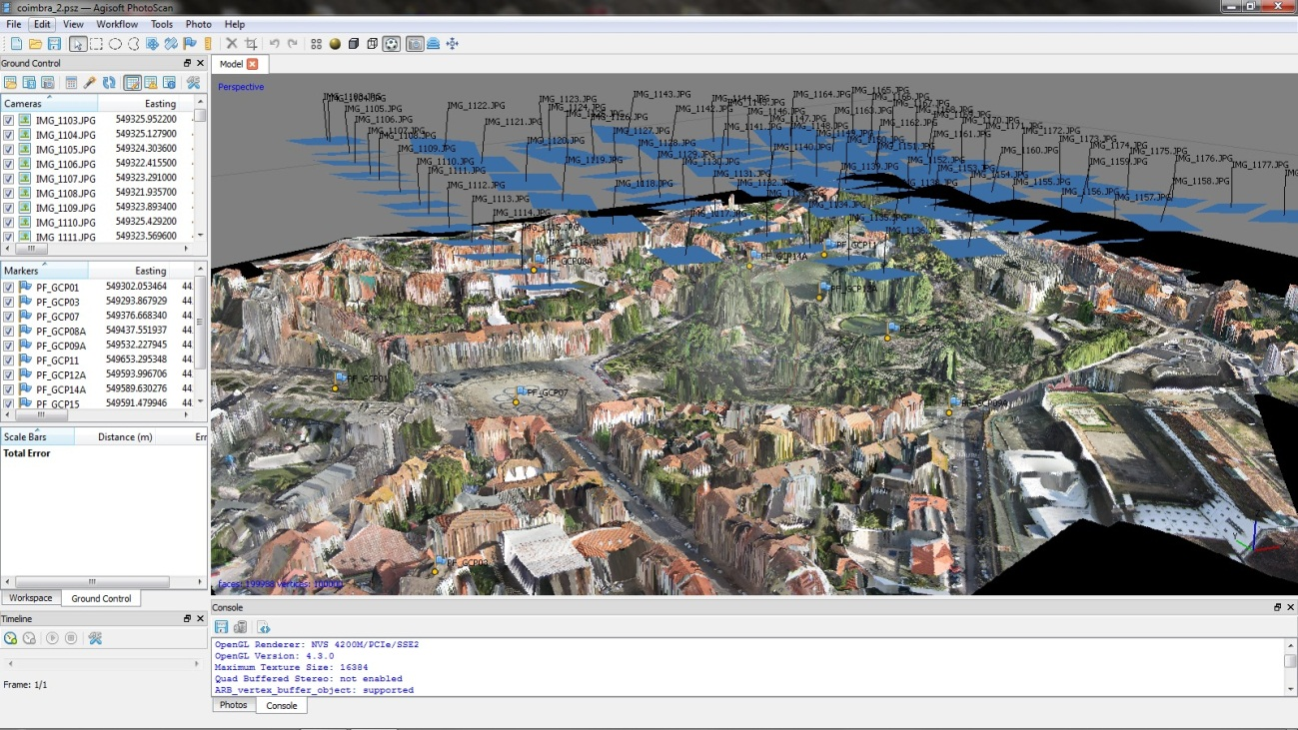
Figure 19 - PhotoScan environment with 3D model of Coimbra from image data set.
The third and final main step in PhotoScan’s workflow is the texturing and final products generation. After the geometric mesh construction texturing to 3D model can be applied to improve the visual quality of the final photogrammetric products such as the orthophoto and DEM generation. This step also provides several texture mapping modes. Apart from the Generic mode, there are also the Adaptive Ortophoto, Ortophoto, Spherical, Single Photo and Keep uv modes, designed for specific purposes. Besides creating the orthophoto in the most popular image file formats, there is also the possibility of exporting it to Google Earth kmz format.
Furthermore, PhotoScan can generate a project summary report. It is not a very detailed report but contains some of the most important statistics and figures to analyze the quality of the processing.

GENA
The Generic Extensible Network Approach (GENA) is a generic and extensible network adjustment software based on a robust non-linear least-squares engine [24]. In other words, is a software platform that optimally estimates unknowns in the sense of the least-squares. Although being at the moment best suited for geodetic networks, photogrammetric and remote sensing blocks (with the BASIC toolbox), GENA can also adjust any other types of networks given the appropriate toolboxes. Some more specific task that can be performed by GENA are, for example, geometric orientation and calibration of frame camera, LiDAR blocks, the combination of both and also trajectory determination [25].
GENA can be seen as two separate components: the runtime platform and the model toolboxes. The directly executable or callable runtime platform is dedicated to perform network adjustments while the toolboxes are solely constituted by the mathematical models for measurements (observation equations) and unknowns to be calculated (parameters), as well as the necessary instrument (constants), that instruct the adjustment engine with the model related information for a set of observables (measurement types). All of these input data must be organized in xml files which are then provided, together with the necessary modeling toolboxes, to the GENA runtime platform to execute the adjustment. A diagram of the software’s concept is found in Figure 20.

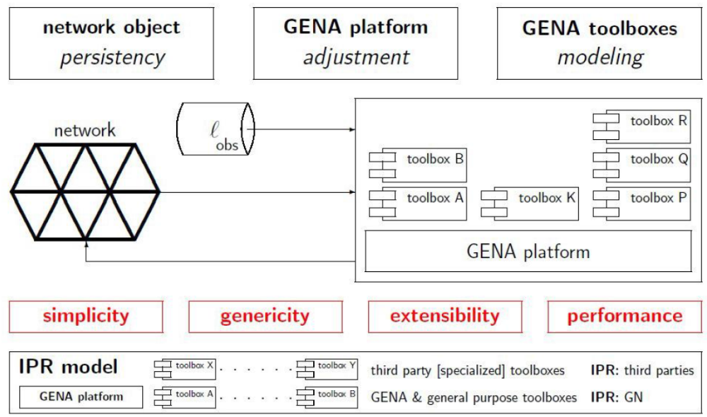
Figure 20 – GENA’s network adjustment system concept [25].

Furthermore GENA can function as a simulation tool, to help planning measurements campaigns, especially remote sensing sensors and multi-sensor systems.
With its Software Development Kit (SDK) GENA’s capabilities can be updated by creating new toolboxes [24].
Although it lacks a graphical interface, GENA generates an extremely detailed statistical report of the adjustments enabling a profound understanding of the data sets being studied.
In this project, besides the toolbox BASIC, will be used also the airVISION toolbox designed for airborne photogrammetry and remote sensing. This toolbox centers its attention on sensors that are operated from aerial platforms navigating within the space defined by the close-range line (100 m altitude) and the so-called Kármán line, usually regarded as the boundary between Earth’s atmosphere and the outer space (100 km). A particular characteristic of airVISION is that it doesn’t resort to orbit models to describe the orientation of sensors. Its broad scope of action allows airVISION to work with both manned and unmanned, whether they might be of small or large dimensions. Regarding sensor types, this toolbox is equally capable of supporting traditional large-format sensors, Laser Scanner (LiDAR) or small- and medium-format cameras. However, it is best suited for geometric optical sensors (visible, infra-red and ultraviolet light domains) and geometric optics.
Despite not being specifically made for close-range photogrammetry it can be used in kinematic close-range or terrestrial mobile mapping scenarios.
To work with GENA it is first necessary have one or several observations files (.obs), depending on the operators organizational preferences, were all the measurements, unknowns and instruments are stored. Besides these files there are also two options files (.op). The options_file.op that contains the observations, parameters, models and instruments files directories, as well as several adjustment control definitions. The second file is the options_lis_file.op, where it’s chosen the information to extract at the end. When all of this is set correctly, the adjustment is started by executing in a command window the following general command:

…>gena options_file.op options_lis_file.op

After the successful processing of the project three files are generated: a log file (log_file.log) that describes the steps executed, an error file (error_file.err) with a list of errors and warnings that occurred during the processing, and a network file (network.nwk) with the results of the adjustment. If no major errors or warning happen the network file information should be extracted in the form of a html/xml report to better analyze them, with the following generic command [25]:

…>gena_nwk_extractor network.nwk file

This network.nwk file is an archive that stores every input file observations, parameters, instruments and options files, as well the resulting output files generated in the adjustment. The final adjustment report is an extremely detailed report with many statistics and numerical tests for all groups of observations and parameters. In fact every individual observation and its properties are analyzed and shown in the report. Therefore, a typical complete report can have a few hundred pages, depending on the size of the network and the amount of observations and parameters that are processed. This data set for instance generated a report of almost 300 pages with a font size of 12. It is divided into five main sections: a Network executive summary, Input data and adjustment options selected, a Summary of network structure with the mathematical models used, observations, parameters and instrument types, reference frames and coordinate systems used, a Numerical Correctness of Solution where several tests are performed to the data, an Adjusted Residuals section with a list of residuals computed for all observations groups with the largest ones highlighted and an Adjusted Parameters section where parameters’ statistics are show as well as their adjusted values.

Data sets processing and results

Data set description
The data sets analyzed in this document was obtained in the 28th of January of 2013 in the Portuguese town of Coimbra. The flying platform used was a SenseFly Swinglet Cam, a lightweight UAV, equipped with a Canon IXUS 220 HS camera. This is, obviously, a small format camera, with 12 Mega pixels, 6.1976 mm by 4.6482 mm sensor and 4.34 mm focal length, which generate RGB, 4000 by 3000 pixels images with 24 bits per pixel. This information was retrieved by the EXIF data from the images themselves. We can also derive that the pixel size in the image is (6.1976/4000 = 4.6482/3000 =) 1.5494 µm.
With its integrated GPS/IMU navigational instruments, the Swinglet provides position (latitude, longitude and both ellipsoidal and orthometric altitude) and attitude (heading, pitch, roll). Given the low cost category of the instruments, the GPS modules C/A code receptor give measurements of several meters (around 5 to 10m) while the IMU accuracy shouldn’t be much better than about 5º) [26]. Additionally, the Swinglet also generates a log file with the times of the platform’s launch, landing, and the photos were taken, as well as, a kml file representation of the trajectory. In Figure 21 it’s possible to see the trajectory (in blue) followed by the UAV from the take-off and landing spot in a football field (spiral segment), as well as the first and last photo of each of the 7 strips and also the locations of the 9 ground control points (GCP) used. There are 76 images distributed in 7 strips, although it’s an uneven distribution: 14 in the first, third, fifth and seventh strips, 6 in the second and 7 in the fourth, 7 in the sixth. The images were originally named with the designations from IMG_1103 to IMG_1178.
The overlap between consecutive images is very variable. The longitudinal overlap, between successive images of the same strip, ranges from approximately 40% to 83%, being the average overlap of around 67%. Lateral overlap, between images of consecutive strips, ranges from around 10% to 64%, with an average overlap of about 43%. These values are only an estimate made by manually superimposing some consecutive pairs of raw, non-calibrated images in Google Earth.

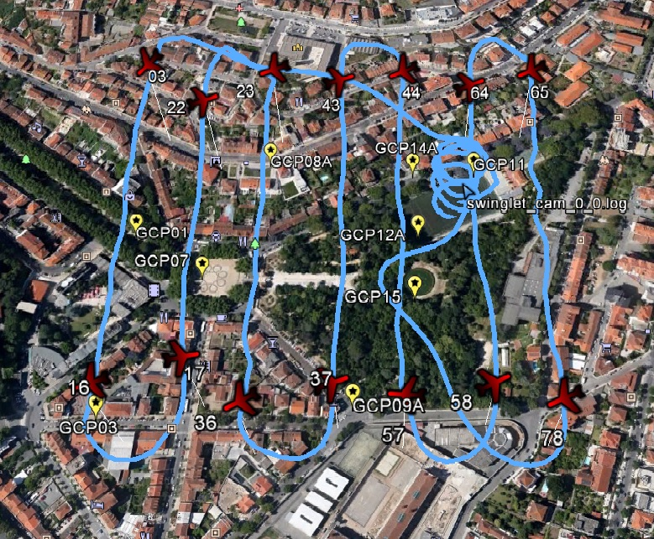
Figure 21 – Swinglet’s flight scheme above Coimbra: trajectory in blue, first and last photos of each strip in red and GCP in yellow.
The image position coordinates are given in geographical latitude and longitude referred to datum WGS84 while the GCP coordinates are in the Portuguese reference system PTTM06, referred to datum ETRS89, which is a Cartesian coordinate system. Therefore, in order to combine the measurements, it’s indispensable to use a common coordinate system. For convenience of further task to be performed in other software like Match-AT and GENA – specially the latter since it doesn’t have tool boxes to handle the Portuguese coordinates system – as well as for easier visualization of the data in programs like Google Earth it was decided to transform both coordinates to the Universal Transverse Mercator cartesian coordinate system. This was made using the well-known Proj.4 libraries, through the PROJ4 Visualizer software which has the added ability to graphically show the position of the transformed coordinates in maps, in order to verify them on the go.
We can also deduce from the GCP coordinates an estimate of the ground elevation of the area in question. The average altitude of the 9 GCP is 78.735 m and since the average flight altitude of the images positions is 193.484 m, then the average flight height of the UAV is about 115 m above the ground. Therefore, the pixel size in the ground should be approximately 3.9 cm.

OpenCV matching algorithms comparison
OpenCV is an open source computer vision and machine learning software library. Its objective is to supply a public repository of computer vision applications in order to stimulate the use of computer automatized capabilities to commercial products. Given its permissive free software licenced nature, OpenCV facilitates its utilization and modification of its code by businesses.
The library is composed of more than 2500 optimized algorithms, spanning the majority areas that comprise the world of computer vision. Some examples are face detection and recognition, object identification, camera movements tracking, generation of 3D models, stitch sets of images in mosaics, feature extraction and matching, among many others. One of its biggest strengths is the 47 thousand plus user community, whose crowdsourcing contributions is used intensively in companies, research groups and also governmental bodies. Although, being originally written in C++ and having a template interface that works with seamlessly with STL (standard template library) containers, OpenCV has also, C, Python and Java interfaces, and supports all major operating systems [27].
Taking advantage of this philosophy, it was assembled a small routine for processing a set of images to detect features and match them, using OpenCV libraries. This program and the OpenCV libraries (2.4.3 version) that it uses was compiled by Pere Molina from the Institute of Geomatics of Catalonia. After some minor additions to adapt it to process the Coimbra UAV flight images, it was tested and used to compare the performance of three feature matching methods with an aerial photogrammetric data set.
Besides the general detection and description, using SIFT, SURF and BRISK algorithms, the matching procedure was implemented using a Brute Force method, which a very simple direct comparison, and an additional matches filter to improve the matches selection. This “good matches filter” defines, from all the matches found, as good match only those whose descriptors have a distance (difference between their vectors) of 4 times a minimum distance. This verification is useful to reject false positive matches that although being similar are not so similar than other matches, and might not be correct.
The implementations of these algorithms in this version of OpenCV libraries are very customizable, allowing for the user to change its parameters depending on the purpose of use and to adapt it to different kinds of image sets. The used algorithms have the following changeable parameters [27]:
- SIFT(nfeatures=0, nOctaveLayers=3, contrastThreshold=0.04, edgeThreshold=10, sigma=1.6)
- SURF(hessianThreshold, nOctaves=4, nOctaveLayers=2, extended=true, upright=false )
- BRISK(thresh=30, int octaves=3, patternScale=1.0f)
Since the most of the default values are the original values from the authors of each algorithm these values were respected. Only the thresholds that should be adapted to the characteristics of each data set were changed and also the number of octaves used by SURF that should be also 3 instead of 4. In the documentation of these libraries there aren’t any indication of the ranges the thresholds should have according to the different types of data. Therefore, a series of tests were perform to evaluate the most adequate threshold. This evaluation was based on the information of Pix4UAV manual that indicates an ideal number of keypoints per image as 2000 and matches per image of around 1000, although 100 can also be an acceptable number of matches for one image in many cases. With this in mind several orders of thresholds were introduced so that the number of keypoints points and good matches were around the referred values. In case of SIFT was found that a possible sufficient combination of thresholds was 0.1 for the contrast threshold and 4 for the edge threshold. For SURF the hessian threshold should be around 5000 to yield the previous indicated keypoints and matches. And for BRISK, 75 could be its threshold.
Executing the program over each pair of consecutive images, it displays the number of keypoints detected per image, the number of matches found, the number of filtered (“good”) matches, and the times of feature extraction and the time needed to match corresponding keypoints. Additionally, the program also represents the image pair side by side with the linked good matches. An example can be seen in Figure 22.
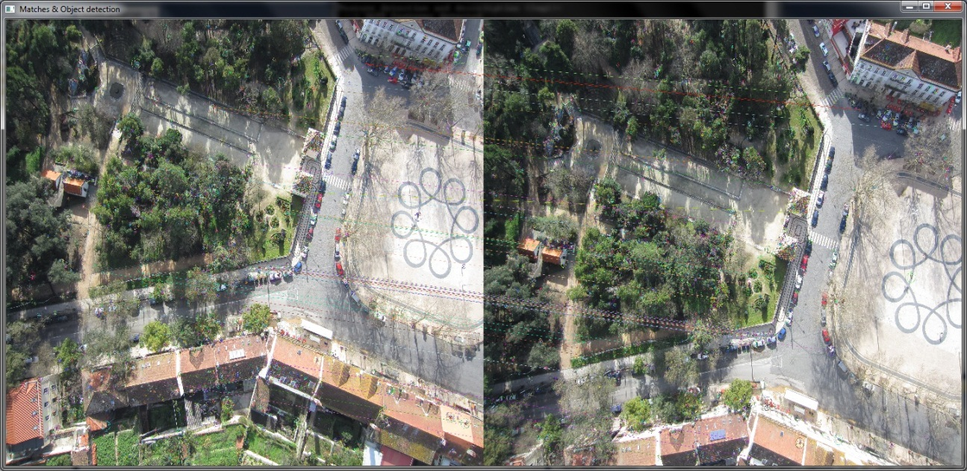
Figure 22 - Linked matches in two consecutive images of Coimbra data set.

Figure 23 - Average keypoints extracted and matched.
After executing the program with each of the algorithms the following results were obtained. In Figure 23 it is illustrated that for this data set, BRISK’s detector and descriptor extracted on average the highest keypoints per image of the three with 4731, a bit more that SIFT while SURF performed a bit worse extracting only 3026 on average. Therefore, SURF detector, seems to be the less efficient of the three. In terms of matches, the matching procedure of SIFT seems more efficient with 2448 average matches per image; BRISK was near this level with 2360 but SURF only linked 1568 on average of the keypoints found in each image pair. In terms of percentage of matches of the total features found, this represent an average 27.62% of matched keypoints per image pair for SIFT, 26.22% for SURF and 24.9% for BRISK. Despite, detecting more keypoints than the others BRISK’s keypoints were less successfully matched, which may indicate that BRISK’s descriptor might be slightly less robust or that its detector is too permissive in the moment to identify the points of interest, compared to SIFT and SURF. Still BRISK’s number of matched keypoints is similar to SIFT and much higher than SURF.
The matches filter used to define a “good match” shows that of the matches established by SIFT, 2448, only 523 are considered very good matches which is than a quarter of them. In the case of SURF, of the 1568 matches a little more than half are good matches while BRISK’s matches almost half of them are good.
Besides a robust feature extraction, computational speed is also another fundamental characteristic of a top algorithm. Figure 24 depicts the processing time needed by each method to match the keypoints of each pair of images. The time required to detect and describe keypoints by SIFT is 6.28 seconds which is slower of the three. SURF is slightly faster but BRISK is definitely the fastest by a big margin with only 0.62 seconds to identify and describe features. Concerning the time that takes to match the keypoints, SURF is the fastest but this we should remember that SURF also found less features so it is not surprise that it takes less time to match them. SIFT and BRISK are comparable but BRISK is a little faster even though it found a slightly bigger number of features.

Figure 24 - Average time of computation of extraction and matching stages (in seconds), per image pair.

Imagery Data sets analyzed

Pix4UAV processing and results

The creation of a new project is quite straight forward in Pix4UAV. Simply name the project, import the image files and coordinates both position and attitude (although attitude is not required) specifying the corresponding datum and coordinate system, and camera specifications. Additionally if there are GCP measurements available it’s necessary to import their coordinates and search the images for the locations of the points and click on them to create an image point. By importing their coordinates the program automatically searches the image set and sorts them taking in to account the closest images to the particular GCP that is selected.
This data set was processed using the Desktop 3D version. The processing options where Full in the Initial project processing step for higher accuracy and High 3D point densification step, without High Tolerance (useful in vegetation or forest areas) since the area is mainly an urban.
With this configuration the processing time took almost 4 hours in a system with a 2.8 GHz processor and 4Gb of RAM.
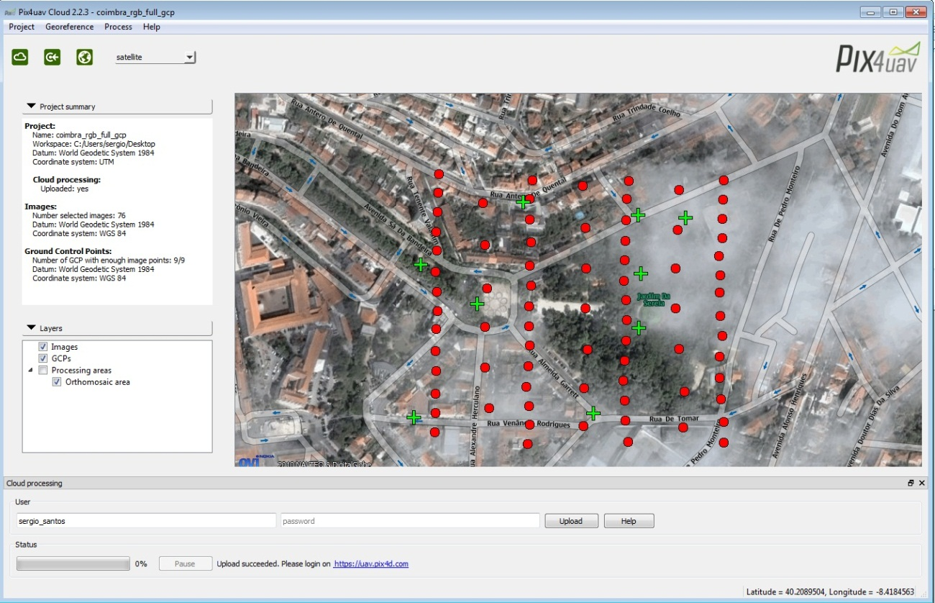
Figure 25 – Pix4UAV main processing window (red dots represent the position of the images and the green crosses the positions of the GCPs).
In the Quality report generated informs that the processing was successful as all the categories of the quality check were considered to be within good value ranges, as we see in Table 1.
31569 was the median of keypoints found per image while the median of matches per calibrated image was 3176, which are both much higher than the usually expected good values, 10000 and 1000, respectively. This means that the images have enough visual content to be processed. There aren’t large uniform areas (deserts, snow or fog), the camera is of decent quality and well configured and the weather conditions were good, avoiding over or under exposed, blurry or noisy images.
All of the images were calibrated in a single block, which indicates sufficient overlap between images and that sufficient matches were found not only among consecutive images but also between different groups of images allowing for a global optimization. If only less than 60% of the images were calibrated that could mean that the type of terrain would be not suitable to perform image calibration and generate DEM and orthomosaic, or that were some problem with the image acquisition process (wrong geo-tagging, inappropriate flight plan, corrupted images, for instance) or even some mistake in the project setup (such as wrong coordinate system or images).

 | Recommended | Obtained
Images | > 10000 | Median of 31569 keypoints per image
Dataset | > 95% | 76 out of 76 (100%)
Camera optimization | < 5% | 1.57% relative difference between initial and final focal length
Matching | > 1000 | Median of 3176 per image
Georeferencing | > 3 GCP | 9 GCP with 0.021 m
Table 1 - Processing quality check with the expected good minimum
Concerning the camera optimization, Pix4UAV performs a simple calibration process optimizing the initial camera model with respect to the images. It’s common that focal length is somewhat different for each project but the initial camera model should be within 20% of the optimized value so that the calibration process can be done quickly and robustly, which is the case in this project since the difference is 1.57%.
For having an adequate geo-referencing of the project it is necessary to use at least 3 GCP and should be well distributed, for best results. In this project were used 9 GCP reasonably well distributed with a calculated average error of 2.1 cm which is an acceptable error and below the computed Ground Sampling Distance (GSD) that is 3.8 cm as it is intended.
Images overlap is an important parameter for the overall quality of the 3D reconstruction in aerial photogrammetric surveying projects. Figure 27 shows the number of images overlapped for each pixel of the orthomosaic. Only the calibrated images are considered, but in this case are all of the images are taken into account. The image coverage of the area is quite good with practically only the borders have 3 or less overlapped images. More than 5 images overlap are necessary for a precise 3D modeling.
The bundle block adjustment was performed using a total of 239547 keypoints which generated 95306 3D points with a mean reprojection error of 0.0121322 pixels. The 3D point generation is done by triangulating together multiple 2D keypoints using the camera parameters.

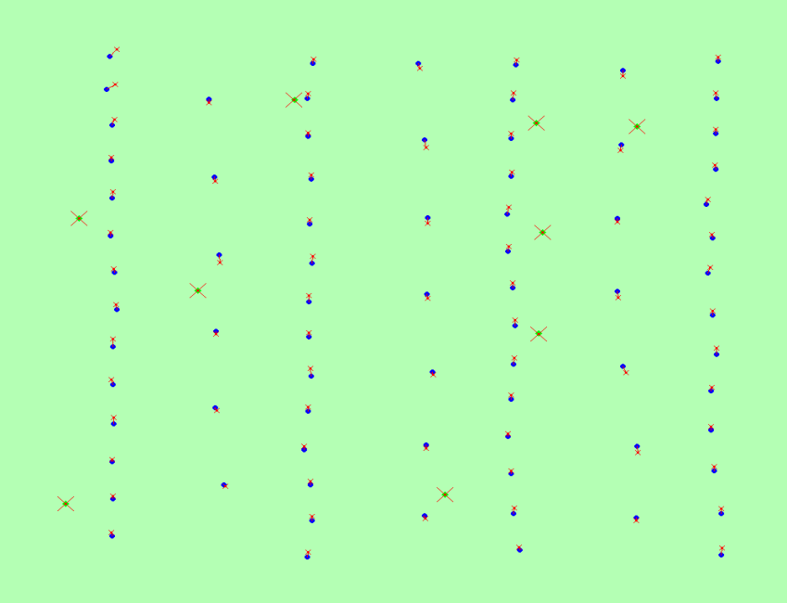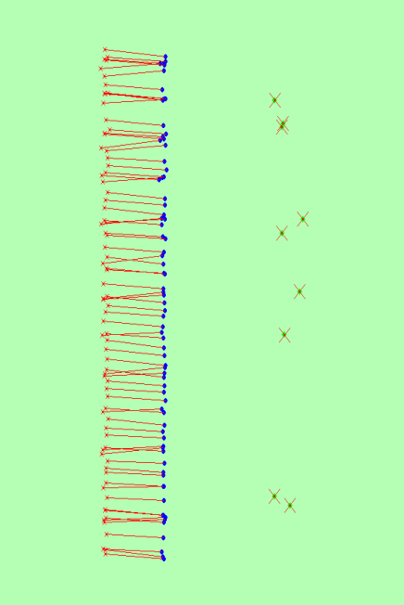
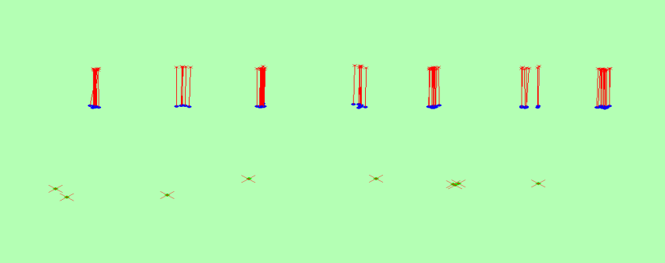
Figure 26 – Offset between image geo-tags (little red crosses) and optimized positions (little blue dots), and between GCP’s measured positions (big red crosses) and their optimized positions (green dots). Upper left figure is the XY plane(top-view), upper right is YZ (side view) plane and XZ plane (front-view) in the bottom.
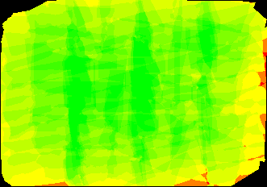
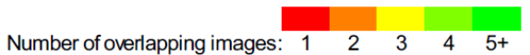
Figure 27 - Number of overlapping images for each image of the orthomosaic.
The minimum of matches to calibrate an image is 25, although it is advisable to have more than 1000 per image. In Figure 28 can be seen a graphical representation of the number of 2D keypoints matched between adjacent images. Most images of the same strip have more than 1000 matches while images in different strips have usually less matches due mainly to a lesser overlap in these ones. It is also easily identified two particular zones where the density of connections is considerably smaller, even inexistent in some neighbor images. In particular the “hole” in lower right zone of the graph is especially evident and might be related with relatively dense wooded area which makes the feature detection and matching process a bit more challenging. Other possible reasons might be the slightly higher distance between the adjacent images, some issue related to the attitude of the UAV making the overlap (especially lateral) of the images insufficient for the particular characteristics of that area appearance.

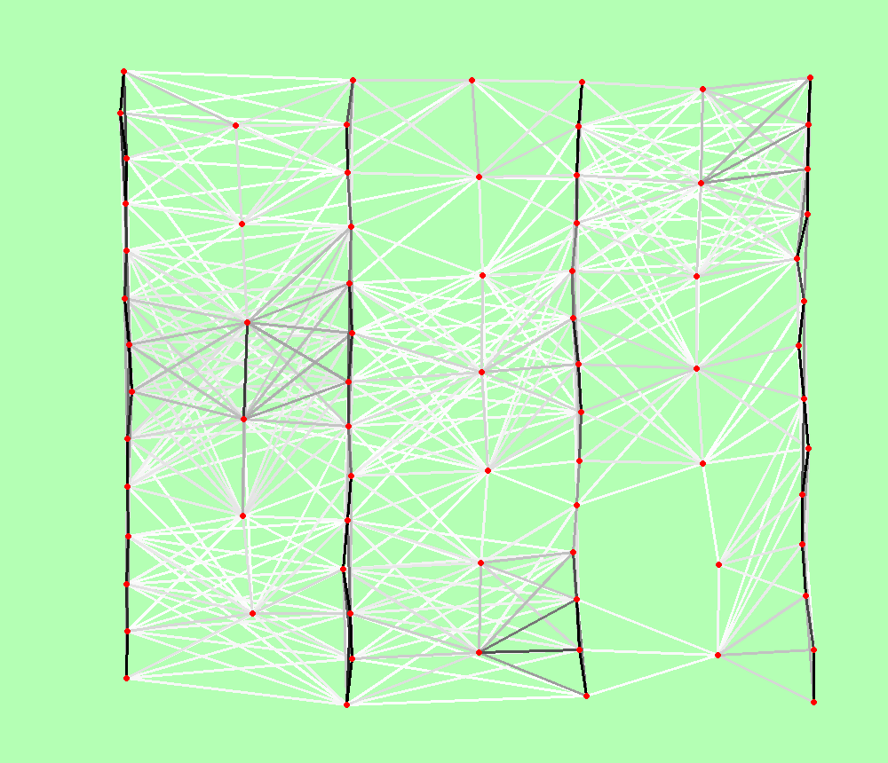
Figure 28 – 2D keypoint graph.
The only way to evaluate and correct the geo-location (scale, orientation, position) of a project is using GCP, 3 of them at least. The 9 GCP introduced in this projected had different visibility conditions. They could be seen in a minimum of 4 images and a maximum of 12 images but some of the locations weren’t particularly easy to identify and to measure. For this reason a couple of them had a position error of a few centimeters and a projection error of a bit more than a pixel, being one of them of 2 pixels. Still, in 9 GCP having only a couple of them with a projection error of approximately a pixel is quite good and a positional error of a few centimeters is quite good.
Finally, the camera calibration process calculated the following radial distortions (RD) and tangential distortions (TD): -0.042, 0.022, -0.003, respectively for RD1, RD2 e RD3, and -0.003 e 0.003 for TD1 e TD2, respectively.
 | Focal  length | Principal  point x | Principal  point y | RD1 | RD2 | RD3 | TD1 | TD2
Initial  values | 2775.268 pix  4.3 mm | 2000 pix  3.099 mm | 1500 pix  2.324 mm | 0.000 | 0.000 | 0.000 | 0.000 | 0.000
Optimized  values | 2819.08 pix  4.368 mm | 2034.307 pix  3.046 mm | 1461.832 pix  2.383 mm | -0.042 | 0.022 | -0.003 | -0.003 | 0.003
Table 2- Camera calibration paramters (radial and tangential distortions) estimated by Pix4UAV.
In the end, Pix4UAV generates the products mentioned earlier: geo-referenced orthophoto and DSM (Figure 29), point cloud, 3D model and a collection of project parameters information.

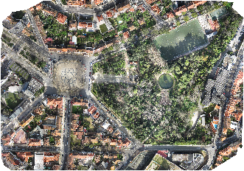
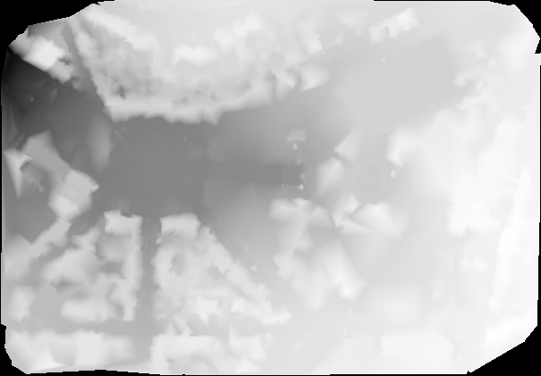
Figure 29 – Final products preview: Orthomosaic (above) and DSM (below).
The orthomosaic seems of very good at first sight but inspecting more closely (Figure 30) we can see that there are a lot of artifacts and ghost objects especially in the borders. Still for such an easy to use and automated software, these are reasonably good solutions.
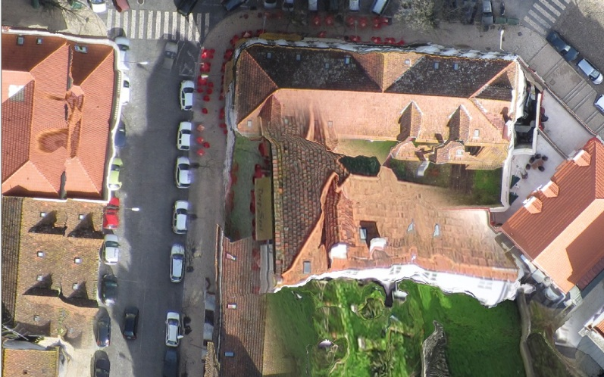
Figure 30 - Artifacts in Pix4UAV orthomosaic.

PhotoScan processing and results
The Coimbra data set obtained by UAV was also processed in PhotoScan. Although not being as complex as other professional products, this software isn’t also as simple and straight forward as Pix4UAV. The several stages of the base workflow require some decision making, with various processing modes. After importing the image set and camera coordinates, and mark GCP locations to insert their coordinates, the photos need to be aligned. When this information is imported, the relative camera positions are represented in the advanced graphical interface just like they were in the moment the photo was taken above the still blank ground surface. To execute the photo alignment processing, High accuracy and Ground Control options were selected, since GCP information is available. This is where the feature detection and matching is performed.
With the alignment done, the next stage is to build model geometry. This is a 3D model geometry so is quite a computationally intensive operation that can take several hours, especially with a big image set and if the resolution of the images is high. Height Field option, recommended for aerial photography processing, with Smooth Geometry and Ultra High Target Quality options were chosen to generate the 3D model. In fact this was a lengthy processing with approximately 11h to reconstruct Depth and another 3h30 to Generate the Mesh. After this stage it is advised to perform check for holes and amend them with the Close Holes tool and also Decimate Mesh because sometimes PhotoScan tend to produce 3D models with excessive geometry resolution.
The final step is to build the model texture to improve the visual quality of the final model. Adaptative Orthophoto mapping mode, to guarantee good texture quality for vertical surfaces such as wall and building since this is an urban scenario, and Mosaic blending mode, to better combine pixel values from different photos. Also, another final hole filling procedure was perform as it is suggested at this phase due to using previously Height field geometry reconstruction mode.
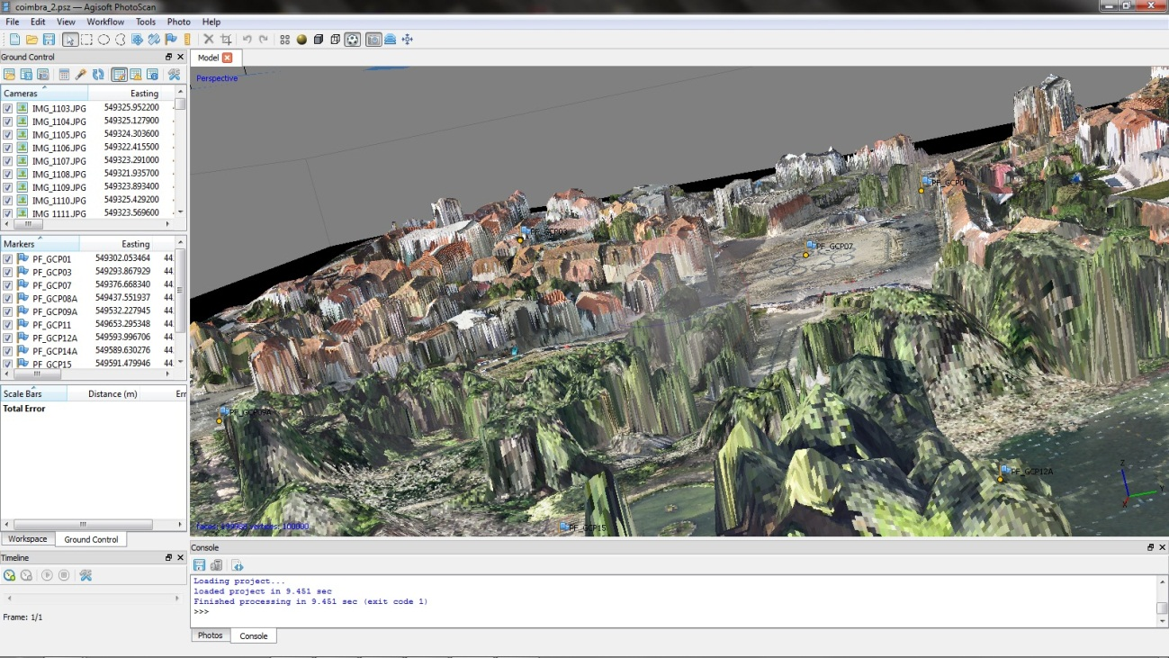
Figure 31 – Part of the 3D model generated in PhotoScan with GCP (blue flags).

At this moment all the major procedures are done. We can now export the model itself and the point cloud to use in other software if necessary, generate the orthophotos, DEM and the project report.
The project report is quite simple with only a statistical information and illustration. It provides for instance For instance, the image overlap map throughout the entire area covered by the photos (Figure 32). The coverage is good with the great majority of the area being seen in at least 3 photos, unless the borders obviously, and a significant are with coverage of 9 or more images. The area covered is estimated as being of 0.26623 square km. The ground resolution is of 3.803 cm per pixel and the flying altitude was computed as 117.719 m. The tiepoints identified in the alignment phase were 142662 associated with 367953 projections with an average error of 0.674117 pixels which is quite accurate. There is a tool in the software interface to view the number of matches between images. On average the matches per image is around 3000, usually between consecutive images.
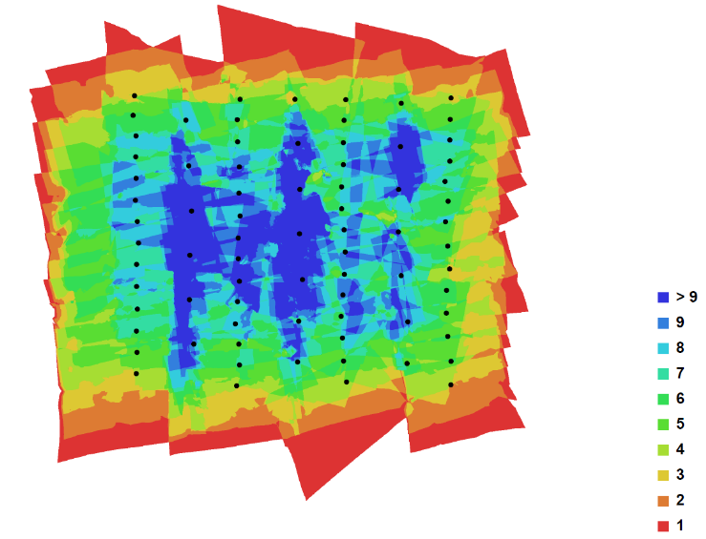
Figure 32 - Image overlap and camera position.

The predicted camera position errors are shown in Figure 33, via color coded error ellipses. The camera estimated position (black dots) in the moment the photo is taken is surrounded by error ellipses whose shape represents the amount of error in the X and Y directions. On the other hand, Z error is represented by the color of the ellipse, which range from -7 m to 5.58m. On average, errors in X direction was computed at 4.536327 m, while in Y component is 4.833348 m and in Z is 4.469242 m. These values are expected for a UAV given their less stable position during the flight and also due to the low precision position instruments.
On the other hand, the GCP accuracy is a bit too high. Some of them have estimated errors of about 3 m in the Z component which is very weird. The average errors are all of them unexpectedly high: 0.441056 m, 0.298496 m and 1.796295 m, for the X, Y and Z coordinates, respectively. The GCP were measured with a double frequency receptor and although two or three of them are located in non-ideal places, such as near or even under trees and near somewhat tall buildings, the values are quite high. In the previous section, we saw that Pix4UAV made in its report a similar estimation but with much smaller values in the order of a couple of centimeters on average. Nevertheless, these values could indicate a more careless manual marking of the GCP position or some inadequate processing option.
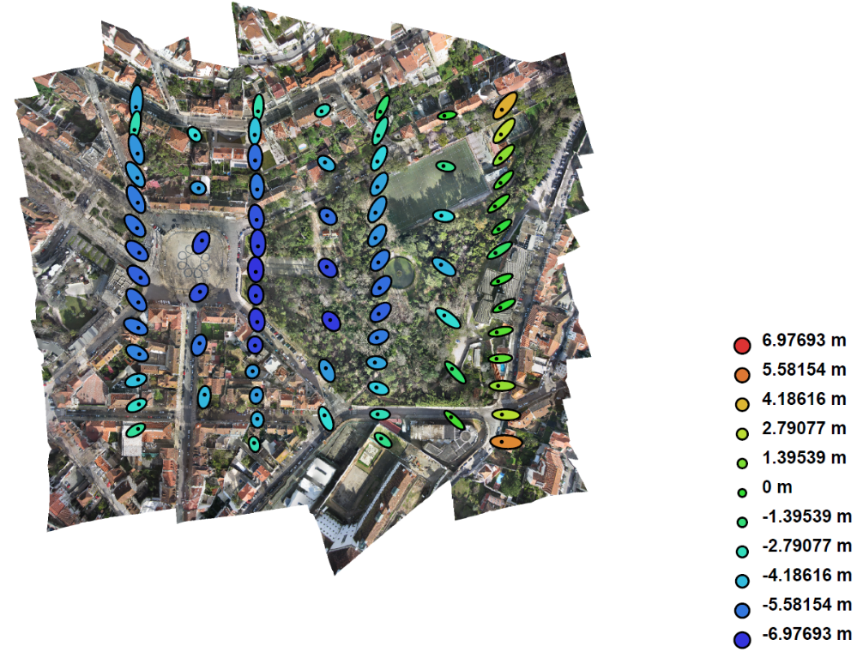
Figure 33 - Color coded error ellipses depict the camera position errors. The shape of the elipses represent the direction of error and the color is the z-component error.

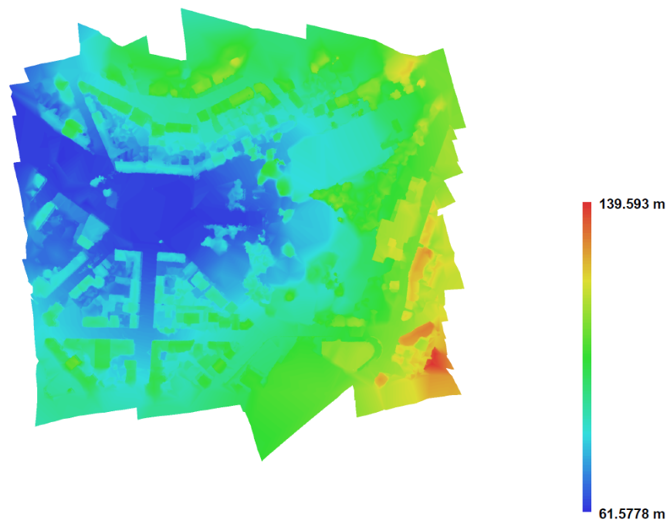
Figure 34 - DEM generated by PhotoScan
The report finalizes with a small version of the area DEM, representing the elevation values of the analyzed area, based on a point cloud of 34.4054 points per square meter. The elevation values range between 61.5778 m and 139.593 m, although most of the area is below 100 m, which is consistent with the area studied.
Although it doesn’t appear in the report PhotoScan also derives the distortion parameters of the camera sensor, within one of its software environment tools. The adjusted parameters are similar with the ones calculated by Pix4UAV, but PhotoScan doesn’t calculate the tangential distortion parameters or it estimates them as zero

 | Focal  length | Principal  point x | Principal  point y | k1 | k2 | k3 | p1 | p2
Initial  values | 2775.27  pix | 2000  pix | 1500 | 0.000 | 0.0000 | 0.0000 | 0.0000 | 0.0000
Optimized  values | 2767.84  pix | 2011.68  pix | 1484.24 | -0.0566 | 0.0256 | -0.0061 | 0.0000 | 0.0000
Table 3 - Calibrated parameters, in pixels, computed by PhotoScan.
Like it was seen in Pix4UAV section there are quite a few ghost objects in the generated orthophotos, if we more closely. Figure 35 is one example.
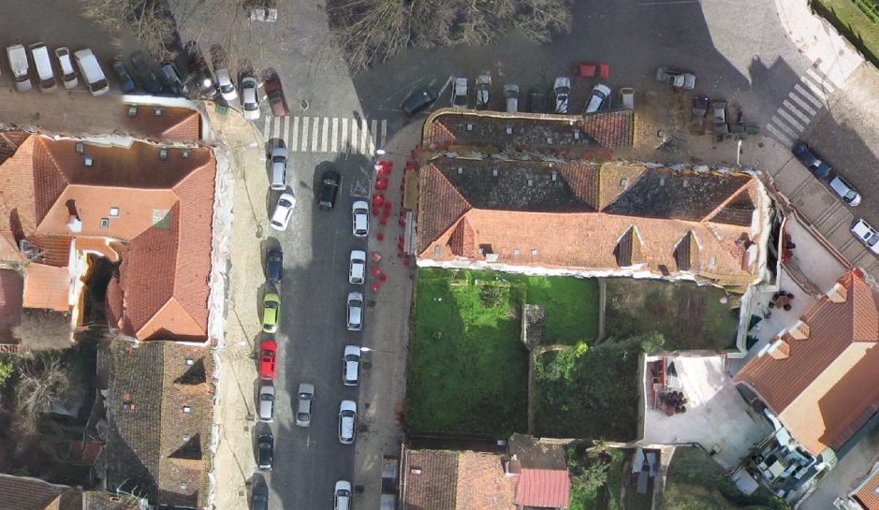
Figure 35 - Artifacts in PhotoScan generated orthophoto.

GENA processing and results

As it was said in chapter, GENA is a network adjustment software and doesn’t have, at the moment, any feature extraction and matching process. In fact, GENA doesn’t directly work on image files, just their known measurements in order to adjust and calibrate them along with the desired parameters. This means that for this kind of project it will be needed additional external information which is a set of previously identified and matched tie points of the project’s images. One of the output products generated by Pix4UAV is a text file containing the image coordinates (x,y), in millimeters, of the GCP and keypoint matches in each image, in BINGO format. The origin of this image coordinate system is the center of the image, with x axis increasing to the right and the y axis increasing upwards. The BINGO format is as follows:

ImageName### cameraName
controlPointID# x y
…

This file will be used as the observations that were missing to make the network adjustment. The BINGO file contained 2491 unique tie points distributed for 11035 tie points.
To execute the adjustment the necessary files were organized in the following manner.
The two main control files, options files (.op) were named op_coimbra.op and options_lis_file_coimbra_foto.op. In particular, in op_coimbra.op were defined several adjustment control options (convergence maximum iterations, thresholds, residual, sorting modes, among others) and also the directories to the observations, parameters and instrument files to import the project specific data, as well as the directories to save the output, log and error files.
After a battery of tests both observations and parameter were divided in several individual elements. The set of observations files are:
- obs_file_coimbra_im.obs – containing the image coordinates in millimeters of the GCP and matches in the format “IMG_#### match_id x y”;
- obs_file_coimbra_GCP.obs – containing the coordinates in meters of the GCP in UTM -29N, in the form “PF_GCP## X Y Z”;
- obs_file_coimbra_AC.obs – Aerial Control which is constituted by the Shift/Drift, lever-arm and images GPS coordinates divided by strips together with the GPS time of collection of the images in form “GPStime IMG_#### X Y Z heading pitch roll”;
- obs_file_coimbra_IO.obs – camera interior orientation.

As for the parameter files (par) to determine or to adjust are:
- par_file_coimbra_EO – Exterior Orientation of each image in the form “IMG_#### X Y Z omega phi kappa”;
- par_file_coimbra_points.obs – approximated terrain coordinates of the matched tiepoints, “point_id X Y Z”;
- obs_file_coimbra_GCP.obs – same as the observation file above;
- par_file_coimbra_lev.obs – UAV lever-arm, offset between the GNSS receptor and the camera;
- par_file_coimbra_sd.obs – UAV Shift and Drift errors;
- par_file_coimbra_bore.obs – UAV boresight angles, misalignment angles, between the IMU and the digital camera frames of reference;
- obs_file_coimbra_IO.obs – same as the observation file above;
- par_file_coimbra_Ebner.obs – Ebner model parameters of camera calibration;

Besides the options, observation and parameters files there is also another file with the information about the camera, in particular the focal length, the ins_file_coimbra.obs file.

Preliminary tasks

In the initial tests not all the parameter files were used. The lever-arm, shift and drift and boresight were not included to simplify the computation and focus on the correct selection of the standard deviation values of the measurements and on the tie point initial approximations to achieve the necessary convergence of the adjustment for a successful process. No measurement is absolute, 100% precise. Every measurement instrument has errors and that has to be taken into account. Therefore the selection of appropriate standard deviations of the measurements is important to achieve a quick, efficient and robust adjustment. Many tests were made by including and excluding several files from the condition of observations or putting them just as parameters to adjust and testing the observations as fix measurements (very small standard deviations) or free (very high standards deviations), to evaluate the best configurations that enable a successful and convergent network adjustment. The configuration of files referred above and the following measurements standard deviation is one of those possible optimized configurations.
The GCP have a standard deviation of about 3 cm but since some of GCP used don’t have the best of location because are among buildings and near or even beneath trees, a standard deviation of 4 cm was considered. Pix4UAV doesn’t have any document about the precision with which its system can create the tie points, but it is not expected to exceed one or two pixels so it was considered a standard deviation of 3.5 µm (about 2 pixels) to the image coordinates obtained with Pix4UAV. The images Internal Orientation should have in general very low standard deviation around 0.1 mm. The Aerial Control file elements had the following standard deviations: since the shift and drift were completely unknown were considered as zero, but knowing that the shift can sometimes be in the order of meters while shift is usually much more lower, a standard deviation of 10 m and 0.001 m/s for shift and drift respectively; the internal structure of the Swinglet UAV is also unknown so we can only speculate about the lever-arm but a reasonable standard deviation should be 10 cm; regarding the precision of the GPS and IMU modules of the this UAV model, a study estimated their measurements should have a standard deviation of less than 10 m for the position and less than 5º in attitude [26].
The content of BINGO file, mentioned above that include the matched keypoints obtained from Pix4D processing, was adapted to GENA’s required format and imported to the par_file_coimbra_points.obs. Although, there still is some work to be done in order to have all necessary information to correctly execute the adjustment process with GENA. In particular, initial approximations of the terrain coordinates of the matched keypoints are necessary. These terrain coordinates aren’t provided by Pix4UAV so it’s necessary to devise a method to make a sufficiently good estimate.
Several methods were attempted. The simplest one would be to use the precise coordinates of the most central GCP of the whole block and attribute them as initial approximations. None of the GCP is exactly centric so it would hardly work. Nevertheless, it was tried but as suspected, GENA processing failed due to singularity errors. From here several other more elaborated methods based on the GCP coordinates were tested. Given the rectangular symmetry of the image set, the block was divided in two, 36 images in each sub-block and the tie points of the first 38 images were attributed the coordinates of GCP07 while the others were attributed the coordinates of the GCP15, which were the most centric GCP of each of the sub-blocks. Still the adjustment processing was unsuccessful. Therefore, the next logical step would be to determine the closest images to every GCP and assign to the tie points of those images the closest GCP coordinates. For example, the tie points from the first six images would be attributed the coordinates of GCP01 because are closer to it, while the following two images are assign the GCP07 coordinates, and so on. The distances between the GCP and the images projected in the ground were estimated in Google Earth. This also didn’t work because some tie points can be more than a couple of hundred meters away from the closest GCP. A better method must be devised rather than based on the GCP.
Another possibility would be using the coordinates of the images (UAV camera) to assign the initial approximations to the tie points. This strategy should be more efficient than using GCP because there are more images and better distributed along the area. Obviously, for the Z-coordinate it is best to assign an average terrain elevation since the tie points should be in the ground. This method still isn’t very precise because ground projection center of the images isn’t truly vertical due to the variable attitude of the UAV platform but hopefully should provide sufficiently good approximations. In fact, it was later verified that some image border tie points of a sample of points had a displacement of up to 30 meters, but these were the minority of the points.
The following procedure was implemented to determine the initial approximations. First the 11035 tie points from the BINGO file were imported to a spreadsheet, along with its image coordinates and the image numbers they are present (as every tie point appears in several images) and were ordered alphabetically. Secondly, taking advantage of the image coordinate system used by Pix4UAV to create the BINGO, was calculated the geometric distance to the origin. Then with an auxiliary routine written in Visual Basic was determined which image center were each unique tie point number that the distance is minimum. In other words, for each unique tie point number were assigned the real world coordinates of the image that it is closest to (Figure 36). Once again, the terrain coordinates computed didn’t seem to yield a successful adjustment. Therefore, it was introduced another improvement to the method.

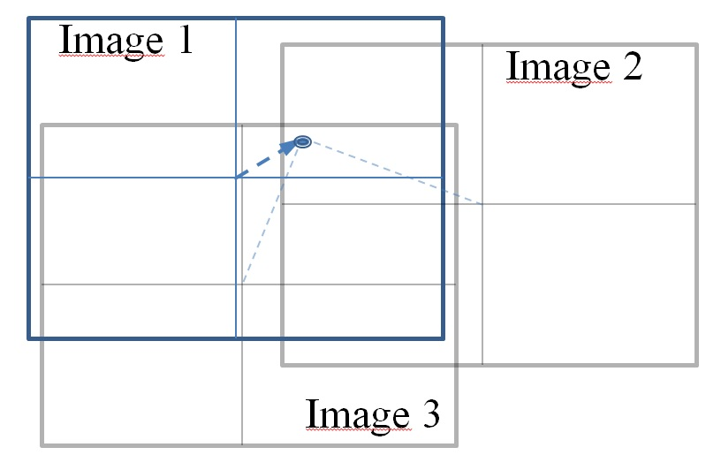
Figure 36 - Method for attributing initial approximations to the tie points based on the proximity to the closest image center.
The calculation of the geometric distance was decomposed in its two components (x,y) in order to add a term to the known coordinates of the image center associated with the distance, in pixels, to the tie point associated to the direction x or y. This way, the distance from the tie point to the center of the image in one of the directions, x or y, would be converted to a distance in pixels, and knowing that each pixel in the ground represents approximately 3.9 cm, it should be possible to improve the precision of the approximate ground coordinates of the tie points .

$$E_{UTM}^{TP}=\left\{\begin{aligned}E_{UTM}^{ic}-\frac{x^{im}}{pixel sizel}*pixel size in ground , N→S strip \\ E_{UTM}^{ic}+\frac{x^{im}}{pixel sizel}*pixel size in ground , S→N strip\end{aligned}\right.$$
(2)
$$N_{UTM}^{TP}=\left\{\begin{aligned}N_{UTM}^{ic}-\frac{y^{im}}{pixel sizel}*pixel size in ground , N→S strip \\ N_{UTM}^{ic}+\frac{y^{im}}{pixel sizel}*pixel size in ground , S→N strip\end{aligned}\right.$$

where $E_{UTM}^{TP}$, $N_{UTM}^{TP}$ are the ground coordinates of the tie points we want to estimate, $E_{UTM}^{ic}$, $N_{UTM}^{ic}$ the coordinates of each image and $x^{im}$,$y^{im}$ the image coordinates of the tie points.
It must be also taken into account that the equations must are different if the UAV is flying from north to South or from South to North. The second element of each equation to "transport" the ground coordinates of the image centers to the ground coordinates of the tie points, as it is illustrated in Figure 37.
Nevertheless, the GENA network adjustment still couldn’t converge to a solution. The divergence problem could be in other source rather than the initial approximations. One of the last steps in GENA’s network adjustment process is to compute residuals of the observations. It could provide some insight about possibly irregularities by analyzing these residuals. To force GENA to stop the adjustment process we could define in the options file a maximum iteration of zero, which makes the process to just compute the residuals.
Analyzing the residuals it was seen that a significant part of the image coordinates of the tie points, obtained in Pix4UAV, had unusually high residuals for some reason. Some of them presented residuals of a few dozen millimeters, which is absurd since the images are only about 6.2 by 4.6 mm. Maybe the way that Pix4UAV software architecture deals with the tie points internally is very different from the way the GENA works, especially in what concerns the tolerance to high residuals. And these kind of residuals could well be the cause of the divergent adjustment process.
With this in mind, we should remove these high residuals tie points. This was done with a routine in Matlab, where all tie points that were identified in GENA with residuals with more than 2 mm were removed. This procedure removed 1403 tie points from the initial 11035, leaving 9632. Furthermore, this removal makes that some unique tie points will appear in 3 or less images and that can’t be allowed to not lose integrity in the image block because any aerial photogrammetry project should ideally have, for best results, tie points visible in at least 4 images. For this reason, it was made, also in Matlab, another routine to identify and remove the tie points present in only 3 or less images. Once this was done, another 2450 were removed leaving the final number of 7182 tie points distributed for the 76 images which makes 94.5 tie points in average for each image. This is not ideal but is still sufficient. In terms of unique tie points there are now 1439 of the initial 2491.

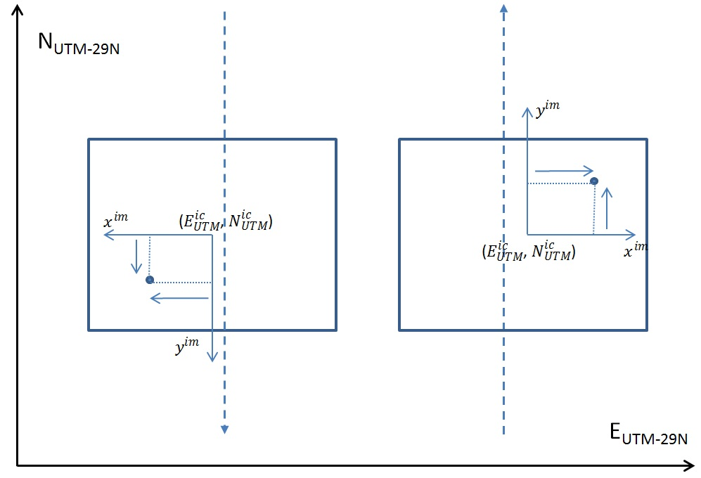
Figure 37 - Scheme of the estimation of the initial approximations of the tie points' ground coordinates.
And finally with this set of low residuals tie points, the initial approximations derived from the images position coordinates referred previously and with adequate standard deviations for the observations provided to GENA, the network adjustment process was successful and convergent. To try to improve the results, the adjustment was reprocessed, with the output image coordinates of the tie points and the image position coordinates as input of this new adjustment. The network adjustment process converged in 9 iterations. Past experiences with other data sets suggested that the convergence should be expected within around four or five iterations. In this case it took a little longer, indicating that this data set might be a little more instable, which is not surprising since it is a UAV flight.

Network adjustment results

One of the most recurrent calculations present in the network adjustment report is sigma 0 (or sigma naught) represented as S0. It can be defined as a quality indicator of the adjustment; more specifically is a statistical measurement of the degree of deviation from an assumed a priori accuracy. Normally, in block adjustment the a priori weight of 1 is assumed as a priori weight for the photogrammetric observations, therefore it is the accuracy of the photogrammetric measurements [28]. GENA calculates S0 as it follows:
${S0}^{2}=\frac{1}{r}*(v^{T}Pv)$ ,

where v are the residuals, P the system matrix and r the difference between the number of observations and the number of parameters. If the S0 score is below 1 it means that the initial standard deviations (Std) attributed to the observation was too pessimistic and, on the contrary, if it is more than 1 the initial Std were too optimistic
From GENA’s final adjustment report using Ebner’s camera calibration model we can mentioned the following results. In the Numerical Correctness of Solution section all of the performed tests were Passed successfully: Non-linear least-squares convergence test, Global Vs Local Redundancy Test, the Fundamental rectangular Triangle of Least-Squares Test and Misclosure Test; all had results below the normal expected threshold and their computed values were mostly very small.
In the Adjusted Residuals section, the tie points image coordinates set S0 was computed as 0.575464, with an average vector of residuals (v) of -2.91957e-6 µm and -5.33593e-6 µm for x and y component, respectively. These values are very small and show the majority of the image coordinates are very precise. However with an average Standard Deviation of v (Cvv-Sv) of 1.747 and 1.65518 µm, there is some considerable dispersion on values from the average on the image coordinates set but don’t seem to be too harmful since the S0 is acceptable (Table 4).
S0 (o_set_obs_image_coordinates) | 0.575464
S0 (o_set_obs_image_coordinates, x) | 0.537211
S0 (o_set_obs_image_coordinates, y) | 0.614896

 | v (µm) |  | Cvv-Sv (µm)
 | x | y | x | y
Mean | -2.91957e-6 | -5.33593e-6 | 1.74764 | 1.65518
Std | 1.575 | 1.71669
Table 4 - Computed S0 and residuals statistics of image coordinates observations.
The GCP residuals are somewhat high with an S0 of 5.74625. This calculation is mainly due to the abnormally high 15.9431 of Z component S0 that, in theory, should be around 1 while the X and Y components were 2.77761 and 3.27283. This very high S0 in Z is an indication that the initial expected (4 cm) standard deviations were too optimistic at least in Z coordinate. As for the X and Y coordinates the initial Std expected were also too optimistic but are closer to the estimated one because the corresponding S0 are closer to 1. Still, the average v and Cvv-Sv were very small, even too small with -17 power of 10 which is a strange and hard to comment. Anyway, there must be some error whose origin could not be determined (Table 5).

S0 (o_set_par_GCP) | 5.74625
S0 (o_set_ par_GCP, X) | 2.77761
S0 (o_set_ par_GCP, Y) | 3.27283
S0 (o_set_ par_GCP, Z) | 15.9431

 | v (m) |  |  | Cvv-Sv (m)
 | X | Y | Z | X | Y | Z
Mean | -1.46488e-17 | -2.73701e-17 | -1.00228e-17 | 0.0120739 | 0.0123483 | 0.00550528
Std | 0.0573635 | 0.0688438 | 0.154104
Table 5 - SO and residuals statistics estimated for the GCP coordinates.

The next element in this section was the images GPS position residuals that scored a global S0 of 0.757621 which is near 1, meaning that the defined input Std are reasonably correct. The other components had the S0 values that can be seen in Table 6. The positional coordinates are near 0 while the attitude coordinates around 1 except the heading component that is also near 0. Therefore, these components were given overly pessimistic initial Std was considered which could be a little more fixed. This might be explained by the fact that these input coordinates are already adjusted coordinates from a previous adjustment so they are a little more precise than the Std considered which weren’t changed. The residuals v and Cvv-Sv are within the expected range of values for this specific Swinglet UAV (less than 10 m in position and around 5º in attitude). Finally in this section 4 of the adjustment report, there’s also the residuals computation of the Interior Orientation parameters of the camera, displayed in Table 7. The general S0 calculated is 0.844756, 1.42622 for the focal length and 0.172683 and 0.31574 for the x and y component of the principal point. Both v and Cvv-Sv with respect to the input values are in the order of the decimal part of a millimeter, which are reasonably small.

S0 (o_set_obs_GPS_position) | 0.757621
S0 (o_set_obs_GPS_position, X) | 0.00319051
S0 (o_set_obs_GPS_position, Y) | 0.00452616
S0 (o_set_obs_GPS_position, Z) | 0.00982843
S0 (o_set_obs_GPS_position, h) | 0.0869531
S0 (o_set_obs_GPS_position, p) | 1.11632
S0 (o_set_obs_GPS_position, r) | 1.37576

v | X (m) | Y (m) | Z (m) | h (º) | p (º) | r (º)
Mean | 6.8475e-19 | -5.47807e-19 | -3.28684e-18 | -0.186354 | 0.00875812 | 5.50989e-13
Std | 0.028813 | 0.0408707 | 0.088767 | 0.389615 | 5.54321 | 6.83043

Cvv-Sv | X (m) | Y (m) | Z (m) | h (º) | p (º) | r (º)
Mean | 5.3942 | 5.3936 | 5.3947 | 2.97457 | 2.97378 | 2.97334
Table 6 - Estimated S0 and residual statistics for the camera position and orientation.

S0 (o_set_lab_calibration) | 0.844756
S0 (o_set_lab_calibration, Delta_f) | 1.42622
S0 (o_set_lab_calibration, Delta_x0) | 0.172683
S0 (o_set_lab_calibration, Delta_y0) | 0.31574

 | v (m) |  |  | Cvv-Sv (m)
 | f | x0 | y0 | f | x0 | y0
Mean | 0.000141251 | 1.72553e-5 | 3.15364e-5 | 5.93118e-5 | 5.98425e-5 | 5.98164e-5
Table 7 – Computed S0 and residual statistics for the interior parameters of the sensor.
In summary, the results are good having passed the chi-square test with a good global S0 of 0.598877 for the observations used. Therefore, in general, the observations have an initial estimation of its supposed Std, slightly pessimistic.
The estimated Ex for the displacement of interior camera parameter delta_f, delta_x0 and delta_y0 are the same as it’s residuals from Table 7. These values are more or less consistent with the same adjusted values obtained with Pix4UAV and PhotoScan (Table 2 and Table 3). In Pix4UAV the adjusted focal length is 4.368 mm, or 2819.08 pix (Table 2), which corresponds to a 0.068 mm difference from the initial known value, 4.3 mm, of the focal length. GENA estimates a delta_f = 0.141251 mm in section 5.3.1 of GENA report (with Ebner calibration). This value is a little higher than 0.068 mm but can be considered on the same order of magnitude. The same reasoning is valid for principal points delta_x0 = 0.0172553 and delta_y0 = 0.0315364 mm related to the 0.053 mm and 0.059 mm difference from the optimized values and the initial values for x and y principal point coordinates in Table 2.
Next in section 5 of GENA report are shown the adjusted parameters and related statistics. Starting with the camera calibration the values shown in Table 8 are the 12 Ebner parameters calculated, both the expectation of the parameter (Ex) and the Std vector of the parameter (Cxx-Sx).

 | Ex | Cxx-Sx |  | Ex | Cxx-Sx
b1 | -0.000854955 | 6.89301e-005 | b7 | -4.11387e-010 | 1.75818e-011
b2 | 0.000478085 | 6.73877e-005 | b8 | -3.42606e-010 | 1.81683e-011
b3 | -3.55326e-007 | 1.756e-008 | b9 | -8.737e-010 | 1.90901e-011
b4 | -4.54184e-007 | 1.45961e-008 | b10 | -7.74026e-010 | 2.18753e-011
b5 | 1.01666e-006 | 3.00764e-008 | b11 | -1.60887e-014 | 8.58456e-015
b6 | 1.23328e-006 | 3.38841e-008 | b12 | 3.19586e-014 | 8.94992e-015
Table 8 – Estimated Ebner parameters for the camera.
The next adjusted parameters are the exterior orientation parameters of the images. In Table 9, we can see the adjusted coordinates (Ex) against the initial values provided by the UAV GPS and IMU units. Only four example images are shown to avoid inserting the full 76 images which would occupy several pages. And since the variation of values of the other images relatively to the initial ones is more or less in the same amount it would be redundant to show them all. Still, all the coordinates can be found in folder “network_coimbra” of the adjustment made with the Ebner calibration in the DVD; the specific files are par_file_coimbra_EO.obs and output_par_EO_pXYZwpk_imported.obs. The adjusted values are consistent with the expected range of Std of the UAV navigational measurements except for the k value that seems to be inverted. The adjusted k value should be around -90º or +270º in images oriented to South (images 1103, 1110 and 1155) and should be around -270º or +90º for images oriented North (like image 1121 in this case). Unfortunately, in some moment, the attitude coordinate frame (omega, phi, kappa) wasn’t correctly defined and ended up rotated leading to this error. Still, it appears that this problem didn’t affect the adjustment process of the other coordinates that seem to be consistent with initial original coordinates, varying only for some meters and degrees, within the expected position and attitude errors.
Another important group of parameters to analyze is the estimated tiepoints coordinates, whose initial coordinates where derived from the point cloud obtained in the Pix4UAV software (Figure 37 and related Equation (2)). Once again only a few examples are shown in Table 10, because there are a few thousand tiepoints in this project. The files where all the points are archived are the par_file_coimbra_points.obs and output_par_PT_3D_pXYZ_imported.obs files, on the folder mentioned in the last paragraph. The initial approximations are sometimes very different from the adjusted coordinates, reaching up to 30 meters in the X and Y coordinates. This means that GENA is very efficient and tolerant to very inaccurate approximations in the order of a few dozens and is able to nevertheless execute successfully the adjustment. Therefore we can believe more confidently in the estimated values of adjusted by GENA.

 |  | Ex | Initial values
IMG_1103 | X (m) | 549317.034 | 549325.952
IMG_1103 | Y (m) | 4451342.836 | 4451340.76
IMG_1103 | Z (m) | 187.99 | 195.77
IMG_1103 | w (º) | -8.38 | -12.23
IMG_1103 | p (º) | -4.94 | -4.91
IMG_1103 | k (º) | -162.11 | -114.9
IMG_1110 | X (m) | 549323.042 | 549325.429
IMG_1110 | Y (m) | 4451157.996 | 4451160.41
IMG_1110 | Z (m) | 194.221 | 192.77
IMG_1110 | w (º) | -5.832 | 1.45
IMG_1110 | p (º) | -2.6136 | -7.26
IMG_1110 | k (º) | -168.89 | -89.11
IMG_1121 | X (m) | 549383.592 | 549387.731
IMG_1121 | Y (m) | 4451254.072 | 4451247.919
IMG_1121 | Z (m) | 196.761 | 193.71
IMG_1121 | w (º) | 5.17 | -1.7
IMG_1121 | p (º) | 0.21 | -7.21
IMG_1121 | k (º) | -0.46 | -263.32
IMG_1155 | X (m) | 549580.516 | 549574.171
IMG_1155 | Y (m) | 4451336.586 | 4451043.136
IMG_1155 | Z (m) | 193.47 | 193.56
IMG_1155 | w (º) | -9.63 | -3.49
IMG_1155 | p (º) | -5.15 | -6.33
IMG_1155 | k (º) | -165.374 | -83.76
Table 9 - Adjusted Exterior Orientation parameters against initial values. Only 4 images are represented to avoid putting all 76 images.

 |  | Ex (m) | Initial approximations (m)
1118 | X | 549274.093 | 549287.642
1118 | Y | 4451135.579 | 4451159.515
1118 | Z | 64.56 | 68
1728 | X | 549707.15 | 549699.142
1728 | Y | 4451254.015 | 4451251.463526
1728 | Z | 88.07 | 89
2175 | X | 549359.94 | 549366.384
2175 | Y | 4451071.239 | 4451080.37
2175 | Z | 83.111 | 77
3034 | X | 549576.909 | 549570.494
3034 | Y | 4451258.789 | 4451273.578
3034 | Z | 83.55 | 80.00
Table 10 - Adjusted tiepoint coordinates versus initial coordinates.

The adjustment made also provides information about the unknown parameters related to the UAV Shift and Drift displacements per strip of the flight (Table 13), lever arm (Table 11) and boresight (Table 12). The lever arm values obtained are clearly wrong since it's impossible to be on the order of the micrometers as they were estimated.
 | Ex | Cxx-Sx
  a_x (m)
  a_y (m)
  a_z (m)
  -1.51667e-006
  2.5632e-006
  3.72869e-006
  0.0598855
  0.0598855
  0.0598874
Table 11- Lever arm estimated values of displacement.

 | Ex | Cxx-Sx
  DE_x (º)
  DE_y (º)
  DE_z (º)
  -7.91171
  0.965661
  0.26505
  0.343946
  0.343766
  0.342611
Table 12 – Computed Boresight angle.
On the other hand, the boresight estimated values can be considered feasible.

 | SD | Ex | Cxx-Sx |  | SD | Ex | Cxx-Sx
 |  |  |  | 5
  1
  s_x
  s_y
  s_z
  d_x
  d_y
  d_z
  0.442982
  -0.22389
  0.162577
  -0.00235839
  0.0112949
  -0.00905124
  1.6075
  1.60463
  1.61882
  0.0993116
  0.0993726
  0.0993327
  s_x
  s_y
  s_z
  d_x
  d_y
  d_z
  -0.253254
  0.00924103
  0.0569185
  0.00180259
  0.0123844
  0.00414424
  1.6038
  1.60346
  1.61523
  0.09932
  0.09935
  0.09929
 |  |  |  | 6
  2
  s_x
  s_y
  s_z
  d_x
  d_y
  d_z
  0.276746
  -0.098948
  -0.0140252
  0.0189563
  -0.0359799
  0.0144262
  2.44836
  2.44807
  2.45654
  0.358201
  0.358216
  0.357953
  s_x
  s_y
  s_z
  d_x
  d_y
  d_z
  -0.435148
  0.121664
  0.30171
  -0.00821228
  -0.0225619
  -0.00965518
  2.26901
  0.28329
  2.27389
  0.28329
  0.28332
  0.28315
 |  |  |  | 7
  3
  s_x
  s_y
  s_z
  d_x
  d_y
  d_z
  0.0695314
  -0.0268675
  -0.0927227
  -0.00720031
  0.0163558
  0.00121537
  1.6037
  1.6039
  1.61723
  0.0968927
  0.0969286
  0.0968803
  s_x
  s_y
  s_z
  d_x
  d_y
  d_z
  -0.343151
  0.0106299
  0.538195
  0.000703255
  0.01067
  0.00301467
  1.6086
  1.60783
  1.61821
  0.09675
  0.09688
  0.0969
  4
  s_x
  s_y
  s_z
  d_x
  d_y
  d_z
  -0.14262
  0.11169
  -0.06335
  0.0108262
  -0.0303969
  -0.00606441
  2.26598
  2.26631
  2.27453
  0.283031
  0.283214
  0.282977

Table 13 – Computed Shift and Drift displacements for each of the 7 strips. Shift values are in meters and drift values are meters per second.
Finally, the shift and drift estimates are seem to be an acceptable range of values but the standard deviations a somewhat high with shift in the order of a couple of meters.

Conclusions
The contributions of computer vision community have been increasingly important in the automation of image and video processing tasks in the last decades. In fact this is a very wide and dynamic world, with new methods, techniques and improvements being proposed every year. Its areas of interest have also been expanding rapidly, leaving their traditional close-range applications to target as well medium and long-range photogrammetric applications. Geosciences, in particular aerial photogrammetry and surveying areas have been and will surely benefit even more from this influx of automated processing knowledge. What were once long lasting processes are becoming unprecedently fast and accurate.
Feature detection, description and matching algorithms like SIFT, SURF, BRISK are some of the top methods for image registration and object recognition in close range image sets but also, in some degree, make a reasonable job with image sets aerial capable of the automatically analyze a set of images obtained from aerial platforms both conventional airplanes and the latest UAV.
In the aerial image set analyzed in this document it was shown that BRISK had a generally better performance in both the number of features detected and, specially, the very fast performance. SIFT also demonstrated to be a good detector of features although much more slower than BRISK and a considerable amount of its matched keypoints seemed to be not as good as BRISK’s or SURF’s, as they didn’t got approved in a simple quality check test. Lastly SURF, didn’t performed so well in the detection of features stage but most feature it detected were successfully matched and with a good percentage of them were considered as very good matches by the good matches test. In terms of computational cost, in this image set was a little better than SIFT but very slow compared with BRISK. With this, and despite only based in one isolated test, BRISK algorithm seems to be a better suited for processing aerial photogrammetric data than SIFT or SURF and, given its great speed it could be an interesting solution for real-time applications.
The big increase in popularity of lightweight UAV, at ever more affordable prices, is being accompanied the development of UAV focused software with highly user-friendly interface and automation. Pix4UAV and PhotoScan are probably the easiest solutions at the moment for the extraction of photogrammetric products like orthophotos and DEM. Both are commercial products that need a paid license to use its full potencial. Still Pix4UAV has a Cloud based service that everyone can use where most of the main features are available to test how many times needed. Plus every user has 3 free trials with full access to all the final products provided by Pix4UAV at no expense. PhotoScan’s demo is time limited and not every feature is available to use. On the contrary the license is much cheaper than Pix4UAV’s and has a big advantage over it that is its 3D modeling engine and graphical interface that Pix4UAV simply doesn’t have. Additionally PhotoScan, appears to be much more interoperable with other software having several import and export tools over a variety of results and data. In terms of productivity and precision both seem to be more or less on the same level. After processing the same data set, in general, was obtained more or less the same information. Pix4UAV has a slight more complete project report in terms of statistics and errors of the observations but PhotoScan displays extra information in the desktop based tools. In terms of keypoint extraction and matching method their performance appears also to equivalent both averaged above 3000 matches per image. PhotoScan has a bigger processing time but it also generates a full 3D model. Both provide the same final products: orthophoto, DEM, 2D and 3D point cloud.
GENA software is a product with a very steep learning curve. It requires quite an effort to learn how to use it properly. And the fact of still not having a user manual and a graphical interface, makes the task of understanding even harder for inexperienced users in this kind of programs. On the other hand, is easy to see that it is a high quality piece of software. It provides total control over the processing options. Of the adjustment, the amount of detailed statistical information provided goes deep into the most elementary component such as the individual keypoints residuals and standard deviation and other statistical properties. The generated report can easily have several dozens of the pages for the smallest of projects. However, the results obtained with the Coimbra data set are not very satisfactory, although the adjustment was considered successful. Some estimated parameters are somewhat inconsistent and some adjusted observations are very different from the initial measurements, for example, the attitude parameter "z". But anyway, it was possible to estimate some unkown characteristics of the flight, such as the boresight and Shift-Drift deviations with little or no information about them.

Works Cited

[1] | N. Jonas and K. Kolehmainen, "AG1322 Photogrammetry - Lecture notes 1. Introduction. Definitions, Overview, History," 2008.
[2] | AEROmetrex, "High Resolution Digital Aerial Imagery vs High Resolution Satellite Imagery," January 2012. [Online]. Available: http://aerometrex.com.au/blog/?p=217.
[3] | Cho, G.; Hildebrand, A.; Claussen, J; Cosyn, P.; Morris, S., "Pilotless Aerial Vehicle Systems: Size, scale and functions," Coordinates magazine, 2013.
[4] | G. Petrie, "Commercial Operation of Lightweight UAVs for Aerial Imaging and Mapping," GeoInformatics, January 2013. [Online]. Available: http://fluidbook.geoinformatics.com/GEO-Informatics_1_2013/#/28/.
[5] | P. Moreels and P. Perona, "Evaluation of Features Detectors and Descriptors based on 3D objects," in 10th IEEE International Conference on Computer Vision, 2005.
[6] | F. Remondino, Detectors and Descriptors for Photogrammetric Applications, Zurich: Institute for Geodesy and Photogrammetry, ETH Zurich, Switzerland, 2005.
[7] | R. Szeliski, Computer Vision Algorithms and Applications, Springer, 2011, pp. chapters 1.1, 1.2, 4.1.
[8] | C. Schmid et al, "Evaluation of interest point detectors," InternationalJournal of Computer Vision, pp. 37(2) 151-172, 2000.
[9] | T. Lindeberg, Edge detection and ridge detection with automatic scale selection, 1998.
[10] | T. Lindeberg, Feature Detection with Automatic Scale Selection, 1998.
[11] | C.Harris & M.Stephens, A Combined Corner and Edge Detector, 1988.
[12] | T. Lindeberg, Detecting Salient Blob-likeImage Structures and Their Scales with a Scale-Space Primal Sketch: A Method for Focus-of-Attention, International Journal of Computer Vision, vol. 11, no. 3, pp. 283-318,, 1993, pp. 1-5.
[13] | T. Lindeberg, Space-scale, Encyclopedia of Computer Science and Engineering (Benjamin Wah, ed), John Wiley and Sons IV: 2495–2504. , 2008.
[14] | S. Leutenegger, M. Chli and R. Y. Siegwart, BRISK: Binary Robust Invariant Scalable Keypoints, 2011.
[15] | G. J. C.-R. L. Gonçalves H., "Automatic image registration through image segmentation and SIFT," IEEE Transactions on Geoscience and Remote Sensing, no. 49 (7), pp. p 2589-2600, 2011.
[16] | D. Lowe, "Distinctive Image Features from Scale-Invariant Keypoints," International Journal of Computer Vision, vol. 60(2), pp. 91-110, 2004.
[17] | H. Bay, A. Ess, T. Tuytelaars and L. Van Gool, Speeded-Up Robust Features (SURF), 2008.
[18] | M. Brown and D. Lowe, "Invariant features from interest point groups," in Brithish Machine Vision Conference, 2002.
[19] | E. Mair, G. D. Hager, D. Burschka, M. Suppa and G. Hirzinger, "Adaptive and Generic Corner Detection Based on the Accelerated Segment Test," in In Proceedings of the IEEE Conference on Computer Vision and Patern Recognition (ECCV), 2010.
[20] | J. McGlone, Manual of Photogrammetry 5th edition, Bethesda, MA, USA: American Society for Photogrammetry and Remote Sensing, 2004.
[21] | M. Blásquez and I. Colomina, On the role of Self-Calibration Functions in Integrated Sensor Orientation.
[22] | D. Brown, "Close range camera calibration," in Photogrammetric Engineering, 37(8) 855-866, 1971.
[23] | Christoph Strecha - Pix4D, Automated Photogrammetric Techniques on Ultra-light UAV Imagery, 2011.
[24] | GeoNumerics, 13 12 2010. [Online]. Available: http://geonumerics.es/index.php/products/12-gena-generic-extensible-network-approach. [Accessed 09 2013].
[25] | A. Pros, M. Blázquez and I. Colomina, "Autoradcor: Software - Introduction and use of GENA," 2012.
[26] | J. Vallet, F. Panissod, C. Strecha and M. Tracol, "Photogrammetric Performance of an Ultra light Weight Swinglet UAV," in UAV-g - Unmanned Aerial Vehicle in Geomatics, ETH Zurich, 2011.
[27] | OpenCV, "OpenCV documentation web page," 2013. [Online]. Available: http://docs.opencv.org/index.html.
[28] | Geographic Data BC, "Specifications for Aerial Triangulation," Ministry of Sustainable Resource Management - Province of British Columbia, May 1998.
[29] | P. &. P. Perona, Evaluation of Features Detectors and Descriptors based on 3D objects, 2005.

Anexes
- Pix4UAV Report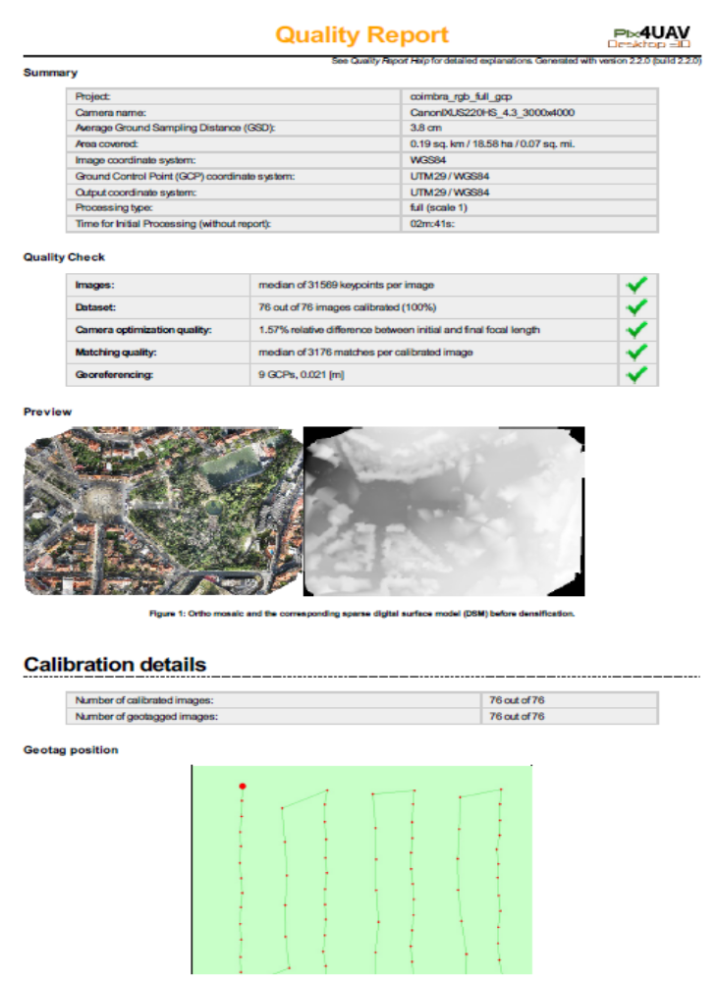

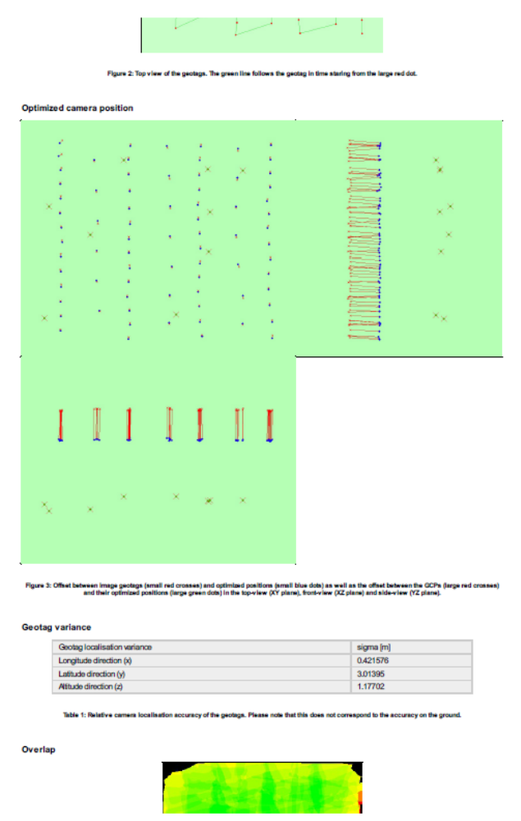

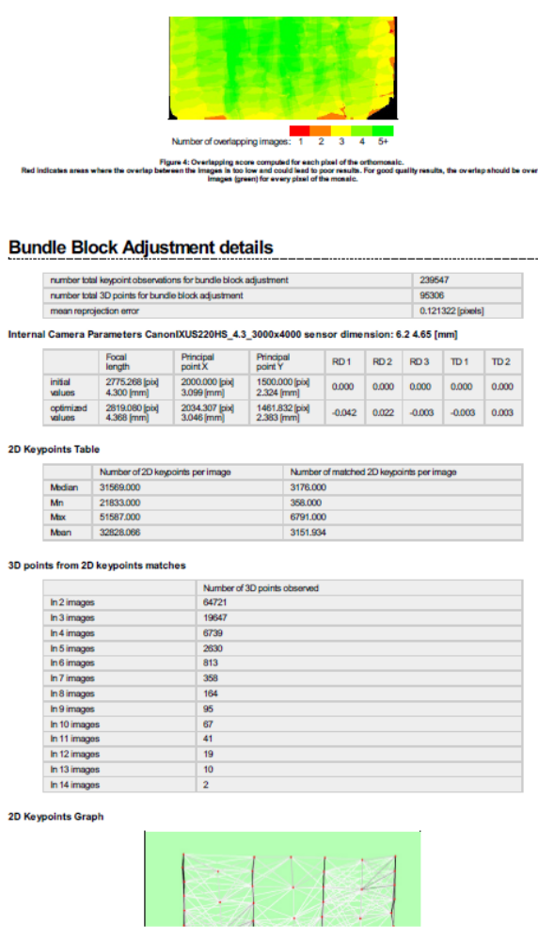

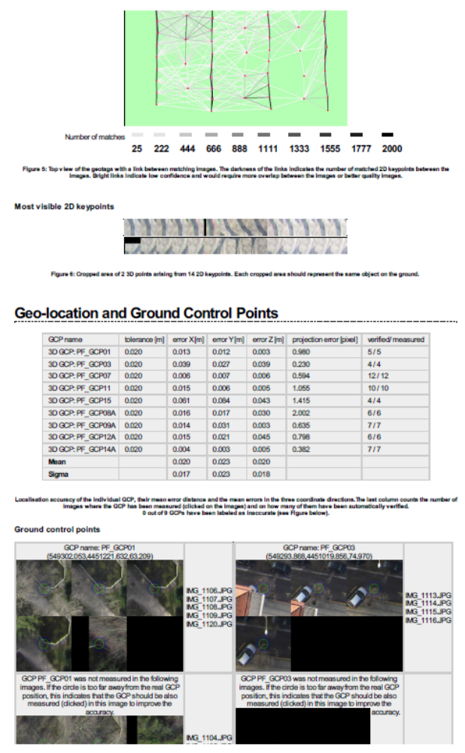
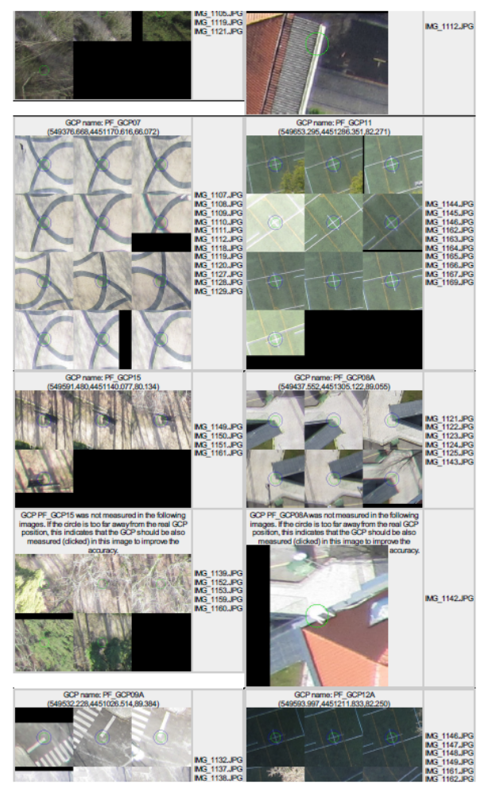

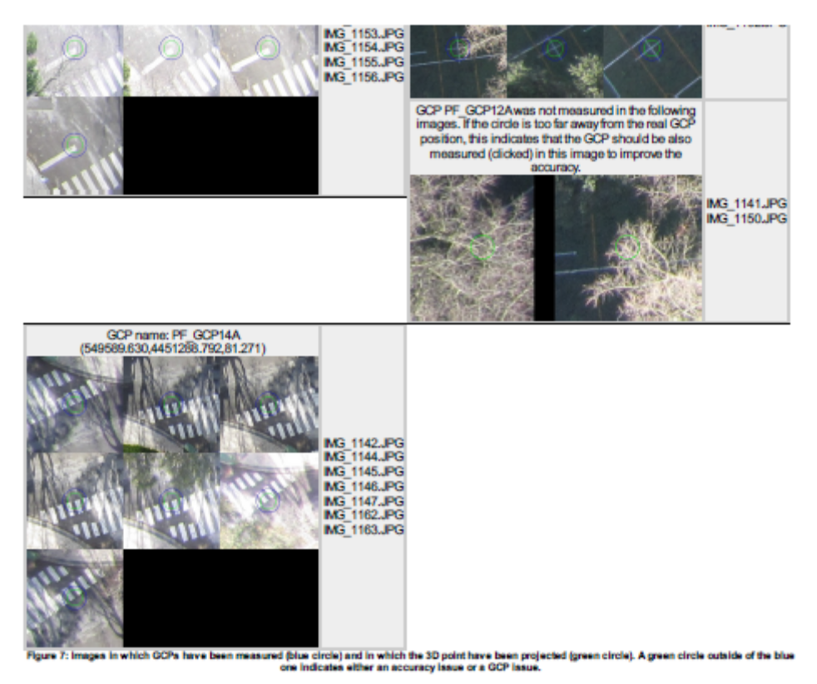

- PhotoScan Report
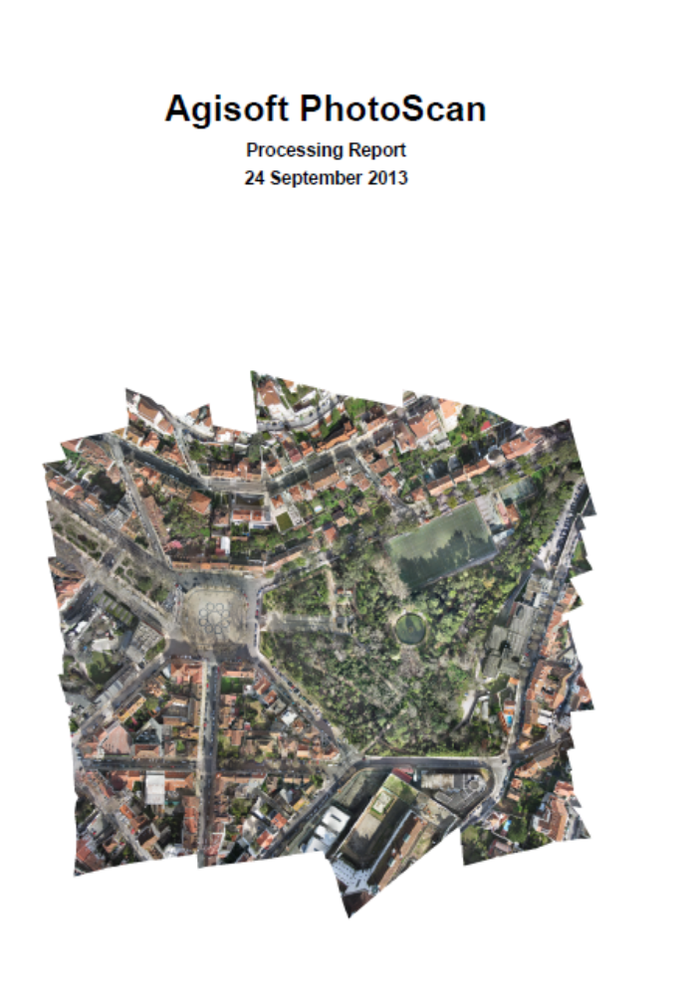

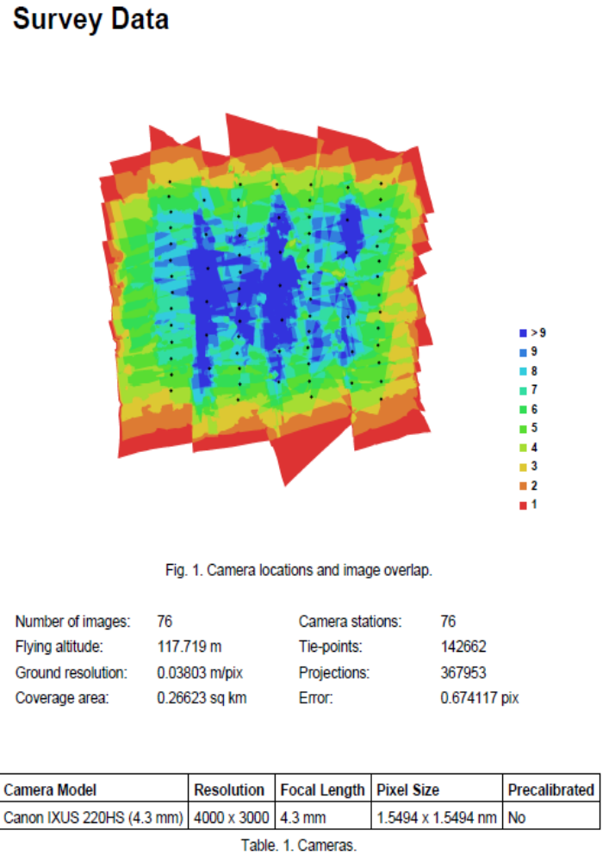

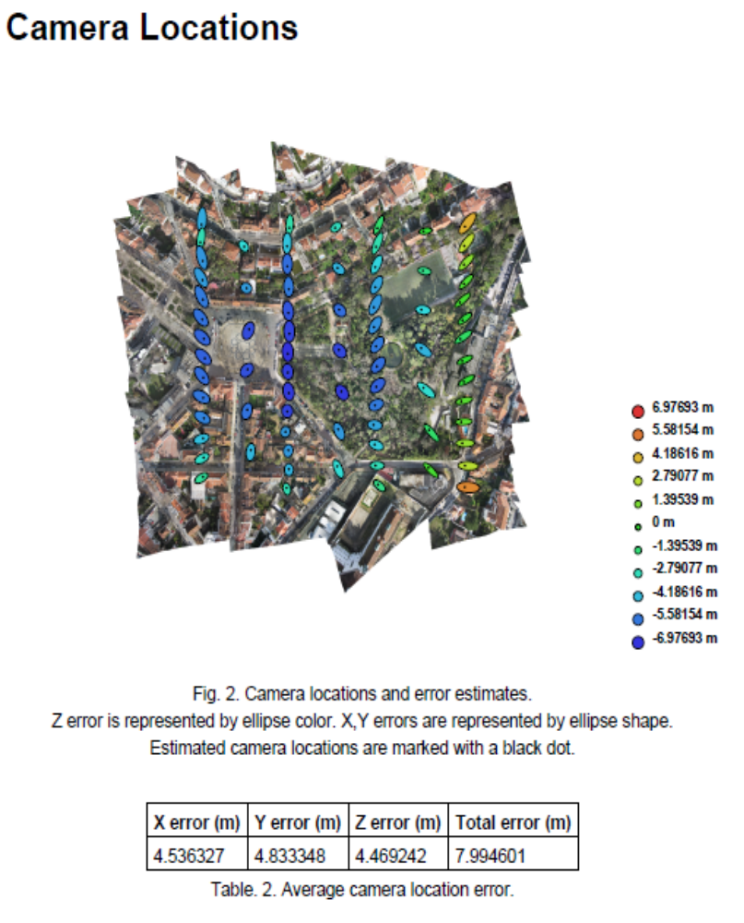

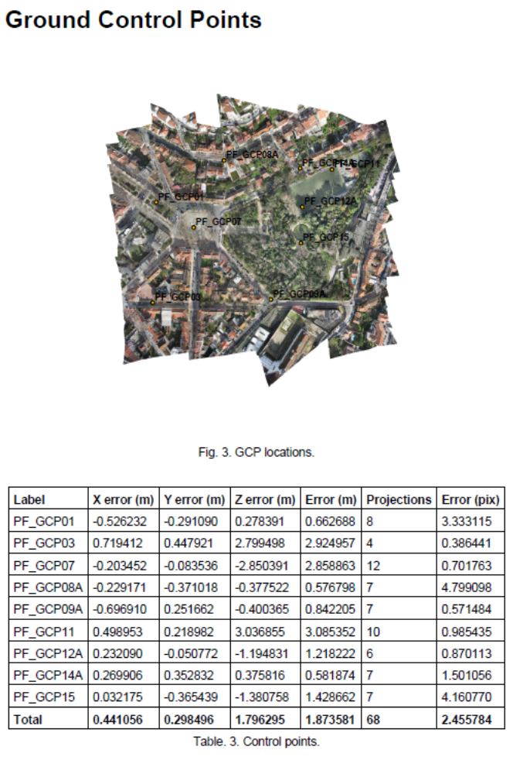

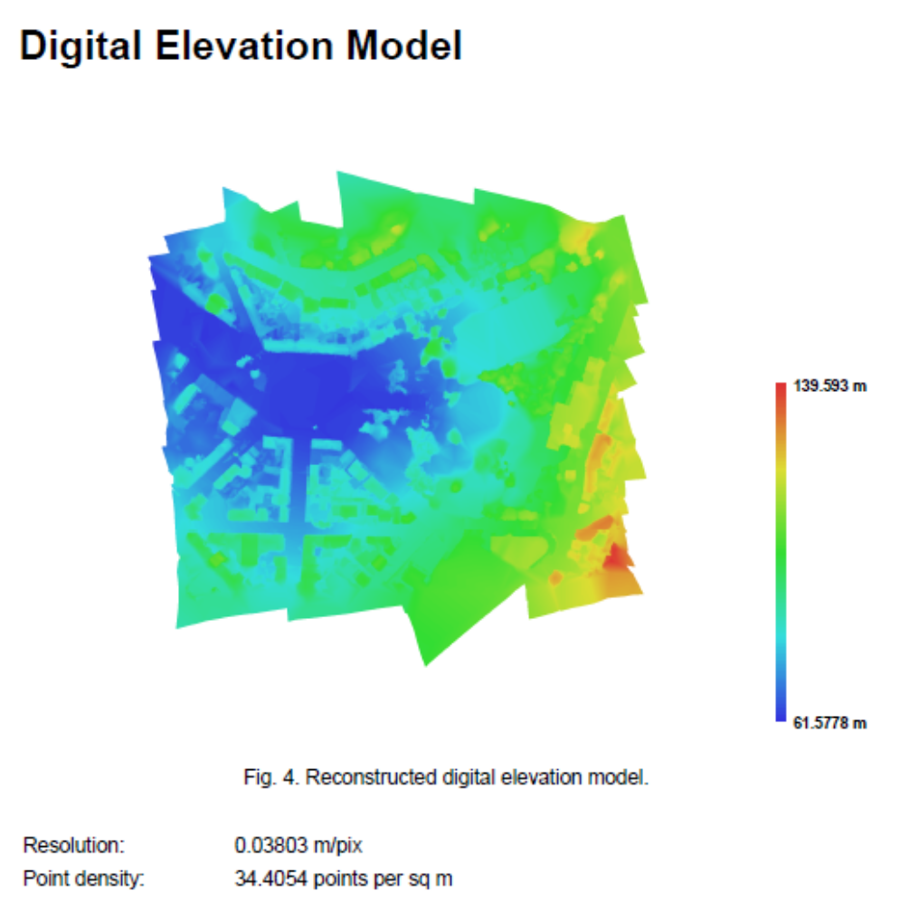
- OpenCV rotine to compare of SIFT, SURF and BRISK
#include <stdio.h>
#include <time.h>
#include <iostream>
#include "opencv2/opencv.hpp"
#include "opencv2/nonfree/nonfree.hpp"

#include <fstream>
#include <list>

using namespace cv;
using namespace std;

void readme();
bool sort_by_distance (DMatch , DMatch );

int main( int argc, char** argv )
{
{

initModule_nonfree();

int image_id=03; // image id of the data set (UPDATE for every new data set)
int cont=0, count_img=0, count_feat=0, id_good_match; //id_detector, id_extractor, id_matcher, median_index;
bool extractor_brisk=false;

double min_dist;
//double img_time;
//double t_end_1_secs, t_end_2_secs, t_total_secs, t_matching;

//OUTPUT FILES
FILE * f_out = fopen("C:\\IG\\CODES\\c++\\ILP\\Matching_test\\matching_results.txt", "w");
//FILE * f_out = fopen("C:\\IG\\CODES\\c++\\ILP\\Param_test\\param.txt", "w");
FILE * f_out_GENA = fopen("C:\\IG\\CODES\\c++\\ILP\\Matching_test\\GENA.txt", "w");
//FILE * f_out_test = fopen("C:\\IG\\CODES\\c++\\ILP\\Matching_test\\TEST.txt", "w");

char aux_str1[300], aux_str2[300];

//string detector_name_ = "SIFT"; // SIFT, SURF, BRISK, FAST, STAR, MSER, GFTT, HARRIS, DENSE
//string extractor_name_ = "SIFT"; // SIF, SURF, BRISK, FREAK, BRIEF

//string detector_name_ = "SURF";
//string extractor_name_ = "SURF";

string detector_name_ = "BRISK";
string extractor_name_ = "BRISK";

clock_t t_start;
clock_t t_detextr_1, t_detextr_2, t_matching, t_good_matches, t_pair_match, t_total=0;

vector<Mat> img;
Mat descriptors_0, descriptors_1;
Mat aux_img;
Mat H;
Mat img_matches;

vector<KeyPoint> keypoints_0, keypoints_1;
vector<KeyPoint> aux_v1, aux_v2;
vector<KeyPoint> keypoints_with_descriptor_0, keypoints_with_descriptor_1;

vector<Point2f> obj;
vector<Point2f> scene;

vector<DMatch> matches;
vector<DMatch> aux_match;
vector<DMatch> good_matches;

// PARAMETERS
// SIFT::SIFT(int nfeatures=0, int nOctaveLayers=3, double contrastThreshold=0.04, double edgeThreshold=10, double sigma=1.6) -> opencv.org
//^ quanto >, menor # features; ^ quanto maior, maior # features
// http://docs.opencv.org/modules/nonfree/doc/feature_detection.html#sift
//SIFT sift_detector (0, 3, 0.04, 10, 1.6); // DEFAULT
SIFT sift_detector (0, 3, 0.1, 4, 1.6);
//SIFT sift_detector (0, 3, 0.001, 40, 1.6); //IGI

// SURF::SURF(double hessianThreshold, int nOctaves=4, int nOctaveLayers=2, bool extended=true, bool upright=false )
SURF surf_detector (5000, 3);
BRISK brisk_detector (75);

FastFeatureDetector fast_detector (30, true);
StarFeatureDetector star_detector;
MserFeatureDetector mser_detector;
GoodFeaturesToTrackDetector GFTT_detector (1000, 0.01, 1., 3, false, 0.04);
GoodFeaturesToTrackDetector harris_detector (1000, 0.01, 1., 3, true, 0.04);
DenseFeatureDetector desnsefeatdetector;
BriefDescriptorExtractor brief_extractor;
FREAK freak_extractor;

DescriptorMatcher * BFmatcher_l2 = new BFMatcher (NORM_L2, true);
DescriptorMatcher * BFmatcher_h = new BFMatcher (NORM_HAMMING, true);
DescriptorMatcher * Flannmatcher = new FlannBasedMatcher ();

cout.precision(15);

do
{
// DATA FILES

// CATUAV
//sprintf(aux_str1, "C:\\IG\\DATA\\termic_img_CATUAV\\201302041327-imagen-00%.3d.tiff", image_id);
//sprintf(aux_str2, "C:\\IG\\DATA\\termic_img_CATUAV\\201302041327-imagen-00%.3d.tiff", image_id+1);

//sprintf(aux_str1, "C:\\Mavinci Data\\2012_10_24_Colombia_ClubAvispero\\Unprocessed_Images\\images\\P1000240_1351106427747.jpg");
//sprintf(aux_str2, "C:\\Mavinci Data\\2012_10_24_Colombia_ClubAvispero\\Unprocessed_Images\\images\\P1000241_1351106427747.jpg");

//sprintf(aux_str1, "C:\\IG\\DATA\\[20090527] Demo Dataset DigiTHERM [IGI]\\16bit\\Line_1_tiff_16\\exp0003660.tiff");
//sprintf(aux_str2, "C:\\IG\\DATA\\[20090527] Demo Dataset DigiTHERM [IGI]\\16bit\\Line_1_tiff_16\\exp0003670.tiff");

//sprintf(aux_str1, "C:\\IG\\DATA\\[20090527] Demo Dataset DigiTHERM [IGI]\\16bit\\Line_1_tiff_16\\exp000%.3d0.tiff", image_id);
//sprintf(aux_str2, "C:\\IG\\DATA\\[20090527] Demo Dataset DigiTHERM [IGI]\\16bit\\Line_1_tiff_16\\exp000%.3d0.tiff", image_id+1);

//sprintf(aux_str1, "F:\\Swinglet_Cam_Coimbra_2013\\Coimbra_28_Jan_2013_RGB\\voo\\Coimbra_Jan28\\IMG_1103.jpg");
//sprintf(aux_str2, "F:\\Swinglet_Cam_Coimbra_2013\\Coimbra_28_Jan_2013_RGB\\voo\\Coimbra_Jan28\\IMG_1104.jpg");

sprintf(aux_str1, "F:\\Swinglet_Cam_Coimbra_2013\\Coimbra_28_Jan_2013_RGB\\voo\\Coimbra_Jan28\\IMG_11%.2d.jpg", image_id);
sprintf(aux_str2, "F:\\Swinglet_Cam_Coimbra_2013\\Coimbra_28_Jan_2013_RGB\\voo\\Coimbra_Jan28\\IMG_11%.2d.jpg", image_id+1);

cout << "IMG 1:" << endl;
cout << aux_str1 << endl;
cout << "IMG 2:" << endl;
cout << aux_str2 << endl << endl;

aux_img = imread( aux_str1, CV_LOAD_IMAGE_COLOR );
//aux_img = imread( aux_str1, CV_LOAD_IMAGE_GRAYSCALE); //!! IGI data set FUNCIONA MAL!!
img.push_back(aux_img);

aux_img = imread( aux_str2, CV_LOAD_IMAGE_COLOR );
//aux_img = imread( aux_str1, CV_LOAD_IMAGE_GRAYSCALE);
img.push_back(aux_img);

if( !img[0].data || !img[1].data )
{ cout<< " --(!) End of images " << endl; break;}

image_id++;

// start detection image 1

t_start = clock();
if ( detector_name_ == "SIFT")
sift_detector.operator()(img[0], cv::noArray(), keypoints_0, descriptors_0, false);
else if( detector_name_ == "SURF")
surf_detector.operator()(img[0], cv::noArray(), keypoints_0, descriptors_0, false);
else if( detector_name_ == "BRISK")
brisk_detector.operator()(img[0], cv::noArray(), keypoints_0, descriptors_0, false);
else if( detector_name_ == "FAST")
fast_detector.detect ( img[0], keypoints_0 );
else if( detector_name_ == "STAR")
star_detector.detect ( img[0], keypoints_0 );
else if( detector_name_ == "MSER")
mser_detector.detect ( img[0], keypoints_0 );
else if( detector_name_ == "GFTT")
GFTT_detector.detect ( img[0], keypoints_0 );
else if( detector_name_ == "HARRIS")
harris_detector.detect ( img[0], keypoints_0 );
else if( detector_name_ == "DENSE")
desnsefeatdetector.detect ( img[0], keypoints_0 );

keypoints_with_descriptor_0 = keypoints_0; // In extraction, method 'compute' removes features if descriptor cannot be computed

// start extraction image 1

if ( extractor_name_ == "SIFT")
sift_detector.operator()(img[0], cv::noArray(), keypoints_with_descriptor_0, descriptors_0, true);
else if( extractor_name_ == "SURF")
surf_detector.operator()(img[0], cv::noArray(), keypoints_with_descriptor_0, descriptors_0, true);
else if( extractor_name_ == "BRISK")
brisk_detector.operator()(img[0], cv::noArray(), keypoints_with_descriptor_0, descriptors_0, true);
else if( extractor_name_ == "FREAK")
freak_extractor.compute (img[0], keypoints_with_descriptor_0, descriptors_0);
else if( extractor_name_ == "BRIEF")
brief_extractor.compute (img[0], keypoints_with_descriptor_0, descriptors_0);

//t_end = clock() - t_start; // (1)
//t_end_1 = (clock() - t_start)/CLOCKS_PER_SEC;
t_detextr_1 = clock() - t_start;
printf("Feature detection and descritption (Img1): \n");
printf(" --> %d features detected\n", keypoints_0.size());
printf(" --> %d features succesfully described\n", keypoints_with_descriptor_0.size());
//printf(" --> %f total time\n\n", (double)t_end/CLOCKS_PER_SEC); // (1)
printf(" --> %f total time (secs)\n\n", (double)t_detextr_1/CLOCKS_PER_SEC);

// start detection image 2

t_start = clock();
if ( detector_name_ == "SIFT")
sift_detector.operator()(img[1], cv::noArray(), keypoints_1, descriptors_1, false);
else if( detector_name_ == "SURF")
surf_detector.operator()(img[1], cv::noArray(), keypoints_1, descriptors_1, false);
else if( detector_name_ == "BRISK")
brisk_detector.operator()(img[1], cv::noArray(), keypoints_1, descriptors_1, false);
else if( detector_name_ == "FAST")
fast_detector.detect ( img[1], keypoints_1 );
else if( detector_name_ == "STAR")
star_detector.detect ( img[1], keypoints_1 );
else if( detector_name_ == "MSER")
mser_detector.detect ( img[1], keypoints_1 );
else if( detector_name_ == "GFTT")
GFTT_detector.detect ( img[1], keypoints_1 );
else if( detector_name_ == "HARRIS")
harris_detector.detect ( img[1], keypoints_1 );
else if( detector_name_ == "DENSE")
desnsefeatdetector.detect ( img[1], keypoints_1 );

keypoints_with_descriptor_1 = keypoints_1; // In extraction, method 'compute' removes features if dewscriptor cannot be computed

// start extraction image 2

if ( extractor_name_ == "SIFT")
sift_detector.operator()(img[1], cv::noArray(), keypoints_with_descriptor_1, descriptors_1, true);
else if( extractor_name_ == "SURF")
surf_detector.operator()(img[1], cv::noArray(), keypoints_with_descriptor_1, descriptors_1, true);
else if( extractor_name_ == "BRISK")
brisk_detector.operator()(img[1], cv::noArray(), keypoints_with_descriptor_1, descriptors_1, true);
else if( extractor_name_ == "FREAK")
freak_extractor.compute (img[1], keypoints_with_descriptor_1, descriptors_1);
else if( extractor_name_ == "BRIEF")
brief_extractor.compute (img[1], keypoints_with_descriptor_1, descriptors_1);

t_detextr_2 = clock() - t_start;
printf("Feature detection and descritption (Img2): \n");
printf(" --> %d features detected\n", keypoints_1.size());
printf(" --> %d features succesfully described\n", keypoints_with_descriptor_1.size());
//printf(" --> %f total time\n\n", (double)t_end/CLOCKS_PER_SEC);
printf(" --> %f total time (secs)\n\n", (double)t_detextr_2/CLOCKS_PER_SEC);

// start matching image 1 and 2

matches.clear();
good_matches.clear();

t_start = clock();

if( extractor_name_ == "SIFT" || extractor_name_ == "SURF")
{
BFmatcher_l2 -> match ( descriptors_0, descriptors_1, matches);
//BFmatcher_l2 -> radiusMatch (descriptors_object, descriptors_scene, matches, 80); //different possible matches
}
else if( extractor_name_ == "BRISK" || extractor_name_ == "BRIEF"|| extractor_name_ == "FREAK")
{
BFmatcher_h -> match ( descriptors_0, descriptors_1, matches);
//BFmatcher_h -> radiusMatch (descriptors_object, descriptors_scene, matches, 80); //different possible matches
}
else
{
Flannmatcher -> match ( descriptors_0, descriptors_1, matches);
}

t_matching = clock() - t_start;
printf("Img 1 & Img 2 Feature Matching in %f secs\n\n", (double)t_matching/CLOCKS_PER_SEC);

// DEFINE GOOD MATCHES (FILTER KEYPOINTS)
// Distance criteria: if 3 times bigger than the minimum, not a good match
t_start = clock();

id_good_match = 3; //CHOOSE CRITERIA (1, 2, 3)

if(id_good_match == 1)
{
good_matches = matches;
}
else if(id_good_match == 2)
{
sort(matches.begin(), matches.end(), sort_by_distance);

for (int i = 0; i < matches.size(); i++)
{
if ( (matches[i].distance - matches[0].distance) < 0.4 * (matches[matches.size()-1].distance - matches[0].distance))
good_matches.push_back (matches[i]);
else
break;
}
}
else if(id_good_match == 3)
{
min_dist = 10000;

for (int i = 0; i<matches.size();i++) {if(matches[i].distance < min_dist) min_dist=matches[i].distance;}
for (int i = 0; i<matches.size();i++)
{
if ( matches[i].distance < 4. * min_dist)
good_matches.push_back (matches[i]);
}
}

t_good_matches = clock() - t_start;
// double t_good_matches_sec = t_good_matches/CLOCKS_PER_SEC;

cout << "NUMBER OF MATCHES: " << matches.size() << endl;
cout << "NUMBER OF GOOD MATCHES: " << good_matches.size() << endl;
cout << "GOOD MATCHES CALCULATION TIME: " << (double)t_good_matches/CLOCKS_PER_SEC << endl;
cout << "\n";

//t_total += t_detextr_1 + t_detextr_2 + t_matching + t_good_matches;
t_pair_match = t_detextr_1 + t_detextr_2 + t_matching + t_good_matches;
//t_total += t_pair_match;

cout << "IMAGE PAIR MATCHING TIME (secs): " << (double)t_pair_match/CLOCKS_PER_SEC << endl;
cout << "_____________________________________________" << endl << endl;
//t_total_secs = t_total/CLOCKS_PER_SEC;
// cout << "MATCHING TOTAL TIME: " << (double)t_total/CLOCKS_PER_SEC/60 << " minutes" <<endl;
// WRITE GOOD MATCHES to TXT FILE

//break;

cont=0;
for( int i = 0; i < good_matches.size(); i++ )
{
obj.push_back ( keypoints_0[ good_matches[i].queryIdx ].pt );
scene.push_back( keypoints_1[ good_matches[i].trainIdx ].pt );

if (i > 0 &&
fabs(keypoints_0 [ good_matches[i].queryIdx ].pt.x - keypoints_0 [ good_matches[i-1].queryIdx ].pt.x) < 1. &&
fabs(keypoints_0 [ good_matches[i].queryIdx ].pt.y - keypoints_0 [ good_matches[i-1].queryIdx ].pt.y) < 1. )
{
continue;
}

//fprintf(f_out, "%lf %lf %lf %lf\n",
//keypoints_0 [ good_matches[i].queryIdx ].pt.x,
//keypoints_0 [ good_matches[i].queryIdx ].pt.y,
//keypoints_1 [ good_matches[i].trainIdx ].pt.x,
//keypoints_1 [ good_matches[i].trainIdx ].pt.y);

// <o> id_imagen id_punto x y </o>
//fprintf(f_out_GENA, "<o> %i %i %lf %lf </o>\n",
//image_id, good_matches[i].queryIdx, keypoints_0 [ good_matches[i].queryIdx ].pt.x, keypoints_0 [ good_matches[i].queryIdx ].pt.y);
//image_id, good_matches[i].queryIdx, keypoints_0 [ good_matches[i].queryIdx ].pt.x, keypoints_0 [ good_matches[i].queryIdx ].pt.y);

//fprintf(f_out_GENA, "<o> %i %i %lf %lf </o>\n",
//image_id +1, good_matches[i].trainIdx , keypoints_1 [ good_matches[i].trainIdx ].pt.x, keypoints_1 [ good_matches[i].trainIdx ].pt.y);
//image_id +1, good_matches[i].queryIdx , keypoints_1 [ good_matches[i].trainIdx ].pt.x, keypoints_1 [ good_matches[i].trainIdx ].pt.y);

//fprintf(f_out_test, "<< %d %d %d %f %d %f %f %d %f>>\n",
//image_id, image_id + 1, keypoints_0.size(), (double)t_detextr_1/CLOCKS_PER_SEC), keypoints_1.size(), (double)t_detextr_2/CLOCKS_PER_SEC)matches.size(), t_pair_match/CLOCKS_PER_SEC, good_matches.size(), (double)t_matching/CLOCKS_PER_SEC, );

cont++;

}

// DRAW IMAGES & CONNECT MATCHES

/*
H = findHomography( obj, scene, CV_RANSAC );
cout << H.row(0) << endl;
cout << H.row(1) << endl;
cout << H.row(2) << endl;*/

//*
drawMatches( img[0], keypoints_0, img[1], keypoints_1,
good_matches, img_matches, Scalar::all(-1), Scalar::all(-1),
vector<char>(), cv::DrawMatchesFlags::DRAW_RICH_KEYPOINTS );

namedWindow("Matches & Object detection", CV_WINDOW_NORMAL);
imshow( "Matches & Object detection", img_matches );

//break;
waitKey();
//*/

//fprintf(f_out, "%d %f\n", good_matches.size(), (float)good_matches.size()/matches.size());
//fflush(f_out);

img.clear();
keypoints_0.clear();
keypoints_with_descriptor_0.clear();
keypoints_1.clear();
keypoints_with_descriptor_1.clear();

descriptors_0.empty();
descriptors_1.empty();
matches.clear();
good_matches.clear();
img_matches.empty();

obj.clear();
scene.clear();
count_img++;

cout << endl;
cout << endl << "========================= ANALYZING NEW PAIR OF IMAGES =======================" << endl;
cout << endl;

}while(1);

cout << "*** Number of images: " << count_img <<endl;
cout << "*** Average Matching TIME per image: " << (double)(t_total/CLOCKS_PER_SEC)/count_img << " minutes ***" <<endl;

delete BFmatcher_l2;
delete BFmatcher_h;
delete Flannmatcher;

return 0;
}
}

void readme()
{ cout << " Usage: ./exe_name <img1> <img2>" << endl; }

bool sort_by_distance (DMatch m1, DMatch m2) { return (m1.distance<m2.distance); }

- Visual Basic rotine for tiepoint coordinate approximation
Sub TP_init_aprox()

Dim ws1 As Worksheet: Set ws1 = ThisWorkbook.Sheets("Sheet1")
Dim ws2 As Worksheet: Set ws2 = ThisWorkbook.Sheets("Sheet2")
Dim rang As String

Set ws1 = ThisWorkbook.Sheets("Sheet1")
For i = 1001 To 3491 Step 1
' identificar conjunto de imagens onde aparece o TP t
' primeira occurrência
Application.Range("B4:B11038").Find(i).Select
start_cell = ActiveCell.Address(False, False)
Range("A1") = start_cell
start_row = ActiveCell.Row
Range("B1") = start_row

' última ocurrência
last = Application.WorksheetFunction.CountIf(Range("B1:B11038"), i)
Range("B1") = last
end_row = start_row + last - 1
Range("B2") = end_row
last_cell = "B" & end_row
Range("A2") = last_cell

' definir range das respectivas distâncias
rang = "E" & start_row & ":" & "E" & end_row
Range("D1") = rang
Application.Range(rang).Select

Min = Application.WorksheetFunction.Min(Range(rang))
Range("D2") = Min

For Each C In Range(rang)
If C.Value = Min Then
C.EntireRow.Copy
ws2.Rows(i - 1000).PasteSpecial
End If
Next C

Next i

End Sub

Sub TP_height_init_aprox()
Dim j As Integer
Dim v As Range
'Dim MyRange As Range
Dim ws1 As Worksheet: Set ws3 = ThisWorkbook.Sheets("Sheet1")
Dim ws2 As Worksheet: Set ws4 = ThisWorkbook.Sheets("Sheet2")
'Set ws3 = ThisWorkbook.Sheets("Sheet3")

'For Each v In Range("L1:L10")
j = 1
For i = 1 To 11 Step 1
MyRange = "L" & i
c = Application.WorksheetFunction.Index(i,
With ws2
Range("H3") = Range(MyRange).Value2
'v = 5000625
'Range("G1") = v

End With
Next i
End Sub

- Matlab rotine to filter the tiepoints with high residuals

----------------------------- TP_filter.m ------------------------------------------

%{
Identifies x-fold TPs and re-values them to 9999 to be eliminated afterwards

INSTRUCTION:
Import TO "data_tp" matrix:
C:\IG\GENA\GENA files\TP\TP_123_img_filter\TP_123_img_filter.csv
or
C:\IG\GENA\GENA files\TP\TP_123_img_filter\TP_residuals_sin_v-2_2.csv

data_tp necesssary Columns:
1: #TP | 2: #img : Y | 3: (blank)
4: img name | 5: img #| 6: TP # | 7: TP img coord x | 8: TP img coord x
%}

clc
clear i,j

[line,col] = size(data_tp)

to_remove = 0;
x = 0;

for i = 1:2491
if data_tp(i,2) == x % | data_tp(i,2) == 2 | data_tp(i,2) == 3
tp = data_tp(i,1)
% Search TP in table
for j = 1:11035 % existing TPs
if data_tp(j,6) == tp
data_tp(j,3) = 9999;
to_remove = to_remove +1;
%else
%data_tp(j,3) = '<o s="a">';
end
end
end
%i = i + 1;
end
%x_to_remove = to_remove/x

total_to_remove = to_remove

-------------------------- TP_9999_cleaner.m ------------------------------

%{
Eliminates rows with 9999 elements

INSTRUCTION:
Import TO "tp_9999" matrix:
C:\IG\GENA\GENA files\TP\TP_123_img_filter\Total_sin_v-2_to_remove_9999.csv

data_tp necesssary Columns:
% Col.1: 9999s | Col.2: 0s
% Col.3: = img # | Col.4: TP # | Col.5: img coord x | Col.6: img coord y
%}

[l,c] = size(tp_9999);
TPs = 0;
eliminated = 0;
i = 1;
while i <= l
if tp_9999(i,1) == 9999
tp_9999(i,:) = []; % eliminate line
eliminated = eliminated + 1;
else
i = i +1;
TPs = TPs + 1;
%continue
end
end

