




MASTER
ECONOMICS

Hysteresis in the Dynamics of Investment: Tangible vs Intangible Assets
Rodrigo Andrade Ribeirinho Soares

M
2023



Hysteresis in the Dynamics of Investment: Tangible vs Intangible Assets

Rodrigo Andrade Ribeirinho Soares

Dissertation
Master in Economics

Supervised by

Professor Paulo Ricardo Tavares Mota

2023

Agradecimentos

Esta dissertação é fruto de um esforço pessoal aliado ao acompanhamento e apoio de várias pessoas. Razão pela qual não lhes poderia deixar de agradecer.
Agradeço ao Professor Paulo Mota, todo o acompanhamento, disponibilidade e empenho ao longo deste processo. Além de orientador desta dissertação, considero ser um Professor de excelência e alguém com quem tive a felicidade de aprender nas unidades curriculares em que fui seu aluno.
Agradeço à minha família por ter apoiado e incentivado todo o meu percurso académico e por me terem proporcionado a oportunidade de aprender. Aprender é algo de que verdadeiramente gosto e sinto-me com muita sorte de o poder ter feito na Faculdade de referência que é a Faculdade de Economia do Porto com o seu corpo docente de prestígio, a quem endereço também os meus agradecimentos, por todas as aulas que tive, todos os momentos de aprendizagem de que pude usufruir e pela disponibilidade que sempre demonstraram em esclarecer as minhas dúvidas.
Agradeço à minha namorada por ser uma fonte inesgotável de felicidade e de apoio. Agradeço também aos meus amigos, pelo suporte contínuo.

Resumo

Os efeitos de histerese estão presentes num abrangente conjunto de áreas nas economias, no entanto nem sempres são bem compreendidos ou mensurados. Histerese refere-se à propriedade de um sistema de input-output em que certos efeitos persistem mesmo após as causas que lhes deram origem terem sido removidas. Na presença de um sistema histerético, não existe um equilíbrio único, mas ao invés existem múltiplos equilíbrios que são dependentes da história do sistema (path-dependent). Compreender os efeitos de histerese é de crucial importância para a melhor formulação de políticas económicas que visam contribuir para um aumento do bem-estar da sociedade.
Esta dissertação estuda a presença de histerese na dinâmica do investimento, mais especificamente os potenciais diferentes efeitos de histerese no investimento entre ativos intangíveis e ativos tangíveis. Para tal usamos o, linear play model de histerese, implementado através de um tipo de equação de switching.
No trabalho empírico utilizamos dados trimestrais para os países do G7, obtidos das bases de dados da OCDE, no período compreendido entre o primeiro trimestre de 2000 e o último trimestre de 2022. Os resultados corroboram a existência de histerese na dinâmica do investimento em ativos tangíveis e intangíveis. Concluímos que a magnitude dos efeitos de histerese é maior no caso do investimento em ativos intangíveis em quatro das sete economias analisadas.

Códigos JEL: C61, E22, E44
Palavras-chave: incerteza, custos de ajustamento não-convexos, investimento, histerese.

Abstract

Hysteresis effects present themselves in a broad scope of fields in economies yet are not always well measured or understood. Hysteresis is a property of an input-output system where certain effects persist after the causes that have brought them about have been removed. Under a hysteretic system, there is no single point of equilibrium but rather multiple equilibria that are in turn path-dependent. Understanding hysteresis effects is of crucial importance for the better design of economic policies that aim to contribute to a greater society's welfare.
This thesis studies the presence of hysteresis in the dynamics of investment, more specifically the possible different hysteresis effects between intangible investment and tangible investment. To do so we apply the linear play model of hysteresis, through a kind of switching equation.
In the empirical work, we use quarterly data for the G7 countries, obtained from the OECD databases, in the time span between the first quarter of 2000 and the last quarter of 2022. The results corroborate the existence of hysteresis in the dynamics of investment in tangible and intangible assets. We conclude that the magnitude of hysteresis effects is greater in the case of the investment in intangible assets in four of the seven economies analysed.

JEL codes: C61, E22, E44
Keywords: uncertainty, non-convex adjustment costs, investment, hysteresis.

Index

Agradecimentos i
Resumo ii
Abstract iii

Introduction 1

Chapter 1. Literature Review 3

1.1 The Concept and the Properties of Hysteresis 3
1.2 The Micro-Foundations of the Presence of Hysteresis in the Dynamics of Investment 4
1.3 The Particular Characteristics of Intangible Assets 6

Chapter 2. The Model of Hysteresis 15

2.1 The Non-Ideal Relay Model 15
2.2 The Preisach Model 19

Chapter 3. The Empirical Strategy 24

3.1 The Play Model of Hysteresis 24
3.2 The Data 28

Chapter 4. Results of the Estimation 34

Conclusion 43

Appendix 44

References 48

Index of Figures

Figure 1- Relationship between Investment and Productivity. 9
Figure 2- Ratio of Intangible to Tangible Assets for US public firms, 1975-2021. 11
Figure 3- Tangible vs Intangible Investment’s Share of GDP. 12
Figure 4- Financial Structure of different regions. 14
Figure 5- Graphic Representation of the Non-Ideal Relay Model. 17
Figure 6- Hysteretic Investment Dynamics 20
Figure 7- Preisach Loop of Hysteresis 22
Figure 8- Linear Play loop 25
Figure 9- Tangible and Intangible Investment Dynamics 29
Figure 10- Rate of Capacity Utilization, Manufacturing (2000-2022). 32
Figure 11- R² of the Investment Equation (for the USA) for each Play Value Chosen from the Grid. 40
Figure 12- Original Forcing Variable of the Investment Equation and the Hysteresis Variable for the USA 41
Figure 13- Investment Band of Inaction for the G7, Tangibles vs Intangibles 42

Index of Tables

Table 1- Components of Intangible investment 7
Table 2- Unit Root Tests 35
Table 3- FM-OLS Estimation Results of the Investment Hysteresis Equation 38

Introduction

The recent Covid-19 pandemic crisis, as well as the global financial crisis that started in August 2007 in the USA, were major disruptions in economic activity. Crises of this dimension can in turn have long-term consequences, such as a sub-optimal persistent level of investment. A lower level of investment originates a lower quality of the capital stock of firms, as over time the capital stock degrades becoming outdated, inefficient or unusable. By investing, firms can better suit their production needs, lower their production costs and even expand their production capacity, resulting in an increased, or more efficient, production of goods and services. As a consequence, prolonged low levels of investment have long-term consequences on economic growth.
Therefore the dynamics of the investment may display hysteresis, defined as a property of an input-output system in which some temporary shocks have permanent effects. Under a hysteretic system, the reversion of a negative shock (that harms the investment), does not lead the system back to its original position, i.e., the shock’s effects remain even after the initial causes have been removed.
As technology evolves and human capital stock levels rise, developed economies become more reliant on the use of intangible assets that are seen as increasing labour productivity (Roth & Thum, 2013) and firms’ sales growth (Cucculelli & Betinelli, 2015). In turn, this dynamic leads to greater investment in this type of asset.
Intangible assets are more firm-specific in comparison with tangible assets. That is why it is more difficult to resell them, i.e., they have significant sunk costs. As a consequence, the investment in intangible assets is more prone to display hysteresis effects.
Over the last decades, the analysis of the presence of hysteresis effects in the dynamics of investment has flourished. Notably, Pyndick (1991), Dixit (1992) and later Dixit and Pyndick (1994) laid the groundwork for other researchers to build upon (see Dias & Shackleton, 2011, Bassi & Lang, 2016, Belke et al., 2019 and Mota & Vasconcelos 2022a). However, as far as we know there are no studies that compare the magnitude of hysteresis effects between tangible and intangible investment, at least with methodologies that follow closely to the original definition of hysteresis.
The purpose of our study is to shed some light on the following research question: Does the intangible investment have associated greater hysteresis effects than the tangible investment?
This topic has also important policy implications. Indeed, the presence of hysteresis in the dynamics of investment works as an argument for the application of policies designed to protect the investment from falling following major recessions.
To describe the hysteretic dynamics of investment at the firm level we apply the non-ideal relay model of hysteresis, and we use the well-known Preisach operator to aggregate firms’ behaviour up to the macro level. In the empirical work, we use the linear play model of hysteresis which can be viewed as a linearization of the Preisach loop (see, Visintin, 1994).
The linear play model is implemented by means of a kind of investment switching equation in which for relatively large changes in aggregate demand there is a strong response of aggregate investment, whereas for relatively small changes of aggregate demand there is a weak reaction of aggregate investment. Within this framework the estimated switching parameter of the investment equation is used as a proxy of the magnitude of the hysteresis effects.
We use OECD quarterly data for the G7 countries, from the first quarter of 2000 to the last quarter of 2022.
This thesis is organized as follows. Chapter 1 presents the concept of hysteresis, its properties and an adequate literature review. Chapter 2 presents a model of weak (microeconomic) and strong (macroeconomic) hysteresis. Chapter 3 presents the empirical strategy and the data set. Chapter 4 presents our empirical results and afterwards, we then conclude.

Chapter 1. Literature Review

The Concept and the Properties of Hysteresis

The term “hysteresis” derives from the ancient Greek term “ύστερέω" which means, “that which comes later”, having been coined by James Alfred Ewing, a Scottish engineer and university professor, in the field of physics of magnetism in 1881 (see Cross, 1993).

However, the concept of hysteresis is far from merely applying to the field of physics and engineering. In Ewing’s own words (1885, p.526): “(…) there are cases of hysteresis which have, as far as can be seen, nothing to do with magnetic condition, (…) I have therefore found it convenient and even necessary to employ a new term, which merely designates this peculiar action without implying any theory as to its cause”.

Hysteresis can be defined as a property of an input-output system in which some temporary shocks may have permanent effects (see, Mayergoyz, 1986; 2003). In other words, a hysteretic system exhibits path dependence. According to Mayergoyz (1986; 2003), a hysteretic system has the properties of nonlinearity, remanence, and selectivity. Nonlinearity refers to the notion that reversing the original shock would not bring the system back to its original path. Remanence implies that there can be permanent effects due to temporary shocks. Finally, selectivity entails that only large and non-dominated shocks can originate permanent effects. Under hysteresis, there are multiple equilibria that are path dependent, i.e., the equilibrium value of the system depends on the sequence of the historical values of the input (explanatory) variable.
Hysteresis was introduced in labour economics by Phelps (1972) that recognized that the equilibrium rate of unemployment could depend upon the actual unemployment rate, rather than being stable as before theorized. Since then unemployment and employment hysteresis has attracted considerable interest in the economic literature (see, e.g., Blanchard & Summers, 1986, Amable et al., 1995, Cross, 1995, Belke & Göcke, 1999; 2001a; b, Darby et al., 2005, Mota et al., 2012; 2015, Mota & Vasconcelos, 2012; 2015; 2020; 2021, Cuestas & Gil-Alana, 2023, and Konstantinos, 2023). Hysteresis is also being studied in other economic domains, such as international trade (see, e.g., Baldwin, 1988, Baldwin & Krugman, 1989, Dixit, 1989, Kannebley Jr., 2008, and Campbell, 2020), and investment (see, e.g., Pyndick, 1991, Dixit, 1992, Dixit & Pyndick, 1994, Dias & Shackleton, 2011, Bassi & Lang, 2016, Belke & Göcke, 2019, Mota & Vasconcelos, 2022a, and Fornaro & Wolf, 2023).

The Micro-Foundations of the Presence of Hysteresis in the Dynamics of Investment

Hysteresis in the dynamics of aggregate investment is mainly caused by the presence of non-convex investment adjustment costs at the firm level.

Adjustment costs are classified as convex (variable) or non-convex (fixed or linear), depending on how they vary with the size of the investment adjustment. In the absence of such adjustment costs firms would, in theory, instantly adjust their portfolio of investments to its optimal value in reaction to variations in economic conditions such as the state of aggregate demand and the level of interest rates (Cooper & Haltiwanger, 2006). However, we know from empirical observation that firms do not behave in this manner. In practice, we do not observe such rapid, swift, and disruptive changes in investment decisions for every minor or even moderate change in the state of economic activity (see, Dixit, 1992, Dixit & Pyndick, 1994, Dias & Shackleton, 2011, Bassi & Lang, 2016, Belke & Göcke, 2019, Belke et al., 2019).

The reason that explains why firms do not instantly adjust their investment portfolio is fundamentally tied to the presence of non-convex adjustment costs. The acquisition of an asset by a firm frequently entails a given degree of irreversibility that is higher the more firm-specific the asset is. As such firms incur in sunk costs related to investment and the acquisition of assets (see, Dixit, 1989; 1992, Pyndick, 1991, Dias & Shackleton, 2011, Bassi & Lang, 2016, Adamonis & Göcke, 2019, and Belke & Göcke, 2019).
One source of sunkenness is the inexistence of secondary markets for some assets, in the sense that if after the acquisition of an asset, if a firm decides to disinvest, it will be difficult or even impossible to resell that asset (Cooper & Haltiwanger, 2006). For this reason, there is a strong irreversibility associated with the acquisition of certain types of assets. This irreversibility is higher the more firm-specific the asset is.
Industry-specific investment expenditures are considered to be sunk costs and that derives from the notion that the firms act in a competitive environment. In a competitive environment if an investment decision proves to be fruitless for one firm, then it is likely that it is going to be fruitless for the other firms because the value of the assets acquired will be about the same for all firms in the industry, therefore, to be considered as a mostly sunk cost (Pyndick, 1991). Another reason that explains why investment expenditures entail a given level of irreversibility is because of asymmetric information, as assets hold less resale value than under perfect information, contributing to larger sunk costs (Pyndick, 1991, Dixit & Pyndick, 1994, Folta et al., 2006, and Bontempi, 2016).
Let us consider a firm that is making an initial investment. This firm will incur in sunk costs, such as market research, setting up supplier chains, advertising campaigns and marketing to create customer awareness and establish a brand. At the same time, firms also face exit costs, if they consider disinvesting reselling of firm-specific assets could be difficult.
When a firm decides to invest, the firm-specific investments ought to be considered as sunk costs, however, as long as the firm does not disinvest those sunk costs do not have to be written off. In a full cycle of investment and disinvestment, both sunk entry costs and sunk exit costs have to be written off. As a consequence, there is a dynamic loss consisting of the sum of sunk entry and sunk exit costs, analogous to a hysteresis loss in physics. These adjustment costs create hysteresis effects inducing path-dependent investment dynamics. (Adamonis & Göcke, 2019).

Under the presence of hysteresis, firms’ investment reactions are discontinuous and lumpy, with episodes of large adjustment between large periods of inaction (see, e.g., Pyndick, 1991, Dixit, 1992, Cross, 1993, Dixit & Pyndick, 1994, Belke et al., 2019, and Belke & Göcke, 2019).

The Particular Characteristics of Intangible Assets

Gross Fixed Capital can be tangible or intangible. Tangible capital as the name implies is everything that holds a physical presence such as buildings, machinery, vehicles, land, inventories, computers, etc. Whilst intangible assets are assets that are immaterial such as design, software, human capital, and brands. Intangible assets can be best defined using the Young (1998)’s classification (see Table 1):

Table 1. Components of Intangible Investment
- Computer Related | - Production and Technology | - Human Resources | - Organisation of the Firm | - External: Marketing and sales | - Industry-Specific
- Software  - Large databases  - Other computer services | - R&D  - Design and engineering  - New quality control systems  - Patents & licenses  - Know-how | - Organised training  - Learning by doing  - Activities to improve health and motivation of the workforce (incl. labour relations, physical check-ups and other sport and fitness programmes)  - Remuneration for innovative ideas | - New methods of organisation of the firm as a whole  - Setting up networks  - New working methods in administration and finance | - Market research  - Advertising  - Brands  - Name and symbol of the firm  - Customer list, subscribers list and list of potential customers  - Product certification, quality certificates  - Goodwill | - Mineral exploitation  - Entertainment, literary and artistic originals  - Milk quotas

Source: Young (1998, p.4)

Young (1998) suggests six core categories of intangible investment: i) computer-related; ii) production and technology; iii) human resources; iv) organisation of the firm; v) external, marketing and sales and vi) industry-specific.
The first category, computer-related, includes assets that are of everyday use such as software and large databases. The category of production and technology embodies assets that are widely perceived as intangible, such as R&D and patents, but also assets that are less likely to be thought of as capital such as know-how. Indeed, the knowledge of how to produce that is embedded in workers is also considered as an intangible asset. The category of human resources embodies Becker’s (1964) human capital theory and the intrinsic value of team working. Organisation of the firm incorporates the value of networks and working methods. External: marketing and sales incorporate marketing and advertising-related aspects of conducting a business. The industry-specific category incorporates legal rights (such as mineral exploitation and milk quotas) among intellectual property rights resulting from creative industries.

Intangible assets are of great importance in modern economies as they increase labour productivity (Roth & Thum, 2013), firms’ sales growth (Cucculelli & Betinelli, 2015) and total factor productivity (Dal Borgo et al., 2013). Cincera et al. (2020), report that due to globalization, firms must continuously improve their performance due to resulting added competition. Consequently, firms invest in intangible assets to overcome this increased market pressure.

Using a database of 28 European Union member states, Cincera et al. (2020) provide evidence of a pronounced relationship between the amount of intangible investment and the added turnover per employee (see Figure 1).
Figure 1. Relationship Between Investment and Productivity.

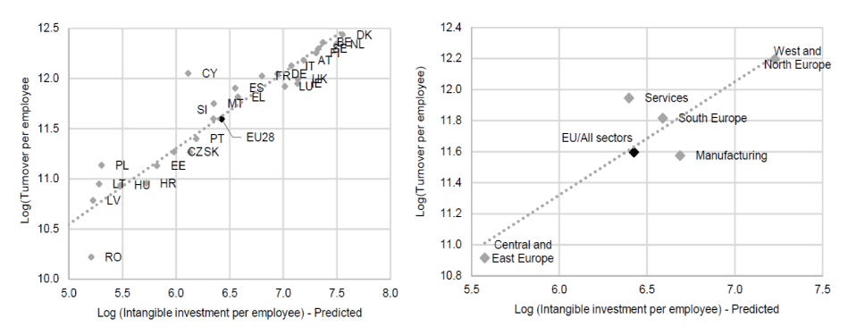
Source: Cincera et al. (2020, p. 22)

In the same line Fukao et al. (2009) have found a link between intangible capital and economic growth in Japan. According to Fukao et al. (2009), Japan has grown mainly due to the tangible asset-intensive manufacturing sector, but in order to thrive it ought to make changes to the accounting and financial system, so that investment in intangible assets becomes easier.
Concerning the evolution of intangible investment in comparison to tangible investment, Crouzet et al. (2022) provide a recent illustrative portrait of the U.S. (see Figure 2). In addition, Haskel and Westlake (2018) provide a very helpful picture to better understand this matter with the inclusion of European countries (see Figure 3).
In Figure 2, we can observe that since the 1970s US public firms have increased their investment in intangible assets at a faster rate than in tangible assets. In 1975, US public firms invested 25% less in intangible assets than in tangible assets. In 1995, that difference was less than 10%. In 2005, the investment in intangible assets and tangible assets reached parity. After 2005 (except for the years of the pandemic crisis) there has been more investment in intangible assets than in tangible assets.
Figure 2. Ratio of Intangible to Tangible Assets for US Public Firms, 1975-2021.

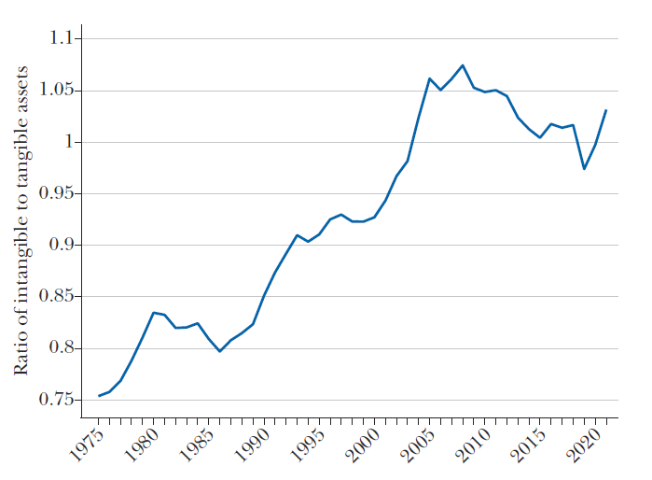

Source: Crouzet et al. (2022, p.31)
Figure 3. Tangible versus Intangible Investment's Share of GDP (1999-2013).

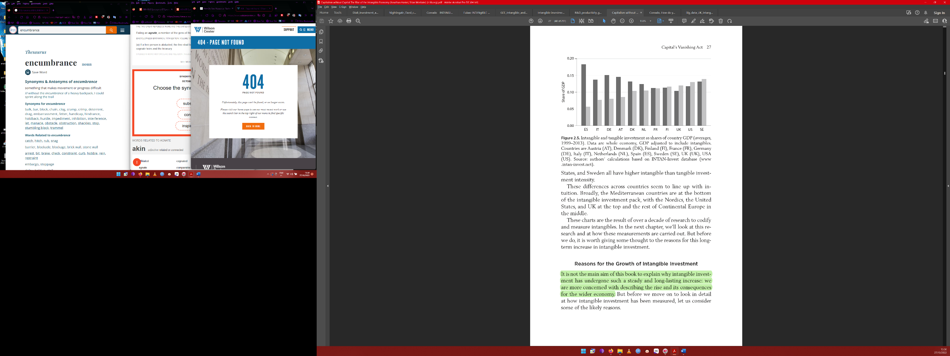

(Darker bars represent the tangible investment, while lighter bars represent the intangible investment).
Source: Haskel and Westlake (2018, p.27)

Figure 3 shows that Sweden, the United States, the United Kingdom and Finland already have higher GDP shares of investment in intangible assets than in tangible assets. Furthermore, the authors point out that the turning point occurred in the mid-1990s for the US and in the early 2000s for the UK. It is interesting to note that a lot of European countries still seemed to be very tangible intensive.
A possible reason that explains some of the disparities between the countries in the investment intensity in intangible assets has to do with debt finance. If investments in intangible assets are assumed to be riskier, banks will (ceteris paribus) be less willing to lend. When a business with tangible assets fails and the debt incurred is not repaid, the creditor can usually take recourse in some assets of the firm, thereby lowering the financial risk subjacent to the credit contract. Regarding intangible assets, however, there is an additional difficulty concerning liquidating the assets, as they can often be firm-specific and have a low or inexistent resale value. Intangible investment is more likely to be irrecuperable, which poses a barrier to the achievement of credit. From the perspective of debt holders, intangibles may be perceived as worthless (Bontempi, 2016).
Indeed, the investment in intangible assets involves sunk costs that are of a larger magnitude than the ones incurred in the investment in tangible assets (see, Young, 1998, Bloom and Van Reenen, 2002, and Haskel & Westlake, 2018).
As Haskel and Westlake (2018), indicate, intangible assets have four distinctive properties: scalability, sunkenness, spillovers, and synergies. Although scalability, spillovers and synergies are important properties of intangible assets, here we underline the sunkenness property of these assets.
To further explore the notion of sunk costs and irreversibility associated with investment let us consider the following example: As Young (1998) reports, organizational models are intangible assets, but how can they be separated from a given firm and be individually sold? How can Toyota separate its lean management practices from the rest of the firm? Intangible assets are likelier to be embedded in the firm and are hardly separable.
Moreover, the uncertainty associated with tangible and intangible investment is, not homogenous (Thum-Thysen et al., 2019). Intangible investment seems to be more affected by uncertainty than tangible investment is. Bontempi (2016) finds that for both R&D and non-R&D intangibles the delay effect (the postponement of investments under uncertainty) is much higher than the delay effect for tangible assets.
If we now compare the European firms versus the United States firms it is observable that the capital structure of the first is bank-based and the latter is mostly capital markets-based (see Figure 4). This distinction is essential to better understand why it is easier to fund intangible investments in the United States than in Europe. Moreover, the bank-based financing structure may contribute to more systemic risk than capital markets financing on account that banks are highly leveraged and when asset values fall, banks may be required to shrink their balance sheet or lower their risk to meet the regulatory requirements. This in turn may lead banks to scale back on higher-risk loans such as corporate loans and mortgages, in favour of lower-risk securitized assets (Bats & Houben, 2020). This in itself could lead to more uncertainty in times of crisis, which in turn can increase hysteresis effects as we will further observe.

Figure 4. Financial Structure of different regions.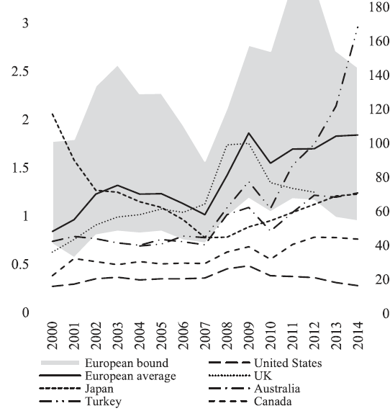
(Left axis represents the bank credit to non-financial debt ratio; Right axis represents the stock market capitalization).

Source: Bats and Houben (2020, p.7)

Chapter 2. The model of Hysteresis

The Non-Ideal Relay Model

To describe the microeconomic investment adjustment behaviour of firms we use the non-ideal relay model. This model is a binary hysteresis model that can be used to describe individual firm choices regarding the decision to invest or disinvest (see, e.g., Amable et al., 1995, Adamonis & Göcke, 2019, Belke & Göcke 2019, and Mota & Vasconcelos 2020).
In line with Mota and Vasconcelos (2022), the firm $j$ investment, $I_{j,t}$ is specified as follows, $I_{j,t}=f(x_{t},i_{t}, {BCI}_{t})$, where $x_{t}$ is the exogenous component of aggregate demand, $i_{t}$ is the interest rate, and ${BCI}_{t}$ is the agents' confidence in near future business performance (capturing animal spirits in the Keynesian accession).
We assume that our hysteresis explanatory variable is aggregate demand. The interest rate and the business confidence indicator are considered here as non-hysteretic determinants of investment.
For a broader comprehension of the matters at stake let us consider that a firm $j$ must decide in period $t$ to either invest or disinvest considering the dynamics of the exogenous aggregate demand shock variable, $x_{t}$. For a level of $x_{t}$ below $β_{j}$ the firm does not undertake an investment. As soon as the level of aggregate demand, $x_{t}$, rises above $β_{j}$ the firm starts to invest, and remains in that state for higher levels of $x_{t}$. $β_{j}$ is therefore known as the investment trigger. If, however, the level of aggregate demand falls to below $β_{j}$ the firm will not automatically disinvest. The notion that the reversion of a shock does not bring the system back to its original position is known as nonlinearity. The firm $j$ will only start to disinvest when the level of aggregate demand falls below let us say $α_{j}$, remaining in that state for levels of aggregate demand lower than the disinvestment trigger $α_{j}$. Therefore, if a firm did not invest in the previous period, it will not invest in the current period if $x_{t}$ is lower than $β_{j}$. If the firm has invested in the previous period, it would not disinvest if $x_{t}$ is higher than $α_{j}$. If $x_{t}$ varies in between $α_{j}$ and $β_{j}$, firm $j$ will not change its investment state. Therefore ($β_{j}-α_{j}$) is called an investment band of inaction.
The motive that explains the existence of investment and disinvestment triggers is the existence of sunk costs, as they delay firms’ decisions to invest or disinvest. If there were no sunk costs, firms in theory, would react faster to changes in the level of aggregate demand, as investments would be more reversible. In that alternative scenario, firms could resell the assets in which they invested in with lower losses leading to a better outcome than before and making it easier to reverse the investment. Pyndick (1991) highlights this notion by referring to the behaviour of managers of mines that simultaneously face sunk costs to open or exit a mine as well as output price uncertainty. In periods when the prices are low, managers do not immediately shut down the mines nor do they open them back up when prices become high. That is because disinvesting or investing entails a variety of sunk costs that in turn creates an opportunity cost due to the probability that the project’s value might rise, or decrease, respectively (Pyndick, 1991).
Therefore, non-convex adjustment costs are a key determinant of the investment’s band of inaction.
Figure 5. Graphic Representation of the Non-ideal Relay Model.

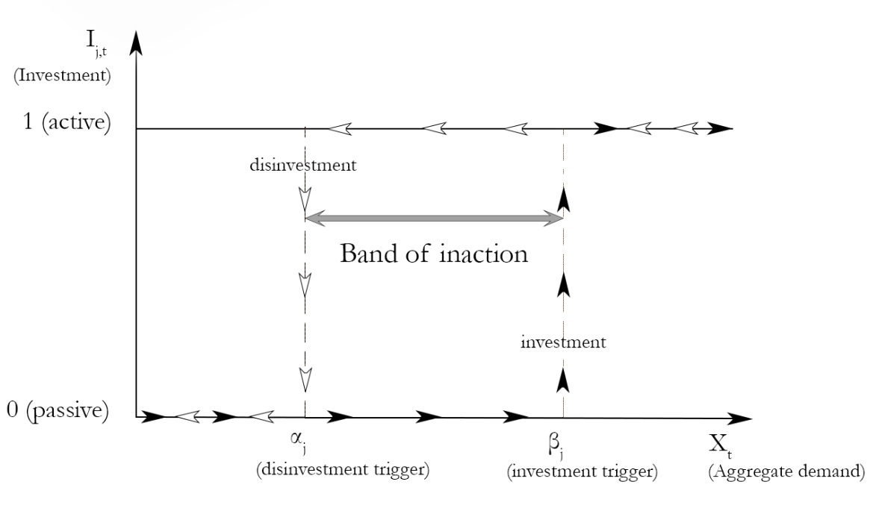

Figure 5 offers a graphic description of the non-ideal relay model of firm-level investment. There are two possible trajectories that can be followed, regarding the decision to invest or disinvest. Namely the trajectory to invest, in which a firm that starts from a state of 0 (i.e., no investment) starts to invest as the level of aggregate demand surpasses the $β_{j}$ investment trigger (black arrows depict the trajectory in which investment occurs) and the trajectory of disinvestment in which a firm that starts from a state of 1 (i.e. an investment has occurred in the previous period) starts to disinvest as the level of aggregate demand $x_{t}$ falls below the $α_{j}$, disinvestment trigger (white arrows depict the trajectory of disinvestment). For any given value of aggregate demand between $α_{j}$ and $β_{j}$ there is path dependency, in the sense that in order to know whether the firm is investing or disinvesting requires knowing its previous investment state.
It is also the case that before a firm decides to either invest or disinvest, very often it does not possess perfect information. Information about future economic and financial variables such as demand for goods and services, and interest rates is of paramount importance for a correct cost-benefit analysis. Consider the following example, knowing that the level of aggregate demand is one of the main drivers of investment, if there is a high demand uncertainty, the profitability of a given project will be unknown. In this case, the firm has a strong incentive to await further information (that is gradually arriving) before deciding. Likewise, so will the firm postpone the decision of disinvestment amid an environment of uncertainty. Therefore, the higher the level of uncertainty the wider the band of inaction.
Since the firm decides in a context of uncertainty, and considering that investment opportunities may not extinguish themselves in a short period, there is value in waiting to enter the market, or to invest (Pyndick, 1991, and Dixit, 1992).
The opportunity that the firm has to invest can be viewed as an option similar to a financial call option. Therefore, the firm has the possibility but not the obligation to acquire an asset at a posterior date. When a firm decides to undertake an irreversible investment it exercises its option to invest. The firm pays the sunk cost, acquiring an asset with fluctuating value and relinquishing the potential of waiting for new information that could affect the profitability of the investment project. By waiting, the firm is therefore forgoing the stream of cash flows it would have received had it invested and opens itself to the possibility other firms might enter the market, yet in turn receives valuable information that can significantly impact the decision to invest altogether (see, e.g., Dixit, 1992, Dixit & Pyndick, 1994, Bontempi, 2016, Belke et al., 2019, and Belke & Göcke, 2019).
The firm’s decision to invest depends on a comparison between the present expected value of waiting and see, and the present expected value of investing immediately. Likewise, the decision to exit the market is based on the expected value of waiting and see and the present expected value of disinvesting immediately. Indifference within strategies of both sets results in an investment and disinvestment trigger, respectively (see for more detail, Belke et al., 2019).
The band of inaction is therefore affected not only by the presence of non-convex adjustment costs but also by the level of uncertainty related to future demand (see, Dixit, 1992, Bontempi, 2016, Belke et al., 2019, Belke & Göcke, 2019).

The Preisach Model

To describe the aggregate dynamics of investment we use the Preisach model of hysteresis, which can be viewed as an aggregation procedure from firm-level investment behaviour described by the non-ideal relay model up to the macroeconomic level.
As Göcke (2002) puts it, aggregation leads to a stronger pattern of hysteresis. Strong hysteresis that arises at the macro level has different properties that are well defined in Amable et al. (1994). Differently from the dynamics described by the non-ideal relay model, the current output of the hysteretic system at the aggregate level depends now on a much richer history than before. In the non-ideal relay model, there were critical thresholds that had to be surpassed, to produce remanence effects. At the aggregate level, however, due to the heterogeneous nature of the firm’s investment and disinvestment triggers every transitory shock in the input variable originates remanence. Moreover, and still, in contrast with the Non-Ideal Relay model, the magnitude of the remanence effects depends now on the magnitude of the change in the exogenous variable (Amable et al., 1994). Another property of a hysteretic system that only emerges at the macro level is selectivity. Selectivity refers to the notion that the equilibrium investment level neither dismisses all previous shocks nor does it remember all past shocks. The only shocks that are not erased from the system’s memory are the non-dominated extrema. This notion will become clearer in the coming paragraphs.
To illustrate the aggregate dynamics of investment let us consider a set of all potentially investing firms, each one characterised by a pair of investment and disinvestment triggers ($β_{j}$ and $α_{j}$, respectively) where $β_{j} ≥ α_{j}$. This set of potentially investing firms can be represented by a triangle $T$ (Preisach Triangle), defined as (see also Figure 6 b):

$$T= \left\{\left(α_{j},β_{j} \right) : β_{j}≥α_{j}∧α_{j} ≥α_{min}∧β_{j}≤ β_{max}\right\}$$ | (2.1)

Where $α_{min}$ is the disinvestment trigger of the firm with the lowest disinvestment trigger, and $β_{max}$ is the investment trigger of the firm with the highest investment trigger.

Figure 6. Hysteretic Investment Dynamics.

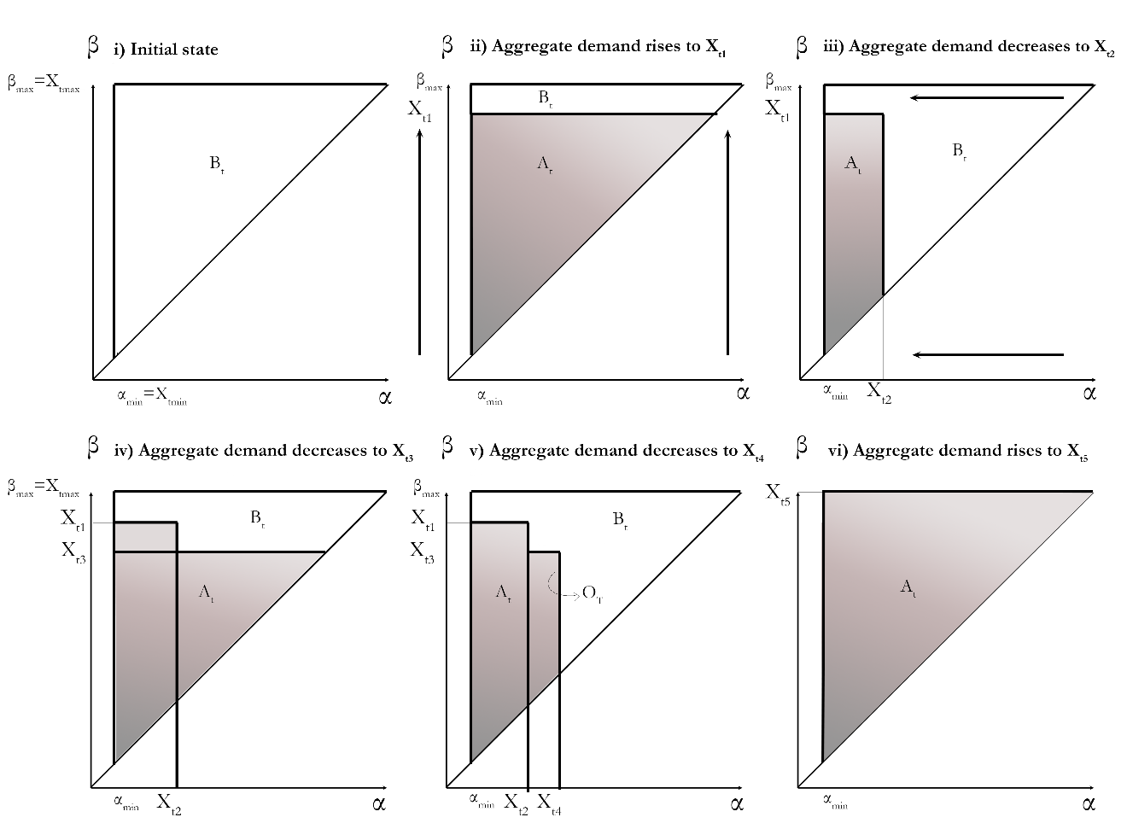
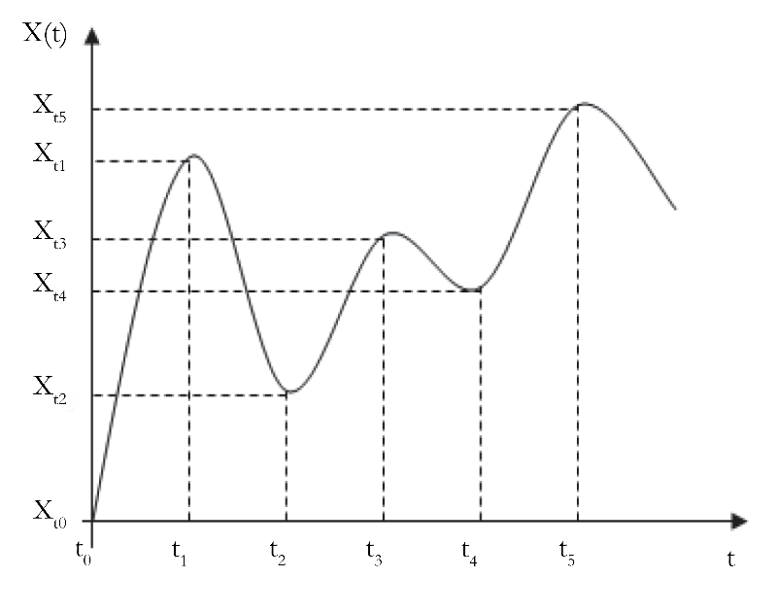
- b)

Source: Based on Mota and Vasconcelos (2012, p.99)

Let us now consider the aggregate demand dynamics exhibited in Figure 6 a). In the first period, $t_{0}$, the level of aggregate demand, $x_{t0}$, is 0, and hence no firm is investing since their investment triggers have not been surpassed (the area of inactive firms is represented by $B_{t}$). In the following period, $t_{1}$, the level of aggregate demand rises to $x_{t1}$, which exceeds several firms’ investment triggers, $β_{j}$, and hence they start to invest. The number of firms that are now investing can be represented by the shaded area $A_{t}$ in Figure 6 b) ii, which results from a horizontal line shifting upwards. If in the following period, $t_{2}$ the level of aggregate demand falls to $x_{t2}$ for some firms, the exit trigger condition is surpassed, which means that they start to disinvest. The firms that are still investing are represented by the shaded area in Figure 6 b) iii, which results from a vertical line shifting to the left.
As mentioned before, selectivity is an important property of a hysteretic system. Selectivity entails that only the non-dominated extrema of $x_{t1}$ matter to determine the equilibrium path of aggregate investment, $I_{t}$, being the case that the values that are dominated are erased from the memory bank (Cross, 1995). We can observe this property graphically in Figure 6 a) from a level of aggregate demand, $x_{t4}$ to $x_{t5}$ which is a non-dominated extremum. For that reason, $x_{t5}$ will determine the path of aggregate investment, Figure 6 b) v to vi. The memory bank is stored in the vertices of the staircase line, $O_{t}$ (Figure 6 b) v), $\left[(α_{min}, x_{t1});( x_{t2}, x_{t1});( x_{t2,}, x_{t3});( x_{t4,}, x_{t3})\right]$ that establishes the division of the Preisach Triangle, between the shaded area (that represents firms that are investing, $A_{t}$) and the white area (that represents firms that are not investing, $B_{t}$). The output of the system at $t_{4}$ depends on the sequence of aggregate demand levels $\left\{x_{t1},x_{t2},x_{t3},x_{t4}\right\}$. At $t_{5}$ it occurs that the previous memory sequence is eliminated by the new absolute maximum, $x_{t5}$. Consequently, to know the current value of $I_{t}$, it is only necessary to know the local maxima and minima that have not been eliminated, which in turn forms the reduced memory sequence (Mota & Vasconcelos, 2022b).
Figure 7. Preisach Loop of Hysteresis.

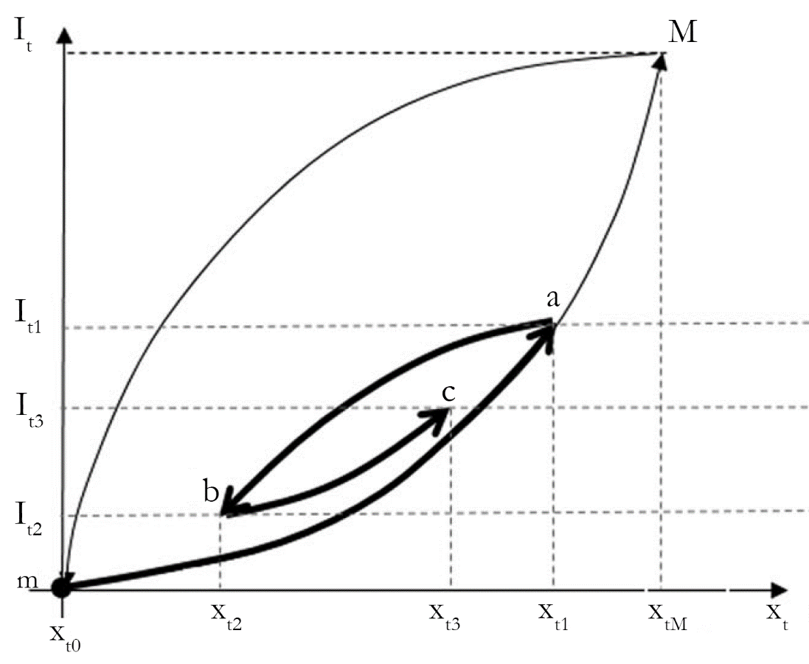

Source: Based on Mota and Vasconcelos (2022c, p.6)

The graphical representation of the relationship between the areas of the Preisach triangle (in Figure 6 b) and the value aggregate demand shock variable $x_{t}$, known as the Preisach loop of Hysteresis is shown in Figure 7. It is composed of two major loops and several minor loops. The major loop represents the reaction of investment when $x_{t}$ increases from $x_{t0}$ (in which no firm is investing) to $x_{tM}$ (in which all firms are investing) referring to the upward branch mM, and the reaction of investment when $x_{t}$ decreases from $x_{tM}$ to $x_{t0}$, along a downward branch (Mm).
From the origin to point $a$, we can observe a minor loop. As the level of aggregate demand rises, firms gradually have their investment triggers surpassed and consequently they start to invest. Initially, there is a weak aggregate reaction because for most firms their investment triggers are not yet surpassed. And as the aggregate demand level increases the adjustment becomes more intense, as more firms have their investment triggers surpassed. Consequently, firms increase their investment levels (Figure 6 b) i to Figure 6 b) ii). From point $b$ to point $a$ we have another minor loop that represents a fall in aggregate demand from $x_{t1}$ to $x_{t2}$ and again we can observe a weak initial aggregate reaction, and as the negative variation in aggregate demand intensifies so do more firms have their respective disinvestment trigger surpassed and consequently disinvest.

Chapter 3. The Empirical Strategy

The Play Model of Hysteresis

To identify hysteresis empirically, we apply the linear play model of hysteresis. This model can be viewed as a piecewise-linear approximation of the Preisach hysteresis loop where the slope of the linear branches changes at extrema (Mota & Vasconcelos, 2022c).

Figure 8 exhibits the graphic representation of the play model of hysteresis. The model is characterised by two steep lines: an upward spurt line and a downward spurt line. These two spurt lines are connected with flatter lines called the play lines.

In this model, following a relatively small aggregate demand shock there is a small change in aggregate investment, along a play line. Only when the shock is of significant dimension is the reaction of investment stronger, which is represented by a movement along a spurt line.

Beginning in a spurt line, following a reversal of a positive (negative) shock, firms do not immediately start disinvesting (investing) at the same rate as they were investing (disinvesting). A small variation in aggregate demand will result in a small variation in aggregate investment, since for most firms, the change in aggregate demand change is not enough to overcome their investment trigger. For this reason, the initial investment reaction of firms is represented along a play line. Only after a significant aggregate demand shock, there is a stronger reaction of investment, represented graphically by the variation of investment along the spurt lines, as the larger aggregate demand change will surpass most firms' investment thresholds.

The minimum variation of aggregate demand that causes a stronger reaction of aggregate investment (along a spurt line) is called ‘the play interval’, $γ$, which is interpreted as, an investment’s band-of-inaction. The investment band of inaction is a positive function of the magnitude of the non-convex adjustment costs and the level of aggregate demand uncertainty. Within our framework, the width of this investment band of inaction (i.e. the play interval, $γ$) is used as an indicator of the magnitude of hysteresis effects.

Figure 8. Linear Play loop.

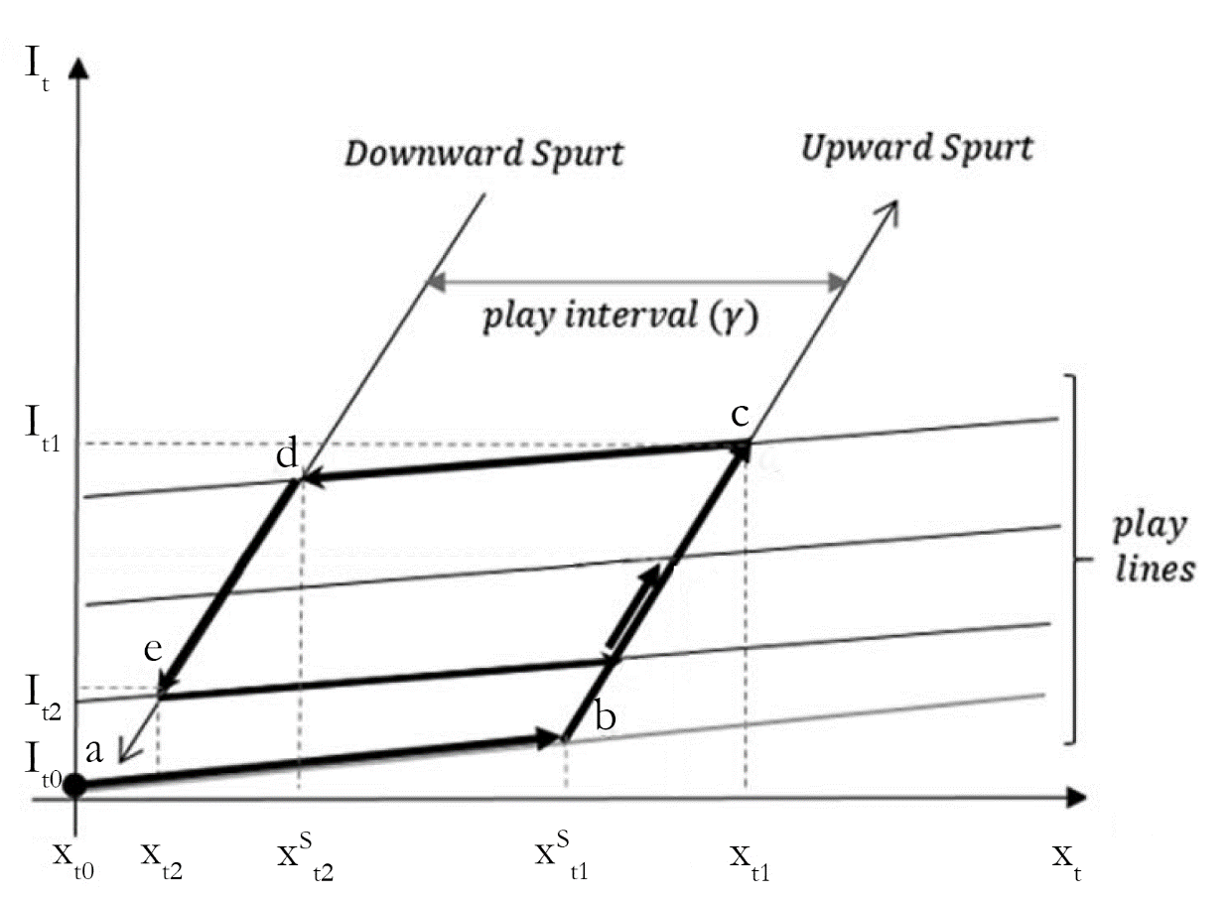

Source: Adapted from Mota & Vasconcelos (2022c).

To better understand how changes in aggregate demand, $x_{t}$, affect the aggregate investment, $I_{t}$, within the Linear Play model, let us assume that starting from point $a$ ($x_{t0}$, $I_{t0}$) there is an increase in aggregate demand up to $x_{t1}$. This originates initially a weak response of aggregate investment (along a play line), until a threshold value $x_{t1}^{S}$ is surpassed (at point $b$). As mentioned before, what justifies this weak reaction is the presence of non-convex, investment adjustment costs interacting with uncertainty. When the change in aggregate demand becomes large enough, i.e., when the aggregate demand threshold $x_{t1}^{S}$ is surpassed, there is a stronger response of aggregate investment to changes in aggregate demand along the upward spurt line. The system moves to point $c$. Hence if aggregate demand rises from $x_{t0}$ to $x_{t1}$, the level of aggregate investment follows the sequence $abc$. From point $c$, if aggregate demand decreases to $x_{t2}$, initially, there is a weak response of aggregate investment to the negative aggregate demand variation, due to non-convex investment adjustment costs, along a play line that has moved upwards. When aggregate demand becomes sufficiently low, i.e., when a threshold value $x_{t2}^{S}$ is surpassed (at point $d$), the aggregate investment starts to respond strongly along the downward spurt. Hence if aggregate demand falls from $x_{t1}$ to $x_{t2}$, the level of aggregate investment follows the sequence $cde$.

In line with the play model of hysteresis, to test the presence of hysteresis in aggregate investment, we estimate a hysteretic investment Equation (3.1).

$I_{t}= β_{0}+β_{1}x_{t}+β_{2}S_{t}+β_{3}i_{t}+β_{4}{BCI}_{t}+ε_{t}$ (3.1)

Where $x_{t}$ represents the aggregate demand in period t, $S_{t}$ represents the hysteresis variable (called ‘the spurt variable’), $i_{t}$ represents the interest rate, ${BCI}_{t}$ represents the business confidence index, and $ε_{t}$ is a random disturbance term with the usual properties of the linear regression model.

The spurt variable, $S_{t}$, is a hysteresis-transformed original forcing variable, $x_{t}$ where small changes ($∆x_{t}<γ$) are filtered away. Therefore, $S_{t}$ can be viewed of as a filtered $x_{t}$ variable (see for more detail Mota & Vasconcelos, 2022b). The spurt variable, $S_{t}$, is generated using a play hysteresis algorithm first described in Göcke (1994), and further developed by Göcke (2001), Belke and Göcke (2001a), Mota et al. (2012), Belke et al. (2013), Mota and Vasconcelos (2015, 2020). In the estimation we use the algorithm implemented in MATLAB by Mota and Vasconcelos (2021) - see Algorithm 1 in the Appendix 2.

In this framework and referring to Equation (3.1) and Figure 8, parameter $β_{1}$ gives the reaction of aggregate investment, $I_{t}$, to variations in aggregate demand along the play lines while $β_{1}+β_{2}$ represents the reaction of aggregate investment along the spurt lines. Therefore, the presence of hysteresis is assessed by the result of the following hypothesis test over the $β_{2}$ coefficient (see Belke & Göcke, 2021, and Mota & Vasconcelos, 2022a):

$$H_{0}: β_{2}=0$$

$$H_{1}: β_{2}>0$$

If the Wald test statistic is greater than the critical value, we reject the null hypothesis and hysteresis effects appear to manifest themselves in the data. If on the other hand, the Wald test statistic is smaller than the critical value then we fail to reject the null hypothesis implying that we are not able to find hysteresis in the dynamics of investment.

The Data

In our research, we use data from the G7 countries, i.e., Canada, France, Italy, Germany, Japan, the United Kingdom, and the United States, for the period from the first quarter of 2000 to the last quarter of 2022.
Regarding our dependent variable – aggregate investment, $I_{t}$, we use the gross fixed capital formation, retrieved from OECD - Quarterly National Accounts, separated by tangible assets, ${I_TAN}_{t}$ and intangible assets, ${I_INT}_{t}$. Gross capital formation in tangible assets includes: i) dwellings; ii) other buildings and structures; iii) machinery and equipment plus weapon systems. Gross capital formation in intangible assets includes only intellectual property products. We use data in real terms (chained volume estimates) and seasonally adjusted. In order to apply the hysteresis algorithm we have transformed the original data into an index (base period: 2012:01).
Figure 9 presents the dynamics of the constructed index of gross fixed capital formation by type of asset (the descriptive statistics are in Appendix 1). In the time span of our data the investment in intangible assets has grown more than investment in tangible assets in the G7 countries (the exception was the United Kingdom).
In the specific case of the USA, intangible investment was 2.83 times greater in the last quarter of 2022 than in the first quarter of 2000, whilst tangible investment was only 1.18 times greater in the last quarter of 2022 than in the first quarter of 2000. The gap between intangible and tangible investment in the USA is remarkable, and it seems to have taken greater proportions ever since the fourth quarter of 2015.
In the G7 countries (with the exception of Japan, for which, there are no data after the last quarter of 2016), intangible investment was less affected by the Covid-19 pandemic than tangible investment.
Comparing the last quarter of 2022 with the first quarter of 2000, we can find that on average, tangible investment has grown 21,00% and intangible investment has grown 91,92%.
Figure 9. Tangible and Intangible Investment Dynamics (Index 2012:1=100).
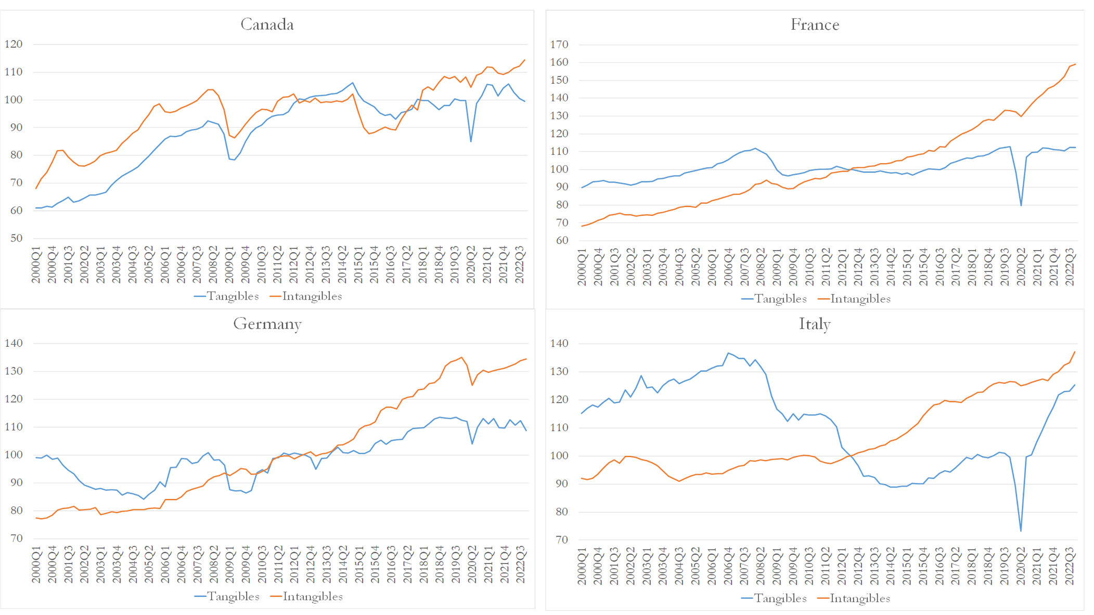
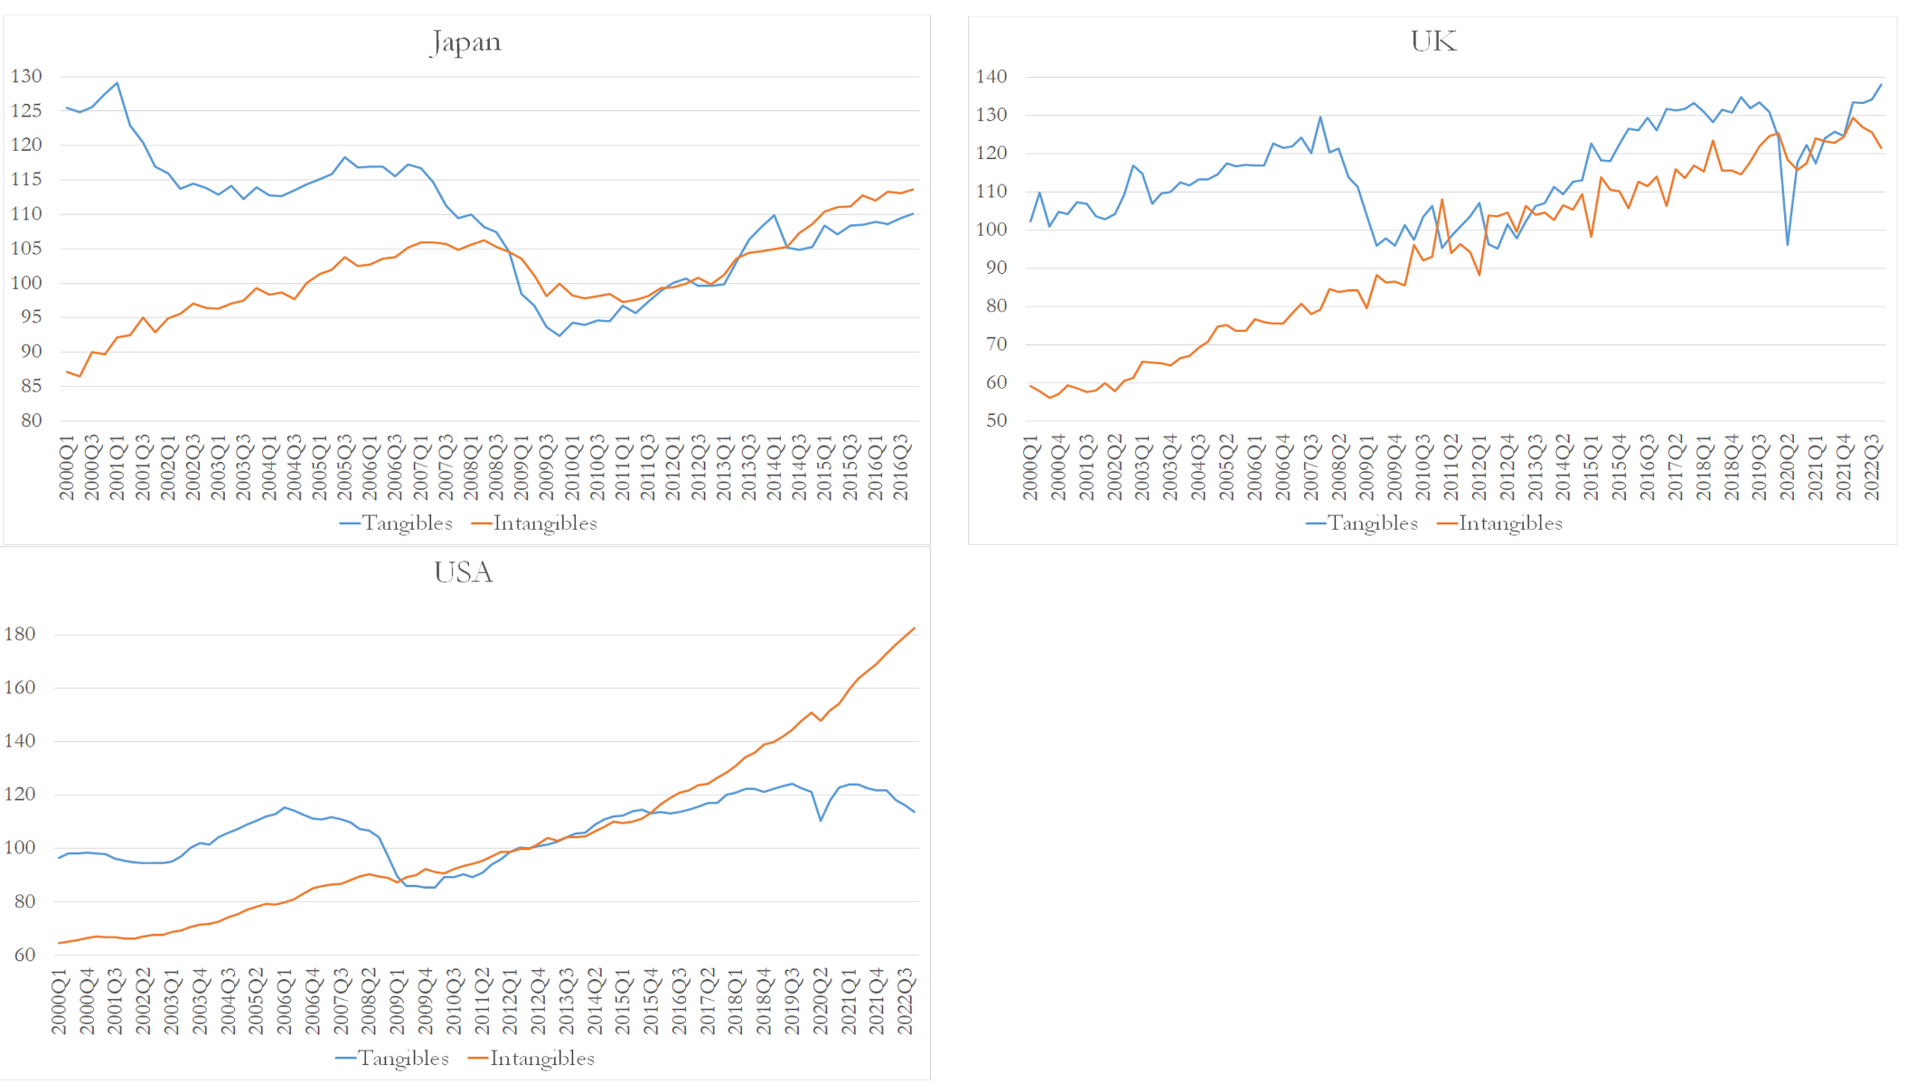
Source: OECD.

We use the rate of capacity utilization in manufacturing, from OECD- Business Tendency Surveys for Manufacturing, as a proxy of aggregate demand (see Figure 10).
Figure 10 shows that from the first quarter of 2000 to the last quarter of 2006, the rate of capacity utilization was relatively stable in Canada, France, Germany, Italy and in the United Kingdom. The United States and Japan are exceptions, as within this period this rate displayed more volatility. After the third quarter of 2007 (which marks the beginning of the recent financial crises), there was a steep decline in the rate of capacity utilization in all the countries. The recovery of the capacity utilization rates after the 2007-2008 financial crisis was almost complete after the first quarter of 2012. From then onwards we observe a relative stability of this rate, for all countries, until the emergence of the Covid-19 pandemic. This time, however, the recovery of the rate of capacity utilization was much faster in all the G7 countries (for which we have data).
Concerning the non-hysteretic explanatory variables, we use the Long-Term Government Bond Yields – 10-year benchmark maturity for the interest rate, $i_{t}$, obtained from OECD- Main Economic Indicators. And the business confidence indicator from OECD- Business Tendency Surveys for Manufacturing, used as a proxy of “animal spirits”, captured in Equation 3.1. by ${BCI}_{t}$.
Figure 10. Rate of Capacity Utilization in Manufacturing.

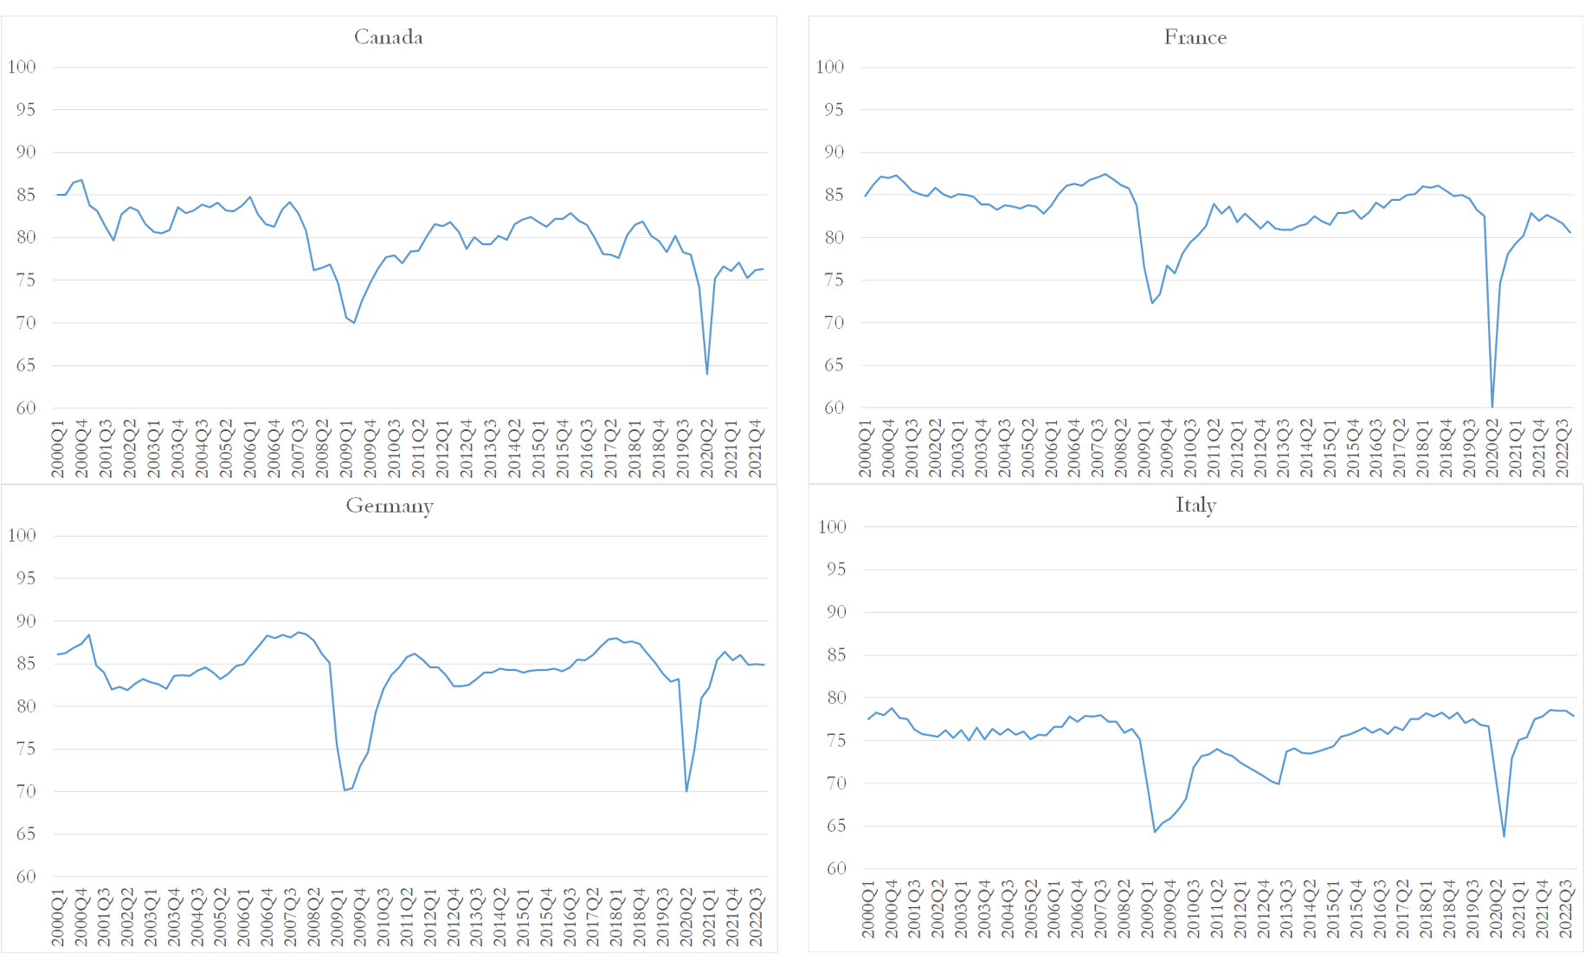
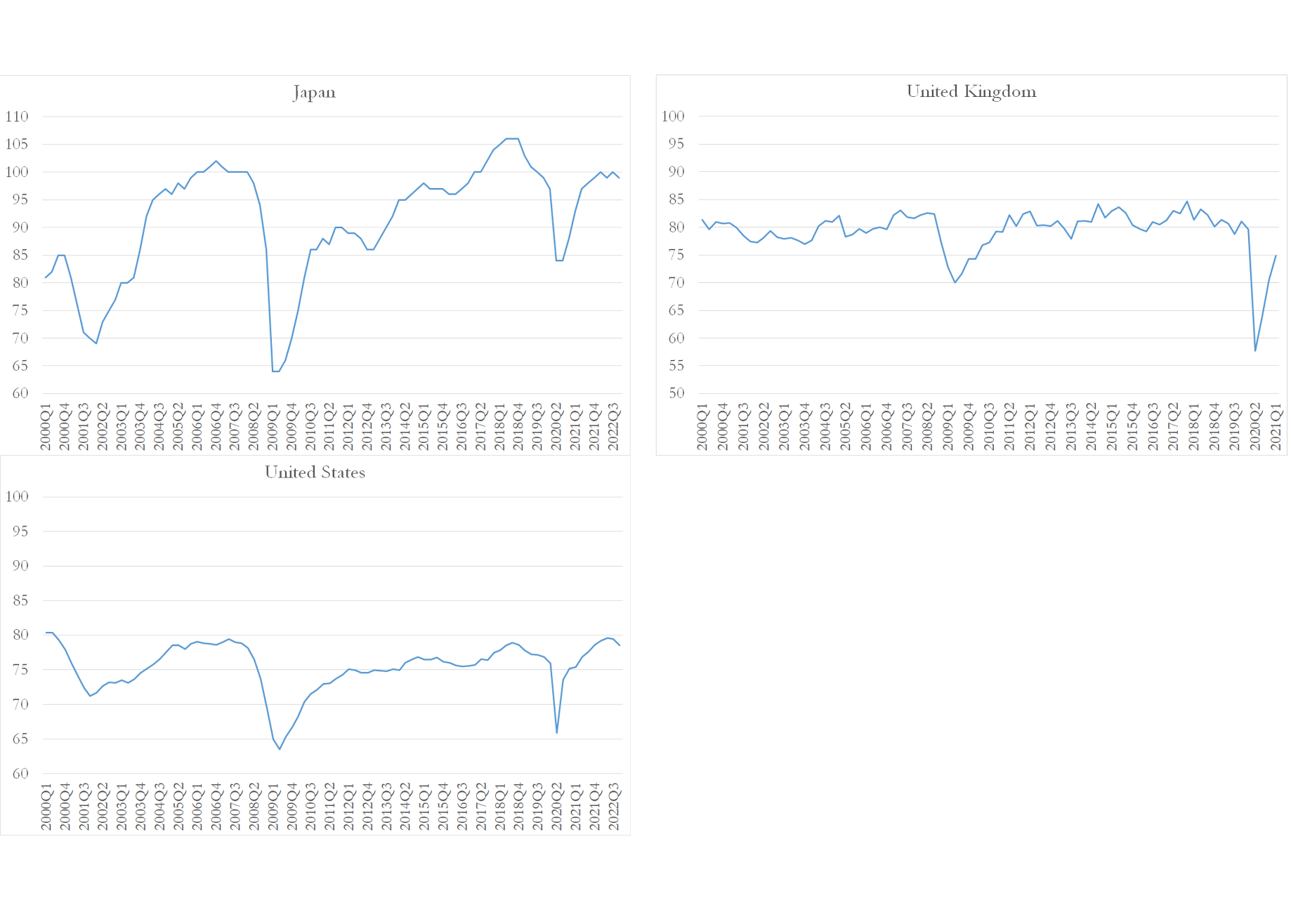

Source: OECD. Business Tendency Surveys.

Chapter 4. Results of the Estimation

When using aggregated time series, it is of the utmost importance to analyse their stationarity. If the series are non-stationary, spurious correlations could be found and misleading conclusions would follow suit. To ensure the estimation results have any validity and meaning it is essential to test the stationarity of the variable series.
We use the augmented Dickey-Fuller test that analyses if unit roots are present. The null hypothesis of this test is that the data are non-stationary (we do not reject the hypothesis that a unit root exists) and the alternative hypothesis is that the data are stationary (we reject the hypothesis that a unit root exists). We reject the null hypothesis if the t-statistic is greater than the critical value (considering absolute values) and we fail to reject the null hypothesis if the t-statistic is smaller than the critical value (considering absolute values). We have concluded that aggregate investment, the hysteresis variables and the long-term government bond yields are in general non-stationary in levels but stationary in their first differences, which means that they are integrated of order one, I(1), see Table 2.
Table 2. Unit Root Tests

Independent  Variable | Canada |  | France |  | Germany |  | Italy |  | Japan |  | UK |  | US
Independent  Variable | Levels | 1st Difference | Levels | 1st Difference | Levels | 1st Difference | Levels | 1st Difference | Levels | 1st Difference | Levels | 1st Difference | Levels | 1st Difference
${I_TAN}_{t}$ | -2.2107 | -9.7586 | -3.1680 | -9.2592 | -1.1448 | -9.7647 | -1.4013 | -10.6797 | -2.0337 | -4.7854 | -2.1665 | -12.4445 | -1.4160 | -6.4121
${I_INT}_{t}$ | -1.9956 | -6.5333 | 1.6809 | -5.6110 | 0.1600 | -8.7959 | -1.9956 | -6.5333 | -1.5825 | -9.0932 | -2.2002 | -15.7002 | 2.9541 | -7.7217
$x_{t}$ | -3.0698 | -10.2249 | -4.5489 | -12.5411 | -3.8023 | -7.9653 | -2.8216 | -8.5664 | -2.8781 | -6.0168 | -3.7866 | -9.5347 | -2.5647 | -8.8508
${S_INT}_{t}$ | -0.9524 | -5.9590 | -1.7358 | -5.8700 | -1.2574 | -5.7452 | -1.4927 | -3.8134 | -2.9433 | -4.8566 | -1.5941 | -8.6053 | -1.7255 | -5.7941
$${S_TAN}_{t}$$ | -0.9437 | -8.8866 | -1.9102 | -9.9670 | -3.8925 | -7.3728 | -1.5994 | -6.1701 | -2.9433 | -4.8566 | -1.3864 | -8.0755 | -1.7352 | -6.1477
$i_{t}$ | -2.2148 | -7.9903 | -1.6469 | -6.7334 | -1.6321 | -6.5006 | -1.9879 | -6.6189 | -1.3682 | -8.5493 | -1.5567 | -6.2053 | -2.4059 | -7.3011
${BCI}_{t}$ | -5.6194 | -5.9195 | -4.6710 | -6.2093 | -4.9563 | -4.4133 | -4.7271 | -5.5617 | -3.2027 | -5.5005 | -4.0283 | -6.3451 | -4.7390 | -6.4567
Dickey-Fuller Critical Value (5%): -2.893956

To analyse if there is a non-spurious relationship between the variables, we test for cointegration using the Johansen Test procedure. The null hypothesis of this test is that there is no cointegration and the alternative hypothesis is that there is at least one cointegrating vector that connects the variables. We reject the null hypothesis if the test statistic is greater than the 5% critical value (79.341, see Table 3). We have found that the trace test statistic is greater than the 5% critical value for all countries, with only one exception – the equation for Canada’s intangible investment. Therefore, there is at least one cointegrating vector relating the variables.
Given that the series are in general cointegrated, we estimate the Equation 3.1, by Fully Modified Least Squares (FM-OLS), to obtain asymptotically unbiased estimates of the parameters. FM-OLS is an asymptotically efficient estimator of long-run economic relationships (Philips & Hansen, 1990). The FM-OLS estimator modifies least squares through semiparametric corrections that lead to a class of fully modified Wald tests. The new statistics greatly facilitate inference in I(1) regression models, as they account for serial correlation effects and endogeneity in the regressors that result from the existence of cointegrating relationships (Philips & Hansen, 1990, and Philips, 1995).
In Table 3 we present the results of the estimation of the investment Equation 3.1. Table 3 shows that using fully modified Wald tests, the coefficient from which we can attest if hysteresis is present, $β_{2}$ is positive and statistically significant in the equation estimated for tangible investment in France, Italy, Japan, the UK, and the US. $β_{2}$ is also positive and statistically significant in the estimated equation for intangible investment in Canada, France, Germany, Italy, and the US. $β_{2}$ is negative and statistically significant in the case of intangible investment in the UK.
These results mean that hysteresis is present in several equations for tangible and intangible investment.
The coefficient from which we can assess the reaction of aggregate investment, $I_{t}$, along the play lines, $β_{1}$, is positive and statistically significant in the estimated equation for tangible investment in France and the US, and in the estimated equation for intangible investment in Germany, Japan and the UK. $β_{1}$ is non-significant in the estimated equation for tangible investment in Canada, Germany, Japan and the UK, and in the estimated equation for intangible investment in France, and the US, which means that in these cases the play lines displayed in Figure 8 are in fact horizontal. $β_{1}$ is negative and statistically significant in the estimated equation for tangible investment in Italy and in the estimated equation for intangible investment in Canada and Italy, which is not expectable, in these cases a small increase in the level of aggregate demand leads to a decrease in investment (negative coefficient for $β_{1}$) but a large enough positive aggregate demand variation leads to an increase in investment (captured by the positive coefficient for $β_{2}$).
Concerning $β_{3}$, the coefficient associated with the interest rate variable it is negative and statistically significant in the estimated equation for tangible investment in Canada, Japan, and the US, which would be in line with our expectations, as when the interest rate levels rise, investment tends to fall, given that interest rates are considered to be a fundamental determinant of the cost of capital, impacting in turn profitability. The exceptions are when $β_{3}$ is positive and statistically significant in the estimated equation for tangible investment in France and Italy, as well as in the estimated equation for intangible investment in France, Italy, the UK, and the US, which are unexpected.
The coefficient associated with the business confidence indicator, $β_{4}$ is positive and statistically significant in the estimated equation of tangible investment in Canada, Italy, Japan and the UK and in the estimated equation for intangible investment in Canada and Italy. These estimations would be in line with our expectations, as when businesses are more optimistic about the current and future near performance of their firms, they invest more. The exceptions are when $β_{4}$ is negative and statistically significant in the estimated equation for intangible investment in Germany and Japan, which are unexpected.
Table 3. FM-OLS Estimation Results of the Investment Hysteresis Equation
Independent  Variable | Canada |  | France |  | Germany |  | Italy |  | Japan |  | UK |  | US
Independent  Variable | Tangible Investment | Intangible Investment | Tangible Investment | Intangible Investment | Tangible Investment | Intangible Investment | Tangible Investment | Intangible Investment | Tangible Investment | Intangible Investment | Tangible Investment | Intangible Investment | Tangible Investment | Intangible Investment
Band of Inaction $(γ_{t}$) | 0.166 | 0.138 | 0.158 | 0.362 | 0.032 | 0.234 | 0.142 | 0.186 | 0.148 | 0.148 | 0.160 | 0.160 | 0.156 | 0.196
$$β_{0}$$ | -4.181  (-1.135) | -2.689  (-0.996) | 2.023  (0.817) | 2.826**  (2.406) | 3.674  (1.088) | 9.806***  (4.701) | -19.3***  (-3.600) | -3.074  (-0.613) | -0.606  (-0.055) | 3.07**  (2.38) | -3.866  (-0.998) | 4.669**  (2.322) | -2.760  (-1.299) | 4.600***  (1.585)
$$x_{t}$$ | -0.444  (1.132) | -0.699**  (.2.439) | 0.524***  (2.688) | -0.041  (-0.459) | 0.543  (1.468) | 0.399***  (2.737) | -1.94***  (-4.719) | -1.072***  (-2.877) | -0.145  (0.510) | 0.641**  (2.557) | -0.410  (-1.007) | 0.626***  (2.964) | 1.148***  (8.441) | -0.037  (-0.385)
$${Spurt}_{t}$$ | 1.050  (1.481) | 3.059***  (4.212) | 0.356**  (2.213) | 0.477***  (6.496) | 0.268  (1.183) | 1.255***  (3.419) | 2.176***  (8.465) | 1.215***  (4.696) | 0.591***  (5.236) | 0.44  (0.445) | 1.658***  (4.259) | -0.526**  (-2.604) | 1.806***  (7.510) | 2.322***  (7.438)
$$i_{t}$$ | -0.09***  (-3.23) | 0.005  (0.256) | 0.034***  (3.474) | 0.025***  (5.299) | -0.004  (-0.411) | -0.007  (-1-025) | 0.047***  (4.365) | 0.041***  (4.219) | -0.11***  (-5.490) | -0.008  (-0.470) | 0.004  (0.169) | 0.039***  (2.745) | -0.024***  (-2.820) | 0.015**  (2.389)
$${BCI}_{t}$$ | 2.360***  (2.415) | 2.187***  (3.056) | -0.003  (-005) | 0.308  (1.019) | -0.346  (-0.342) | -1.57***  (-2.842) | 7.005***  (4.897) | 2.565*  (1.327) | 1.371*  (2.611) | -4.638*  (-1.99) | 2.230**  (2.011) | -0.755  (-1.310) | 0.546  (1.082) | -0.089  (-0.243)
$$trend$$ | 0.001  (0.586) | -0.01***  (-3.123) | 0.004***  (6.146) | 0.010***  (31.332) | 0.002***  (2.828) | 0.006***  (9.566) | 0.003***  (3.228) | 0.,008***  (8.637) | -0.005***  (-10.106) | 0.001**  (2.659) | 0.004**  (2.325) | 0.011***  (11.524) | 0.002***  (5.229) | 0.012***  (42.101)
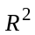 | 0.786 | 0.743 | 0.641 | 0.993 | 0.831 | 0.980 | 0.752 | 0.731 | 0.816 | 0.705 | 0.417 | 0.959 | 0.920 | 0.995
Trace Test Statistic (critical value: 79.341) | 98.153 | 65.195 | 103.241 | 105.633 | 113.742 | 100.033 | 140.771 | 101.328 | 109.012 | 100.514 | 113.647 | 122.817 | 101.404 | 113.844
Wald test statistics are in parentheses.
***, **, * Significant at 1, 5, and 10 per cent respectively

For a better comprehension of how the spurt variable, $S_{t}$, is computed, we present the example of the USA. The hysteresis algorithm, briefly described in Appendix 2., filters out the small changes in the original capacity utilization variable ($∆x_{t}<γ$), by taking different values of the play interval from a grid of admissible values. It computes several filtered $x_{t}$ series (one for each chosen play interval, $γ$), and estimates several Equations 3.1. with these filtered series. It finally selects the value that originates a filtered $x_{t}$ series that maximizes the R² of the investment Equation (3.1).
Figure 11 shows the value of the R² associated with each play value, $γ$, chosen from a grid. The maximum of the R² of the intangible investment equation occurred for a play interval equal to 0.196 which is higher than the play interval that is associated with the maximum R² of the tangible investment equation (0.156).

Figure 11. R² of the Investment Equation for the USA for each Play Value Chosen from a Grid.

- Tangible Investment

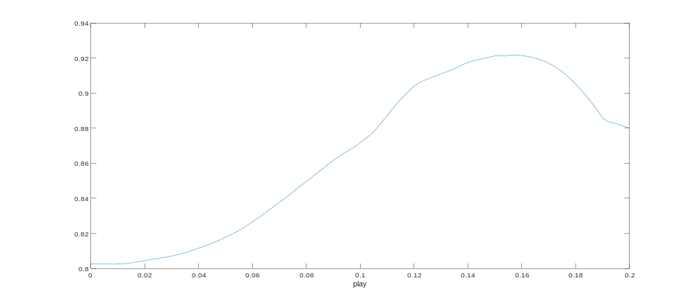
Max: Play: 0.156; R²: 0.921

- Intangible Investment

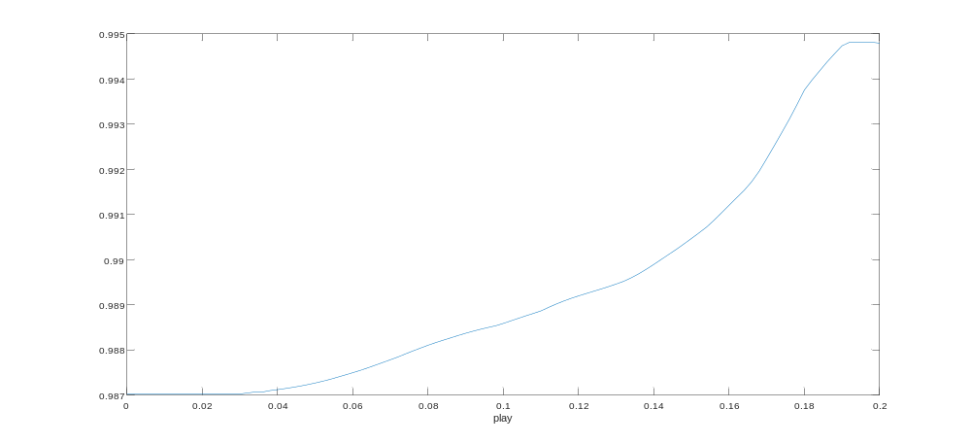
Max: Play: 0.196; R²: 0.994

In Figure 12, the rate of capacity in manufacturing, $x_{t},$ is displayed along with its hysteretic transformation based on the play interval values mentioned above.

Figure 12. Original Forcing Variable of the Investment Equation and the Hysteresis Variable for the USA.
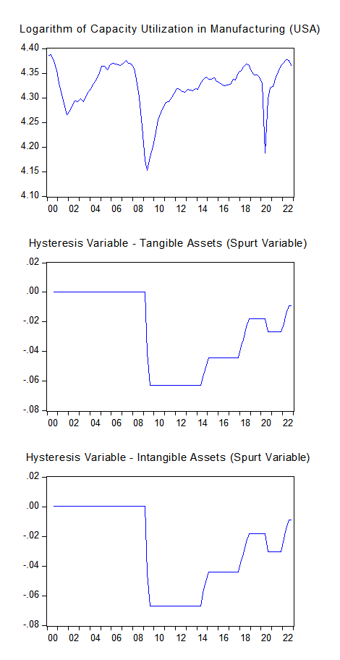

The estimated play intervals, i.e., the investment band of inaction for tangibles assets and intangible assets for the G7 countries are displayed in Table 3, and in Figure 13.
Our main hypothesis that hysteresis effects are greater in the case of investment in intangibles relative to investment in tangibles is corroborated in the cases of France, Germany, Italy, and the United States. Hysteresis effects in the dynamics of investment seemed to be of the same magnitude in Japan and the UK. The estimated investment band of inaction for Canada is, larger for tangible investment. However, we fail to find at least one cointegrating vector relating the variables of the equation for tangible investment. Therefore greater case should be put in the conclusions for this country.

Figure 13. Investment Band of Inaction for the G7- Tangibles vs Intangibles.

Conclusion

This work analyses hysteresis in the dynamics of investment and the distinctions between tangible and intangible investment. The results of our research indicate that there are hysteresis effects both relating to tangible investment and intangible investment. As for the answer to our research question, there do appear to be greater hysteresis effects relating to intangible investment than those associated with tangible investment. Germany, France, Italy and the USA exhibit greater bands of inaction for intangible investment than for tangible investment and they compose the majority of the G7 countries.
The implications of our research are of great importance for fiscal and monetary policies. To ensure that investment levels (especially in intangible assets) are not greatly harmed in times of economic recessions, since sufficiently severe negative shocks (even if temporary) may not be easily reversed, it is important to apply the preventative, significant and sustained expansionary fiscal and monetary policy to avoid the decrease of aggregate investment. This policy reaction is particularly important for the intangible investment that appears to present greater hysteresis effects. One possibility, on the side of fiscal policy, could be government co-financing (and bank loan guarantees) of intangible investment, bypassing the debt finance hurdle and impeding a fall of investment in intangible assets. This example is not exempt from issues such as the moral hazard problem that could arise from managers knowing they would be protected in times of crisis and taking on more risks for personal gain, or the possibility of protecting firms that would benefit society more if they went bankrupt and ceased to exist (i.e., Schumpeter’s creative destruction). Another possibility, on the side of monetary policy, could be having lower interest rates for firms that invest heavily in intangible assets.
As for recommendations for future research, it would be very interesting to analyse the dynamics of intangible investment in more disaggregated terms, considering each subdivision of intangible assets one by one, which requires data that for the present is only available for the United States. This would make it possible to design more targeted investment policies.

Appendix. 1. Descriptive Statistics of the Variables

Gross Fixed Capital Formation, from OECD – Quarterly National Accounts (including dwelling, other buildings and structures, and machinery and equipment plus weapon systems) (${I_TAN}_{t}$)

 | Canada | France | Germany | Italy | Japan | UK | USA
Mean | 86902.58 | 93095.88 | 121490.6 | 71671.99 | 26576311 | 68496.47 | 622050.5
Median | 91543 | 91954.8 | 121093.8 | 73755.4 | 26672000 | 68276.5 | 633557.7
Maximum | 103903.5 | 103839.9 | 138857.8 | 87795.7 | 31405050 | 82136 | 722321.5
Minimum | 59752.3 | 73300.8 | 102787.8 | 47052.6 | 22465325 | 56661 | 496487
Std. Dev. | 13406.59 | 6199.474 | 10681.07 | 9850.105 | 2202516 | 7056.181 | 64271.3
Skewness | -0.770 | -0.022 | 0.003 | -0.201 | -0.033 | 0.054 | -0.195
Kurtosis | 2.284 | 2.774 | 1.956 | 1.877 | 2.394 | 1.870 | 1.960
Jarque-Bera | 11.058 | 0.203 | 4.178 | 5.451 | 1.052411 | 4.943 | 4.727
Probability | 0.004 | 0.903 | 0.124 | 0.066 | 0.590843 | 0.084 | 0.094
Sum | 7995037 | 8564821 | 11177133 | 6593823 | 1.81E+09 | 6301675 | 57228650
Sum Sq. Dev. | 1.64E+10 | 3.50E+09 | 1.04E+10 | 8.83E+09 | 3.25E+14 | 4.53E+09 | 3.76E+11
Observations | 92 | 92 | 92 | 92 | 68 | 92 | 92

Gross Fixed Capital Formation, from OECD – Quarterly National Accounts (including intellectual property products) (${I_INT}_{t}$)

 | Canada | France | Germany | Italy | Japan | UK | USA
Mean | 13395.29 | 26465.48 | 24634.6 | 11778.4 | 6631297 | 17056.68 | 220519.7
Median | 13617.65 | 25344.6 | 24008 | 11039.45 | 6609375 | 17391 | 203518.1
Maximum | 16080.8 | 41620.5 | 32761.1 | 15171.2 | 7436250 | 23636 | 386315.3
Minimum | 9564.3 | 17810.9 | 18704.5 | 10064.5 | 5659925 | 10261 | 136327.8
Std. Dev. | 1496.461 | 6148.093 | 4679.778 | 1448.887 | 403942.2 | 4103.822 | 67445.17
Skewness | -0.453 | 0.659 | 0.398 | 0.720 | -0.040 | -0.153 | 0.766
Kurtosis | 2.521 | 2.518 | 1.744 | 2.021 | 2.879 | 1.679 | 2.644
Jarque-Bera | 4.031 | 7.543 | 8.475 | 11.617 | 0.059 | 7.051 | 9.492
Probability | 0.133 | 0.023 | 0.014 | 0.003 | 0.971 | 0.029 | 0.009
Sum | 1232367 | 2434824 | 2266383 | 1083613 | 4.51E+08 | 1569215 | 20287809
Sum Sq. Dev. | 2.04E+08 | 3.44E+09 | 1.99E+09 | 1.91E+08 | 1.09E+13 | 1.53E+09 | 4.14E+11
Observations | 92 | 92 | 92 | 92 | 68 | 92 | 92

Capacity Utilization in Manufacturing, from OECD – Business Tendency Surveys for Manufacturing ($x_{t}$)

 | Canada | France | Germany | Italy | Japan | UK | USA
Mean | 80.012 | 82.867 | 83.922 | 75.036 | 91.174 | 79.324 | 75.436
Median | 80.7 | 83.7 | 84.4 | 75.9 | 95.5 | 80.2 | 75.984
Maximum | 86.8 | 87.5 | 88.7 | 78.8 | 106 | 84.7 | 80.386
Minimum | 64 | 60 | 70 | 63.8 | 64 | 57.7 | 63.544
Std. Dev. | 3.744 | 3.880 | 3.813 | 3.286 | 10.432 | 4.08 | 3.511
Skewness | -1.259 | -2.775 | -2.031 | -1.626 | -0.870 | -2.727 | -1.331
Kurtosis | 5.883 | 15.165 | 7.633 | 5.423 | 2.935 | 13.082 | 4.896
Jarque-Bera | 54.335 | 685.323 | 145.524 | 63.044 | 11.618 | 465.293 | 40.960
Probability | 0 | 0 | 0 | 0 | 0.003 | 0 | 0
Sum | 7121.1 | 7623.8 | 7720.8 | 6903.35 | 8388 | 6742.5 | 6940.089
Sum Sq. Dev. | 1233.756 | 1370.262 | 1322.797 | 982.671 | 9903.217 | 1399.313 | 1121.547
Observations | 89 | 92 | 92 | 92 | 92 | 85 | 92

Long-Term Government Bond Yields – 10-Year Benchmark Maturity for the Interest Rate Obtained from OECD – Main Economic Indicators ($i_{t}$)

 | Canada | France | Germany | Italy | Japan | UK | USA
Mean | 3.094 | 2.620 | 2.277 | 3.590 | 0.838 | 3.079 | 3.214
Median | 3.002 | 3.035 | 2.342 | 4.056 | 0.981 | 3.310 | 2.982
Maximum | 6.286 | 5.571 | 5.460 | 6.614 | 1.902 | 5.609 | 6.480
Minimum | 0.546 | -0.319 | -0.614 | 0.637 | -0.218 | 0.251 | 0.650
Std. Dev. | 1.495 | 1.759 | 1.885 | 1.500 | 0.645 | 1.620 | 1.326
Skewness | 0.281 | -0.171 | -0.026 | -0.401 | -0.116 | -0.140 | 0.251
Kurtosis | 1.941 | 1.662 | 1.556 | 2.047 | 1.530 | 1.543 | 2.276
Jarque-Bera | 5.511 | 7.313 | 8.006 | 5.945 | 8.488 | 8.436 | 2.976
Probability | 0.064 | 0.026 | 0.018 | 0.051 | 0.014 | 0.015 | 0.226
Sum | 284.624 | 241.034 | 209.526 | 330.235 | 77.074 | 283.247 | 295.700
Sum Sq. Dev. | 203.449 | 281.601 | 323.323 | 204.836 | 37.868 | 238.944 | 159.938
Observations | 92 | 92 | 92 | 92 | 92 | 92 | 92

Business Confidence Indicator from OECD – Business Tendency Surveys for Manufacturing (${BCI}_{t}$)

 | Canada | France | Germany | Italy | Japan | UK | USA
Mean | 99.998 | 100.377 | 100.471 | 100.459 | 100.141 | 100.324 | 99.989
Median | 100.209 | 100.309 | 100.570 | 100.605 | 100.511 | 100.432 | 100.012
Maximum | 104.015 | 103.885 | 103.466 | 102.639 | 101.692 | 105.503 | 102.017
Minimum | 95.245 | 94.877 | 96.102 | 96.440 | 96.837 | 93.754 | 96.055
Std. Dev. | 1.793 | 1.529 | 1.431 | 1.196 | 1.140 | 2.168 | 1.148
Skewness | -0.673 | -0.690 | -0.444 | -0.911 | -0.968 | -0.427 | -0.830
Kurtosis | 3.573 | 4.802 | 3.438 | 4.237 | 3.242 | 3.866 | 4.364
Jarque-Bera | 8.122 | 19.526 | 3.717 | 18.390 | 14.420 | 5.602 | 17.500
Probability | 0.017 | 0.000 | 0.156 | 0.000 | 0.001 | 0.061 | 0.000
Sum | 9099.791 | 9134.289 | 9142.879 | 9141.793 | 9112.828 | 9129.444 | 9098.997
Sum Sq. Dev. | 289.3 | 210.431 | 184.179 | 128.655 | 116.910 | 423.208 | 118.627
Observations | 91 | 91 | 91 | 91 | 91 | 91 | 91

Appendix. 2. Hysteresis algorithm

Algorithm: Linear switching investment equation estimation with breaks in the switching parameter (based in Mota and Vasconcelos, 2021)

Input data: ${I_{tangibles}}_{t}$, ${I_{intangibles}}_{t}$, $x_{t}$, $i_{t}$, ${BCI}_{t}$.
Output: ${γ_{t}}_{ }, {SPURT}_{t}$, parameter estimates and statistics.

- Options

Choose:
- Constant play interval, $γ$, over the entire sample.
- Estimates with breaks in the play interval, $γ_{t}$, manually introduced (up to three).

- Generation

Generate grid of admissible values of the play interval, $γ_{t}$.

- Building

- Execute a grid search over a set of admissible values of $γ_{t}$,
- Build ${SPURT}_{t}=f\left(γ_{t}, \right)$ for each admissible value of $γ_{t}$, from the grid.

(Belke and Göcke, 2001b, algorithm implemented in MATLAB by Mota et al. 2012; 2015)

- Estimation

- Estimate Equation (3.1) by FM-OLS
- Compute the $R^{2}$

- Conclusion

- Chose ${SPURT}_{t}=f\left(γ_{t}\right)$ that maximizes the $R^{2}$ of Equation (3.1)
- Get $γ_{t}, {SPURT}_{t}$, parameter estimates and statistics.

References

Adamonis, J., & Göcke, M. (2019). Modelling economic hysteresis losses caused by sunk adjustment costs. Journal of Post Keynesian Economics, 42(2), 299-318. https://doi.org/10.1080/01603477.2017.1401902

Amable, B., Henry, J., Lordon, F. & Topol, R. (1994). Strong Hysteresis Versus Zero- Root Dynamics. Economic Letters, 44(2), 43-47. https://doi.org/10.1016/0165-1765(93)00300-D

Amable, B., Henry, J., Lordon, F. & Topol, R. (1995). Hysteresis Revisited: A Methodological Approach. Cambridge University Press.

Baldwin, R. (1988). Hysteresis in Import Prices: The Beachhead Effect. The American Economic Review, 78(4), 773-785. https://www.jstor.org/stable/1811174

Baldwin, R., & Krugman, P. (1989). Persistent Trade effects of Large Exchange Rate Shocks. The Quarterly Journal of Economics, 104(4), 635-654. https://doi.org/10.2307/2937860

Bassi, F., & Lang, D. (2016). Investment hysteresis and potential output: A post-Keynesian-Kaleckian agent-based approach. Economic Modelling, 52(A), 35-49. https://doi.org/10.1016/j.econmod.2015.06.022

Bats, J., & Houben, A. (2020). Bank-based versus market-based financing: Implications for systemic risk. Journal of Banking & Finance, 114, 1-13. https://doi.org/10.1016/j.jbankfin.2020.105776

Becker, G. (1964). Human Capital: A Theoretical and Empirical Analysis, with Special Reference to Education. Columbia University Press.

Belke, A., & Göcke, M. (1999). A Simple Model of Hysteresis in Employment under Exchange Rate Uncertainty. Scottish Journal of Political Economy, 46(3), 260-286. https://doi.org/10.1111/1467-9485.00132

Belke, A., & Göcke, M. (2001a). Exchange Rate Uncertainty and play nonlinearity in aggregate employment. International Advances in Economic Research, 7(1), 38-50. https://doi.org/10.1007/BF02296590

Belke, A., & Göcke, M. (2001b). Exchange rate uncertainty and employment: an algorithm describing ‘play’. Applied Stochastic Models in Business and Industry, 17(2), 181-204. https://doi.org/10.1002/asmb.436

Belke, A., Göcke, M., & Günther, M. (2013). Exchange rates of inaction and play-hysteresis in German exports- Sectoral evidence for some OECD destinations. Metroeconomica, 64(1), 152-179. https://doi.org/10.1111/meca.12000

Belke, A., & Göcke, M. (2019). Interest Rate Hysteresis in Macroeconomic Investment under Uncertainty. Institute of Labor Economics. No. 12566. http://dx.doi.org/10.2139/ssrn.3445832

Belke, A., Frenzel Baudish, C., & Göcke, M. (2019). Interest Rate Bands of Inaction and Play-Hysteresis in Domestic Investment: Evidence for the Euro Area. Journal of Economic Behavior & Organization, 175(2020), 19-39. https://doi.org/10.1016/j.jebo.2020.03.030

Belke, A., & Göcke, M. (2021). Interest Rate and Macroeconomic Investment under Uncertainty. Credit and Capital Markets, 54(3), 319-345. https://doi.org/10.3790/ccm.54.3.319

Blanchard, O.J., & Summers, L. H. (1986). Hysteresis and The European Unemployment Problem. NBER Macroeconomics Annual, 15-78. https://doi.org/10.2307/3585159

Bloom, N., & Van Reenen, J. (2002). Patents, real options and firm performance. The Economic Journal, 112(478), C97-C116 https://doi.org/10.1111/1468-0297.00022

Bontempi, M. (2016). Investment–uncertainty relationship: differences between intangible and physical capital. Economics of Innovation and New Technology, 25(3), 240-268. http://dx.doi.org/10.1080/10438599.2015.1076197

Campbell, D. (2020). Relative Prices and Hysteresis: Evidence from US Manufacturing. European Economic Review, 129(2020), 1-19. https://doi.org/10.1016/j.euroecorev.2020.103474

Cincera, M., Delanote, J., Mohnen, P., Santos, A. & Weiss, C. (2020). Intangible investments and productivity performance. Gabinete de Estratégia e Estudos do Ministério da Economia, 145(2020),1-34. https://www.gee.gov.pt/RePEc/WorkingPapers/GEE_PAPERS_145.pdf

Cooper, R. & Haltiwanger, J. (2006). On the Nature of Capital Adjustment Costs. The Review of Economic Studies, 73(3), 611-633. https://doi.org/10.1111/j.1467-937X.2006.00389.x

Cross, R. (1993). On the Foundations of Hysteresis in Economic Systems. Economics and Philosophy, 9(1), 53-74. https://doi:10.1017/S0266267100005113

Cross, R. (1995). The Natural Rate of Unemployment: Reflections on 25 Years of the Hypothesis. Cambridge University Press

Crouzet, N., Eberly, J., Eisfeldt, A. & Papanikolaou, D. (2022). The Economics of Intangible Capital. Journal of Economic Perspectives, 36(3), 29-52. https://doi.org/10.1257/jep.36.3.29

Cucculelli, M., & Bettinelli, C. (2015). Business models, intangibles and firm performance: evidence on corporate entrepreneurship from Italian SMEs. Small business economics, 45 (2), 329-350. https://doi.org/10.1007/s11187-015-9631-7

Cuestas, J., & Gil-Alana, L. (2023). Unemployment Hysteresis by Sex and Education Attainment in the EU. Journal of the Knowledge Economy, 1-27. https://doi.org/10.1007/s13132-023-01106-1

Dal Borgo, M., Goodridge, P., Haskel, J., & Pesole, A. (2012). Productivity and Growth in UK Industries: An Intangible Investment Approach. Oxford Bulletin of Economics and Statistics, 75(6), 806-834. https://doi.org/10.1111/j.1468-0084.2012.00718.x

Darby, J., Cross, R., & Piscitelli, L. (2005). Hysteresis and Unemployment: A Preliminary Investigation. In Bertotti, G., & Mayergoyz, I., The Science of Hysteresis (pp. 667-699). Academic Press

Dias, J., & Shackleton, M. (2011). Hysteresis effects under CIR interest rates. European Journal of Operational Research, 211(3), 594-600. https://doi.org/10.1016/j.ejor.2010.12.021

Dixit, A. (1989). Hysteresis. Import penetration, and exchange rate pass-through. The quarterly journal of economics, 104(2), 205-228. https://doi.org/10.2307/2937845

Dixit, A. (1992). Investment and Hysteresis. Journal of Economic Perspectives, 6(1), 107-132. https://dx.doi.org/10.1257/jep.6.1.107

Dixit, A., & Pyndick, R. (1994). Investment Under Uncertainty. Princeton U. press.

Ewing, J.A. (1885). Experimental Researches in Magnetism. Proceedings of the Royal Society, 38(235), 523-640. https://doi.org/10.1098/rspl.1884.0062

Folta, T., Johnson, D. & O’Brien, J. (2006). Uncertainty, irreversibility and the likelihood of entry: An empirical assessment of the option to defer. Journal of Economic Behavior & Organization, 61(3), 432-452. https://doi.org/10.1016/j.jebo.2004.11.011

Fornaro, L., & Martin, W. (2023). The scars of supply shocks: Implications for monetary policy. Journal of Monetary Economics, 18-1. https://doi.org/10.1016/j.jmoneco.2023.04.003

Fukao, K., Miyagawa, T., Mukai, K., Shinoda,Y. & Tonogi, K. (2009). Intangible investment in Japan: Measurement and contribution to economic growth. The review of income and wealth, 55(3), 717-736. https://doi.org/10.1111/j.1475-4991.2009.00345.x

Gaëlle, P. & Scarpetta, S. (2006). Employment protection: Do firms’ perceptions match with legislation? Economic Letters, 90(3), 328-334. https://doi.org/10.1016/j.econlet.2005.08.026

Göcke, M. (1994). An approximation of the hysteresis loop by linear partial functions. Econometric modelling and estimation. Jahrbücher für National ökonomie
und Statistik, 213(5), 572–596. https://doi.org/10.1515/jbnst-1994-0505

Göcke, M. (2001). A macroeconomic model with hysteresis in foreign trade. Metroeconomica, 52(4), 449-473. https://doi.org/10.1111/1467-999X.00129

Göcke, M. (2002). Various Concepts of Hysteresis Applied in Economics. Journal of Economics Surveys, 16(2), 167-188. https://doi.org/10.1111/1467-6419.00163

Haskel, J., & Westlake, S. (2018). Capitalism without Capital: the rise of the Intangible Economy. Princeton University Press.

Kannebley Jr., S. (2008). Tests for hysteresis hypothesis in Brazilian industrialized exports: A threshold cointegration analysis. Economic Modelling, 25(2), 171-190. https://doi.org/10.1016/j.econmod.2007.04.011

Konstantinos, G. (2023). Hysteresis, financial frictions and monetary policy. Journal of Economic Asymmetries, 27(2023), 1-19. https://doi.org/10.1016/j.jeca.2022.e00286

Mayergoyz, I. (1986). Mathematical Models of Hysteresis. Springer New York.

Mayergoyz, I. (2003). Mathematical Models and their applications. Academic Press.

Mota, P., Varejão, J., & Vasconcelos, P. (2012). Hysteresis in the dynamics of employment. Metroeconomica, 63(4), 661-692. https://doi.org/10.1111/j.1467-999X.2012.04159.x

Mota, P., Varejão, J., & Vasconcelos, P. (2015). A hysteresis model-based indicator for employment adjustment rigidity. Empirica, 42(3), 547-569. https://doi.org/10.1007/s10663-014-9263-1

Mota, P., & Vasconcelos, P. (2012). Nonconvex adjustment costs, hysteresis and the macrodynamics of employment. Journal of Post Keynesian Economics, 35(1), 93-112. http://dx.doi.org/10.2753/PKE0160-3477350106

Mota, P., & Vasconcelos, P. (2015). The macrodynamics of employment under uncertainty. In Bourguignon, J. (ed.), Dynamics Games and Science (pp.479-497). Springer

Mota, P., & Vasconcelos, P. (2020). Hysteresis and sources of aggregate employment inertia. Studies in Nonlinear Dynamics & Econometrics, 26(1), 137-154. https://doi.org/10.1515/snde-2019-0135

Mota, P., & Vasconcelos, P. (2021). Estimating the Employment Band of Inaction with Multiple Breaks due to Labor Market Reforms. Mathematics in Computer Science, 15(1), 121-133. https://doi.org/10.1007/s11786-020-00471-3

Mota, P., & Vasconcelos, P. (2022a). Play-Hysteresis in the Joint Dynamics of Employment and Investment. Mathematics in Computer Science, 16(5), 1-13. https://doi.org/10.1007/s11786-022-00523-w

Mota, P., & Vasconcelos, P. (2022b). Labour market reforms and employment hysteresis. Acta Oeconomica, 72(2). https://doi.org/10.1556/032.2022.00010

Mota, P., & Vasconcelos, P. (2022c). Hysteresis in the Dynamics of Employment by Activity Sector. Review of Political Economy, 26(1). https://doi.org/10.1080/09538259.2022.2105139

OECD (2003). Business Tendency Surveys A Handbook https://www.oecd.org/sdd/leading-indicators/businesstendencysurveysahandbook.html

Phelps, E. (1972). Inflation Policy and Unemployment Theory. Macmillan.

Philips, P., & Hansen, B. (1990). Statistical Inference in Instrumental Variables Regression with I(1) Processes. The Review of Economic Studies, 57(1), 99-125. https://doi.org/10.2307/2297545

Philips. P. (1995). Fully Modified Least Squares and Vector Autoregression. Econometrica, 63(5), 1023-1078. https://doi.org/10.2307/2171721

Pyndick, R. (1991). Irreversibility, Uncertainty and Investment. Journal of Economic Literature, 29(3), 1110-1148.

Roth, F., & Thum, A. E. (2013). Intangible capital and labor productivity growth: Panel Evidence for the EU from 1998-2005. The review of income and wealth, 59 (3), 486-508. https://doi.org/10.1111/roiw.12009

Thum-Thysen, A., Voigt, P., Bilbao-Osorio, B., Maier, C., & Ognyanova, D. (2019). Investment dynamics in Europe: Distinct drivers and barriers for investing in intangible versus tangible assets? Structural change and Economic Dynamics, 51, 77-88. https://doi.org/10.1016/j.strueco.2019.06.010

Visintin, A. (1994). Differential Models of Hysteresis. Springer.

Young, A. (1998). Measuring Intangible Investment: Towards an Interim Statistical Framework: Selecting the Core Components of Intangible Investment. https://www.oecd.org/sti/ind/1943301.pdf

faculdade de ECONOMIA

See, e.g., Visintin 1994, and Mayergoyz, 2003.
See Chapter 2 for more detail.
The non-convex costs of adjustment are meant to reflect indivisibilities in capital, increasing returns to the installation of new capital and increasing returns to retraining and restructuring of production activity (Cooper & Haltiwanger, 2006).
The investment nature of a firm may be classified as initial (i.e., a firm is entering a market) or ongoing.
However, there are some possibilities to fixing this problem. Haskel and Westlake (2018) suggest three possibilities. The first possibility is government action for example by co-financing loans. The second possibility is a regulatory reform to balance the fiscal benefits between debt finance and equity finance (the authors claim that most developed countries’ tax system favours debt finance over equity finance) and the third possibility presented is for firms to change their finance mix to depend more on equity, with the increment of venture capital being one of the solutions proposed.
Other authors, such as Belke and Göcke (2019), consider the interest rate as the hysteretic variable in the investment equation.
The heterogeneity between investment and disinvestment triggers between firms is explained by differences in the firm’s cost or revenue structures (Belke & Göcke, 2019, p.15) as well as size, age, ownership, average accumulated human capital and innovation and how firms deal with uncertainty (see e.g., Gaëlle & Scarpetta, 2006). Another source of investment triggers heterogeneity is related to the fact that the effects of uncertainty on investment may be lower for larger firms that are present in a broader variety of sectors, i.e., have a more diversified portfolio (Folta et al., 2006).
These authors estimated an employment hysteresis equation that we have adapted to the dynamics of investment.
Business tendency surveys ask firm managers about the current situation of their firm and about their plans and considerations for the near future. Although these surveys do not provide precise information on levels of output or investment, they are useful for analysing the business cycle as they can be used to predict changes in these aggregates (OECD, 2003).
We estimate Equation 3.1 with the variables in logarithms (except for the interest rate).
Note that $β_{2}$ represents the difference of the reaction of aggregte investment to aggregate demand shocks along the spurt and play lines.

