Relatório Final de Estágio
Mestrado Integrado em Medicina Veterinária

Evaluation of the immune response elicited in cattle through combined mucosal and systemic immunization with Neospora caninum membrane antigens

Carolina Gomes Pinto

Orientadora: Isabel Alexandra Duarte Ferreira Lopes Correia

Coorientadora: Margarida Duarte Cerqueira Martins de Araújo

Porto, 2022

Relatório Final de Estágio
Mestrado Integrado em Medicina Veterinária

Evaluation of the immune response elicited in cattle through combined mucosal and systemic immunization with Neospora caninum membrane antigens

Carolina Gomes Pinto

Orientadora: Isabel Alexandra Duarte Ferreira Lopes Correia

Coorientadora: Margarida Duarte Cerqueira Martins de Araújo

Porto, 2022
Resumo
Neospora caninum é um protozoário intracelular obrigatório que está na origem da doença neosporose. Os bovinos são hospedeiros intermediários do parasita que se destacam pela importância da doença clínica nesta espécie. Quando os bovinos são infetados, o parasita dissemina-se extensivamente antes de enquistar e ser estabelecida uma infeção crónica. Os animais infetados sofrem aborto frequentemente e N. caninum pode ser transmitido à descendência durante a gestação. Dado o elevado impacto económico da doença, as medidas preventivas são essenciais. A vacinação é considerada a medida mais rentável, contudo, não existem atualmente vacinas comerciais disponíveis.
Neste trabalho, pretendeu-se estudar a resposta imunitária e proteção do hospedeiro contra a infeção com N. caninum, resultantes de uma vacina contra a neosporose bovina que está a ser desenvolvida pelo grupo de Imunobiologia.
Vitelas Holstein-Friesian foram imunizadas com uma combinação de administrações subcutâneas e intranasal de proteínas de membrana de N. caninum (NcMP) e os adjuvantes CpG e Resiquimod. O adjuvante Carbigen™ foi adicionalmente incluído na administração intranasal. As vitelas controlo receberam apenas os adjuvantes.
As vitelas imunizadas apresentaram níveis elevados de IgG e IgG1 específicos para o parasita, que aumentaram após a infeção com taquizoítos de N. caninum. A imunização induziu ainda maior proliferação das células T circulantes. Após a infeção, não foram encontradas diferenças na proliferação de células T, produção de citocinas ou expressão de genes que codificam os fatores de transcrição T-bet e RORγt entre animais imunizados e controlo. Os resultados da quantificação do DNA parasitário por PCR foram inconsistentes e será necessária uma otimização da técnica para avaliar com precisão a proteção conferida pela vacina.
Os resultados mostram que a estratégia de imunização utilizada induz imunidade humoral e celular específica para o parasita no hospedeiro bovino. No entanto, a avaliação da proteção contra a neosporose em animais imunizados está ainda em estudo.

Palavras-chave: Neospora caninum; transmissão horizontal e vertical; vacina combinada subcutânea e intranasal; imunidade mediada por células; imunidade humoral

Abstract
Neospora caninum is an obligate intracellular protozoan that causes neosporosis. Bovines are intermediary hosts of the parasite that stand out due to the importance of the clinical disease in this species. When bovines get infected, the parasite disseminates extensively before forming cysts and establish a chronic infection throughout the host’s life. Infected animals are more prone to abortion and N. caninum can be transmitted to the offspring during pregnancy. Considering the high economic impact of the disease, effective preventive measures are crucial. Biosecurity and animal handling are important preventive measures, but vaccination is considered the most cost-effective approach. However, currently there are no commercially available vaccines.
In this work, we intended to study the immune response and protection conferred by a vaccine against bovine neosporosis that is being developed at the Immunobiology group.
Holstein-Friesian calves were immunized by a combination of subcutaneous and intranasal administrations of N. caninum membrane proteins (NcMP) plus CpG and Resiquimod adjuvants. Carbigen™ adjuvant was additionally included in the intranasal administration. Control calves were sham-immunized using only the adjuvants.
Immunized calves presented elevated levels of parasite-specific IgG and IgG1, that were further increased after infection with N. caninum tachyzoites. Higher T cell proliferation was also observed in PBMC from immunized calves before infection. After infection, no differences could be found in T cell proliferation, cytokine production or expression of genes encoding the transcription factors T-bet and RORγt between immunized and control animals. Results of parasitic DNA quantification in the organs of infected animals by PCR were found inconsistent and further optimization of the technique is needed to accurately assess host protection.
These results show that the used immunization strategy induces parasite-specific humoral and cellular immunity in the bovine host. Whether these responses in the immunized animals could result in protection against neosporosis is still under study.

Keywords: Neospora caninum; combined subcutaneous and intranasal vaccine; horizontal and vertical transmission; cell mediated immunity; humoral immunity

Agradecimentos
À Professora Doutora Alexandra Correia, pela sua disponibilidade e orientação no decorrer deste projeto, e à Professora Doutora Margarida Araújo, por toda a sua ajuda e encorajamento, sem as quais esta nova etapa e a realização deste relatório não teriam sido possíveis.
Aos colegas de laboratório, por me acolherem e ensinarem.
À minha família, como não podia deixar de ser, pelo carinho e apoio incondicional.

The present work was funded by FEDER through COMPETE 2020 and by Portuguese Funds through FCT – PTDC/CVT-CVT/31020/2017.

Index
1. Introduction 1
1.1. Neosporosis: agent, hosts and transmission cycle 1
1.2. Host immune response 3
1.3. Immunization strategies 5
1.4. A combined mucosal and systemic immunization strategy approach 7
2. Objectives 8
2. Materials and Methods 9
2.1. Parasites 9
2.2. Parasitic membrane proteins extraction 9
2.3. Electrophoretic analysis of NcMP 10
2.4. Immunization strategy and collection of biological samples 10
2.5. PBMCs isolation 11
2.6. RNA extraction and real-time reverse transcription PCR analysis 11
2.7. DNA extraction and real time-PCR 12
2.8. Serum antibody detection 13
2.9. Serum cytokine detection 14
2.10. Flow cytometry analysis 15
2.11. Statistical Analysis 16
3. Results 16
3.1. Neospora caninum membrane protein extract preparation and electrophoretic analysis 16
3.2. Analysis of the levels of IgG and IgG1 induced by vaccination and infection 17
3.3. Assessment of the IL-2, IL-4, IL-17A and IFN-γ levels in the serum of vaccinated and infected animals 18
3.4. Analysis of T cell proliferation and cytokine production by Flow Cytometry 20
3.5. Evaluation of TBX21 and RORC gene expression 24
3.6. Neospora caninum DNA detection in infected control and immunized animals 26
4. Discussion 27
5. Conclusion 30
References 31
Annex A. Primers used for PCR 36
Annex B. Flow cytometry antibodies 36
Annex C. Flow cytometry gating strategy 37

Figure Index
Figure 1. Neospora caninum extracts’ migration profile 17
Figure 2. Serum IgG and IgG1 antibody detection 17
Figure 3. Serum IL-2, IL-4, IL-17A and IFN-γ cytokines detection 19
Figure 4. Percentage of division of CD3⁺, CD4⁺, CD8⁺ and CD4⁻ CD8⁻ T cells in the PBMCs 21
Figure 5. Percentage of division of CD3⁺, CD4⁺, CD8⁺ and CD4⁻ CD8⁻ T cells in the PBMCs 22
Figure 6. Percentage of CD3⁺, CD4⁺, CD8⁺ and CD4⁻ CD8⁻ T cells producing IFN-γ 23
Figure 7. Percentage of CD3⁺, CD4⁺ and CD4⁻ CD8⁻ T cells producing IL-17A 24
Figure 8. mRNA relative expression levels for TBX21 and RORC in comparison to β2 microglobulin mRNA expression 25
Figure 9. Detection of Neospora caninum DNA in liver, lung, spleen, and in two regions of the brain (cerebellum and frontal cortex) samples using qPCR 26
Figure C1. Flow cytometry gating strategy used to determine CD4⁺, CD8⁺ and CD4⁻ CD8⁻ T cells from the peripheral blood and the percentage of division 37
Figure C2. Flow cytometry gating strategy used to determine CD4⁺, CD8⁺ and CD4⁻ CD8⁻ T cells from the peripheral blood producing IFN-γ and IL-17A 38

Table Index
Table 1. qPCR results using nested PCR amplification products as template DNA 27
Table A1. Primers used for RT-PCR mRNA expression analysis 36
Table A2. Primers used for qPCR Neospora caninum DNA detection 36
Table B. Dye-conjugated antibodies for surface and intracellular staining 36

Abbreviations
APC antigen-presenting cells
BSA bovine serum albumin
CD cluster of differentiation
ConA concanavalin A
CpG-ODN cytosine-guanine oligodeoxynucleotides
DAMP damage-associated molecular pattern
DNA deoxyribonucleic acid
ELISA enzyme-linked immunosorbent assay
Ig immunoglobulin
IL interleukin
IFN interferon
IP interface protein
FACS fluorescence-activated cell sorting
FMO fluorescence minus one
FVD fixable viable dye
HP hydrophilic protein
HRP horseradish peroxidase
LT lymphotoxin
mAb monoclonal antibody
mRNA messenger ribonucleic acid
N. caninum Neospora caninum
NcMP Neospora caninum membrane proteins
NcT Neospora caninum tachyzoites
NK natural killer
PAMP pathogen-associated molecular pattern
PB permeabilization buffer
PBS phosphate buffered solution
PBMCs peripheral blood mononuclear cells
PC8 phenol-chloroform reagent
PCR polymerase chain reaction
qPCR quantitative real-time polymerase chain reaction
R848 resiquimod
RNA ribonucleic acid
RT-PCR real-time reverse transcription-polymerase chain reaction
SDS sodium dodecyl sulphate
SDS-PAGE sodium dodecyl-sulfate polyacrylamide gel electrophoresis
ssRNA single-stranded ribonucleic acid
Th1 T helper type 1
Th2 T helper type 2
Th17 T helper type 17
TLR Toll-like receptor
TMB 3,3′,5,5′-tetramethylbenzidine
TNF tumour necrosis factor
Treg T regulatory

1. Introduction

1.1. Neosporosis: agent, hosts and transmission cycle
Neosporosis is a parasitic disease that is widely known as one of the most common causes for abortion in cattle, bearing a heavy economic impact in dairy and beef industries [1]. The agent, Neospora caninum, is an obligate intracellular protozoan, belonging to the Apicomplexa phylum, whose close structural proximity to Toxoplasma gondii had them mistakenly categorized as the same parasite [1]. It wasn’t until 1984 that Bjerkås et al. identified a new protozoan with the propensity of generating cystic lesions in the central nervous system and the skeletal muscle of a litter of dogs that demonstrated no reactivity against Toxoplasma gondii specific antibodies [2]. In 1988, Dubey et al. further investigated this toxoplasmosis-like disease and upon reviewing 23 cases, they were able to differentiate 10 that shared the agent identified in 1984; the newfound parasite was then classified to a new genus and species and further described [3].
Upon being detected in the dog, N. caninum has been isolated from several hosts, including cattle and sheep. Also, a N. caninum specific antibody response was found in a diverse range of domestic and sylvatic animal species [4]. It has been further confirmed that domestic and wild canids (such as the grey wolf, the coyote and the Australian dingo) are the definite hosts where the life cycle of the parasite completes [5–8]. Among the several animal species where N. caninum has been detected, cattle acquire a relevant position due to its frequency and economic impact. The protozoan is acquired by the definitive hosts by ingestion and likely undergoes a process of sexual reproduction in the epithelial cells of the gastrointestinal tract, resulting in the generation of the oocysts. These are an environmentally resistant but non-infectious form of the parasite. Infectiousness is developed once the oocysts are expelled in the faeces, and sporulation ensues in the next 12 to 72 hours (one oocysts gives rise to two sporocysts, each one containing four sporozoites) [9, 10]. Sporocysts are the ingested infectious form of the parasite that can cause the disease in the intermediate hosts. [10]
The infection in cattle begins when the sporocysts in contaminated pasture or water are ingested and a process called excystation begins in the gastrointestinal tract: the sporocyst ruptures and the four sporozoites are released, transforming into tachyzoites in the intestine [10, 11]. Tachyzoites can potentially invade a wide range of host cells (including mononuclear phagocytes that are hypothesized to have a major part in parasitic spread [10, 12]), where replication occurs by a mode of asexual replication called endodyogeny [11]. Roughly after 20 divisions, tachyzoites differentiate into bradyzoites, a dormant form of the parasite whose replication, also by endodyogeny, occurs at a much slower rate [10, 11]. Bradyzoites are in the genesis of the tissue cysts and behind the maintenance of a lifelong infection [10]. In an immunocompetent host, a cystic wall is developed as a direct reaction to a strong immune response and functions as a mean for protecting the bradyzoites within from the host’s defensive measures; in this case, the infection is perpetuated without the host manifesting any symptoms of the disease [10]. Episodic immunosuppression or modulation due to pregnancy, for example, may result in a failure to uphold the immunological barrier maintained by an immunocompetent host and the infection can recrudesce. Bradyzoites switch back into the tachyzoites and spreading to other tissues may occur [10]. Ingestion of cyst-contaminated meat by canids completes the life cycle of the protozoan [11].
Although horizontal transmission (via ingestion of tissue cysts by the definite hosts or sporocysts by the intermediate hosts) is essential to preserve the life cycle of the protozoan and establishes the connection between dogs and cattle, there is another way of transmission that cannot be overlooked, the vertical (or transplacental) transmission [1, 11]. In bovines, it is considered that the transplacental route is the primary route of infection [1]. Within transplacental transmission, two routes for foetus infection can be distinguished: the endogenous transmission, when a dam was already a carrier before the pregnancy began and exogenous transmission, when the dam gets infected during the pregnancy [1]. Endogenous transmission is well documented in pregnant animals with chronic asymptomatic disease. Whenever the immune system is compromised, recrudescence of infection occurs, allowing for the bradyzoites to switch back into tachyzoites and for the parasite to spread across other organs and tissues, including the placenta and the consequent infection of the foetus [1, 10]. As opposed to this, exogenous transmission happens during the first contact of the pregnant dam with the sporocyst and tachyzoite dissemination to the placenta and unborn foetus occurs once the intestinal barrier is broken [1, 12]. Regardless the disease origin, there are several and costly implications to the livestock industry: abortion of the foetus in the third trimester of pregnancy is very frequent, but should the pregnancy be carried out and the calf be born, it is likely that it will show signs of clinical disease or that it will be chronically infected for life [1]. There is no evidence that lactogenic transmission may occur in natural setups, although new-born calves could be experimentally infected by contaminated milk [9, 10]. Similarly, venereal transmission is considered unlikely as, even though parasitic DNA was detected in the semen of bulls naturally exposed to the protozoan, viable organisms were very infrequent, and insemination with tachyzoite-contaminated semen (after being frozen and thawed) has failed to develop infection in cows [9]. Antibodies against N. caninum and parasitic DNA have been detected in humans, which indicate exposure to the protozoan; however, the zoonotic relevance of the disease is yet to be determined as there has been no reports of cyst findings on human tissues [13, 14].
There is no single strategy for the control of neosporosis. A cost-benefit analysis that compares the costs of the preventive measures to the benefit of reducing the economic burden behind reproduction failure must be accounted for when deciding optimal control strategy [9]. The primary goal for N. caninum free herds is to remain free of infection, while, in infected herds, it is to decrease the vertical and horizontal transmission within or outside the herd to impede further dissemination of the parasite [9]. Biosecurity measures prevent the dissemination of the disease within infected or into healthy herds by: (1) quarantining and testing new animals to the herd; (2) preventing horizontal transmission to or from definitive hosts (these should not have access to cattle’s feedstuff and water or cyst-infected tissues, and ideally their presence in farms should be avoided); (3) controlling rodents; and (4) avoiding disease recrudescence. While immunomodulation during pregnancy might be hard to mitigate, supplying the animals with steady ambient conditions and guaranteeing the well-being of all animals can prevent immunity imbalance [9].
Adding to the biosecurity measures, it might be beneficial to consider several reproductive handling techniques to diminish dissemination in infected herds, such as: (1) transferring embryos into uninfected dams to avoid endogenous vertical transmission, and (2) artificial insemination (crossbreed pregnancies have shown benefits regarding placental functions) [9]. Other options include a test and cull approach. Here, the cost-benefit analysis is essential to determine if the economic burden is bearable. Culling infected animals is effective when it comes to preventing dissemination of the disease but the economic burden might not be entirely realistic or bearable by the owner [9].
At this point, there is no approved drug treatment or commercially available vaccines against neosporosis. However, in the later years, there has been substantial advances on the development of vaccines [16].

1.2. Host immune response
Host resistance to N. caninum is associated with a predominant T helper type 1 (Th1) response where pro-inflammatory cytokines interleukin (IL)-12 and interferon (IFN)-γ have a key role in controlling the acute infection by promoting Th1 cells development [10, 16, 17]. Interleukin-12 is a heterodimer produced by a wide range of cells from the first line of the immune defence, including antigen-presenting cells (APC), such as dendritic cells, monocytes and macrophages [19]. Teixeira et al. identified both conventional and plasmacytoid dendritic cells as early sources of this interleukin in a murine model of intraperitoneal neosporosis [20]. Prior studies have highlighted the importance of this cytokine by showing that mice that have a defect in IL-12 signalling succumb to infection [21] and that treatment of BALB/c mice with recombinant IL-12 decreased the severity of clinical manifestations, including less lesions and parasite load in the brain tissue [18]. The protective effect of IL-12 is attributed to its ability to activate Th1 and NK cells and to induce the production of INF-γ [19]. However, Boysen et al. demonstrated that NK cells were able to produce INF-γ independently of IL-12, when stimulated directly by the protozoan [22]. It is thus recognized that parasite antigens can directly induce the production of both IL-12 and INF-γ. During toxoplasmosis, IL-12 production is also induced, however, this production has been shown to be dependent on the translocation of commensal bacteria from the gastrointestinal tract due to inflammation [23]. In neosporosis, however, noteworthy inflammation of the intestine was not shown, despite considerable IL-12 production by both conventional and plasmacytoid dendritic cells of the mesenteric lymph nodes [12]. Gut inflammation can be attributed to IL-17, a pro-inflammatory cytokine associated with inflammation against extracellular bacteria and fungi, but that has also been identified in protozoan infections [19, 21]. It was already associated with gut immunopathology in response to experimental infection with T. gondii [25] and Eimeria tenella [26].
Activated Th1 cells produce IL-2, IFN-γ and tumour necrosis factor (TNF)-α, and promote antibody-dependent cytolysis [18]. This response explains the maintenance of a latent asymptomatic infection by containing the slow-replicating bradyzoites inside cysts in the tissues [10]. Interferon-γ is a glycoprotein produced mainly by NK and Th1 CD4⁺, CD8⁺, and TCR γδ T cells [19]. Correia et al. demonstrated, in intragastrically infected mice, that CD8⁺ T cells were early sources for this cytokine while CD4⁺ T cells were only detected later in the infection [13]. IFN-γ suppresses parasitic growth in brain cells, and the lack of this cytokine in mice rendered them highly susceptible to the infection [27]. Therefore, IFN-γ is considered a crucial element in managing the infection caused by N. caninum.
Interleukin-2 is a glycoprotein produced by Th1 cells that enhances T cell proliferation, IFN-γ and antibody production, as well as cell cytotoxicity [19]. Tumour necrosis factor-α (TNF-α) is a protein produced by numerous cell types including monocytes/macrophages, Th1 and cytotoxic T cells. It has pleiotropic effects on various cell types, and its protective role in infection with intracellular pathogens includes macrophage activation and stimulation of microbicidal molecule production, target cell killing and IFN- γ induction [19, 28]. Nevertheless, although infected mice produce high levels of TNF-α, this cytokine does not seem to be essential for protection in murine neosporosis [24].
While the IL-12/IFN-γ pathway provides host resistance to N. caninum, there are mechanisms that allow the parasite to evade the host immune response [12, 24]. A Th2-type response is associated with host susceptibility against intracellular organisms, such as N. caninum. This type of response, mostly mediated by IL-4, suppress IFN-γ production [19] and allows the recrudescence of the infection (where the cystic wall weakens and the bradyzoites switch back into rapid-replicating, fast-disseminating tachyzoites). Nevertheless, increased IL-4, also promotes the proliferation of B cells and is associated with a humoral response, particularly inducing the production of immunoglobulin G1 (IgG1), that can recognize the parasite in a transient extracellular state [10, 11, 18]. The immunomodulation that occurs during pregnancy favours a Th2-biased immune response and decreased Th1-type immune responses, and is associated with the resurgence of the infection and tachyzoite dissemination [10, 19]. It also involves the induction of a tolerogenic status to avoid foetus rejection that can be exploited by pathogens that cause prenatal infection [31]. The immune system has the capacity of self-regulation to ensure the maintenance of an immune response that is efficient but does not harm the individual. This is possible due to the existence of T regulatory cells (Tregs) [25, 26]. Maternal Tregs accumulate during pregnancy and their sustained expansion is crucial for pregnancy maintenance [31]. The role of Tregs regarding the infection is paradoxical: while Tregs protect the host by limiting tissue lesions along with inflammation complications, this happens by a dampening of the immune response, which favours the survival of the parasite and host susceptibility [33]. In toxoplasmosis during pregnancy, the decrease in Treg cells is associated with abortion and studies suggest that transferring regulatory T cells had a favourable outcome for the foetus [32]. Similarly, N. caninum might take advantage of their high suppressive Treg activity to guarantee its survival within the host [13].
A new mechanism of evasion was recently described by Zhang et al. that had only been identified thus far in specific bacterial and viral infections: N. caninum induced mitophagy in vitro and in vivo, which results in decreased production of pro-inflammatory cytokines and, therefore, halts the host immune response [34].

1.3. Immunization strategies
Several experimental vaccines have been developed against neosporosis, both in mice and bovines. Most studies have focused on studying the generated systemic immune response and conferred protection first in the mouse model, since it is a suitable model that mimics many features of bovine neosporosis and thus allows later extrapolation to bovines [28, 29]. Live vaccines [37] and live vaccine vectors [38] have been used against neosporosis, some of them with promising results against vertical N. caninum transmission, but safety problems due to possible reversion of virulence of live vaccines or disease induced by the vector cannot be excluded [39]. To overcome those limitations, several subunit vaccines have been developed [37, 39]. In silico approaches to subunit vaccine investigation have been a growing tendency in the later years [16]. For this effect, N. caninum genes and proteins, as well as cell receptors that interact with those proteins, have been extensively described [34, 35], and attempts at designing vaccines using these predictive programs have been made [42]. Immunoinformatics cannot replace the wet lab procedures and testing, however, it can represent a supported and rational use of resources [42].
There are several aspects that must be considered when designing a vaccine that could prevent neosporosis: (1) N. caninum is an obligate intracellular agent, for what a cell-mediated response is required; (2) the IL-12/IFN-γ pathway is essential for host resistance, even though a strong Th1 response and increased levels of IFN-γ might increase the risk of abortion; (3) there is a natural immunomodulation towards Th2 to avoid foetus rejection that favours infection and vertical transmission; (4) even though the intracellular nature of the parasite, a humoral response may be effective at controlling parasite dissemination during its extracellular stage [9].
The intraperitoneal or subcutaneous routes of infection are usually preferred in mouse model studies; however, the most similar route of infection for N. caninum on natural setups is the intragastric [13]. Therefore, the Immunology group of the Instituto de Investigação e Inovação em Saúde of Universidade do Porto has long been interested in understanding the immune response generated in the gut mucosa upon intragastric infection with N. caninum [13]. This route of infection was then used in mucosal vaccination studies against murine neosporosis [30, 31]. Ferreirinha et al. evaluated protection conferred by an intranasal immunization strategy in intragastrically challenged mice [44]. The utilized adjuvant, CpG, favoured the generation of a predominant Th1 response, while treatment with NcMP without adjuvant induced a predominant Th2 response [44]. Interestingly, no significant Th1 response could be observed in NcMP/CpG animals following infection, although the parasitic load was barely detectable [44]. This likely happened due to lack of antigenic stimulation, since spleen cells from similarly non-infected immunized mice produced high levels of IFN-γ when stimulated ex-vivo with N. caninum antigens [43]. Since an increase of IgA, that was shown to agglutinate parasites, was detected in the intestinal lumen [44], it is possible that a much lower number of parasites were able to cross the gut and induce a sustained immune response. The study of IgA importance in mucosal immunization was continued in Ferreirinha et al., where the titres of this immunoglobulin were found high in a long-term basis [43]. Treatment of N. caninum tachyzoites with IgA from the intestinal fluid of NcMP/CpG animals resulted in reduced parasitic DNA in infected epithelial cells of the gastrointestinal tract [43]. Parasite-specific IgA was further investigated and found to bind mainly a parasitic protein that is involved in adherence to host cells, the microneme protein 1 (MIC1) [43]. These results strengthened the proposed mechanism in the previous study, showing that IgA in the gut prevents the parasites from entering into the host epithelial cells and the induction of an overwhelming Th1 response through the IL-12/IFN-γ pathway [30, 31]. Given the harm of a strong Th1 response and high levels of IFN-γ in pregnancy, this mucosal immunity promoted by mucosal immunization might be interesting to consider [44].
Cell mediated immune responses, along with the increased production of pro-inflammatory cytokines IL-12 and IFN-γ, are key to host resistance to N. caninum [10, 16], but the role of antibodies in the protection against the infection cannot be ruled out. The protective mechanism of the above referred intranasal vaccine was further evaluated in mice with a defective IL-12 receptor (il12b^{-/-}) and thus with impaired cellular mediated immunity [45]. To better elucidate the role of systemic antibodies and T cell response, intraperitoneal infection was chosen to overcome the mucosal-IgA mediated protection. Serum IgG isolated from immunized and sham-immunized mice were transferred into il12b^{-/-} mice. The protective effect of parasite-specific IgG was limited as parasite burden did not decrease substantially in mice receiving IgG from NcMP/CpG animals. Interestingly, there was an increase in the levels of IFN-γ in il12b^{-/-} immunized mice, which concurs with the fact that this cytokine may be produced independently of IL-12 [23, 32]. The production of IFN-γ was identified as the main protective mechanism since when IFN-γ neutralization abrogated protection conferred by immunization [32].

1.4. A combined mucosal and systemic immunization strategy approach
Building on their previous results, a vaccine that combines mucosal (intranasal) and systemic (subcutaneous) administration routes is being investigated by the Immunobiology group. Earlier studies have focused on the effectiveness of mucosal vaccination approaches against N. caninum infection in mice [21, 30–32]. However, preliminary studies revealed that translation from mouse to cattle immunization was not straightforward and that further optimization had to be done. Subsequent non-published studies from the group have determined that combination of different adjuvants and routes of immunogen administration was the best approach to induce a measurable parasite-specific immune response.
The combined mucosal and systemic vaccine was comprised of N. caninum membrane antigens plus cytosine-guanine oligodeoxynucleotides (CpG) and resiquimod (R848) adjuvants that are able to skew the induced immune response towards a Th1-type response by triggering specific Toll-like receptors (CpG triggers TLR-9 and R848 triggers TLR-7 and TLR-8) [37, 38]. Toll-like receptors belong to a group of cellular molecules, the pattern recognition receptors (PRR), that recognise and bind pathogen-associated (PAMP) or damage-associated molecular patterns (DAMP), and initiate a signalling cascade that end with the production of pro-inflammatory cytokines as a response to a microbial infection or damaged host tissue, respectively [19]. TLR-9 is an intracellular PRR that specifically recognizes bacterial and viral DNA, that differs from DNA of animals by the presence of unmethylated cytosine-guanosine (CpG) dinucleotides that are mainly methylated in animals. TLR-7 and TLR-8 are also intracellular PRRs that recognize viral single-stranded (ss)RNA. Although ssRNA are the natural ligands for TLR7 and TLR8, they are highly unstable and are degraded quite easily. Thus, for vaccination studies, the use of synthetic small molecules, imidazoquinolines, such as imiquimod and resiquimod, is much preferred [19, 37]. The combined vaccination approach also contains the adjuvant Carbigen™ in the intranasal immunization preparations. This low-cost adjuvant has already been used through the intranasal route and, although inducing mixed Th1-Th2 type responses, it conferred partial protection against neosporosis in mice [24]. Polyacrylic acids, such as Carbigen™, are adjuvants used in the veterinary field and have mucoadhesive characteristics that make them suitable for intranasal administrations and are able to induce antigen-specific IgA [39, 40].

2. Objectives
The main objectives of this work were:
- to investigate the immune response elicited in cattle by the combined intranasal and subcutaneous experimental vaccine;
- to assess the protection conferred by immunization in cattle infected through the intravenous and subcutaneous routes with N. caninum tachyzoites.

2. Materials and Methods

2.1. Parasites
Neospora caninum (strain Nc-1, ATCC® 50843) parasites were obtained as described by Teixeira et al. [20]. Briefly, tachyzoites were cultured in Vero cells at 37 ºC in MEM containing Earle’s salts, supplemented with 4 mM L-glutamine, 10% (v/v) foetal bovine serum (FBS), (200 units/mL) penicillin and (200 μL/mL) streptomycin (all from BioWest, Nuaillé, France). Infected cell cultures were maintained until most of the host cell monolayer was destroyed. Supernatant and cells adherent to the flask, collected with a cell scrapper, were recovered and centrifuged at 1500 g for 15 min at 4 ºC. The pellet was passed through a 25 G needle, to destroy Vero cells still containing parasitic forms, washed with Phosphate Buffered Saline (PBS; Sigma-Aldrich, St Louis, MO, USA) and centrifuged under the same specifications. Three washes with PBS were performed and the obtained pellet was suspended in 3 mL of PBS and passed through a 25 G needle before being applied to a PD-10 column filled with SephadexTM D-25 M (Amersham Biosciences Europe GmbH, Freiburg, Germany) previously equilibrated in PBS. Parasite concentration was calculated using a haemocytometer and the suspension was centrifuged at the same conditions as before. Supernatant was discarded and the pellet was stored at -80 ºC.

2.2. Parasitic membrane proteins extraction
Neospora caninum membrane proteins (NcMP) were extracted previously described [44]. Briefly, isolated tachyzoites were resuspended in PBS containing 0.75% (v/v) Triton X-14 (Sigma-Aldrich) and incubated on ice for 10 min. They were then centrifuged at 10 000 g for 30 min at 4 ºC and the supernatants were transferred into new tubes and incubated for 3 min at 30 ºC. These steps were repeated and the resulting supernatant was centrifuged at 1 000 g for 3 min at room temperature. Supernatant (containing the hydrophilic proteins) and interface surface were separated from the organic phase (containing the hydrophobic proteins) into different tubes. NcMP and interface were then precipitated by the addition of 4 volumes of absolute ethanol (Merck, Darmstadt, Germany), followed by 15 seconds vortexing and a 1-hour incubation on ice. Samples were centrifuged (12 000 g for 20 min at 4 ºC) and the obtained pellet was dried, suspended in PBS and stored at -20 ºC. Quantification was performed using the Pierce™ BSA Protein Assay Kit (Thermo Fisher Scientific, Rockford, IL, USA) on a 96-well microplate using a BioteK™ μQuant Microplate Reader (Thermo Fisher Scientific).

2.3. Electrophoretic analysis of NcMP
Migration profile of NcMP, interface and hydrophilic proteins was determined by SDS-PAGE. Gel electrophoresis was prepared using a Bio-Rad Mini-Protean system (Bio-Rad, Hercules, California, USA) and a two-layer gel, a 12% Resolving gel layer and a 4% Stacking gel layer, using the Bio-Rad’s reagents and instructions. Samples were prepared with 2× sample buffer [0.15 M Tris-HCl pH 6.8; 10% (v/v) β-mercaptoethanol; 1.2% (w/v) SDS; 30% (v/v) Glycerol; 0.04 % (w/v) Bromophenol blue], boiled at 95 ºC for 5 min and cooled on ice. Samples and the molecular weight marker (Bio-Rad Precision Plus Protein Dual Color Standards) were loaded and the gel was run immersed in Running buffer (25 mM Tris, 192 mM glycine, 0.1% SDS, pH 8.3) at 45 mA for about 1 hour before being silver stained [50].

2.4. Immunization strategy and collection of biological samples
Female Holstein-Friesian calves, 3-4 months old were distributed into two groups per experiment. Two independent experiments (Experiment 1 and Experiment 2) were done using 4 animals per group per experiment. The immunized group (NcMP/CpG/R848) was treated with a 2 mL solution containing 500 μg NcMP, 250 μg CpG ODN 2007 and 250 μg resiquimod (R848) (both from InvivoGen, San Diego, CA, USA) and the control group (CpG/R848) received 2 mL containing 250 μg CpG-ODN 2007 and 250 μg resiquimod. Immunization strategy was as follows: firstly, a subcutaneous immunization over the right scapular region, followed by an intranasal immunization on the right nostril and, lastly, a second subcutaneous immunization. Immunizations were spanned one month. The adjuvant suspension Carbigen™ (MVP adjuvants, Omaha, NE, USA) was additionally added at 10% (v/v) to the intranasal preparation.
Blood was collected before each intervention, two weeks after the last immunization, and every week after infection from the external jugular vein into heparin tubes for peripheral blood mononuclear cells (PBMC) isolation and into clot activator tubes for serum collection. PBMCs isolation is described in the section 2.5.. Non-heparinized blood was centrifuged at 2 200 g for 5 min at 4 ºC and the supernatant was recovered to be centrifuged again at 18 000 g for 15 min at 4 ºC; serum was recovered and stored at -20 ºC for cytokine and antibody detection.
Infection was performed one month after the last booster immunization with 2.5 × 10⁸ parasites in Experiment 1 and 7.0 × 10⁸ parasites in Experiment 2 in a final volume of 4 mL in PBS. Half the dose (2 mL) was administered intravenously in the jugular vein and the other half (2 mL) subcutaneously on the right scapular region.
One month after infection, the animals were humanely sacrificed and samples of the liver, lungs, spleen and several areas of the brain were stored at -80 ºC for DNA and RNA extraction. Blood was collected into heparin tubes for peripheral blood mononuclear cells (PBMC) isolation and into clot activator tubes for serum collection. Serum was stored at -20 ºC for antibodies and cytokines detection.

2.5. PBMCs isolation
Blood diluted 1:2 in PBS was gently put into SepMateTM tubes (STEMCELL Technologies, Vancouver, Canada) already containing 15 mL of Histopaque® 1077 (Sigma) and centrifuged without brake at 1 200 g for 20 min at 23 ºC. The whitish ring (containing the mononuclear cells) was collected with a Pasteur pipette, diluted in PBS and centrifuged at 400 g for 10 min to pellet the cells. The supernatant was discarded and the pellet was washed in PBS and resuspended in FBS. Cells were preserved at -80 ºC in 10% (v/v) DMSO (Sigma) FBS until further use.

2.6. RNA extraction and real-time reverse transcription PCR analysis
Total RNA was extracted from a representative sample of the lungs, liver, spleen and a cerebellar section of the brain, and converted into cDNA as described by Correia et al. [29]. Briefly, samples were homogenized in NYZol (NZYTech, Lisbon, Portugal) using 21 and 23 G needles. Chloroform (1/5 volumes; Sigma-Aldrich) and glycogen (50 µg/mL, Thermo Fisher Scientific) were added and the samples were vortexed for 15 min before incubation on ice for 15 min. After centrifugation (18 000 g for 15 min at 4 ºC), the aqueous phase was collected into RNase-free tubes, an equal volume of isopropanol (Merck) was added and the samples were kept at -20 ºC for 2 hours for precipitation to occur. The samples were centrifuged at the same conditions as before and the supernatant was discarded. The pellet was washed in 75% (v/v) ethanol by vortexing and centrifuging at 10 600 g for 5 min at 4 ºC, and dried of all alcohol before being dissolved in RNase-free water. Concentration was determined in NanoDrop One (Thermo Fisher Scientific).
To be analysed by real time reverse transcription-PCR (RT-PCR), RNA was converted into cDNA using a NZY First-Strand cDNA Synthesis Kit (NZYTech), according to manufacturer’s instructions. The conversion PCR program (10 min at 25 ºC; 30 min at 50 ºC; 5 min at 85 ºC) was ran in a T100 Thermal Cycler (Bio-Rad).
Primers pairs specific to reference genes reported in literature and to genes encoding transcription factors relevant for T cell response were designed using the NCBI Primer Blast platform. The chosen primers are listed in Annex A, Table A1.
To identify the best suited reference gene, RT-PCR was used for the analysis of Beta-2-microglobulin (β2M), MARVEL domain-containing protein 1 (MARVELD1), Ubiquitously expressed transcript protein (UXT), and Peptidylprolyl isomerase A (PPIA) mRNA and validation was determined using NormFinder [52]. Semi-quantification of T-Box Transcription Factor 21 or T-bet (TBX21) and RAR Related Orphan Receptor C or ROR gamma t (RORC) mRNA was determined, using β2M as the reference gene, in a reaction containing 0.2 μL of each primer (Annex A, Table 1), 5 μL of NZTSpeedy qPCR Green Master Mix (2×) ROX (NZYTech) plus 1 μL of synthetized cDNA diluted 1:10 in a total volume of 10 μL. The PCR program consisted of denaturation at 95 ºC for 5 min and 40 cycles of amplification: 95 ºC for 5 seconds, 62 ºC for 20 seconds with green dye acquisition. A melting curve was created (ramp from 65 ºC to 95 ºC with a 90 second hold on the first step and 5 seconds on the remaining steps with green dye acquisition). Each run was performed in a Corbett rotor gene 6000 system (Corbett Life Science, Sydney, Australia). Data was analysed in Rotor-Gene Q Software 2.3.5.1 (Corbett Life Science) by comparing threshold cycles and relative gene expression values were determined with the double delta Ct method [53] by using the formula: $2^{-(Ct gene of interest-Ct reference gene)}$.

2.7. DNA extraction and real time-PCR
DNA from a representative sample of the lungs, liver, spleen and the cerebellar and frontal regions of the brain was extracted for PCR detection of N. caninum as described by Correia et al. [13]. Briefly, samples of infected animals were mechanically homogenized and total DNA was extracted by using phenol-chloroform method and precipitated with ammonium acetate and ethanol.
Briefly, the samples were homogenized using Potter Elvehjem Tissue Homogenizers and digested overnight at 55 ºC in SE buffer (0.1 M Tris–HCl pH 9.0, 0.1 M NaCl, 1 mM EDTA) containing 1% (w/v) sodium dodecyl sulphate solution (SDS) and 1 mg/mL of Proteinase K. PC8 reagent (composed of equal volumes of buffered phenol and chlorophorm, both from Sigma) was added and the samples were homogenised by inversion before centrifugation (6 000 g for 30 min at 4ºC). Supernatants were recovered and the same procedure was repeated. Obtained supernatants were recovered and 1/3 volume 7.5 M ammonium acetate and 2 volumes absolute ethanol were added. The samples were kept overnight at -20 ºC or 1 hour at -80 ºC. After precipitation, the samples underwent centrifugation at 10 600 g for 15 min at 4ºC. Supernatant was discarded and the pellet was washed two times with 75% (v/v) ethanol by centrifugation under the same conditions. The supernatant was discarded and the obtained pellet was dried from all alcohol and dissolved in water. Concentration was determined in NanoDrop One (Thermo Scientific).
Neospora caninum DNA was determined by qPCR in a reaction containing 0.2 μL of primers NcA and NcS (Sigma) (Annex A, Table A2), 5 μL of NZY qPCR Probe Master Mix (2×) (NZYTech, Lisbon, Portugal), 1 μL of fluorescent probe FAM-CCCGTTCACACACTATAGTCACAAACAAAA-BBQ (TIB Molbiol GmbH, Berlin, Germany) plus 1 μL or 2 μL of DNA sample (1 000 ng) in a total volume of 10 μL. The PCR program (denaturation at 95 ºC for 3 min; 60 cycles of amplification: 95 ºC for 5 seconds, 62 ºC for 20 seconds with fluorescence acquisition) was performed in a Corbett rotor gene 6000 system (Corbett Life Science).
To ensure N. caninum DNA detection, a method designated nested PCR was attempted: here, the samples underwent a previous PCR that amplified a wider section of parasitic genome before being submitted to the qPCR procedure described above. Amplification was performed in a reaction containing 0.5 μL of primers Nc6 and Nc21 (TibMolBiol) (Annex A, Table A2), 10 μL of NZY qPCR Probe Master Mix (2×) (NZYTech), plus 2 μL of sample DNA in a total of 20 μL. The PCR program (denaturation at 95 ºC for 7 min; 30 cycles of amplification: 95 ºC for 30 seconds, 63 ºC for 15 seconds and 72 ºC for 45 seconds; and a hold step at 72 ºC for 7 min) was performed in a TProfessional Basic Thermocycler (Biometra GmbH, Goettingen, Germany). A second amplification step was then assessed by qPCR, as described previously, using 1 μL of the amplified nested PCR products as template DNA.
qPCR data was analysed with Rotor-Gene Q Software 2.3.5.1 (Corbett life science, Sydney, Australia) by interpolating the quantity from a standard curve determined using serially diluted standards ranging from 10 to 10⁻⁴ ng of N. caninum DNA that were included in each qPCR run.

2.8. Serum antibody detection
Serum IgG, IgG1 and IgG2 antibodies were quantified by ELISA as described by Ferreirinha et al. [44]. Briefly, N. caninum-specific antibodies were detected by using anti-bovine IgG, IgG1 and IgG2 antibodies conjugated with an enzyme and reading the produced absorbance by the reaction with a chromogenic substance in plates coated with NcMP.
96-well Maxisorp plates (Nunc, Roskilde, Sjelland, Denmark) were coated with NcMP (5 μg/mL in PBS) overnight at 4 ºC. Wells were washed 3 times with PBS with 0.05% (v/v) Tween-20 (Washing Buffer) and blocked with 1% (w/v) bovine serum albumin (BSA, NZYTech) in PBS containing 0.05% Tween-20 (Blocking Buffer) for 1 hour at room temperature. Serum samples were serially diluted in PBS with 0.1% (w/v) BSA and 0.05% Tween-20 and incubated at 37 ºC for 1 hour. Wells were washed 3 times with Washing Buffer and incubated with horseradish peroxidase (HRP)-conjugated sheep anti-bovine IgG1 and HRP-conjugated sheep anti-bovine IgG2 (Bio-Rad; formerly AbD Serotec) or anti-bovine IgG mAb (MT391), HRP (Mabtech, Nacka Strand, Sweden) for 1 hour at room temperature. Wells were washed 3 times and the antibodies that remained bound were detected by the addition of a 3,3′,5,5′-tetramethylbenzidine (TMB) solution (Invitrogen, Waltham, MA, USA) that turns blue after being metabolized by HRP; the reaction was stopped with 1 M sulphuric acid and the absorbance was measured at 450 nm and 570 nm in a Biotek microplate reader.
To the absorbance at 450 nm was subtracted the absorbance at 570 nm as well as the absorbance of the background wells (no serum added) included in every plate. Antibody titres were calculated as the reciprocal of the highest dilution reaching the established cut-off of 0.1. For that, a linear regression curve of Log₁₀ absorvance versus Log₁₀ dilution factor was determined for each sample.

2.9. Serum cytokine detection
Serum IL-2, IL-4, IL-17 and IFN-γ were quantified by using the corresponding ELISABASIC kits (Mabtech) according to manufacturer’s instructions.
Briefly, 96-well Maxisorp plates were coated with capture mAb in PBS overnight at 4 ºC. Wells were blocked with 0.1% (w/v) BSA in PBS containing 0.05% (v/v) Tween-20 (Incubation Buffer) for 1 hour at room temperature and washed 5 times with PBS containing 0.05% (v/v) Tween-20 (Washing Buffer). Samples were diluted 1:2 and standards were serially diluted in Incubation Buffer and incubated at room temperature for 2 hours. Wells were washed 5 times with Washing Buffer and incubated with detection mAb for 1 hour at room temperature. Wells were washed 5 times with Washing Buffer and incubated with streptavidin-HRP for 1 hour at room temperature. Wells were washed 5 times and the antibodies that remained bound were detected by the addition of a TMB solution; the reaction was stopped with 0.2 M sulphuric acid and the absorbance was measured at 450 nm and 570 nm. The standard curves ranged from 6000 pg/mL to 11,72 pg/mL for IL-2, from 10 000 pg/mL to 19,53 ng/mL for IL-4; from 1000 pg/mL to 1,95 pg/mL for IL-17A; from 1500 pg/mL to 2,93 pg/mL for IFN-γ. To the absorbance at 450 nm was subtracted the absorbance at 570 nm as well as the absorbance of the background wells included in every plate. A standard curve was determined by linear regression of the absorbance values of the diluted standards and it was applied to the samples to quantify cytokine concentration.

2.10. Flow cytometry analysis
PBMCs from experiment 1, from before and after infection timepoints, were thawed in warm complete RMPI [RPMI 1640 (Sigma-Aldrich), supplemented with 4 mM L-glutamine, 10% (v/v) FBS, (200 units/mL) penicillin and (200 μL/mL) streptomycin, and 50 ng/mL β-mercaptoethanol], centrifuged at 300 g for 10 min at 4 ºC and suspended in warm complete RPMI. Cells were cultured overnight in 24-well culture plates (Nunc) at 37 ºC and 5% CO₂ and then recovered and centrifuged as before to pellet the cells. Cells were suspended in warm PBS and counted in a haemocytometer. Cells were stained with CellTrace™ Violet (Invitrogen), following the manufacturer’s instructions, for determination of cell proliferation. 1 × 10⁵ PBMCs were cultured in 96-round well cell culture microplates (Nunc) and left unstimulated (negative control) or stimulated with 10 µg/mL NcMP or freeze-killed NcT (4 NcT: 1 PBMC) for 5 days at 37 ºC and 5% CO₂. Microplates were centrifuged and the supernatants were collected and stored at -80 ºC for further cytokine detection by ELISA. Cells were stained with a mix containing surface antigen-specific antibodies (Annex B, Table B) and eFluor 780 Fixable Viable Dye (FVD, Invitrogen), added at 1:500, for 30 min at 4 ºC. Cells were washed and resuspended in Flow Cytometry buffer [FACS buffer - PBS with 1% (v/v) FBS, 2 mM EDTA, 1 mM sodium azide].
For cytokine intracellular staining, PBMCs of the post-infection time point, stained with CellTrace™ Violet and cultured in 96-well microplates as before, were treated with 0.1 µg/mL Brefeldin A (Invitrogen) for the last 5 hours. For cell population lineage and cytokine differentiation, antibody mixes were prepared containing surface antigen and intracellular-specific antibodies (Annex B, Table B). Cells were incubated with eFluor 506 FVD (Invitrogen) at 1:500 together with the surface-staining antibody mix for 30 min at 4 ºC, in the dark. Cells were washed with FACS buffer and then incubated with 2% (v/v) formaldehyde for 25 min at room temperature, in the dark. After centrifugation, supernatants were discarded. Cells were incubated with Permeabilization Buffer [PB, composed of 0.5% (w/v) saponin in FACS buffer] for 10 min at room temperature, in the dark. After centrifugation, supernatants were discarded. The pellet was resuspended in PB with 2% (v/v) mouse serum and incubated for 10 min at room temperature. Cells were incubated with the cytokine antibody Mix for 30 min at room temperature, in the dark. Cells were washed with PB and resuspended in FACS buffer. FMOs were prepared and used for gating selection. UltraComp Beads (Invitrogen) were used to prepare most single stainings.
Flow cytometry analysis was performed in a FACSCantoTMII system (BD Biosciences, San Jose, CA) using FACSDivaTMsoftware (BD Biosciences) and analysed using FlowJo version 10.8.1 software (Tree Star, Inc., Ashland, Oregon).

2.11. Statistical Analysis
Data was analysed in GraphPad Prism, Version 9.4.1 software (GraphPad Software, Inc., La Jolla, CA). Shapiro–Wilk test was used to assess normal distribution. If passing normality test, data were analysed using two-tailed unpaired Student’s t-test. Otherwise, Mann–Whitney test, as indicated in figure legends.

3. Results

3.1. Neospora caninum membrane protein extract preparation and electrophoretic analysis
Membrane protein extracts used to immunize the calves were obtained from two distinct batches of N. caninum isolated tachyzoites. The two extracts were submitted to SDS-PAGE to verify their migration profile (Fig. 1). Both batches of NcMP presented a similar SDS-PAGE band profile that was completely different from the one seen with the hydrophilic proteins (HP). The profile of the proteins recovered from the interphase (IP) was similar to the NcMP’s. The profile obtained for NcMP was very similar to the one obtained by Ferreirinha et al. [44], indicating that the isolation protocol results in consistent membrane protein isolation.

Figure 1. Neospora caninum extracts’ migration profile. MW: molecular weight marker; NcMP corresponds to two hydrophobic proteins from the organic phase, run in duplicate, HP: hydrophilic proteins from the supernatant; IP: interphase proteins that were present between the hydrophobic and hydrophilic phases.

3.2. Analysis of the levels of IgG and IgG1 induced by vaccination and infection
Humoral immunity against N. caninum is mostly comprised of antibodies of the IgG class [10, 11]. To verify whether parasite-specific antibodies were induced by this immunization strategy, as well as by the infection, serum samples were analysed for the presence of N. caninum specific IgG, IgG1 and IgG2. Due to elevated non-specificity of the anti-bovine IgG2 used, it was not possible to evaluate the levels of this antibody isotype.
As displayed in Fig. 2, there was a general increase in both NcMP-specific IgG and IgG1 titres one month after the third booster immunization and 15 days after the infection with N. caninum tachyzoites.
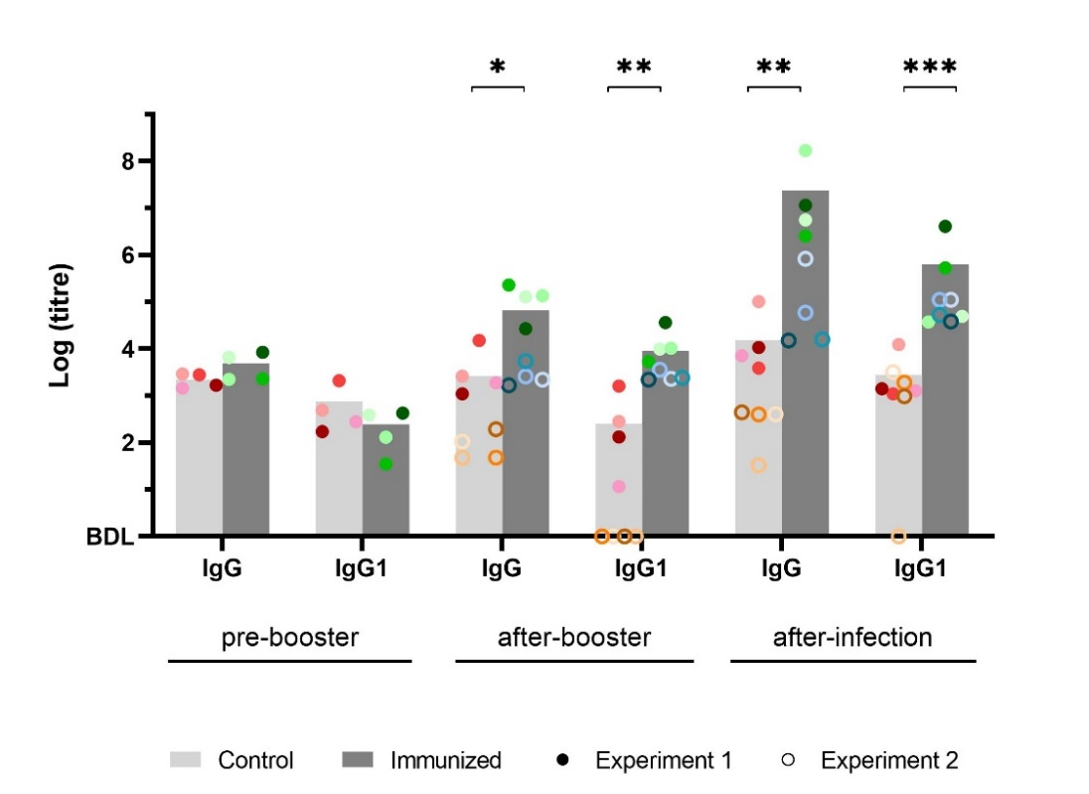
Figure 2. Serum IgG and IgG1 antibody detection. Comparison of IgG and IgG1 levels in the serum of cattle immunized with NcMP/CpG/R848 (immunized) or sham-immunized with CpG/R848 (control), as indicated previously, exactly before (pre-booster) and 4 weeks after the third booster immunization (after-booster), which corresponded to the day of infection with N. caninum tachyzoites (animals from Experiment 1 received 2.5 × 10⁸ parasites and those from Experiment 2 received 7.0 × 10⁸ parasites), and 15 days after infection (after-infection). Data corresponds to pooled serum samples from Experiment 1 (represented with closed circles) and Experiment 2 (open circles) with a total number of 4 animals per group per experiment. Each dot represents an individual animal. Each colour represents one animal throughout the measurements. Each bar represents the mean of each pooled group. Data are presented as Log₁₀ of the antibody titres. Data were analysed with Mann-Whitney (* P 0.05; ** P < 0.01; *** P < 0.001).
Animals from the immunized group displayed significantly higher levels of both NcMP-specific IgG and IgG1 after booster and after infection than animals from the control group in both experiments (P < 0.05). No significant differences in IgG or IgG1 levels were found before the third booster immunization between control and immunized group. Antibody levels presented in the serum of animals from Experiment 2 before immunization were not measured. IgG1 was below detection levels in all animals of the control group of the Experiment 2 before infection, but most of them developed antibodies 15 days after infection (Fig. 2). The serum of animals from Experiment 2 had a smaller increase in the levels of IgG 15 days after infection than in the serum from animals of Experiment 1, despite having received a larger quantity of parasites. The increase in specific IgG1 antibodies is indicative of a Th2-type immune response. However, further conclusions about the predominance of IgG1 and an associated Th2 response cannot be drawn due to lack of IgG2 investigation.

3.3. Assessment of the IL-2, IL-4, IL-17A and IFN-γ levels in the serum of vaccinated and infected animals
Cell mediated immunity is known to be the most effective host resistance mechanism against N. caninum [9–11]. Pro-inflammatory cytokines IFN-γ and IL-2 are considered key mediators in cell mediated immunity [10, 17].
To determine whether immunization and infection induced an increase in these molecules and in other cytokines related to the T cell response to Neospora caninum, serum samples were analysed by ELISA and cytokine concentration was determined. Here, a slight increase in IL-2 levels was noted in both experiments after infection. In general, control groups displayed higher levels of IL-2 than immunized groups in both experiments, which were already evident before infection. Animals from the control group presented significantly higher levels than the immunized group in a pool of samples from Experiment 1 and 2 (P < 0.05; difference between means = 147.2 ± 64.17). These increased IL-2 levels in the serum of control animals are in general in agreement with IFN-γ levels, what is expected, since Th1 cells are major IFN-γ and IL-2 producers [19]. Nevertheless, the levels of IFN-γ were very low in the serum of both immunized and control animals, most of the times below the detection limit. No significant differences were found between groups regarding IFN-γ, although the serum from two animals of the control group from Experiment 1 had markedly increased IFN-γ levels. One of these also had the highest levels of IL-2. Only two animals from Experiment 2 had detectable serum IFN-γ levels 15 days after infection in the immunized group. The serum from one of these animals presented the highest IL-2 level.
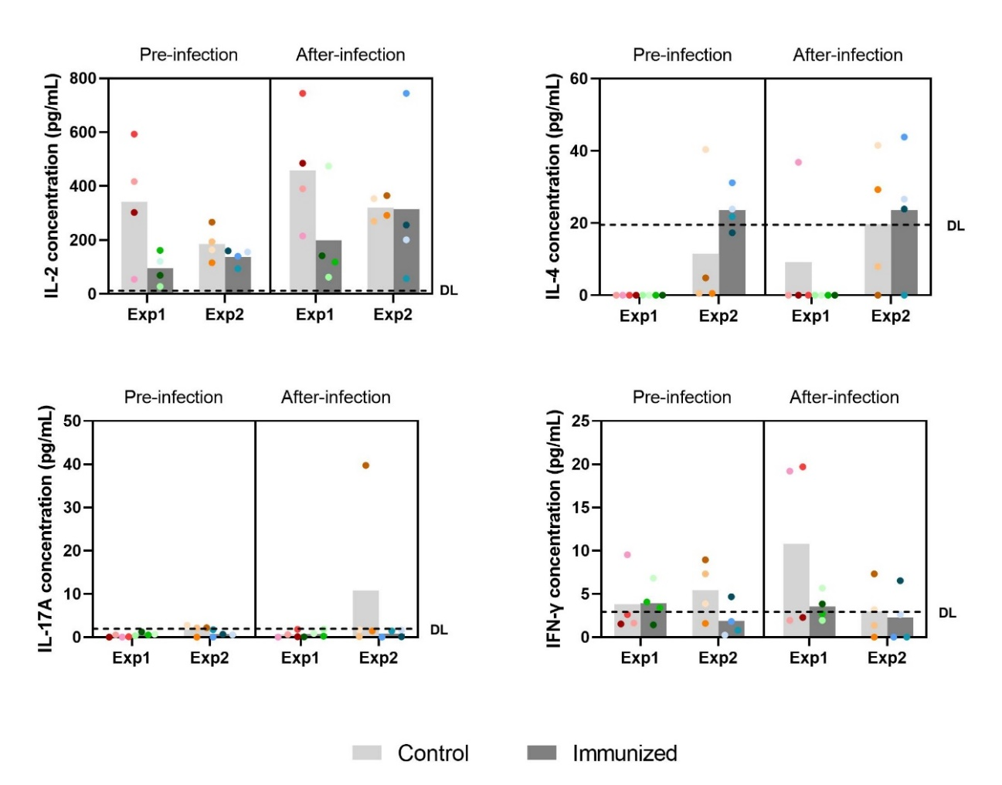
Figure 3. Serum IL-2, IL-4, IL-17A and IFN-γ cytokines detection. Comparison of IL-2, IL-4, IL-17A and IFN-γ levels in the serum of immunized or sham-immunized cattle, as indicated previously, at the infection day (Pre-infection) and 15 days after the infection (After-infection) with N. caninum tachyzoites. Data corresponds to two independent experiments. Each dot represents an individual animal. Each colour represents one animal throughout the measurements. Each bar represents the mean of each group. DL- detection limit.
IL-4 is a Th2-type cytokine and has been associated with a humoral immune response and, therefore, antibody production, particularly of the IgG1 and IgE isotypes [10], [19]. IL-4 is produced by Th2 activated cells and suppresses IFN-γ production [19]. This type of immune response is associated with parasite survival and is often linked to recrudescence of infection that follows modulation of the immune response during pregnancy [1, 11]. Here, an increase of the IL-4 levels was noted after infection in the serum of control calves from Experiment 2 (Fig. 3). In Experiment 1, Il-4 was not detected in any but one serum from an animal of the control group. Controversially, this animal was one of the two animals presenting the highest IFN-γ levels. Comparison of the IL-4 versus IFN-γ levels in the serum of animals from Experiment 2, reveal that in general, and as expected from literature, animals with higher IL-4 levels had lower IFN-γ levels and animals with lower IL-4 levels had higher IFN-γ levels. In Experiment 2, the immunized group showed higher levels of IL-4 than the control group, both before and after infection indicating that in this experiment a Th2-biased response might have been induced. However, no significant differences were observed.
Th17 cells produce cytokines of the IL-17 family that are known to mediate the immune response against extracellular bacteria and fungi [19], but these have also been detected in protozoan infections, such as in a Neospora caninum and Toxoplasma gondii infections [21, 44]. IL-17A production is downregulated by IFN-γ [19, 45]. Here, the levels of IL-17 were very low in bovine serum, regardless of the group and time point analysed. Most values were below the detection limit and only one animal of the control group in Experiment 2 displayed clearly detectable IL-17A amounts in the serum (Fig. 3).

3.4. Analysis of T cell proliferation and cytokine production by Flow Cytometry
Flow cytometry can be used to evaluate both cell proliferation and cytokine production. Using this technique, it is possible to analyse which cells are responding to stimulation and the cytokines each cell is producing. Cell proliferation can be followed by detecting the fluorescence dilution of a cell proliferation dye, that is bound to cell proteins, over the division process. For this reason, two daughter-cells will display each half the dye fluorescence the mother-cell previously possessed [56]. Here, the analysis of T cell proliferation in response to antigenic recall was evaluated, using both whole freeze-killed N. caninum tachyzoites or NcMP. Concanavalin A (ConA) is a lectin extracted from Canavalia ensiformis that is often used to induce potent T cell division and cytokine production [57]. Stimulation with ConA was used here as a positive control of T cell proliferation.
Gating strategy used to determine T cell proliferation and cytokine production is shown in Annex C, Fig. C1. Cell population gating was determined by analysing the FMO controls. Whenever necessary, individual gating was adjusted to select cell populations more accurately. For example, cells stimulated with ConA displayed higher expression of CD4 and CD8 than cells under the other culture conditions. Bovine-specific antibodies labelled with suitable fluorophores to combine in more complex multiparametric flow cytometry analysis are not available commercially and therefore it was necessary to conjugate some antibodies. Spectral overlapping of some fluorophores, and possibly poor dye quenching of in-house conjugated antibodies, difficulted the analysis of some parameters. This was the case of anti-bovine TCR γδ antibody. It was then not possible to accurately distinguish this cell population and, therefore, TCR γδ expression was not evaluated. Nevertheless, results from the group have confirmed that most of the CD4⁻CD8⁻ cells are TCR γδ⁺ and we can indirectly infer the TCR γδ⁺ cell response by looking at the CD4⁻ CD8⁻ cell population. Viability analysis was also compromised in the intracellular cytokine analysis experiment due to CellTrace™ Violet and FVD eF506 spectral overlapping. For this reason, dead cells were not excluded in the analysis of cytokine-producing cells.
Proliferation was determined in PBMCs collected before infection (Fig. 4) and 15 days after infection (Fig.5). Overall, samples stimulated with ConA displayed noteworthy proliferation in all T cell populations.
In cells collected before infection, proliferation was more evident in the immunized group when stimulated with the N. caninum antigens NcMP and NcT. Percentage of division was significantly higher in CD3⁺, CD4⁺ and CD4⁻ CD8⁻ T cells from immunized animals stimulated with NcMP, and in CD3⁺ and CD4⁻ CD8⁻ T cells stimulated with NcT (Fig. 4).
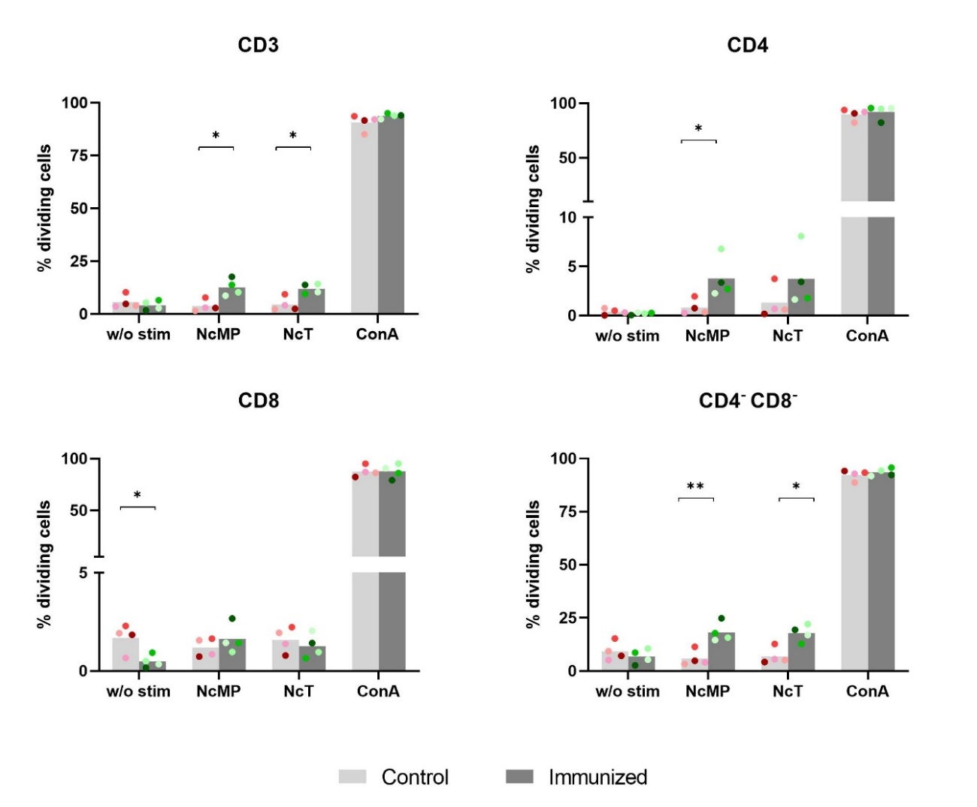
Figure 4. Percentage of division of CD3⁺, CD4⁺, CD8⁺ and CD4⁻ CD8⁻ T cells in the PBMCs of cattle immunized thrice with NcMP/CpG/R848 and sham-immunized with CpG/R848, as indicated previously, before infection, stimulated with concanavalin A (ConA), N. caninum membrane proteins (NcMP), N. caninum tachyzoites (NcT) or without stimulation (w/o stim). Data corresponds to one independent experiment (Experiment 1). Each dot corresponds to an individual animal. Each symbol colour represents one animal throughout measurements. Each bar represents the mean of the group. Data are presented as the percentage of dividing cells in each gated live T cell population. Statistical differences between control and immunized groups, for each culture condition, were calculated using two-tailed unpaired Student’s t-test (* P < 0.05; ** P < 0.01).
Non-stimulated cells were used as negative controls of proliferation, representing basal proliferation levels in culture. Curiously, cells from the control group showed significantly higher basal CD8⁺ T cell proliferation (Fig. 4). Thus, although absolute proliferation percentages were not different in CD8⁺ cells between control and immunized groups upon antigenic recall, when considering the respective basal proliferation levels, it is clear that CD8⁺ T cells from immunized animals also responded to N. caninum antigens.
After infection, proliferation was more evident in all cell populations of the control group when stimulated with NcT, compared to cells from the immunized group. However, no statistical significances were found between groups (Fig. 5).
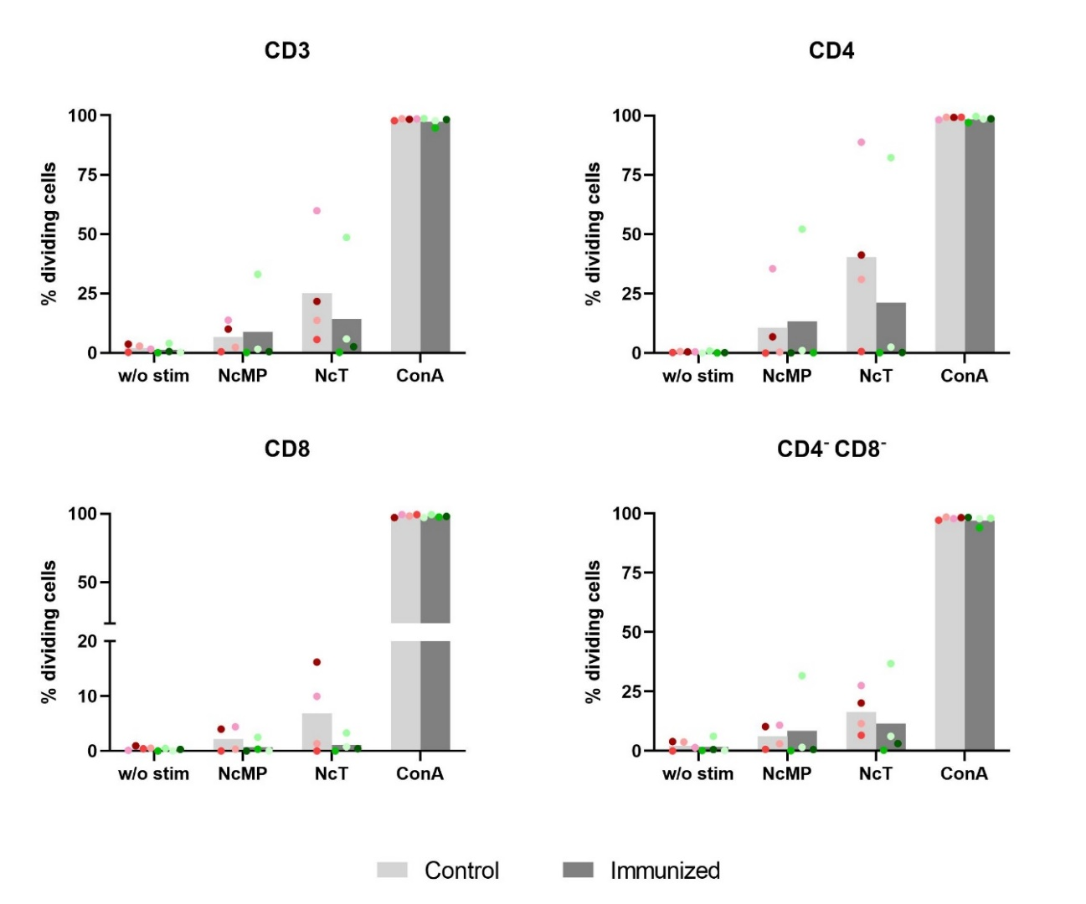
Figure 5. Percentage of division of CD3⁺, CD4⁺, CD8⁺ and CD4⁻ CD8⁻ T cells in the PBMCs of cattle immunized thrice with NcMP/CpG/R848 and sham-immunized with CpG/R848, as indicated previously, 15 days after infection with 2,5 × 10⁸ N. caninum tachyzoites, stimulated with concanavalin A (ConA), N. caninum membrane proteins (NcMP), N. caninum tachyzoites (NcT) or without stimulation (w/o stim). Data corresponds to one independent experiment (Experiment 1). Each dot corresponds to an individual animal; each symbol colour represents a distinct animal. Each bar represents the mean of the group. Data are presented as the percentage of dividing cells in each gated live T cell population.
CD4⁺ Th1, CD8⁺ T cytotoxic and TCR γδ⁺ cells are the main producers of IFN-γ, along with NK cells [12, 18, 19, 48]. To determine if immunization and infection could lead to the induction of parasite-specific T cells, the evaluation of pro-inflammatory cytokine production in response to the different stimuli was done following intracellular staining of IFN-γ and IL-17A. Gating strategy used is presented in Annex C, Fig. C2.
IFN-γ production was generally higher in cells from the control group, which is in accordance with the proliferation results and IFN-γ serum measurement after infection. Antigen-specific CD4⁺ IFN-γ producing cells were more frequent than CD8⁺ and CD4⁻ CD8⁻ cells. NcT induced greater IFN-γ production in all cell populations than NcMP, but more evidently in CD4⁺ T cells (Fig. 6). However, no statistically significant differences were found between groups.
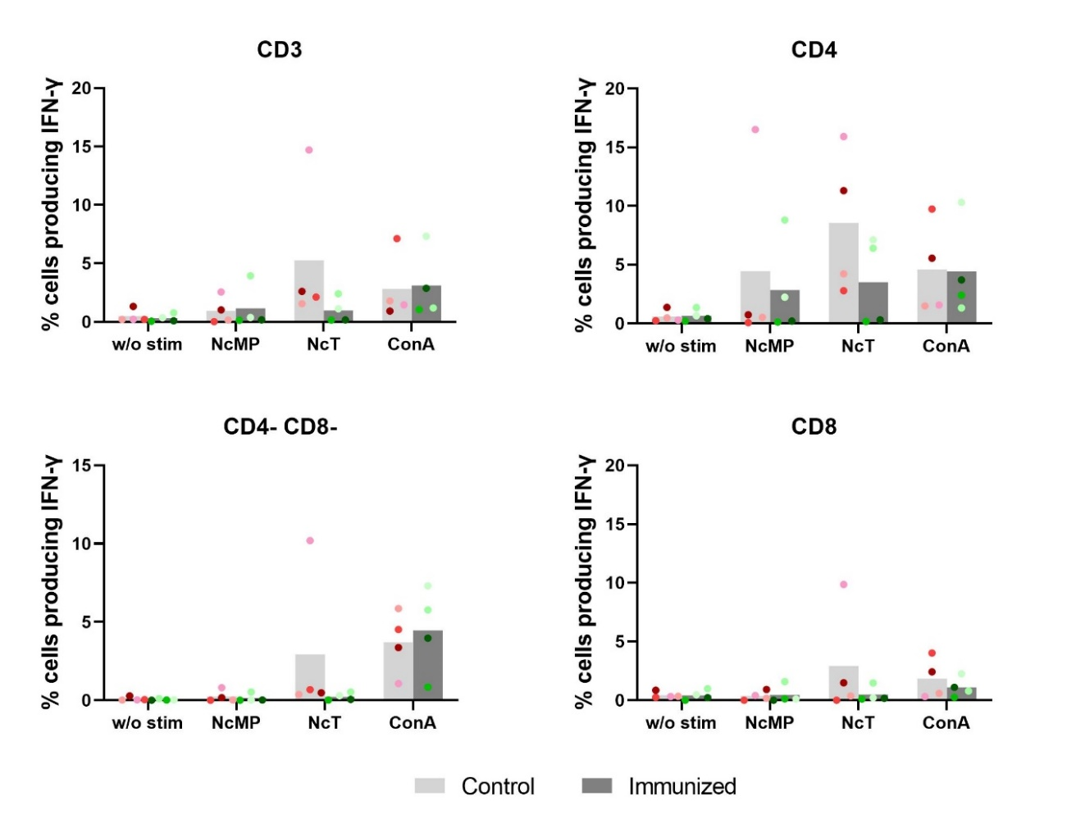
Figure 6. Percentage of CD3⁺, CD4⁺, CD8⁺ and CD4⁻ CD8⁻ T cells producing IFN-γ. IFN-γ producing cells in PBMCs of cattle immunized thrice with NcMP/CpG/R848 and sham-immunized with CpG/R848, as indicated previously, 15 days after infection with 2.5 × 10⁸ N. caninum tachyzoites, stimulated ex-vivo with concanavalin A (ConA), N. caninum membrane proteins (NcMP), N. caninum tachyzoites (NcT) or without stimulation (w/o stim). Data corresponds to one independent experiment (Experiment 1). Each dot corresponds to an individual animal. Each symbol colour represents one animal throughout the measurements. Each bar represents the mean of the group. Data are presented as percentage of the corresponding gated cell populations producing IFN-γ.
IL-17A is produced mainly by Th17 and TCR γδ⁺ cells [19, 45]. TCR γδ⁺ cells were not accurately identified here, due to technical limitations, which compromised IL-17A measurements by TCR γδ⁺ cells. However, these were indirectly determined by evaluating the CD4⁻ CD8⁻ T cell population, as previously mentioned. As displayed in Fig. 7, IL-17A production was higher in all cell populations of the control group samples that were stimulated with NcT. Nevertheless, no statistical significant differences were found between groups.
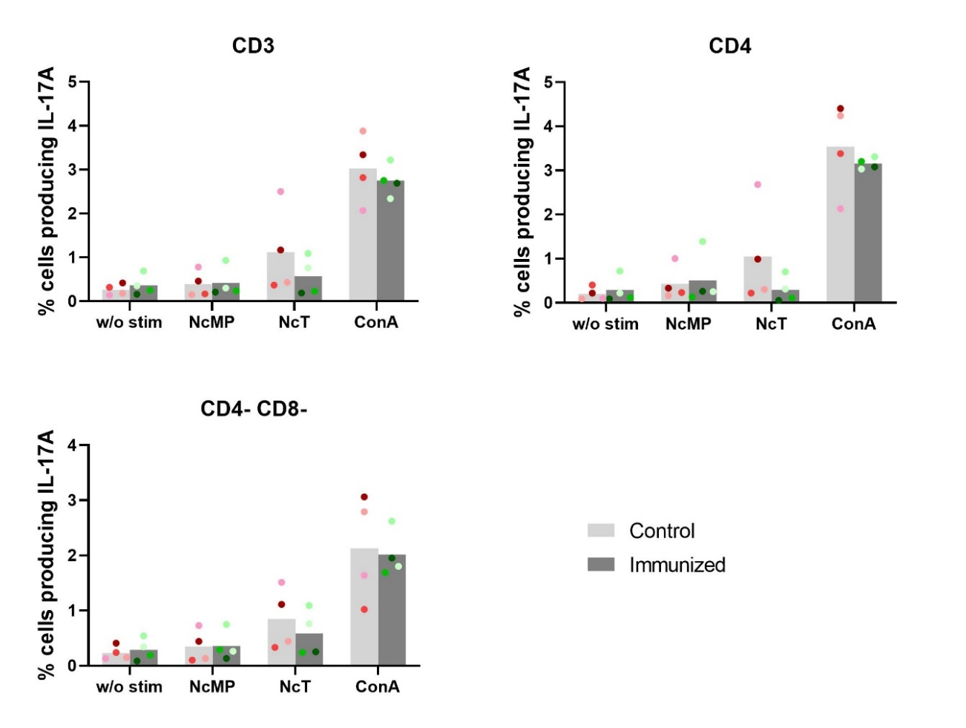
Figure 7. Percentage of CD3⁺, CD4⁺ and CD4⁻ CD8⁻ T cells producing IL-17A. IL-17A producing cells in PBMCs of cattle immunized thrice with NcMP/CpG/R848 and sham-immunized with CpG/R848, as indicated previously, 15 days after infection with 2.5 × 10⁸ N. caninum tachyzoites, stimulated ex-vivo with concanavalin A (ConA), N. caninum membrane proteins (NcMP), N. caninum tachyzoites (NcT) or without stimulation (w/o stim). Data corresponds to one independent experiment (Experiment 1). Each dot corresponds to an individual animal. Each symbol colour represents one animal throughout the measurements. Each bar represents the mean of the group. Data are presented as percentage of the corresponding gated cell populations producing IL-17A.

3.5. Evaluation of TBX21 and RORC gene expression
T-bet and RORγt are transcription factors that are essential for stable Th1 and Th17-type responses and are characteristically expressed by IFN-γ- and IL-17A-producing cells, respectively [19, 21]. β2 microglobulin is a component of major histocompatibility (MHC) class I [59] and was used here as a reference gene to evaluate the relative expression of TBX21 and RORC, the genes encoding T-bet and RORγt, respectively.
Relative expression of TBX21 was higher in the lung samples of animals from the control group, while in brain, samples from the immunized group presented higher relative TBX21 expression. RORC relative expression was slightly higher in the liver and lung samples of the control group, while the relative expression in the spleen was higher in the immunized group samples (Fig. 8). No statistical significant differences were found between groups. TBX21 mRNA transcripts were not detected in the liver samples from one animal of the control group and from another of the immunized group, or in the brain samples from two animals of the control group and one animal of the immunized group. RORC expression was not detected in one animal of the immunized group in the brain. Curiously, RORC is expressed at higher levels in the liver and lung samples than in brain or spleen. Only samples from Experiment 2 were analysed.
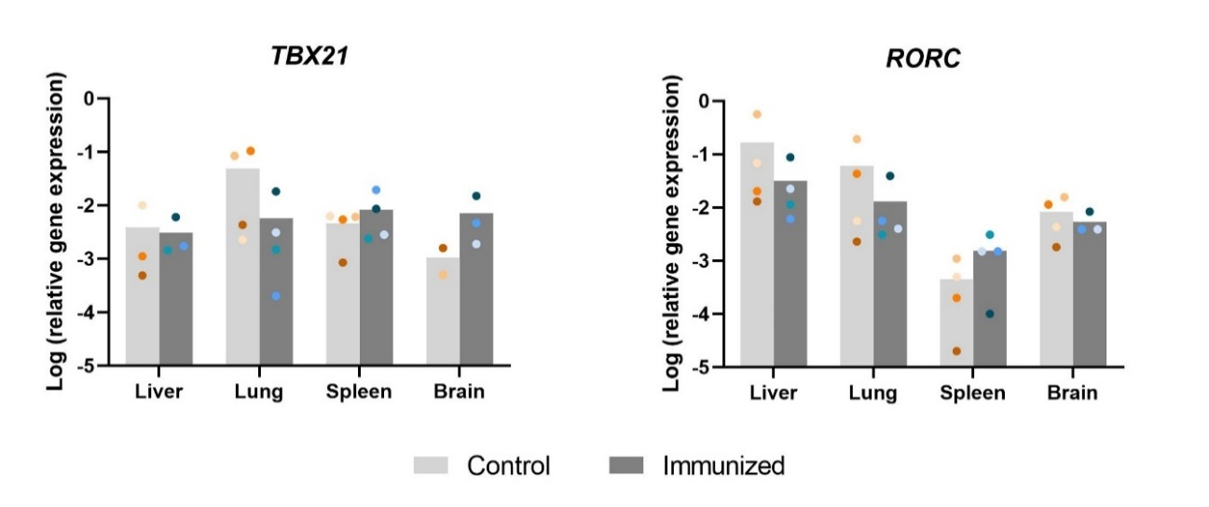
Figure 8. mRNA relative expression levels for TBX21 and RORC in comparison to β2 microglobulin mRNA expression in representative samples of the liver, lung, spleen and a cerebellar region of the brain of cattle immunized thrice with NcMP/CpG/R848 or sham-immunized with CpG/R848, as indicated previously, 4 weeks after the infection with 7.0 × 10⁸ N. caninum. Data corresponds to one independent experiment (Experiment 2). Each dot represents an individual animal. Each colour represents one animal throughout the measurements. Each bar represents the mean of the group. Data are presented as Log₁₀ relative gene expression.
Although TXB21 and RORC mRNA expression was normalized against B2M mRNA expression, we later attempted the assessment of the best reference gene or combination of genes using NormFinder [52]. This determined that the single gene with the best stability was PPIA (stability = 0.635) and the best combination of two genes was PPIA and UXT (stability = 0.298). It will be important to normalise further our results against these reference genes to confirm the relative expression of TBX21 and RORC.

3.6. Neospora caninum DNA detection in infected control and immunized animals
Parasite burden was determined in different tissue samples from infected control and immunized animals by qPCR. Very few samples resulted in DNA amplification using the established qPCR protocol and several discrepancies were found. Thus, to improve the chance of detecting parasitic DNA, the same sample was investigated using three different conditions: using directly 1 μL and 2 μL as template DNA or 1 μL of previously amplified samples (nested PCR) as a template for parasite concentration determination by qPCR. Results varied greatly within the same sample depending on the condition used (Fig. 9).
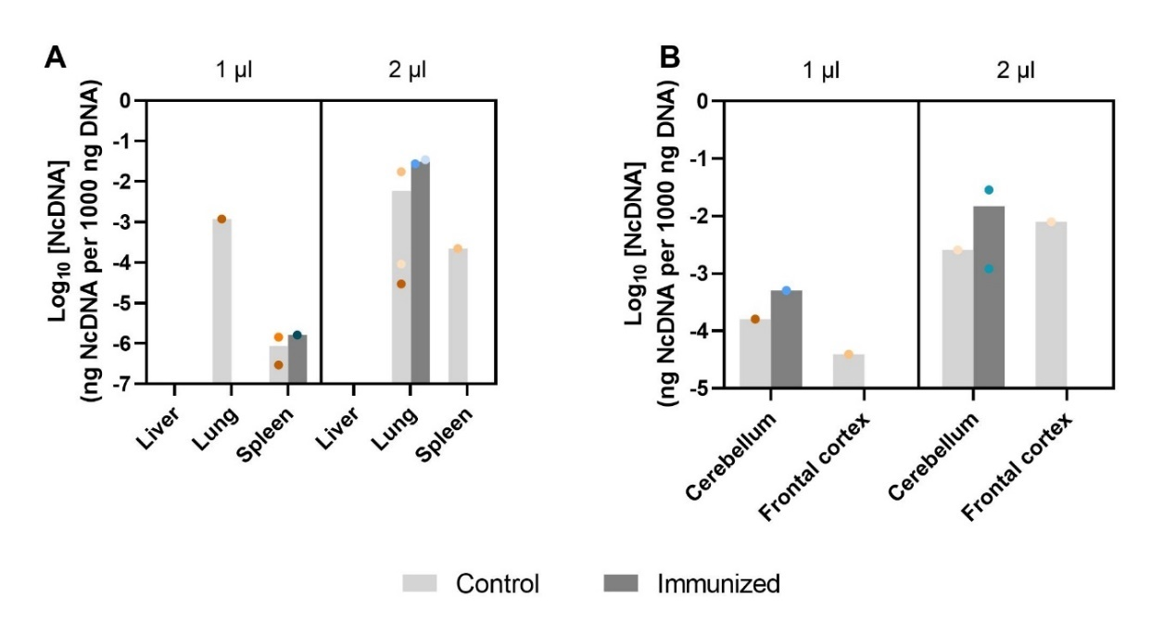
Figure 9. Detection of Neospora caninum DNA in liver, lung, spleen, and in two regions of the brain (cerebellum and frontal cortex) samples using qPCR. (A) Comparison of qPCR results of liver, lungs and spleen samples and (B) grouped samples from two areas of the cerebellum and two areas of the frontal cortex from cattle immunized thrice with NcMP/CpG/R848 or sham-immunized with CpG/R848, as described previously, 4 weeks after infection with 7.0 × 10⁸ N. caninum tachyzoites, using 1 μL and 2 μL of template DNA. Data corresponds to one independent experiment (Experiment 2). Each dot represents one individual animal. Each symbol colour represents one animal throughout the measurements. Each bar represents the mean of each group. Data are presented as Log₁₀ parasitic DNA within total DNA.
It was possible to detect parasitic DNA in almost all tissues (lung, spleen and two different regions of the brain: cerebellum and frontal cortex), but not in all samples. Moreover, in some samples, amplification was found using 1μL but not 2 μL DNA and vice-versa. Since this could be due to extremely low DNA parasitic levels, a nested PCR approach was attempted (Table 1). Using this approach, the presence of the parasite was detected in the liver, for which no amplification was seen using the direct approach, and in the spleen of all animals. Four animals (two from the control group and two from the immunized group) presented parasitic DNA in the lungs using the nested PCR approach. However, the other four animals (two from each group) were not identified as positive, despite having shown amplification using the direct approach. In the brain, discrepancies were more evident. Nested PCR identified the presence of parasitic DNA in all animals in one area of the frontal cortex (frontal cortex 2) and indicated the other area of the frontal cortex (frontal cortex 1) free from parasitic DNA, despite some animals having shown amplification using the direct approach in DNA from this area. Using the direct approach, DNA from the frontal cortex 1 was amplified in samples from two animals of the control group. Similarly, nested PCR detected the presence of parasitic DNA in all but one animal (from the control group) in one area of the cerebellum (cerebellum 2) and indicated all but two animals free of parasitic DNA in the other area (cerebellum 1), despite other animals having shown amplification using the direct approach. In cerebellum 1 samples, two animals from the immunized group and two animals from the control group showed no parasitic DNA amplification either by the direct or the nested approaches. Cerebellum 2 was the same area used to measure the mRNA expression of TBX21 and RORC. Here, only one animal (control group) was declared free from parasitic DNA. A reassessment of all samples and sequencing of PCR products is needed to verify their amplification accurately.
Table 1. qPCR results using nested PCR amplification products as template DNA
Sample | Control groupª | Immunized groupª
Liver | 4/4 | 4/4
Lungs | 2/4 | 2/4
Spleen | 4/4 | 4/4
Cerebellum 1 | 1/4 | 1/4
Cerebellum 2 | 3/4 | 4/4
Frontal cortex 1 | 0/4 | 0/4
Frontal cortex 2 | 4/4 | 4/4
ªNumber of positive samples in total analysed samples

4. Discussion
Neospora caninum is an obligate intracellular parasite [9–11]. For this reason, the protective immune response is mainly cell-mediated [10, 11] and the protective mechanism includes the production of the pro-inflammatory cytokines IL-12 and IFN-γ, and is also associated with generation of parasite-specific antibodies of the IgG2 isotype [17, 19, 50].
The combined immunization approach used here led to the production of parasite specific IgG. Parasite-specific IgG1 titres were elevated in the serum of immunized calves, but since IgG2 titres were not measured, the IgG1/igG2 ratio could not be determined. Measuring the IgG2 levels in the serum should be further investigated since this immunoglobulin subclass is indicative of a Th1-type-biased immune response [61]. Although predominance of IgG2 antibodies could be anticipated because of the adjuvants used here, CpG and resiquimod (R848), that are known to skew the immune response towards a Th1-type response [37, 38], the combination of intranasal immunization with the CarbigenTM adjuvant could have promoted a mixed response [12, 40, 54]. Nevertheless, in response to vaccination, IgG1 was commonly produced at high levels in cattle, even when a Th1-type adjuvant, such as Complete Freund’s adjuvant was used [63]. Since infection was not performed orally, but subcutaneous and intravenously with tachyzoites, due to the difficulty in obtaining oocysts, the mucosal response is not relevant here. Saliva was collected from immunized and control animals, but mucosal antibodies were not evaluated. Measurement of IgA antibodies would be interesting to determine if this immunization strategy also induced a mucosal specific humoral response. It would also be interesting to incubate N. caninum tachyzoites with IgA from immunized and control cattle and evaluate parasite agglutination and parasite entry into enterocytes upon IgA treatment, as done in mice [31].
No differences were found in the levels of IFN-γ, IL-2, IL-17 and IL-4 in the serum of immunized animals. Cytokine levels were very low in the serum of both immunized and control calves, before and after infection. Infection was done with a relatively low number of tachyzoites which could have contributed to the modest cytokine levels measured in serum. It is also possible that IFN-γ could have been produced at a higher amount earlier upon infection and that we could have missed the production peak.
Proliferation of circulating T cell populations in response N. caninum antigens was measured before and after infection. Before infection, an increase of cell division was seen in CD4⁺, CD8⁺ and CD4⁻ CD8⁻ (presumably TCR γδ⁺) T cells from immunized animals in response to antigenic recall. This result indicate that all T cell populations analysed responded to vaccination and might intervene in the response to N. caninum infection. We have not evaluated the cytokines produced by those cells and released into culture supernatants by ELISA yet, but previous results from the group indicate that they could be producing IFN-γ, IL-2, IL-17A, but not IL-4. No differences could however be found after infection, even though cells from control animals were in general proliferating at a higher extent. This result is in line with results found in another vaccination study in cattle, in which one-week after infection no significant differences between immunized and control groups were observed regarding IFN-γ production and antigen-specific proliferation responses, despite protection induced by immunization [64].
CD4⁺ Th1, CD8⁺ T cytotoxic and TCR γδ⁺ cells are the main producers of IFN-γ, along with NK cells [12, 18, 19, 48]. CD4⁺ T cells have been previously identified as important IFN-γ production cells during N. caninum infection [65]. In the mouse model, the importance of CD4⁺ greatly surpassed that of CD8⁺ cells [66], however previous results from the group identified CD8⁺ T cells as earlier sources of IFN-γ in the mouse model [13]. Here, when analysing N. caninum specific circulating T cells, CD8⁺ IFN-γ producing cells were less frequent than CD4⁺ T cells, two weeks after infection. The later were found slightly increased in the blood of control animals. It would be interesting to investigate the T cell response earlier upon infection to assess if parasite-specific memory T cells induced by immunization could be early sources of IFN-γ. Cytokine production kinetics could explain the absence of differential IFN-γ production between immunized and control animals when analysis is done at least one week after infection, despite high IFN-γ production upon antigenic recall before infection [12, 30, 31]. Moreover, in a vaccination study against bovine neosporosis, the peak of IFN-γ production by PBMC collected after challenge occurred 1-2 days post-infection and no significant IFN-γ response was seen one week after challenge [64].
IL-17 cytokine family is known to mediate the inflammation that is usually linked to extracellular bacterial and fungal infections [19], but their action has been extended to several protozoan infections, such as T. gondii, N. caninum and Cryptosporidium parvum [12, 44, 57, 58]. IL-17 has shown a greater importance in enhancing epithelial protection, and is mainly produced by Th17 and TCR γδ⁺ cells [45, 59]. Studies indicate that TCR γδ⁺ seemingly act in short-term and that Th17 may be associated with a long-term IL-17A production [45, 61]. Th17 cells also have been shown to induce IgA production in intestinal Peyer’s patches [59, 60]. A TCR γδ⁺ IL-17A producing cell population was already shown to be an efficient N. caninum killer [55]. Here, IL-17A serum levels were very low and mostly below detection levels. Also, no significant differences were found in IL-17A production by any of the T cell populations analysed two weeks after infection.
We also evaluated the expression of TBX21 and RORC, in the organs of immunized and control animals one month after infection. T-bet, encoded by TBX21 gene, and RORγt, encoded by the RORC gene, are key transcription factors for IFN-γ and IL-17A production, respectively [19, 21]. Although no significant differences were found, there was a slight increase in the relative expression of TBX21 and RORC in the lungs of animals from the control group, which is in accordance with the higher abundance of IFN-γ-producing cells in the blood of these animals two weeks after infection. The TBX21 relative expression tendency was however inverted in the brain of immunized animals. Whether IFN-γ is being produced at higher levels in the brain of immunized calves should be explored. We have also designed primers to amplify the Th2 associated transcription factor, GATA binding protein 3, encoded by GATA3 gene [24] and it would be worth evaluating its relative expression. TBX21 and RORC relative expressions should also be reassessed and normalized against either PPIA or PPIA and UXT, as these were later determined to have higher stability than B2M.
Unfortunately, the efficiency of immunization in protection against neosporosis could not be accurately assessed. Parasite burden was low and quantification of N. caninum DNA by qPCR was inconsistent using different analysis approaches for the same sample. In samples from Experiment 1, already analysed in the group, determination of parasitic DNA was not possible by qPCR, but amplification of brain samples using nested PCR indicated that 4/4 animals of the control group and only 1/4 of the immunized group had detectable parasitic DNA. Here, using nested PCR, we could detect parasitic DNA in the majority of the samples, although results were not convincing. For example, no amplification was detected in frontal cortex samples from area 1, while all samples from region 2 amplified. Further optimization of this protocol is thus required for the correct assessment of parasite burden and to accurately determine the effectiveness of this immunization strategy.

5. Conclusion
A successful immunization strategy against N. caninum should induce both cell mediated and humoral immune responses. The management of infection in pregnancy also requires a balanced Th1 and Th2-type response that can control the parasite dissemination and avoid both the loss of the foetus due to an excessive Th1 response, and the spread of the parasite by transplacental transmission due to lack of IFN-γ [38].The results reported here showed an evident parasitic-specific humoral immune response in immunized calves and the generation of parasite-specific T memory cells in response to vaccination. There is also an indication that IFN-γ and IL-17A are produced before infection in response to N. caninum antigens and, probably, soon after challenge. Although evaluation of the parasite burden in the brain of animals from Experiment 1 pointed to protection conferred by vaccination against neosporosis, no such results could be observed in Experiment 2 samples. The efficiency of this immunization strategy is thus yet to be determined, and optimization of the parasite detection protocol is required before drawing more definite conclusions.

References
[1] T. Nayeri, M. Moosazadeh, S. Sarvi, and A. Daryani, “Neospora caninum infection in aborting bovines and lost fetuses: A systematic review and meta-analysis,” PLoS One, vol. 17, no. 5, p. e0268903, May 2022.
[2] I. Bjerkås, S. F. Mohn, and J. Presthus, “Unidentified cyst-forming Sporozoon causing encephalomyelitis and myositis in dogs,” Z. Parasitenkd., vol. 70, no. 2, pp. 271–274, 1984.
[3] J. P. Dubey, J. L. Carpenter, C. A. Speer, M. J. Topper, and A. Uggla, “Newly recognized fatal protozoan disease of dogs.,” J. Am. Vet. Med. Assoc., vol. 192, no. 9, pp. 1269–85, May 1988.
[4] J. P. Dubey and G. Schares, “Neosporosis in animals—The last five years,” Vet. Parasitol., vol. 180, no. 1–2, pp. 90–108, Aug. 2011.
[5] J. P. Dubey et al., “Gray wolf (Canis lupus) is a natural definitive host for Neospora caninum,” Vet. Parasitol., vol. 181, no. 2–4, pp. 382–387, Sep. 2011.
[6] J. S. King, J. Šlapeta, D. J. Jenkins, S. E. Al-Qassab, J. T. Ellis, and P. A. Windsor, “Australian dingoes are definitive hosts of Neospora caninum,” Int. J. Parasitol., vol. 40, no. 8, pp. 945–950, Jul. 2010.
[7] L. F. P. Gondim, M. M. McAllister, W. C. Pitt, and D. E. Zemlicka, “Coyotes (Canis latrans) are definitive hosts of Neospora caninum,” Int. J. Parasitol., vol. 34, no. 2, pp. 159–161, 2004.
[8] M. M. McAllister, J. P. Dubey, D. S. Lindsay, W. R. Jolley, R. A. Wills, and A. M. McGuire, “Rapid communication: Dogs are definitive hosts of Neospora caninum,” Int. J. Parasitol., vol. 28, no. 9, pp. 1473–1479, Sep. 1998.
[9] J. P. Dubey, G. Schares, and L. M. Ortega-Mora, “Epidemiology and Control of Neosporosis and Neospora caninum,” Clin. Microbiol. Rev., vol. 20, no. 2, pp. 323–367, Apr. 2007.
[10] S. L. Donahoe, S. A. Lindsay, M. Krockenberger, D. Phalen, and J. Šlapeta, “A review of neosporosis and pathologic findings of Neospora caninum infection in wildlife,” Int. J. Parasitol. Parasites Wildl., vol. 4, no. 2, pp. 216–238, Aug. 2015.
[11] S. J. Goodswen, P. J. Kennedy, and J. T. Ellis, “A review of the infection, genetics, and evolution of Neospora caninum: From the past to the present,” Infect. Genet. Evol., vol. 13, no. 1, pp. 133–150, Jan. 2013.
[12] E. Collantes-Fernandez et al., “Infected Dendritic Cells Facilitate Systemic Dissemination and Transplacental Passage of the Obligate Intracellular Parasite Neospora caninum in Mice,” PLoS One, vol. 7, no. 3, p. e32123, Mar. 2012.
[13] A. Correia et al., “Mucosal and systemic T cell response in mice intragastrically infected with Neospora caninum tachyzoites,” Vet. Res., vol. 44, no. 1, p. 69, Dec. 2013.
[14] P. O. Duarte et al., “Serological and molecular detection of Neospora caninum and Toxoplasma gondii in human umbilical cord blood and placental tissue samples,” Sci. Reports 2020 101, vol. 10, no. 1, pp. 1–8, Jun. 2020.
[15] R. M. Shaapan, “The common zoonotic protozoal diseases causing abortion,” J. Parasit. Dis., vol. 40, no. 4, pp. 1116–1129, Dec. 2016.
[16] M. P. Reichel, L. C. Wahl, and J. T. Ellis, “Research into Neospora caninum-What Have We Learnt in the Last Thirty Years?,” Pathog. (Basel, Switzerland), vol. 9, no. 6, pp. 1–18, Jun. 2020.
[17] L. Teixeira et al., “Plasmacytoid and conventional dendritic cells are early producers of IL-12 in Neospora caninum-infected mice,” Immunol. Cell Biol., vol. 88, no. 1, pp. 79–86, Jan. 2010.
[18] T. V. Baszler, M. T. Long, T. F. McElwain, and B. A. Mathison, “Interferon-γ and interleukin-12 mediate protection to acute Neospora caninum infection in BALB/c mice,” Int. J. Parasitol., vol. 29, no. 10, pp. 1635–1646, 1999.
[19] I. R. Tizard, “Veterinary Immunology,” in Elsevier Health Sciences, 9th ed., W.B. Saunders Company, 2012.
[20] L. Teixeira et al., “Plasmacytoid and conventional dendritic cells are early producers of IL-12 in Neospora caninum-infected mice,” Immunol. Cell Biol., vol. 88, no. 1, pp. 79–86, Jan. 2010.
[21] L. Teixeira et al., “Analysis of the immune response to Neospora caninum in a model of intragastric infection in mice,” Parasite Immunol., vol. 29, no. 1, pp. 23–36, Jan. 2007.
[22] P. Boysen, S. Klevar, I. Olsen, and A. K. Storset, “The Protozoan Neospora caninum Directly Triggers Bovine NK Cells To Produce Gamma Interferon and To Kill Infected Fibroblasts,” Infect. Immun., vol. 74, no. 2, p. 953, Feb. 2006.
[23] A. Benson, R. Pifer, C. L. Behrendt, L. V. Hooper, and F. Yarovinsky, “Gut commensal bacteria direct a protective immune response against the human pathogen Toxoplasma gondii,” Cell Host Microbe, vol. 6, no. 2, p. 187, Aug. 2009.
[24] A. Correia, P. Alves, R. Fróis-Martins, L. Teixeira, and M. Vilanova, “Protective Effect against Neosporosis Induced by Intranasal Immunization with Neospora caninum Membrane Antigens Plus Carbomer-Based Adjuvant,” Vaccines, vol. 10, no. 6, p. 925, Jun. 2022.
[25] R. Guiton et al., “Interleukin 17 Receptor Signaling Is Deleterious during Toxoplasma gondii Infection in Susceptible BL6 Mice,” J. Infect. Dis., vol. 427, no. 3, pp. 427–435, 2010.
[26] L. Zhang et al., “Eimeria tenella: Interleukin 17 contributes to host immunopathology in the gut during experimental infection,” Exp. Parasitol., vol. 133, no. 2, pp. 121–130, Feb. 2013.
[27] I. Yamane et al., “The Inhibitory Effect of Interferon Gamma and Tumor Necrosis Factor Alpha on Intracellular Multiplication of Neospora caninum in Primary Bovine Brain Cells,” 2000.
[28] X. Li, H. Körner, and X. Liu, “Susceptibility to Intracellular Infections: Contributions of TNF to Immune Defense,” Front. Microbiol., vol. 11, p. 1643, Jul. 2020.
[29] A. Correia et al., “Predominant role of interferon-γ in the host protective effect of CD8+ T cells against Neospora caninum infection,” Sci. Rep., vol. 5, no. 1, p. 14913, Dec. 2015.
[30] L. Teixeira et al., “Enrichment of IFN-γ producing cells in different murine adipose tissue depots upon infection with an apicomplexan parasite,” Nat. Publ. Gr., 2016.
[31] J. H. Rowe, J. M. Ertelt, L. Xin, and S. S. Way, “Regulatory T cells and the immune pathogenesis of prenatal infection,” Reproduction, vol. 146, no. 6, pp. R191–R203, Dec. 2013.
[32] Y. Belkaid and K. Tarbell, “Regulatory T Cells in the Control of Host-Microorganism Interactions *,” Annu. Rev. Immunol., vol. 27, pp. 551–589, 2009.
[33] J. Demengeot, S. Zelenay, M. F. Moraes-Fontes, Í. Caramalho, and A. Coutinho, “Regulatory T cells in microbial infection,” Springer Semin. Immunopathol., vol. 28, no. 1, pp. 41–50, Sep. 2006.
[34] X. Zhang et al., “Neospora caninum Evades Immunity via Inducing Host Cell Mitophagy to Inhibit Production of Proinflammatory Cytokines in a ROS-Dependent Manner,” Front. Immunol., vol. 13, p. 858, Mar. 2022.
[35] D. Buxton, M. M. McAllister, and J. P. Dubey, “The comparative pathogenesis of neosporosis,” Trends Parasitol., vol. 18, no. 12, pp. 546–552, Dec. 2002.
[36] T. Monney and A. Hemphill, “Vaccines against neosporosis: what can we learn from the past studies?,” Exp. Parasitol., vol. 140, no. 1, pp. 52–70, 2014.
[37] A. Hemphill and J. Müller, “Vaccines and drugs against Neospora caninum, an important apicomplexan causing abortion in cattle and other farm animals,” Reports Parasitol., vol. 4, pp. 31–41, Sep. 2015.
[38] D. Imhof, W. R. Pownall, C. Monney, A. Oevermann, and A. Hemphill, “A Listeria monocytogenes-Based Vaccine Formulation Reduces Vertical Transmission and Leads to Enhanced Pup Survival in a Pregnant Neosporosis Mouse Model,” Vaccines, vol. 9, no. 12, Dec. 2021.
[39] P. Horcajo, J. Regidor-Cerrillo, A. Aguado-Martínez, A. Hemphill, and L. M. Ortega-Mora, “Vaccines for bovine neosporosis: current status and key aspects for development,” Parasite Immunol., vol. 38, no. 12, pp. 709–723, Dec. 2016.
[40] N. Nazari et al., “Determination of B and T Cell Epitopes in Neospora caninum Immune Mapped Protein-1 (IMP-1): Implications in Vaccine Design against Neosporosis,” Biomed Res. Int., vol. 2022, 2022.
[41] A. Asghari, B. Kordi, B. Maleki, H. Majidiani, M. Shams, and R. Naserifar, “Neospora caninum SRS2 Protein: Essential Vaccination Targets and Biochemical Features for Next-Generation Vaccine Design,” Biomed Res. Int., vol. 2022, 2022.
[42] M. Shams et al., “Towards the First Multiepitope Vaccine Candidate against Neospora caninum in Mouse Model: Immunoinformatic Standpoint,” 2022.
[43] P. Ferreirinha et al., “Mucosal immunization confers long-term protection against intragastrically established Neospora caninum infection,” Vaccine, vol. 34, no. 50, pp. 6250–6258, Dec. 2016.
[44] P. Ferreirinha et al., “Protective effect of intranasal immunization with Neospora caninum membrane antigens against murine neosporosis established through the gastrointestinal tract,” Immunology, vol. 141, no. 2, pp. 256–267, Feb. 2014.
[45] P. Ferreirinha, R. Fróis-Martins, L. Teixeira, A. Rocha, M. Vilanova, and A. Correia, “Interferon-γ-dependent protection against Neospora caninum infection conferred by mucosal immunization in IL-12/IL-23 p40-deficient mice,” Vaccine, vol. 36, no. 32, pp. 4890–4896, Aug. 2018.
[46] M. A. Tomai, R. L. Miller, K. E. Lipson, W. C. Kieper, I. E. Zarraga, and J. P. Vasilakos, “Resiquimod and other immune response modifiers as vaccine adjuvants,” https://doi.org/10.1586/14760584.6.5.835, vol. 6, no. 5, pp. 835–847, Oct. 2014.
[47] C. Bode, G. Zhao, F. Steinhagen, T. Kinjo, and D. M. Klinman, “CpG DNA as a vaccine adjuvant,” Expert Rev. Vaccines, vol. 10, no. 4, pp. 499–511, Apr. 2011.
[48] J. A. Angelos, J. M. Edman, and M. Chigerwe, “Adjuvanted with Polyacrylic Acid Recombinant Moraxella bovis Cytotoxin following Intranasal Vaccination with Ocular Immune Responses in Steers,” vol. 21, no. 2, p. 181, 2014.
[49] J. L. Peters et al., “Effects of immunization with natural and recombinant lysine decarboxylase on canine gingivitis development,” Vaccine, vol. 30, no. 47, pp. 6706–6712, Oct. 2012.
[50] A. Shevchenko, M. Wilm, O. Vorm, and M. Mann, “Mass Spectrometric Sequencing of Proteins from Silver-Stained Polyacrylamide Gels,” Anal. Chem., vol. 68, no. 5, pp. 850–858, Mar. 1996.
[51] NCBI, “Primer designing tool Primer designing tool.” [Online]. Available: https://www.ncbi.nlm.nih.gov/tools/primer-blast/. [Accessed: 23-Jun-2022].
[52] C. L. Andersen, J. L. Jensen, and T. F. Ørntoft, “Normalization of real-time quantitative reverse transcription-PCR data: a model-based variance estimation approach to identify genes suited for normalization, applied to bladder and colon cancer data sets,” Cancer Res., vol. 64, no. 15, pp. 5245–5250, Aug. 2004.
[53] K. J. Livak and T. D. Schmittgen, “Analysis of Relative Gene Expression Data Using Real-Time Quantitative PCR and the 2−ΔΔCT Method,” Methods, vol. 25, no. 4, pp. 402–408, Dec. 2001.
[54] J. Líver Alves Silva et al., “IL-17-Expressing CD4 + and CD8 + T Lymphocytes in Human Toxoplasmosis,” 2014.
[55] R. K. Peckham et al., “Two distinct populations of Bovine IL-17+ T-cells can be induced and WC1+IL-17+γδ T-cells are effective killers of protozoan parasites,” Sci. Reports 2014 41, vol. 4, no. 1, pp. 1–5, Jun. 2014.
[56] K. M. McKinnon, “Flow Cytometry: An Overview,” Curr. Protoc. Immunol., vol. 120, no. 1, pp. 5.1.1-5.1.11, Jan. 2018.
[57] Y. K. Suen, K. P. Fung, Y. M. Choy, C. Y. Lee, C. W. Chan, and S. K. Kong, “Concanavalin A induced apoptosis in murine macrophage PU5-1.8 cells through clustering of mitochondria and release of cytochrome c,” Kluwer Academic Publishers, 2000.
[58] P. Sopp, “IFNγ and IL-4 production by CD4, CD8 and WC1 γδ TCR+ T cells from cattle lymph nodes and blood,” Vet. Immunol. Immunopathol., vol. 81, no. 1–2, pp. 85–96, Aug. 2001.
[59] J. W. Becker and G. N. Reeke, “Three-dimensional structure of β2-microglobulin,” Proc. Natl. Acad. Sci. U. S. A., vol. 82, no. 12, pp. 4225–4229, 1985.
[60] I. A. Khan, J. D. Schwartzman, S. Fonseka, and L. H. Kasper, “Neospora caninum:Role for Immune Cytokines in Host Immunity,” Exp. Parasitol., vol. 85, no. 1, pp. 24–34, Jan. 1997.
[61] D. M. Estes and W. C. Brown, “Type 1 and type 2 responses in regulation of Ig isotype expression in cattle,” Vet. Immunol. Immunopathol., vol. 90, no. 1–2, pp. 1–10, Nov. 2002.
[62] S. Acquistapace et al., “Outer membrane protein CD of Moraxella bovis as a potential immunogen against infectious bovine keratoconjunctivitis,” Vet., vol. 57, no. 216, Oct. 2021.
[63] T. V. Baszler et al., “Bovine immune response to inoculation with Neospora caninum surface antigen SRS2 lipopeptides mimics immune response to infection with live parasites,” Clin. Vaccine Immunol., vol. 15, no. 4, pp. 659–667, Apr. 2008.
[64] D. J. L. Williams et al., “Immunization of cattle with live tachyzoites of Neospora caninum confers protection against fetal death,” Infect. Immun., vol. 75, no. 3, pp. 1343–1348, Mar. 2007.
[65] J. Marks, A. Lundén, D. Harkins, and E. Innes, “Identification of Neospora antigens recognized by CD4+ T cells and immune sera from experimentally infected cattle,” Parasite Immunol., vol. 20, no. 7, pp. 303–309, Jul. 1998.
[66] T. Tanaka et al., “The role of CD4+ or CD8+ T cells in the protective immune response of BALB/c mice to Neospora caninum infection,” Vet. Parasitol., vol. 90, no. 3, pp. 183–191, Jun. 2000.
[67] R. J. Flynn and E. S. Marshall, “Parasite limiting macrophages promote IL-17 secretion in naive bovine CD4 + T-cells during Neospora caninum infection,” Vet. Immunol. Immunopathol., vol. 144, no. 3–4, pp. 423–429, Dec. 2011.
[68] E. Drinkall, M. J. Wass, T. J. Coffey, and R. J. Flynn, “A rapid IL-17 response to Cryptosporidium parvum in the bovine intestine,” Vet. Immunol. Immunopathol., vol. 191, pp. 1–4, Sep. 2017.
[69] M. Veldhoen, “Interleukin 17 is a chief orchestrator of immunity,” Nat. Immunol. 2017 186, vol. 18, no. 6, pp. 612–621, May 2017.
[70] K. Chen and J. K. Kolls, “Interluekin-17A (IL17A),” Gene, vol. 614, pp. 8–14, May 2017.
[71] K. Hirota et al., “Plasticity of Th17 cells in Peyer’s patches is responsible for the induction of T cell-dependent IgA responses,” Nat. Immunol., vol. 14, no. 4, pp. 372–379, Apr. 2013.

Annex A. Primers used for PCR
Table A1. Primers used for RT-PCR mRNA expression analysis
Table A2. Primers used for qPCR Neospora caninum DNA detection

Annex B. Flow cytometry antibodies
Table B. Dye-conjugated antibodies for surface and intracellular staining
ªMAC - Monoclonal Antibody Center from Washington State University, USA;
^{b}conjugated with Abcam Antibody Conjugation Kits - Lightning-Link®, Abcam, Cambridge, UK.

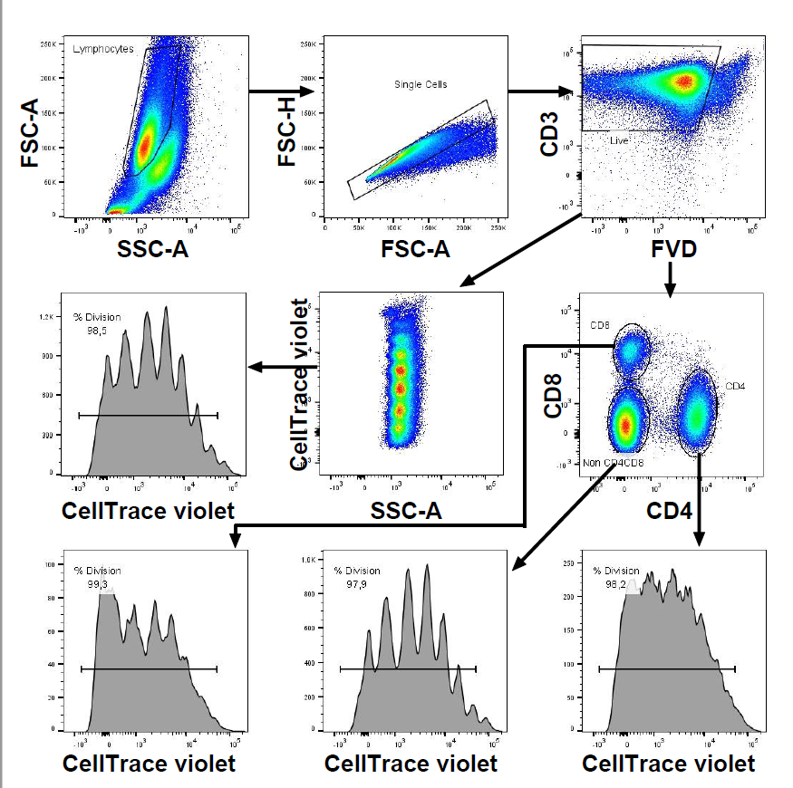
Annex C. Flow cytometry gating strategy

Figure C1. Flow cytometry gating strategy used to determine CD4⁺, CD8⁺ and CD4⁻ CD8⁻ T cells from the peripheral blood and the percentage of division. Lymphocytes were gated based on FSC and SSC parameters and Single Cells were selected in FSC-H versus FCS-A plots. Live CD3⁺ T cells were defined as CD3-expressing FVD negative cells. CD4⁺, CD8⁺ and CD4⁻ CD8⁻ (Non CD4CD8) were determined in CD4 versus CD8 plots in which CD4⁺ were positive for CD4 and negative for CD8, CD8⁺ were positive for CD8 and negative for CD4, and CD4⁻ CD8⁻ were negative for both CD4 and CD8. Cell proliferation was evaluated in each gated T cell population as the percentage of cells that divided at least once, based on CellTrace™ Violet dye dilution. This is a representative example of PBMC isolated from a ConA stimulated calf, 15 days after infection with 2.5 × 10⁸ N. caninum tachyzoites.

Figure C2. Flow cytometry gating strategy used to determine CD4⁺, CD8⁺ and CD4⁻ CD8⁻ T cells from the peripheral blood producing IFN-γ and IL-17A. Lymphocytes were gated based on FSC and SSC parameters and Single Cells were selected in FSC-H versus FCS-A plots. CD3⁺ T cells were defined based on CD3 expression. CD4⁺, CD8⁺ and CD4⁻ CD8⁻ were determined in CD4⁺ versus CD8⁺ plots in which CD4⁺ were CD4⁺ CD8⁻, CD8⁺ were CD8⁺ CD4⁻, and CD4⁻ CD8⁻ (Non CD4CD8) were negative for both CD4 and CD8. IFN-γ and IL-17A-expressing cells were selected in each gated T cell population. Cells were stained with CellTrace™ Violet but analysis of cell proliferation was not evaluated. This is a representative example of PBMC isolated from a NcT stimulated calf, 15 days after infection with 2.5 × 10⁸ N. caninum tachyzoites.

